DEEPEST CUT
COMMISSION STORY
BY CHALDEACHANGE
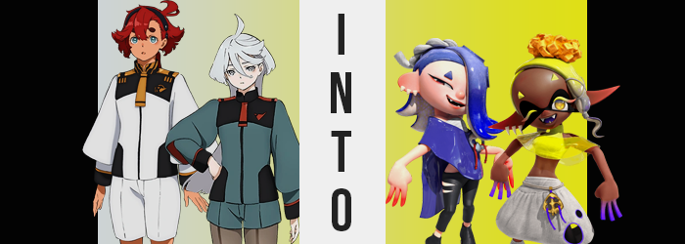

“There it is… Earth.”

“Wow, it’s so pretty Miorine-san!”

It had been a seemingly novel idea. Miorine Rembrandt was always talking about how she wanted to run away to Earth, but while those plans had changed thanks to her establishing GUND-ARM INC., that didn’t mean that she could never go there, right? So with the help of the other members of Earth House Suletta Mercury had managed to plan this trip. It was difficult with Miorine always away on business, but with the Plant Quetta incident still a month away they’d managed to find the time for a few days.

So now they were on a shuttle heading down to the planet slowly, with both girls marveling at the sight of the big, blue planet as they drew closer. Some of the other Earth House girls were with them like Nika and Chuchu, but they were off doing other things elsewhere in the shuttle. “It’s the same color as Suletta’s eyes…” Miorine murmured under her breath.

“Hm? What did you say Miorine-san?” Suletta perked up after hearing her name but nothing else, sliding in close to her bride-to-be. But Miorine immediately pushed her away with a groan.

“N-NOTHING!”

Suletta was pretty sure that wasn’t the case but she knew better than to push Miorine on it. Not that the Gundam pilot really lingered on it for long because a bright light nearby caught her attention. “Huh? Miorine-san? Is that normal?” Leaning forward she had asked her question just in time to point out a rainbow colored portal between their shuttle and the Earth. But it was already too late; the shuttle passed through it and everything turned weird.

“MIORINE-SAN!”

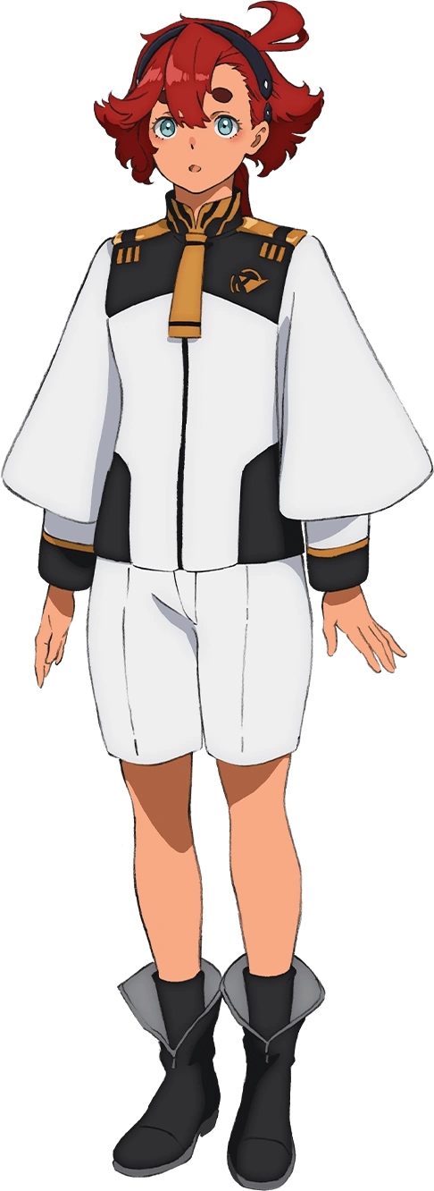
“Huh? Where am I…?” Suletta finally picked herself up off the floor, disoriented after pulling herself out of a state of unconsciousness. What had happened? She was surrounded by tall buildings like she was in the middle of a city on Earth, but… Had their shuttle crashed after passing through that ring of light? So was she actually on Earth? Had she been knocked unconscious from the crash?

Since it was the dead of night there didn’t seem to be anyone else around. Were they sleeping? The street was lit up with extremely bright lights and billboards – Suletta had never seen anything like it in her life considering her sheltered upbringing on Mercury. She didn’t recognize the language on the billboards either but that was to be expected. Earthians spoke a ton of different languages.

The girl walked around for a little bit. If the shuttle had crashed then where was it? Where was everyone else? The more she thought about it the more it didn’t make sense. But after passing by a studio with a large glass window, Suletta noticed the first familiar thing inside of it. “Miorine-san!” Miorine was passed out on the floor of the studio! The Holder ran over to the door but it was locked. It needed a handprint? But…

“Well… No harm in trying, right?” Not too worried about the consequences, she raised her hand and placed it against the hand scanner. It was in that moment that it struck Suletta that the device seemed a little odd? The handprint seemed almost too large, like almost twice the size of her hand? But maybe that was just so people absolutely knew where to put their hands?

Naturally, the device whirred to life once a hand was placed upon it. The panel lit up as a scan line went from top to bottom, but there was ultimately a noise that sounded like an error. “I guess that was to be expected…” Thinking she’d have to find another way to get to Miorine she went to pull her hand away, but… It wouldn’t budge. “E-EH!?” Try as she might, she just couldn’t remove it from the panel! And that’s when she noticed it.

Her fingers were red? No, it was almost like a red light was passing through them? “Wh-Wh-What!?” Had the girl taken a moment to look at her other hand she would have noticed the exact same problem. But more than that? Her fingers – nay, both of her entire hands – soon looked swollen. Little by little they grew until they were big enough to fill out the larger hand panel, making them seem cartoonishly big compared to arms that were… thinner?

Suletta was stronger than most, but you wouldn’t have known it if her sleeves hadn’t been in the way to conceal what was happening to those arms. Thinner and thinner they became until they almost looked as if there were no bones present inside of them whatsoever… which actually was the truth.

“M-My skin!?” Too fixated on her hand to notice anything else that was happening, she could see the skin below the glowing red fingers (which were more pointed in shape and fingerless now) paling towards a white that wasn’t all that different from Miorine or her mom’s skin. She couldn’t see considering her current circumstances, but this was happening to all of her skin. Even her nipples had pinkened.

Though lets talk about the rest of the girl’s body for a moment. Suletta had shrunk vertically oh so slightly, but her torso and legs had been collapsing horizontally. Much like her arms, the shapes of the girl’s legs were thinning although her thighs retained a feminine girth that was comparatively more pronounced when compared to everything beneath her knees. Everything about her torso was narrower, including hips that allowed shorts to pool around her feet. “E-Eh!?” Even the piloting leotard beneath her unform felt loose.

But Suletta’s hand was still stuck, glowing fingers and all. She couldn’t bend over to grab her shorts or anything, but she did feel like her eye level versus the panel was lower now? Had she always been reaching slightly up? “What is happeniiiiing!?” Shoes felt cramped all of a sudden as well, because despite her body becoming more compressed on the whole? Like her hands, her feet had swollen several sides. Eventually they pushed through the toes of her boots, glowing red toes flopping out.

Beneath her top and her piloting leotard? Suletta’s breasts compressed. Maybe it was wrong to say that they had ‘shrunk’, because with her shoulders and torso narrowed they still appeared somewhat sizable, but their perky shapes were definitely squeezed until they were more comparable to her leaner form. This might have been a good time to note her waistline, which was quite pronounced in its inward arch. It was all so strange because her body still strongly resembled a human woman’s, but between the enlarged hands and feet and the glowing fingers, there were aspects of it that were uncannily not.

And that discrepancy worsened.

“What?” Compared to the words she’d spoken previously Suletta’s delivery in this instance was off. It sounded a touch more serious, but beyond that? Her voice had almost echoed within itself, the word hardly distinguishable from that vocal reverberation. Regardless, she’d been prompted to make that noise in the first place because her chin kept tipping downward. Every time she tried to lift it up again it just fell back down, like it was too heavy?

Evidently the changes were affecting her mind too, because it was very obvious why that was. Her head was seemingly inflating like a balloon, its shape and size bloating larger and larger until the width of her head was wider than her shoulders. Suletta’s headband slipped right off during this growth, and her pale facial features expanded and shifted to fit this larger yet flatter canvas.

Eyes and mouth alike widened to better suit this horizontally longer face of hers. Those eyes remained narrow even after becoming wider, red paint lined beneath them while that very same red was soon reflected in her irises. Strangely, her tanuki-like eyebrows found themselves recut into a pair of triangles. Triangles that were blue and, after a moment, didn’t quite look as if they were made of hair. “Maybe this is a sign I need to be getting more sleep…?”

She shook her head with a smirk that showed off her teeth. Or at least a trio of them. It seemed like her canines on top were sticking out? But then why was a third teeth poking up in the center of the bottom row? Just above pronounced, pink lips her nose had taken a very bulbous shape. Also, those words she had just spoken? There was no way that had been a human language.

Humans didn’t typically have heads bigger than their torsos though. Nor did they have hair that was growing and hardening into something rubberier. The red of her hair shifted to a very vivid blue – the same that could be observed in her eyebrows – and it all came to flop over her right eye. Of all things, suction cups appeared across the top of this hair, but that exposed their true nature in the end.

While it took the place of her hair, her head was covered with tentacles.

“Ngh…” The octopus woman made one more disgruntled noise as she finally managed to free her hand from the sensor and stumbled back. In that time? Suletta’s Holder uniform had disappeared, only to be replaced by a white chest wrap, purple shawl, low-cut black leggings and tabi-like shoes. Not to mention the shark tooth earrings in her egregiously large ear. This wasn’t even her complete outfit, but she’d been coaxed into leaving in a hurry.

Shiver shook her head, her tentacles jiggling about as she did so. “What was I in such a rush to head into the studio for this late? Something inside…?” Admittedly it wasn’t all that strange for the Octoling to be out and about this late even if Splatsville was always dead quiet at these hours. It wasn’t all that unusual for the Deep Cut members to meet up at the studio to chill out or practice when they couldn’t sleep. Well, at least when they didn’t have any treasure hunting to do.

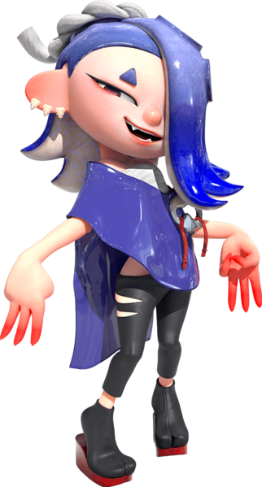
She took several steps back to peer into the window. Had there been someone on the floor a moment ago? A mammal? Her memories had briefly flashed a recollection of such a thing, but looking there now? No one was there. Of course there wouldn’t be a mammal lying on the ground! After dealing with Mr. Grizz there was no longer any threat of Mammalians returning. A new era of peace had been ushered in!

“Oh, wait. I told Frye I’d meet her outside the studio, didn’t I?” After giving her head another shake some memories fell back into place. Frye had texted her asking Shiver to meet her outside the studio. She said something about having a BIG IDEA. Presumably she’d texted Big Man too, which only led her to sigh.

“Am I really the first one here?”

“Ngh… Where am I? …Suletta?” Miorine felt like she had just woken up from a long nap, stirred only by what she believed to have been Suletta’s voice calling to her – albeit muffled in sound (probably because a thick window had been between them). But by the time the silver-haired girl had stirred back into consciousness Suletta had already moved to fret over the door and her transformation had begun. “…Am I inside a building?”

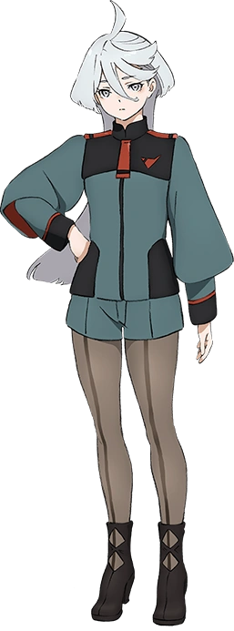
She pushed herself up and off the floor. Memories flooded back about what had transpired prior to her losing consciousness. There had been a strange rainbow portal? The shuttle had passed through it and then the next thing she could recall was waking up. Did the shuttle crash? Did they land? There was definitely a city outside of the big window beside her.

As for where she was? Miorine didn’t have the foggiest idea. She could guess that she was in a studio of some sort, but why was she there? Wouldn’t someone have had to have moved her there if either of her potential scenarios was true? But she really couldn’t think of anything else that would have made sense. “What the hell happened to us?”

Suletta and herself hadn’t even been the only ones on the shuttle, but of course she was more concerned about the Holder than anyone else. Mind you, that concern was quickly turned inward because, well… “HAH!? WHY DOES MY HEAD FEEL SO HEAVY!?” Evidently the order of operations for Miorine’s transformation was not the same as what was transpiring with her partner’s outside at that very moment.

The Benerit Group heiress could feel the weight of her own head upon her shoulders. It was difficult to hold her chin up like she had done so her entire life, prompting her to blush from the feeling of helplessness that ensued. But inch by inch her head was inflating, hands reaching up to help stabilize it only building upon Miorine’s shock as it reached nearly five times its original size. How was that possible!? How was she not dead!? She had a million questions, but at least for the time being she was having problems making much in the way of sound.

“Urp!?” The sounds she could make from a mouth that had increasingly pronounced upper canines (as well as one in the center bottom of her mouth) all sounded bizarre. There was a strange, distorted ring to every sound that was made that didn’t sound like any noise a human could make. All the while? Her bloated head appeared increasingly less human.

A black band darkened around Miorine’s eyes. It was an eye mask typical of the species she was becoming, and inside of it? One could make out her enlarged eyes turning gold with plus-shaped pupils. Eyelashes, if they could be called that since they weren’t technically made of hair, were long and yellow with orange tips. Similar to Suletta her brows took triangular shapes as well, but hers were yellow triangles.

Her hair flattened and shortened dramatically as it was pulled up into short and thin yellow tentacles with a grey gradient at the tip. Strangely, unlike Shiver’s tentacles Miorine’s had suction cups on their undersides, not that they were particularly visible with how short they were. You could plainly see the girl’s ears poking out from behind them, but that wasn’t particularly difficult to do considering those ears were yanked into almost eight inch long points that fanned out to the sides of her head. Her huge forehead was entirely exposed.

“What just…? Why does my voice sound like…? What LANGUAGE is this!?” With the changes to her head done she eventually found it easier to talk once more. But she was hit with the double whammy of realizing her voice was peppy and distorted sounding, but also that she wasn’t speaking in the language she knew. Which was, uh… “I can’t remember any other language!?” This one was called Inkling? Why did she know what a language she had never spoken before was called?

Thankfully it seemed that Miorine’s neck had strengthened to better support her head, but in truth it was easier because there wasn’t exactly a skull in there. In fact the bones in her body were all melting one by one as it changed structurally. It remained humanoid, but much like what was happening with Suletta, it was only doing so in an uncanny sense.

Not like you could get much uncannier than her giant cranium though.

Hands and feet joined her head in the ‘things that seemed much too big for the rest of her body’ area. They bloated and grew several sizes, feet exploding out the front of her shoes to reveal toes that, much like her now swollen fingers, were glowing purple. “What is…? I’m…? Huh? Is that really that weird?” It was in that moment that the breadth of the mental changes she’d slowly been experiencing was exposed. Looking at her hands and toes, she was struggling to consider why she might find them weird?

Even as before her very eyes her skin quickly darkened to a rich, milk chocolate brown did she not question the color it had become. On the contrary… “Was my skin just white a second ago? No way, right!?” As if that was something that could have been possible. She would have sounded delusional if she’d told Suletta Shiver about that!

From that point on it was just a matter of narrowing the rest of her body. Miorine’s uniform increasingly loosened as her torso thinned, legs becoming a little shorter and limbs becoming more tube-like in shapes. Her waistline was ultimately far narrower when all was said and done, though her breasts? They had actually grown despite being compressed. They stood out far more obviously against this new body shape of hers. As did the clear abs on her tummy. Even her arms seemed a little more buff, meaning Suletta and Miorine’s positions had been swapped in terms of fitness levels.

That was all easily exposed once her clothing was replaced. It was seamless and instantaneous, with her Asticassia uniform done away with at the same moment that shark earring appeared in her right ear. A yellow shaw and sleeveless, cropped turtleneck made sure that her toned tummy was exposed above baggy, white pants that hugged her thinner hips. Rather than shoes she was wearing toeless socks, too. But this was just an incomplete evening ensemble.

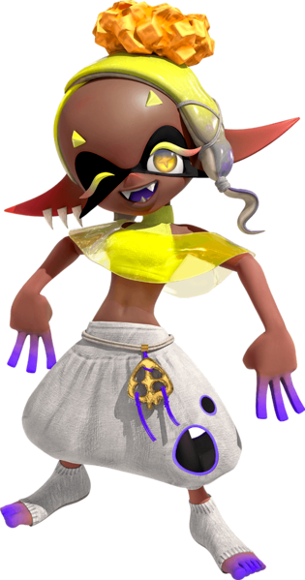
“GUUUUH! I feel so stiff! Like it’s been forever since I was moving around!” Frye did a big stretch of her arms and back before focusing on her legs. Why did she feel so stiff? It was a byproduct of the girl she had once been – Miorine wasn’t exactly the most energetic nor athletic girl in the world. But Frye? She was the polar opposite. She always had a ton of pent up energy and loved to move her body. When it came to Deep Cut’s Splatfest performances she was the one who danced around the most and that suited her just fine! “That’s better!”

Once she had finished stretching the Inkling did a little hop. Now that she felt more limber, she felt a little more clearheaded! Why had she been so groggy in the first place? She’d definitely taken a nap in the evening, and when she’d woken up she’d— “RIGHT!” It all came rushing back to her! Frye’d had a dream with a sick new song and dance routine, or at least as much as she could recall, and she’d wanted to share it with the rest of Deep Cut before she forgot!

And so she’d asked Shiver and Big Man to meet her at the studio! But there had been something else too! Her relationship with Shiver had been getting more intimate lately and she’d wanted to show the Octoling her appreciation. So she’d come early to set up a little surprise in one of the rooms in the studio. A corny display or rose petals and candles for when Big Man eventually went home!

“Wait, did I tell them to meet me outside…? Shoot!” The time between checking the texts she’d sent and running out to the hall that connected to the front door was negligible. How long had she made them wait! She threw the door wide open. “Shiv— Huh? Is Big Man not here yet?” Shiver was there but their manta ray friend was not.

Shiver just gave a little wave of her phone. “Nah, he just texted me to say he wants to sleep. Is this something just you and I can talk about?” Well, considering the plans Frye had for after their discussion maybe it was better that Big Man was staying home after all?

It seemed the Holder and her bride-to-be would retain their relationship regardless of world.

