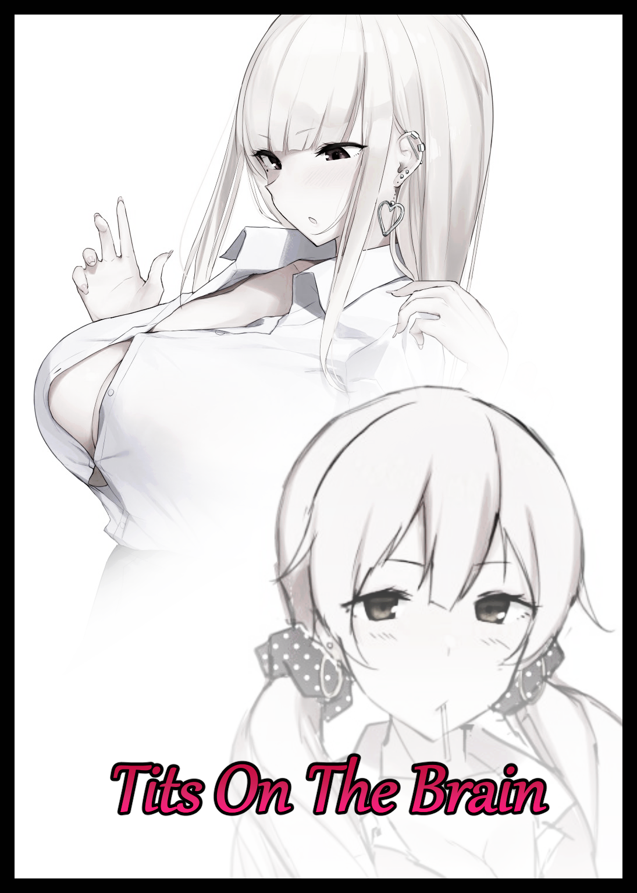

In a quiet, suburban town where its inhabitants had lived quiet lives of idyllic peace for over half a millenia. News of major import was quick to spread, for most of its populace, although happy with the way things were, could only hope for something to incite a little spice in their lives every now and then with nothing else besides home entertainment and the internet to busy themselves with. Even something as minor as a traffic accident was enough to become the talk of the town for weeks on end before they inevitably went back to mulling around.

So it was no surprise when rumor had begun to spread about a certain…curse of sorts that no one seemed to know how to counter or steer clear of. Some said it had to do with occult dealings involving the demonic while others claimed it to be like a virus, spreading itself through physical contact or even more nonsensically; verbal means like an actual incantation spoken in earshot of others. There were also those who believed it to be the invisible hand of a benevolent force that had come over the town to lord over it and all within its sphere of influence, granting wishes, punishing evildoers and maintaining balance…with the one thing most would agree on being that it was all just preposterous rumors and maddening suspicion spread by someone who had grown incredibly bored out of their minds.

With no actual reports about the curse befalling anyone despite how quickly word of it had spread around the quiet town, most paid the phenomenon no mind. Quickly shelving it into the back of their minds a few days after hearing about it. Just like all the other minor blips that had occurred in the past everyone had used to try and make life in ***Oaktown*** seem that much more exciting than the dreadfully mundane locale it was.

Sometimes however, rumors were simply the gateway to something credible. Distorted words that masked a truth whose origins had become muddied by exaggerated pomp and fluff that tended to make the whole routine seem like a multi-step mess that wasn’t worth the trouble to go through just to experience nothing at all. But in this case, the ***Oaktown Malady***, as some had come to call it because of all the trouble it had brought from residents trying to prove its authenticity, was more than that. And tonight, two of Oaktown’s citizens would become privy to that fact. A particularly careless sort who wouldn’t stand much of a chance against the unseen force that had indeed settled upon the cozy town, a place that had already experienced its touch in more ways than one…

The targets in particular weren’t even locals. Staying in the bunks near the local highschool for students without the income or households to afford a luxury like a house, ***Matthius Werner*** and his unwitting ‘buddy’; ***Alex Craner***, were hard pressed for entertainment. Having come from middle class households with parents that could honestly care little for them, the two young men were similar only in their shared hatred for terrible households but not much else. Leaving them as nothing more than amiable partners at best and distant strangers at worst. A standoffish relationship that left little room for growth despite the fact that close to half a year had already passed…and in Oaktown, very little could be done to further a friendship between two distant boys who would rather spend their time on computer games and other personal hobbies than in each other.

And on a hot summer evening, the highschoolers were just as grumpy if not more so than their usual high strung selves were. With Matthius struggling to get reception while sprawled out on his bed with barely anything on, ignoring Alex until he saw a need for his services, tossing aside his phone in a fit of silent frustration as he turns to look over at his friend, somehow still able to function somewhat normally amidst the unprecedented heatwave nestled in the swivel chair with his back facing the bed and narrow eyes focused on the desktop monitor on the desk, fingers rattling noisily away as they hammered on a keyboard in rhythmic fashion like a practiced smith would a hammer against an anvil.

**“Hey…get me an ice cream…how the heck’re you even still working anyway? It feels like thirty effing degrees or something!”**

**“Thirty four to be exact…if it keeps on rising though…forget about homework...damn school keep skimping out on air condition repairs anymore and they’ll have two roasted humans for dinner tonight…”**

**“Ice cream…”**

**“Get it yourself…homework? Remember?”**

Sighing with not so subtle curses spewing out of his mouth, Matthius bounces off the bed before stomping over toward the left side corner of the cramped room where the two roommates kept a shared stash of snacks and other goodies locked up tight in a mini refrigerator sourced from savings pooled together by both tenants after realizing just how bland and tasteless Oaktown Academy’s cafeteria offerings were. A saving grace that had enabled the two of them to outlast the sweltering summer heat…until their stocks ran out and they had to make weekend trips to the local supermarket for more. Forced to roam baked streets and simmering shelters just to make it to a sweltering armpit of a shop for chilled goods before making it back just in time to stash them before they wasted away into a useless pool within the packaging.

Unbeknownst to either of them however, the venture last week would be the last time either of them would feel discomfort amidst the blazing fury of the sun’s embrace as Matthius returns to his roost with his prize in hand while Alex continues to work on his assignment with abject refusal to turn around lest he burn his eyes with an unwanted glimpse of his roomates hairy schlong unabashedly hanging low and free for all to see. A moment of relative calm chosen by the Malady to strike as its influence begins to show in force, knowing full well what the two students were really up to despite their best efforts to mask their respective perversions from one another. With the screen of Matthius’ phone being filled with pictures and videos of alluring women in compromising positions while the same could more or less be said for Alex, whose focus on homework was more or less a cover for the side screen pop-up playing a raunchy video from a site chock full of such seditious content. Giving the magical force all the fuel it needed to concoct a most devilish plan indeed for the two foreigners…a plan that would end with the two enjoying their lives in Oaktown much more than they already were, a wide margin that would most certainly give a certain portion of the locals something else to look forward to as well once this plan had run its course. And with a noticeable change beginning to afflict the still oblivious Alex in the form of broad shoulders gradually caving inward by the second, the running train that was the Oaktown Malady had gone past the point of no return…

**“Goddamn…those boobs are to die for…”**

**“The heck did you just say?”**

**“Mind your own business…unlike you, I’ve got work that needs doing.”**

Shifting his neck back to its forward facing position with a subtle change in hairline and a tumble of stray, lengthening locks that reach past shrinking earlobes cleansed of dirt. Alex resumes his less than noble internet trawl, none the wiser to the way the hands sliding across the keyboard had begun to grow smaller. Taking on a more effeminate silhouette gleaned from supple layers of flesh inserting themselves in the vacant spots left by vanished muscle and repurposed mass around thinning bone that lengthens just a tad bit to further accentuate the undulating wave taking shape just beneath the oblivious youth’s notice as scrawny fingers harden and smooth over, wiping a mild Caucausian tan over with the deathly smooth pallor of someone who had lived a rather reclusive life indoors without seeing the sun too often while tufts of curly body hair disintegrates wherever the wave of new skin touches, replacing the coarse hide of a man with that of a porcelain figure, leaving Alex’s hands temporarily mismatched with the rest of his still manly body before the vestigial remnants of his shoulders crack inward with a noticeable pop that lines itself up nicely with the momentum of a stretch, drawing the ignorant fool’s attention away from his feminized hands before he returns to his lecherous browsing. Blind to the manicured nails clacking away at each key after gnarled shells had been cleansed and polished to a mirror sheen. The cracks and lines running across their length indicative of an unhealthy diet all but forgotten…

*‘Damn…I oughta stretch more often…that did not sound good at all.’*

But drastic changes that bordered on a physical overhaul like this could not go ignored forever, and once Alex’s chest begins to tighten, his breathing impaired. Only then would he realize what was going on as the waifish hand that reaches for his throat draw his gaze downward upon recoiling from the pain of sharpened nails digging into the skin of his neck, driving him into full blown panic as bulging eyes catch sight of an alarming scenario playing out beneath the trembling fabric of a slightly baggier t-shirt as flesh starts to bubble while skin writhes with disturbing life. One thing would lead to another, and as Alex’s increasingly shaky vision draws from his gradually distorting chest over to unrecognizable hands set atop dainty wrists and weak, curvy forearms all wrapped up in impossibly smooth skin that was still in the midst of consuming his original khaki hued self, the inevitable panic and adrenaline rush was all but impossible to contain…

**“What the fuck man?! S-Something’s happening to me! Dude, you’ve gotta…oh shit, you’ve got it too!”**

**“Whut? The heck’re you screaming about? It’s just ice cream…”**

In the brief moment thrashing legs had launched him spinning backward where he sat towards the center of the room, Alex had been able to feel everything that had changed about him in the brief moment of clarity brought about by the sheer panic he felt as the tickle of lengthening hair that had become far smoother runs over plumping cheeks, causing enlarged eyes to blink on instinct. Further alerting the changeling to the way stubby lashes had grown ever so slightly with a mild, upward facing arch that could only be done through the hands of a bona fide fashionista. And as if that wasn’t enough, the way the bubbling mass on his chest had bounced around to the momentum of his rapid movement had been more than enough to prove that this wasn’t a simple hallucination wrought about by heatstroke.

Which also meant that Matthius wasn’t faring too well himself. In fact, his roommate seemed to be a few seconds ahead of him in the metamorphic process that had befallen them. Sporting a renewed head of hair that was steadily starting to bleach itself with a dirty shade of platinum blonde straight from the roots while his burgeoning body had started to fatten up like a sow as layer upon layer of bourgeois meat fills the jock’s frame, granting curves where there had been none before to eliminate the gaunt, blocky figure he once boasted. Eaten away with every passing second as solid muscle sags into pliable fat while a scarred hide seems to simmer up, coating itself in even more sweat that serves to highlight just how smooth and polished his entire being had become in the span of just a few seconds and counting as hairy legs fall to the mutation, trembling almost as if they thought to put up some form of resistance before more pockets of blubber explode into existence, turning the unsightly trunks into curvaceous pillars formed from thickened thighs and firm calves that taper off into petite feet clad in rosy skin that turns a mild shade of strawberry pink in all the right areas to draw the eyes of an onlooker to yet more places that would’ve gone unnoticed otherwise…such as the shadowy pocket further up above that begins to recede once baggy clothes start to tent and rise away, exposing the alarming sight of a flaccid cock lying devastated atop damp sheets that did little to absorb the ongoing downpour of salty fluids raining down from above as trails of it traced the length of Matthias’ now buxom form before soaking into the bed around a dumptruck ass that was still halfway to completion as a blocky rear sags outward to form individual cushions that would become the basis for amazingly ginormous cheeks. Slappable balloons that were just as firm and tight as the tantalizing tummy out front, overshadowed by the unmistakable mass and heft that were a fertile woman’s boobs as an effeminate ‘Mnff~’ slips free from the distorting man’s pouty lips, his dazed expression suggesting complete ignorance to the situation as a manicured hand stripped of muscle continues to piston the milky treat in and out of Matthius’ mouth in promiscuous fashion. His phone, all but forgotten at the side of the bed to either of the afflicted as it too, starts to undergo its own transformation…

**“B-Boobs! You’re! *We’re* growing boobs!”**

**“*\*Pop!\** For fuck’s sake Tammy, stop tryin’ to mess with *\*Suck!\** me…we’re girls! Of course we got tits! Now let me finish this *\*Slurp!\** and then we can get started~”**

**“The fuck? *‘Get started’*? Started on…*ooh*…my head…”**

Collapsing back onto the chair as a wave of nauseous dizziness claims his ability to move about with the vigor and gusto he once displayed, Alex stumbles, trying his best to remain seated despite the shift in orientation as his own set of tits near fruition. Not as large as the melons that tented Matthius’ front but still enough to show their heft as they struggled to shred his soaking wet clothes once a renewed layer of sweat begins to coat his body from the supernatural heat keeping him pinned and helpless to do anything but watch as his roommate succumbs to the mysterious magics responsible for the sudden makeover as the beady eyes of his unlikeable roomie slants into a husky slit, granting him a permanent sultry gaze dripping with wanton appeal as the glazed black orbs within spazz out before widening into crimson spheres. Dilating as unseen processes centered around a dullard’s brain easily scours the synapses clean of anything to do with a deadbeat highschooler just in time for the changes down under to reach their peak, giving Alex a glimpse of the fate that awaited him as well as furrowed eyes take in the mesmerizingly morbid sight of flesh parting to form a flowery gash, formed from repurposed mass and skin as wrinkled sacs that once housed testicles smoothen into shimmering lips. Clearly tuned to react to stimuli at an insane degree as he watches the remnants of a man’s penis shrink until it could no longer be called that, fearing the same as a tiny hole seals itself forever, cutting off the pathetic trickle of semen before redirecting it out through an active hole that puckers in anticipation before tightening itself, eliciting an animalistic moan from Matthias vocalized in an airy tune that was no longer that of the bratty jock ***she*** once was as her back arches inward to the force and irresistible bliss of the orgasm wrought about by the erasure of her manhood. An irresistible explosion of incorrigible pleasure that leaves the newborn girl lying on the bed with her legs spread wide without shame as her urethra squirts out the last of a vanished man’s semen before replacing the milky drool with a translucent spray that splashes across the bed…and onto Alex’s bewildered face, accompanied by a ditzy giggle and a half-hearted shout that sounds more like a high pitched squeal than anything else…

**“Oopsies~ Did I getcha in the eyes?”**

**“F-For fuck’s sake Matthias…s-snap…out of it! You…You have to fight…can’t…forget…”**

**“Forget? If anything, you’re the one who like, totes needs to keep her head straight. Matthias’ a stud’s name…and a man has a cock! Look~ Does this look like a dick to you~”**

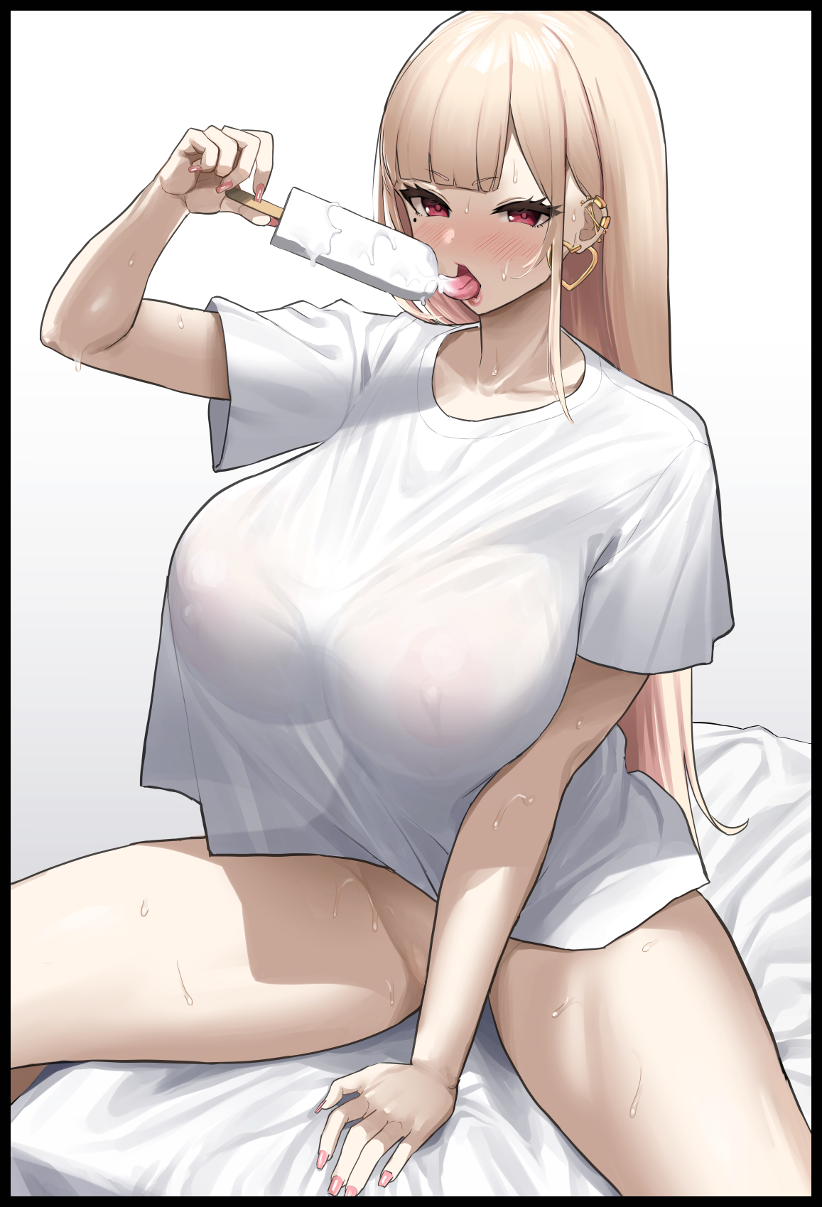

Waving the half melted popsicle in the air with a leer on her face indicative of a complete mental rewrite, the former Matthias reaches down to prod at her still leaking vagina with the assistance of a free hand, spreading pudgy labia before inserting the cold treat into her cunt with unabashed gusto and a depraved squeal that leaves Alex both horrified and aroused at the same time, barely able to keep track of his own bulging body as shivering thighs sag over the seats while sensitive breasts rise and fall with each haggard breath. Stimulating him in a way he’d never thought possible as tiny bolts of electric pleasure shoots through the undeniable body of a plump girl masked behind ill-fitting boy’s clothes lying in a growing pool of steam and sweat once the tiny tent in ***her*** boxers that might as well be a cute little clitoris vanishes from sight just like Matthias before her. With the provided shroud being the only mercy shown to Alex as she slumps into her seat, unable to find the strength to wipe her friend’s cum off her face while she watches her masturbate in decadent bliss before popping the thing out of her second mouth, thoroughly soaked in vaginal juices and what was left of Matthias’ spunk to devour without a second thought, slurping the milky mess up like a thirsty dog just as heart shaped earrings clip themselves into place beneath that long, flowing mane of hers to complete the formation of an utterly depraved whore…an unavoidable outcome Alex herself wished to avoid with all her might despite the futility of it all as she struggles to move her lead weighted arms and legs, hoping to crawl out of the room in a last ditch effort to get away from it all. A sight that amuses her roommate as she rises from her seat without issue to cradle Alex’s chin while stroking her face with the popsicle much to her ‘disgust’, a reaction that comes off as more of a positive one as her face twists against her will into a look of utter euphoria. Double visioned eyes catching a glimpse of pale pink bangs sliding into her field of view alongside the tickle of a longer curtain running down the length of a hypersensitive back.

**“That clear enough for you Tammy? No worries tho, I’m gonna make a few calls…and then you can like, see for yourself…that sounds fun doesn’t it?”**

**“F-Fun…no…I’m not…like you…not at all~ *\*Tee hee!\** You’re not-”**

Despite the stupid look of happiness plastered over her face, Alex desperately wanted to leave, to say how much her former friend reeked of cum and how trashy she was behaving…but once her own frail mind had begun to feel the touch of the Oaktown Malady tracing it’s immaterial fingers over her very being, there was little Alex could do but bend the knee once the combined efforts of her subsumed roomie and the unseen force withers away the last of her resistance. Chipping cracks into her very identity as new memories and experiences began to seed themselves in the vacant spots left open for them to fill each time Matthias…no, ***Suzie*** massages her tits after discarding a cleaned out popsicle stick, squeezing the milky masses like a baker would a pound of batter with expert thumbs ensuring her swollen nipples were included as well, flicking the erect nubs as they poked out through shifting fabrics to form a suffocating ensemble consisting of a baggy pink cotton jacket laid over a flimsy shirt and a lacey black bra beneath to support the heft of her bosom, complete with a matching set of equally seductive panties that were more akin to a thong as it slips around the length of her childbirthing hips before squeezing tight between the depths of her ass, giving her pussy a good rub much like the actual thong Suzie now sported in her own change of attire before finalizing itself under a woefully short, pleated skirt that showed plenty of skin down under as trembling legs spasmed in the throes of orgasm, soaking the floor with her own juices in a messy spray that starts off thick and runny before emptying off in a pale trickle of precum and pussy juice that pools between the curvy legs of both women as the last of Alex Craner struggles to persist amidst a torrential mind storm of memories from another life what little of her former self did not want to be a part of despite the total loss of self. A defiant flame that would-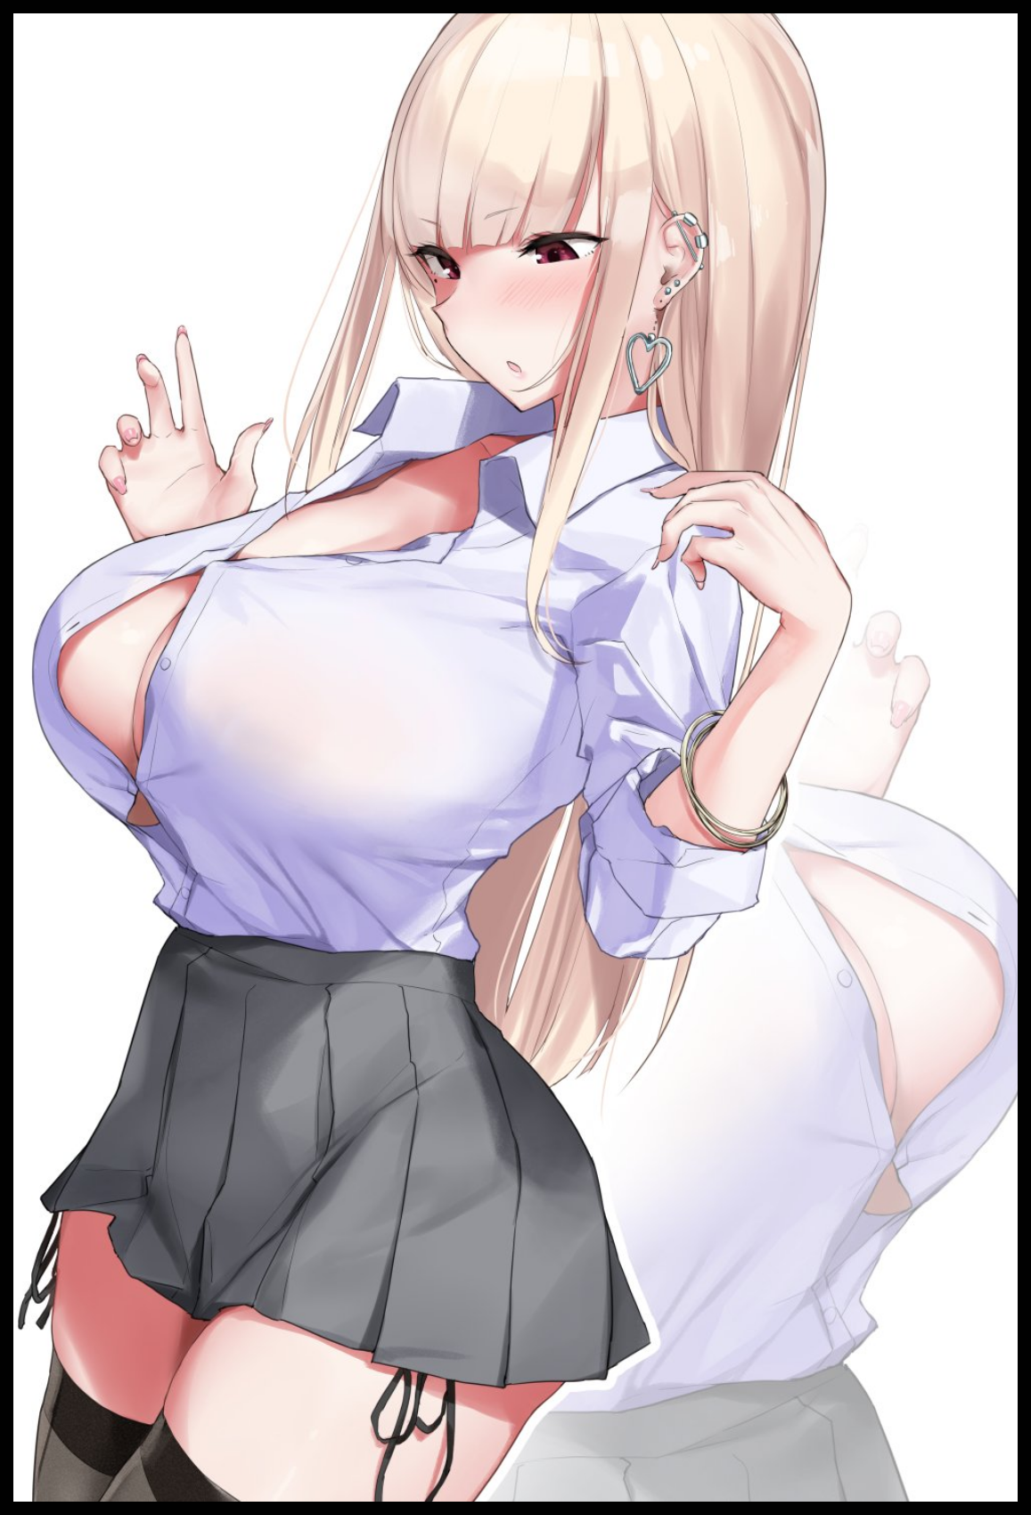

**“Ow! What the fuck *Sis*?! Your tits made out of metal or something?!”**

**“Whoops, soz! A button must’a came loose~ Your boobies were like, so soft I couldn’t help myself y’know?”**

Turning with a flurry of movement from freshly tied twintails held together by polka dotted scrunchies and a jiggle of floppy breasts hanging out the front of a popped jacket, Tammy growls at her sister for the affront to her scalp, rubbing the affected area with a bitter pout on her adorable face while the more mature of the two siblings stares at the front of her half busted shirt, wearing an expression that seemed to mix confusion with utter disbelief. A look that had Tammy barely able to recall feeling the same way not too long before Suzie had started to play with her breasts while they waited for their boyfriends to come over…that was what they were waiting for…*right*?

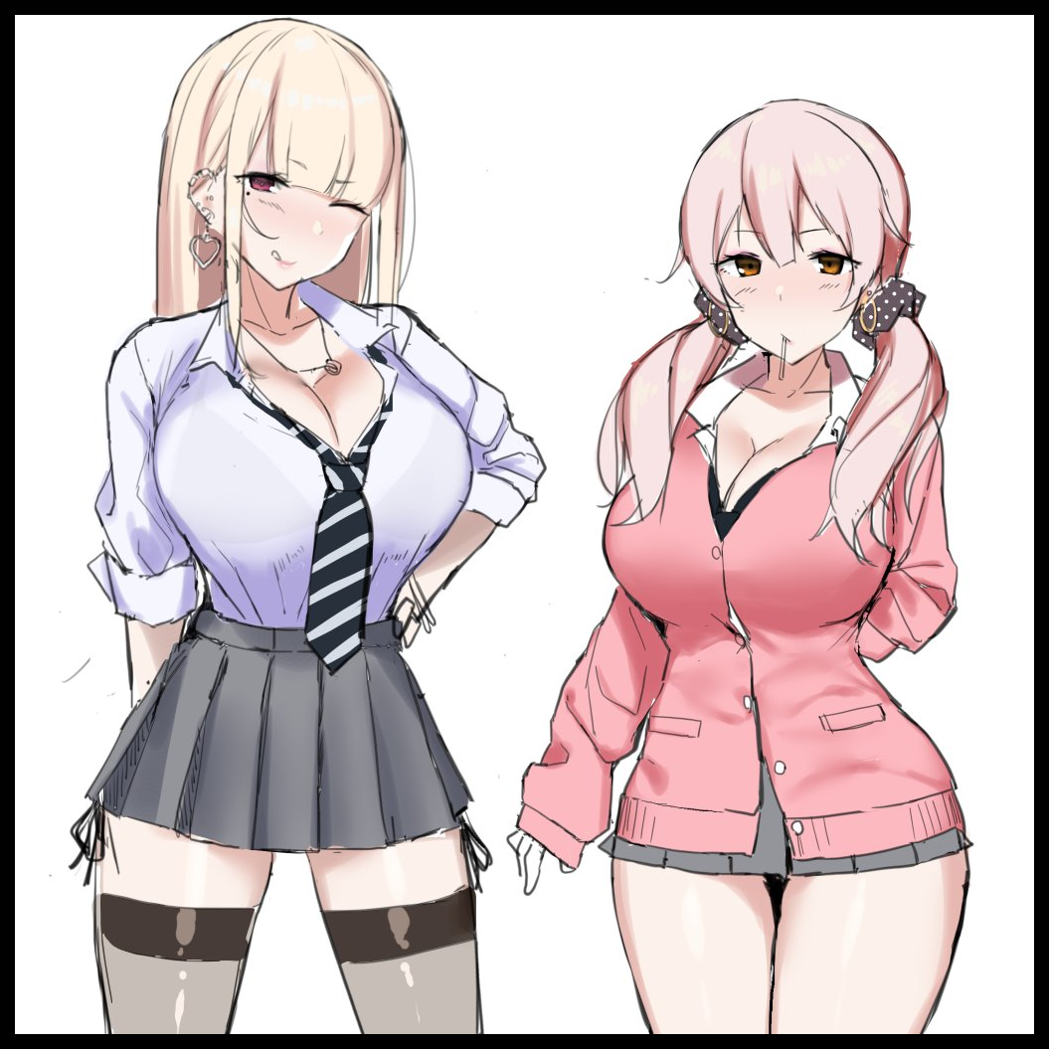

But of course they were, with summer in full swing and being the highschool dropouts they were, there was only one thing the most well known skanks in Oaktown could do; fuck like rabbits. And seeing as how they already had plenty of dough from the many evenings they had spent ‘working the streets’, both Suzie and Tammy could afford to lay back for a couple of days, cutting down on smelly old men and tired officer slavers for the much more virile girth of their respective boy toys who had clung to them after they had been expelled from highschool for ‘illicit behavior’. A term the two ditzy girls had taken for jealousy as they began their seditious lives together away from the uncaring eyes of their parents and the noble upstarts…a fabricated truth the two sisters were now firmly made to believe in as the final fragments of a cramped and heated highschool dorm vanishes in favor of a resplendent bedroom kept at a nice and cool temperature by state of the art air conditioning and ventilation. The girls’ seedy base of operations they each had plenty of fond memories instilled within their pretty little heads by the time the sound of a lock twisting reaches their ears, spurring the two to ready themselves with gleeful aplomb as they gracefully move to present themselves to the newcomers entering the home alongside some last minute touch ups as Suzie licks up the last of her ejaculate from Tammy’s cheeks while the pink haired bimbo hurriedly shoves her boobs back into place just before the door swings open, confronted by two hunks that had the girls tingling and ready at the sight of their young, muscular forms approaching them with lecherous intent clear in their dashing eyes. Eliminating any hope for a saving grace once both girls’ had their attention stolen from them. Forgetting everything that had to do with the troubled boys from overseas as the lax lives of two local bred Oaktown beauties who were ready to do the deed with the men they desired as the blazing sun begins to crest over the horizon…

With reality folding to the whims of the unseen force, the Oaktown Malady’s latest victims would remain none the wiser to their plight. As would the rest of the world who no longer remembered the likes of Matthius Werner or Alex Craner. Their shameless parents freed of the burden they so desperately wished to be removed from while their offspring would fare slightly better. Living free, if depraved, lives without worry or restraint. With the only cause for concern being their weekly competitions to see who bagged the most men…a double edged outcome that was as to be expected of the Malady…if there was anyone aware enough to even take note of its effects of course.

THE END

*Image Sources*

Images by Nanae : <https://www.pixiv.net/en/users/2411940>