**PART 2**

Kyle was sitting outside his apartment very nervously tapping his foot on the stone brick ground beneath his feet. He had been mentoring Stanley for a week now and this was his first REAL day! Kyle had not slept for a second all night, he was tossing and turning all evening while drenching his bedsheets in sweat. What was it going to smell like? He could only imagine some of the farts he could taste from over ten feet away. Kyle had never had someone fart in his face and honestly, he didn’t think he could take it. He was a bit of a clean freak and hated touching anything dirty!

At 7 am he debated calling Stanley and quitting, leaving this whole weird job behind him, but then his shame got the better of him. He couldn’t think of what he would tell his family, his friends, Alanna… for years Kyle bragged about how he would be a rich doctor, flailing so short of his goals, it was humiliating, even more so then sucking strange women’s farts for a living!

As he was waiting outside Kyle tried to mentally prepare himself for what was about to come! The farts he was about to face, surely it couldn’t be that bad. Just as he was deep in thought, his cell phone buzzed, he pulled it out and saw a text from Alanna.

Hey! Everyone's meeting at The Old Mill Pub tonight at 9!

I can’t wait to see you and catch up!

Kyle was about to send a reply when a car horn honking caused him to jump! He looked up to see Stanley waving at him with a big smile on his face. Kyle grabbed his bag and walked to the car. He had brought exactly as Stan requested. A pack of wet wipes, breath freshener, mouthwash, a few changes of shirts, and a few blank file folders to start new client sheets.

Kyle got into the car and took a deep nervous breath…

“Good Morning! How are you feeling?” Stan asked…

“Honestly, a bit nervous” Kyle answered…

“It’ll be fine! Once you see the money you're making today, I’m sure your frown will turn upside down my friend! Now let’s get a move on! We have a busy day ahead of us! We have had a few new clients sign up, so we’re gonna squeeze them in today!” Stan smiled!

“I thought… I thought you said you were not taking on any more clientele?” Kyle asked…

“I wasn’t, but you, you are young and full of energy, I’m sure you can handle it!”

“But… i” Kyle nervously tried to respond but Stan cut him off…

“Listen, part of running a practice is taking on new clients, if you wanna be successful you need to start building a larger client base! A Lot of the women I work for, I have been seeing for years and years” Stan explained.

Kyle was so nervous, as they drove he couldn’t help but see how happy Stan was, it was a total 180 from how he had been acting the previous week! His eyes were full of energy, his skin looked brighter! He was humming and tapping his thumbs on the steering wheel, it took a moment but Kyle finally figured it out, this was the first day in god knows how long that his throat wouldn’t be pulverized by a bevy of different women’s anal gases! The shine and glimmer in his eyes were unmistakable, he was on cloud nine, Kyle suddenly felt a big surge of regret.

**“WE’RE HERE!”** Stan said as he pulled up and parked. Kyle looked out the window and instantly recognized the house as Kacey’s, the first woman he had seen Stan service. He passed a file folder over to Kyle with Kacey’s previous medical history and past sessions.

“Kacey has only been with me a few years now, she will most likely be a client for life so make sure you do well today!” Stan said as he took his cane and got out of the car. Kyle nervously followed with his bag.

**KNOCK KNOCK KNOCK**

The door swung open quickly as Kacey's well-dressed husband came out! He slid out of the door with it only to open a crack and then closed it behind him quietly.

***“WHAT THE HELL AM I PAYING YOU FOR****”* he screamed in a hushed whisper like a baby was sleeping inside the home!

“I’m sorry, I don’t understand sir!” Stan replied…

***“Kacey… has been BLOWING ASS ALL WEEK! And this morning! SHES SO SICK! She can’t even get out of bed! FOR GOD SAKES! I CAN BARELY WALK PAST THE BEDROOM WITHOUT PUKING!”*** he said in a loud angry whisper!

“I promise we will take care of this!” Stan assured him as Kyle gulped nervously…

“***I don’t care what it takes! I want you to do a double session today! Make sure she’s empty so that when I’m home I don’t need to smell a fucking thing***… ***UNDERSTAND?”***

“I promise we will take care of this!” Stan assured the angry young businessman as he grabbed his briefcase and walked to a very expensive sports car. Kyle watched him drive away and down the street until Stan called his name. He looked back to see Stan waving for him to enter the home.

It was dark and quiet, all the blinds were drawn giving the entire place an ominous feel. It had a musty thick odor that filled the entire house, it was like the air had been sitting for years, so stale and pungent. Stan called out softly…

“Kacey?” … there was no response…

“Where is she?” Kyle asked, secretly hoping they would get to leave and move onto the next client.

**BBBBBBBBBBBBBBBBBBBBBBBBBBBBBBBBBBBBBBBBFFFRRRRRRSPPPPRRTTTTPPPpsppprprptpttttt**

Both Kyle and Stan froze as a horrible thundering rumble pierced their ears! It was so loud and echoed down the stairs from the upper floor bedroom. Stan looked at Kyle and smiled as he laughed a tiny bit.

“That’s your cue,” he said jokingly as Kyle took a step back in fear, he was sweating, his throat felt so tight, he was so nervous!

Stan began heading up the stairs as Kyle followed. With each step, the stale smell of thick dead air was slowly replaced by a sour pungent odor of shit! Kyle’s nose began to twitch from how disgusting it was, it smelled almost like rotting Chinese food! Stan covered his nose with one hand as Kyle slowly did the same. When they reached the top of the staircase, Stan reached out and grabbed the master bedroom door handle. The doors were open a crack. As he began to open it, another thundering roar exploded from within.

**BBBBBBBBBBBBBBBBBBBBBBBBFRRTTTBBBBBBBBBBBBBBBBBBBBBFRRTTTTBFRRTTTTTSPPPRTTPRPPRTspprttttttt**

This fart was even louder and more aggressive than the first! The odor was so thick in the air that even covering your nose didn’t help, the only way to avoid it would be to not breathe entirely! Both Kyle and Stan froze as the flavor of her gas washed over their tongues. It was so rotten, so acidic, Stan took a minute to wipe his watering eyes with a handkerchief before stepping inside.

“Kacey, I hear you’re not feeling well today?” Stan asked in a caring tone, Kyle followed him nervously, he had no idea how he was composing himself with the odor in the room, it was the worst thing Kyle had ever smelled. Kacey was laying in a large master size bed with the sheets covering her body up to her neck! Her blonde hair was sweaty and messy on the pillow as she looked up. She was red, flushed, it looked like she was in pain.

“Doctor, I’m so glad you’re here! My.. my stomach, it… it hurts!” She managed to get out before breaking into tears and crying.

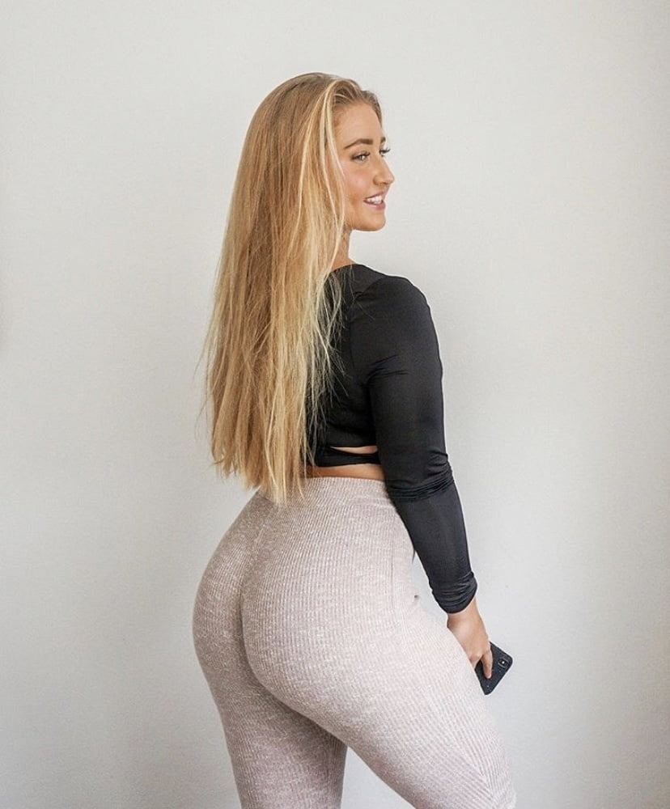

Stan looked at Kyle and widened his eyes before tilting his head towards Kacey, silently trying to tell him to step in and take over, But Kyle was so nervous, his entire body was shaking. Slowly he took his hand off of his nose and stepped towards the bed. He could feel the heat of her gas, it was so intense, he didn’t want to take a breath!

Slowly Kyle took a sniff, willingly taking in the foul odor through his nostrils! His eyes began to water and the inside of his nose burned with fury as he held back the urge to gag loud. It reeked of dying fish, rotting bacteria, sour sweat, and fresh pungent feces! He gasped a bit while trying to speak…

“Ugh oh god,” Kyle said under his breath…

“Have you been eating sushi again Kacey?” Kyle asked as politely as he could…

**BBBBBBBBBBBBBBBBBBBBBBBBBBBBBBBBBBBBBBBBBBBBBBBBBBBBBBBBBBBBBBBBBBBBBBFRRRRRTTFFRRRTTTTBFRRTTSPPPRRTTTTTTTTTTTT**

**sppprrtttttttt**

Kacey let out a fart that was twice as loud as the last! Kyle couldn’t tell if the sheets raising was from the pressure of her gas or from her rolling over onto her side but he wouldn’t have been surprised if it was the methane! She groaned and wiped the sweat from her forehead as Stan took a step back and rubbed under his nose before holding it closed with two fingers.

“I was at my best friend’s birthday, and she had sushi catering at the party! I… I couldn’t help myself!” Kacey broke into tears. She was weeping and crying, Kyle was so embarrassed, he had no idea what to do, he looked back to Stan who nodded for him to continue!

“My husband is gonna leave me! **I JUST KNOW IT!**” she said with tears rolling down her cheeks.

“It will be okay Kacey, you just need to get your diet under control and cut out the raw fish, if you can do that then you’ll be fine!” Kyle assured her!

“Now, I’ll be back next week and we can check on how you’re doing!” Kyle said politely

“Wait, but you're not going to smell up close?” Kacey asked with an immediate attitude change, she was instantly no longer crying as she sat up a bit in bed.

“Well, we already know the issue, so we don’t need a close smell do we?” Kyle asked as his heart began to race, he was trying his best to avoid having to take one of those monster blasts up close!

“Well, my husband said he was paying for a double session today… soooooo are you just going to stand there or should I expect a refund?” Kacey asked with a hint of disappointment in a bratty spoiled tone.

Kyle looked back to Stan who widened his eyes and motioned his head silently for Kyle to continue. Kyle looked back and forth between Stan and Kacey, he didn’t want to do this!

Kyle approached the side of the large master bed and got to his knees. Kacey had a smile on her face as she rolled onto her side with her back and ass facing him. Kyle could already smell the foul stink from under the heavy bedsheets. She wiggled back a bit pushing her ass to the side of the bed before slowly lifting the thick heavy sheet.

When the sheet raised and her ass was revealed Kyle couldn’t hold back, he let out a deep gag from the bottom of his throat! Her cheeks were so big and round, the small bit of light in the room reflected from her tanned skin from how much sweat was accumulated on them! Red lines were going across her cheeks from the pressure and indentation of the wrinkles in her bedsheets. She looked over her shoulder to Kyle who was in shock with how bad the odor was! He could feel his nose burning, the hairs were twitching.

“I think I have one coming doctor!” Kacey said innocently as she reached back and gripped her left ass cheek pulling it far apart from the right one! They spread with a sickening wet **SQUELCH**, almost like wet plastic wrap being pulled off a sticky surface. Kacey giggled from the sound luckily covering the noise of Kyle gagging lightly! As her anus came into view he nearly passed out! It was covered in shit, the entire rim coated in brown! There were bits of yellow and he could see small pieces of undigested rice that had gone right through her caked within it

“You’re gonna miss it!!! Get closer!” Kacey said with glee as Kyle looked back to Stan, he had tears running down his face from how badly he did not want to do this! Stan used his hands to urge him forward, pressuring him to do the job.

Kyle felt like he was going to have a heart attack as he slowly turned his head sideways to meet Kacey's horizontal and spread ass crack. The heat from her steaming anus got more and more intense with each inch he moved! When his nose was just about to touch the sticky rim, it spread wide and unleashed hell!

Kyle never thought in his life he would experience something this terrible! Her anus spread wide and he could see inside of her for a moment just before the burning gas washed over him! Kyle squeezed his eyes closed and began gasping, mistakenly sucking more of her gas down his throat! Hecould taste the flavor at the same time that it burned his nose! It was so stale and thick, so wet and terrible! Like he was huffing wet diarrhea out of a sealed bag!

**BBBBBBBBBBBBBBBBBBBBBBBBBBBBBBBBBBFFRRTBBBBBBFRTBBBBBBBFRTPTPPPPRRBBTBTT SPPPRTTBBFRTTTTT FBRTTTBFBRTTPPPPSRTTTTTT**

**BBBBBBBBBBBBBBBBBBBBBBBBBBBBBBFRTTTSPPRPTTTTTTTTTTT**

**sppprtttttttttt**

**“WHAT THE FUCK!**” Kyle screamed before falling back onto the carpeted bedroom floor and choking uncontrollably! Her fart had ended with a horrifying wet splatter that caused both Stan and Kacey to grimace in disgust! Kacey rolled over and looked onto the floor as she slowly began laughing hysterically! Kyle’s nose was covered in dripping brown shit!

“Oh god! Hahaha, I’m so haha I’m so sorry!” Kacey apologized in a very fake manner as she looked down on Kyle.

“I’m going to wait downstairs in the car, I think Kyle has things under control from here! I will see you in an hour okay!” Stan said with a smile as he walked out of the bedroom closing the door behind him.

“No, wait!” Kyle screamed for him as Kacey got out of bed and stood over him. She had a smile on her face and was completely naked from the waist down! The only thing she was wearing was a sweaty tank top that barely contained her breasts!

“Please... I” Kyle gassed as he wiped his nose and mouth with the back of his hand, thick brown skid marks came off making him choke!

“Aweehaha, such manners, how can I say no when you're begging and asking so nicely!” Kacey smiled as her stomach made a horrifying wet rumble! She instantly grimaced and held her stomach with both hands before turning around above him!

Kyle was going to beg her to stop, beg her to let him leave! He didn’t want this job! While he was wiping his mouth and nose, Kacey had turned around, her big sweaty bare ass jiggling over his face! By the time he opened his eyes and looked up, it was too late, she was already coming down towards him! With Kyle on his back, Kacey sat with her full weight on his face, her sweaty cheeks crashing into his face and pinning him down to the floor! He threw his hands up, grabbing her ass cheeks and trying to lift her, but unintentionally all he did was spread her cheeks!

Her dirty asshole came down over his lips, her weight forcing his mouth so wide open that it felt like his jaw may rip right off! The thick gurgling from inside of her stomach continued, getting louder as she groaned and wiggled back and forth! Her cheeks were so thick that even with her anus over his mouth, his nose was still crammed between her fat mounds of ass!

**“MPPPPHHHHHHH”** Kyle screamed from under the woman as his tongue grazed her dirty asshole! He tasted the sticky bitter shit and instantly pulled his tongue back! It was so foul, like licking dirt that had been infused with the flavor of rotten fish!



“Mmmmm that felt nice, Stanley never used his tongue, do that again!” Kacey cooed with a moan as Kyle whimpered and cried under her fat ass!

She was so heavy, he couldn’t move and could barely breathe! He had both hands on her thick cheeks keeping them spread as he sucked in and out through his nose, he could feel her anus quivering, it was coming.

**BBBBBBBBBBBBBBBBBBBBBBBBBBBBBBBBBBBBBBBBBBBBBBBBBBBBBBBBBBBBBBBBBBBBBBBBBBBBBBBBBBBBBBBBBBFRRRTTTTTSPPPRTTTTTBBBBBBBBBFRTTTSPPPRTTTTTTTTTBBBBFRRTTTSPPPRTTTTTTTT**

**Spppprtt bfpprttt spprtttttt sport**

The fart was on another level, Kyle could feel the pressure of the gas pushing out on his cheeks before blasting down his throat! The pressure and heat were so intense that he feared his lungs may collapse! The fart had only just begun as her anus lips began slapping open and closed, spraying the wet shit covering her ass and more fresh feces from inside out and into his mouth! Kyle could feel the shit coating his tongue like wet cement as she groaned and laughed, the fart was still going! Kyle began pushing on her ass cheeks as she forced her weight down, more than thirty seconds had passed before the gas began turning to a wet splatter. Kyle closed his eyes and cried as she painted his throat!

Kacey laughed maniacally, her big ass wiggling on Kyle’s face as she unloaded! Kyle was crying as she wiped the sweat from her forehead and looked back at him.

“Are you okay down there? I think I have a few big ones coming now, are you ready?” she asked with a nervous smile…

**“BIG ONES?”** Kyle cried inside his head!!!!!

An hour had passed when Stan finally saw Kyle come staggering out the front door of the house. Kyle stopped for a moment as the fresh air washed over him, it was less than a second later that he lost it, his stomach ejected all of its contents as he leaned over the garden bed and painted the flowers in puke! The eggs and toast he had enjoyed for breakfast came up along with a healthy serving of soft brown shit from his most recent client Kacey! It was terrible, indescribable!

Kyle ran back to the car and grabbed his bag, instantly using the mouthwash and ripping off his shit covered button-up shirt! He changed and used a face wipe before getting into the passenger seat and breathing deeply, Stan began to laugh a little.

“You okay?” he asked… Kyle tried to hold back but he just couldn’t, he began crying profusely!

**“I CAN’T DO THIS!”** Kyle cried realizing he was destined to be a waiter for the rest of his life! Stan put an envelope into Kyle’s lap as he whimpered and looked down, slowly drying his tears.

“What’s this?” Kyle asked. He opened the envelope and saw **TONS OF CASH**! He began counting it and was shocked, it was $5000.

“Wha...wha...what’s this?” Kyle asked in a state of shock.

“Your pay for today! Well, for Kacey! Her husband pays well and he paid extra today for a longer session! Does that change your mind?” Stan asked with a laugh as Kyle’s expression changed instantly. Maybe he could do this…

The day continued as Kyle served all types of clients with all types of asses and farts! There was a beautiful middle-aged Asian woman who they met on the 45th floor of a building downtown in the business district! She came into the conference room on her cellphone and unleashed a barrage of hot dry gas down Kyle’s throat!

They visited a public school where a gorgeous young teacher in her twenties used his nose on her lunch break! Her gas was pungent and ripe, it made his eyes water as her thick ass enveloped his face!

There was a terribly fat woman who sat on his face, Kyle thought he was going to die! Her ass crack was so greasy and wet, her anus so big and wide it could practically engulf his entire head! Her gas was atrocious, Kyle had passed out under her, he would have died if it wasn’t for the fact that she got up, angry he had stopped sniffing!

They visited a sorority where a group of four rich and spoiled college girls coated his nose in gas and shit! It seemed like more of a sexual humiliation session for these girls than a medical session! Neither one of them even gave him time to tell them how their gas smelled and what foods they should avoid!



The last client for the day was a pregnant woman in her thirties! She was jaw-droppingly gorgeous with long red hair, her big bloated pregnant belly did nothing to distract from how beautiful she was! Kyle had a crush on her until she began using him that was! Her gas was worse than any he had experienced before! It was so hot that he thought his nose might melt off! She sat on his head so hard that his nose actually slid up inside of her rectum!

When the day was done Kyle sat back and let out a heavy sigh, he was exhausted and couldn’t move! His throat and nose were so sore! Each breath he took was embedded with the combined stale gas from all the women he had visited that day! It was like breathing inside of a garage filling with engine fumes! Kyle gasped and gagged a bit as Stan looked over to him and laughed.

“You alright my boy?” he asked in a joking tone!

“Ugh, ready to go home, I’m spent! How do you do this every day?” Kyle asked as he rubbed his sore and battered nose.

“You’ll get used to it, but we’re not going home yet, we have one more client for the day,” Stan said with a smile.

**“BUT… BUT…** I thought this was the last client! I’m so tired! I can barely breathe!” Kyle complained!

“This is a brand new client, someone just called asking for an appointment, it’s a very rich family, so I would recommend you take the time! Work first, always! Remember that!” Stan said as if to teach him a lesson. Kyle didn’t answer as Stan began to drive…

They drove for forty-five minutes into the countryside before pulling up to a **MASSIVE** estate! Kyle looked out the window in shock before turning to stan…

“You weren’t kidding when you said rich”

“I told you!” Stan smiled as he parked at the front of the long bending driveway! The place was huge!

“I’m gonna wait here, you know what to do, be professional, and make a good impression, these could be new clients for life!” Stan smiled as Kyle got out of the car. Almost a second later, a maid came running down the front steps from the main doors to meet him at the car.

“You must be the Doctor! Thank you for coming on such short notice! Amelia and Cecilia have had terrible stomach issues as of late, they have been under a lot of stress with the party coming up this evening! Come come, follow me!” The young maid smiled as she spoke quickly and began leading Kyle around the side of the massive estate.

They walked on a brick path down past a huge garden and pool to a private tennis court where too absolutely goddesses were currently finishing up a game! Kyle could see instantly that the two of them were twins, looking back and forth at either one down the court, it was like a mirror image with the small exception of their clothing! Both of them were thin, toned, perfect! Their long blonde hair looked like each strand was individually straightened to perfection! Their skin was flawless, their teeth so white! They were perfect women! Both of them were grunting as they ran up and down the tennis court, aggressively battling and smacking a tennis ball up and down over the net! Eventually one of the sisters won as the ball hit the back fence!



**“GODDAMMIT!**” the other twin screamed as she threw the racket at the ground, breaking it into two pieces!

“Oh dear, I’ll leave you to it,” The maid said as she backed away seeing how upset her employers were! Kyle turned to see her hurrying away back towards the house.

Kyle looked back to the two goddesses and saw them both staring him down from a distance, inspecting him like prey! He took a deep breath and began heading to the tennis court and approaching them. The closer he got the more nervous he became, their beauty was unreal! As he stood before the two women a strong sweaty odor washed over him, it was thick and vinegary, very salty! He could see the sweat dripping down their arms and necks.

“Are you the doctor?” one of them asked with a smile.

“Of course he’s not! Look how young he is!” the other sister replied!

“I’m the doctor! It’s actually my first day, I’m taking over Dr. Molassians practice. My name is Kyle, it’s nice to meet you” he stuck out his hand politely as both of them looked to his palm and then back to his face, neither made a motion to meet his handshake.

“Well, to make things short and sweet, both of us have been suffering from some irregular intestinal distress, we have a big party this evening, and it's imperative that we are not bloated and gassy!” one of the sisters instructed!

“Oh no! What if I can’t fit into my dress!” the other sister exclaimed!

“I’m sure we can figure out what the problem is and have you two ready for the party this evening,” Kyle said with a smile.

“You, you can figure it out!” the other sister said rudely.

“Well, of course, it’s just an expression, nevermind!” Kyle smiled not wanting to upset the two rich goddesses! The overwhelming smell of their sweaty bodies was so strong, it made him a bit dizzy, he felt his dick growing as he quickly adjusted to hide it. This feeling was so strange, a mix of absolute disgust and uncontrollable desire!

“Let’s go” one of the sisters demanded as they both began walking back up towards the massive mansion.

Kyle followed the two women, their sweaty bodily odors washing back over him like a wave! He couldn’t tear his eyes off their toned asses! Each cheek was so powerful and small but also bubbly! Their asses jiggled left and right, shaking and wobbling, it was the first time he had been genuinely aroused on the job.

**SPPPPFRTVVVRT**



A very sweaty wet fart squeezed out from one of the asses in front of him as both sisters began laughing! The odor hit him hard like a ton of bricks! He stopped walking for a second and choked while regaining his composure! The odor was so disgusting, like burnt cheese and broccoli mixed into one! The sisters looked back, almost as if they were judging his reaction, they both had cruel spoiled smiles on their faces…

“Are you coming???” one of them asked impatiently…

“Yes of course!” Kyle replied as he hurried behind them with his bag and folder of files and patient info.

Kyle was trying to control his throat and nose the entire time he followed them, the gas, the smell, it was worse than anything he had smelled today! The cheese smell was embedded into his nose, stuck to the hairs! He continuously massaged his nose while following the sisters, trying to get the odor out! As they entered the house they led Kyle into a living room, he was sure there was staff around but for the time being, they had privacy!

“So how do we do this?” one of the sisters asked…

“Well, if you’d like to get on the couch and kneel with your asses sticking out” Kyle instructed as both Women immediately followed his instructions. The odor of the sweaty bodies was way worse inside in a confined environment! without the fresh air and wind it began to accumulate making a thick mist of their stink! Kyle tried to ignore it as he took out a folder and pen.

“Now what kind of foods do you both eat regularly! Lunch, breakfast, and dinner!” Kyle asked, trying to sound professional, both of them had their asses sticking out towards him and it was hard to keep his eyes off them!

They both began listing several foods, way too fast for Kyle to keep up and write but he did his best! There was no broccoli in their diet though and that was what he smelt before, it was clear as day.

“I have another fart coming Doctor,” one of the sisters said while looking back at him over her shoulder. Her ass was up in the air as Kyle stepped forward and pushed his nose into her crack! He had to hold back from gagging! The odor of her previous fart was still thick in the fabric of her yoga pants! The wet sweat had formed a layer that held in the scent keeping it fresh! She wiggled her ass back and forth a bit rubbing Kyle’s nose in her ass before laughing…

“Here it comes!”

**SPPPRRRT vvvvrrrtttttttttttttt**

Both of them laughed as Kyle quickly stepped back and began fanning his nose, coughing, and choking wildly! The odor was so terrible, the smell of burnt cheese was a perfect accompaniment to the rancid steamed broccoli, it was a fart from a place of nightmares! His eyes watered as he looked away trying to hide his face from the laughing women.

“I thought you were a professional? The girl who just ripped in his face asked…

“It’s his first day!” the other sister replied while laughing!

“That’s no excuse!”

Kyle ignored their insults and gained his composure trying not to vomit all over the fancy carpet and furniture!

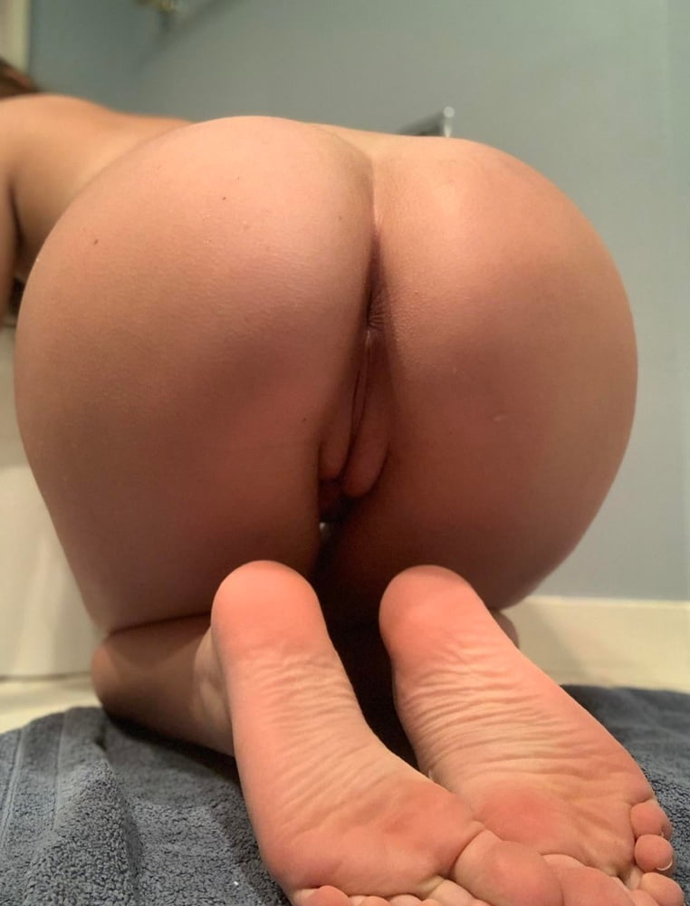

“Uhmm, have you been eating any broccoli or cheese lately?” Kyle asked as he looked over his notes trying to pretend he knew what he was doing! Both of them shook their heads back and forth with blank stares…

“Maybe you should get a second sniff Doctor! I think I feel one coming!” The other blonde said while she stuck out her yoga pants-clad ass!

Kyle didn’t want to, but he knew that at this point he had no choice! The quicker he got this over with, the quicker he could go home. He could use a drink after all of this...**ALANNA**! Kyle suddenly remembered as he checked his watch! He was gonna be late for the bar!!!! It was almost 7 and he hadn’t even gotten home to shower.

**“WHAT ARE YOU DOING, YOUR GONNA MISS IT?”** the Blonde shouted in anger as Kyle threw his face into her ass trying to keep the client happy!

The odor was almost identical to her sister, an overwhelming sweaty sour odor like vinegar mixed with the pungent cheesy smell of fresh ass! Kyle could feel her anus puckering under the pants as she pushed and let loose!

**BBBBBBBBBBBBBBBBFRRTVRRTTTTspppprttttttttttt**

The fart was long and ended with a wet splatter causing Kyle to pull his face away gagging in disgust! The heat and power of her gas were so intense, it was like fresh shit was being injected straight into his nose! She had the same smell as her sister, burnt cheese, and broccoli! Kyle was choking and scraping the sweaty odor off his nose as she grimaced and began pulling down her yoga pants!

“Fuck, I ruined another pair!” She said while pulling her pants down over her big toned ass and thighs! Kyle looked up to see a thick coating of greenish shit between her perfect ass cheeks! It was horrifying! He could see her anus winking at him under the shit!

“Ugh, oh god, the smell! The other girl complained as she plugged her nose!

“See doctor, this is what we were talking about! This can’t happen during the party, we need to get to the bottom of this! **RIGHT NOW!”** she demanded!

Kyle watched as the other sister began taking off her yoga pants as well, both their bare asses were pushing out towards him, both of them coated with sweat! His eyes watered as he let out a deep gag from the bottom of his stomach, they were so beautiful but this was so foul!

**BBBBBBBBBBBBBBBBBBBBBBBBBBBBBBBBBBBFRRTTTTTTTTTTTTTTTTTVVVRRTTTTTsppprttttttt**

Another fart washed over his face as the other sister moaned in relief! Kyle could feel the hairs on his head moving as his eyes watered watching her asshole! It tightened up at the end just before leaking a sludge of green shit just like her sister had! Both of them groaned in disgust.

“Are you gonna take care of this?” One of them asked in an angry bratty tone while pointing to her sisters’ ass crack! Green shit was leaking down and about to hit the couch!

Kyle felt so humiliated as he scraped some kleenex up her crack cleaning the shit! He held the soiled paper in his hand as both sisters looked back at him over their shoulders.

“I have another fart coming! Get close this time, so you can take in the smell and get to the bottom of this mess!” the other sister said with a smile as she pushed her ass out.

Kyle nervously got his face right behind her ass, he could feel the heat of the shit in her ass crack as she grunted and pushed! He closed his eyes bracing himself as suddenly, a hand on the back of his head pushed him forward! Kyle let out a gasp trying to scream as his face entered her messy ass crack! There was a horrifying **SQUISH** as his face mashed between her toned bubbly cheeks, shit pushed into his nose, mouth, and eyes!

**“HAHAHA** if you wanna get to this issue, you're **REALLY** gonna need to bury your nose into your work!” The sister holding his head said with a laugh as he cried out into the shitty sweaty cheeks!

**BBBFRTTPPFBBRTTTTT**

**VVVVVFRTTTBBFRTTTTTTTTTTTTTTTT**

**BBFRTTT vvrrtttttttt**

**Spprttttprpptt bfrttpsprttttttttrrrr**

The fart was a cacophony of horrific wet noises enough to make any sane person lose their stomach! Kyle was lucky to survive and come out alive with his face right next to the source! Her gas sprayed out like a burning wind before unleashing feces that filled his nose! Kyle screamed as the sister behind him pushed his head up allowing the other twin to unload inside of his mouth! He could feel the hot shit piling on his tongue, he could picture the green mess in his mouth, there was no way he could eat it!

Both of them laughed uncontrollably as they released Kyle letting him fall backward! They were laughing so hard that they were crying! Kyle was in a state of shock, his heart racing as he dripped with sweat! His cheeks were puffed out like a frog, filled to the brim with hot green shit! The flavor of broccoli was intense, it was rotten, green, he could feel his body twitching, begging him to sit it out!

“Well, Doctor?” one of them asked as Kyle sprinted down the hall looking for a bathroom! When he finally found it he could still hear the girls laughing down the hall!

Kyle was in the bathroom for more than thirty minutes throwing up before he could finally work up the courage to face the two twins again! he felt so humiliated, so used. He walked back down the hallway with his head hanging low and the file folder in his hands. He could feel both of their eyes on him.



“Have you eaten anything with broccoli in it recently?” Kyle asked…

They both paused for a moment…

“No, why would we do that! We are allergic to broccoli!” the other one replied.

“Well think, it’s possible you may have eaten some accidentally!” Kyle explained.

Both of them thought for a minute until the one who had destroyed his mouth finally asked…

“There’s no broccoli in cream of broccoli soup is there?” She asked

“Of course there is!” Kyle replied! He wanted to scream at them for their stupidity! Could they seriously be that dull! They both began to laugh a little bit as they looked back to Kyle…

“Just, cut that from your diet **IMMEDIATELY!** And then you should be fine! Drink a lot of water before the party!” Kyle explained and instructed as he gathered his things, the flavor of her shit was still thick in his mouth and throat even though he had washed his mouth many times.

As he was walking to the door, one of them called out from behind him.

“We will call you again if we “accidentally” eat some broccoli,” she said with a pause as they both began to laugh. Kyle continued to leave, he had a feeling they had planned this.

Kyle and Stan barely spoke on the way home, Stan knew Kyle would need time to adjust. When they reached his condo Stan passed him a large envelope with his pay from all the clients today.

“Well, do you think you can carry on my practice?” he asked

Kyle looked over the stack of cash, it felt like he was selling his soul to the devil….

**PART 3 COMING SOON**