|  |  |
| --- | --- |
| Domestic Duties  Inspired by a Captioned Image  By Maryanne Peters  Scott and Kyle were friends of mine. I knew them both from high school in our little town. They were always together, those two, though folks never knew why. I suppose they had women in common then – always chasing pussy. Well that ain’t the way it is now, that’s for sure. | https://4.bp.blogspot.com/-WbWHwOKIBM4/WcRNsQXujOI/AAAAAAAAAOc/2GbdHxBntsQalt-lLYjLqW-BbXjsdIxjwCLcBGAs/s1600/0001.jpg |

They moved in to the shack I had out the back of my place soon after Scott got the job at the Plant on the edge of town. I suppose I just felt that by giving them a place they could leave that old life behind them. Truth is, that was no kind of life.

Some folks say that hypnosis can’t do that to a person – make them do what they don’t want to do. I think even the professor himself didn’t believe it. If he had I am sure he would never have given that kind of power to a no-good like Scott.

Anyways, somehow, Scott used that thing to put an idea in Kyle’s head that he was a woman. Like, his woman. And that “Kylie” (as he called “her”) was there to keep house for him and look after his every need. Scott said that it was because Kyle was good for nothing else.

Somehow Kyle, or Kylie (whatever) just lapped it up. Like, accepted that he was now a she. Went about saying the she was a girl named Kylie and that Scott was her man. It was the craziest things. All the folks in our town saw it, and nobody believed it could happen.

Turns out that Kyle’s family were down with anything that was going to put that boy right. He was the youngest of four brothers, and those other boys were done with their lazy brother, shaming them and always looking for money. His mom ran the local beauty salon, so she was able to take Kylie in for some treatments and some training.

So, then Kylie was looking for new drugs, those drugs were those female hormones, and Scott was happy to pay for them. Who would have thought that those little pills could make such changes in the body of a young man? He went from the rough hairy little prick he was, to this big breasted girl, in less than a year. It was the darndest thing.

He had some long stringy hair before, but that grew longer and now he always kept it tidy. He kept his body smooth too, and those hormones, they made his skin so soft. It was like his muscles had become pillows. And those tits! Beautiful.

Scott bought him some girly clothes to wear, but Scott kept them, what you would call, skimpy. He liked to see those big soft tits, and those big, soft, smooth legs too.

Word has it, he got in between them legs, as well. Seems like Kylie took her instructions to heart and was prepared to do anything to please her man, including taking him up her ass.

I think lots of folks around town had a quiet snigger about Scott and Kylie. But nobody was unkind to the new girl when she was around town for groceries and the like. If Scott was a lazy good-for-nothing, then Kylie was a hard-working and dutiful housewife, and a nice person. She was always outgoing and helpful, and won folks over. Nobody liked Kyle. Everybody liked Kylie. She is too good for that Scott.

She would go around to her mother’s salon to have her hair fixed up and nails done, and she would talk to the ladies about cooking, and fashion, and celebrities, and all that stuff that women talk about. She didn’t sound like Kyle no more, with her voice sort of soft and song-like. She carried herself like a lady, sort of classy. Hell, she was more of a woman than some of them around town.

Scott was her only problem. He made her dress like trailer trash. Whether he was controlling her mind or whatever, he never seemed to be satisfied. That man just seemed to get to treat her worse than their dog. The more Kylie did for him the worse she got treated. Always cussing at the girl, and demanding that she cook or fetch for him, or walk the dog. I lived right alongside them, so I saw it all.

I told her that if she ever saw fit to leave that prick, I would be happy to have her in my home. She was kind and useful, as so pretty and soft. Who knows? What with what surgeons can do these days, she could be all woman. The kind of woman I would be happy to live with.

Truth is, I had a crazy crush on that girl. I told her so. I told her that she should go back over to their place and tell Scott that she was leaving and coming over to live with me. I told her that she was no longer in his power. So, I watched as she walked over.

Scott was standing at the back door. He said: “Kylie! Stop standin’ there with that confused look on yer face. Get back in this darn house and get me some dinner started, woman.”

Suddenly Kylie says: “What the hell are you saying to me? Why are you calling me Kylie? What is going on with these fingernails? What the hell am I wearing? What have you done to me? You can go to hell, Scott.”

And she turns around and she starts walking over towards me. And I was thinking ‘yes, I have won this woman over, and she is gonna be mine, all mine.”

She is not looking at me - her face is as angry as a grizzly bear, but so pretty. And she just walks straight on past me, with that butt just as cute as anything in those tight little daisy dukes. That is my kind of woman.

The End

Rebelling

Inspired by a Captioned Image

By Maryanne Peters

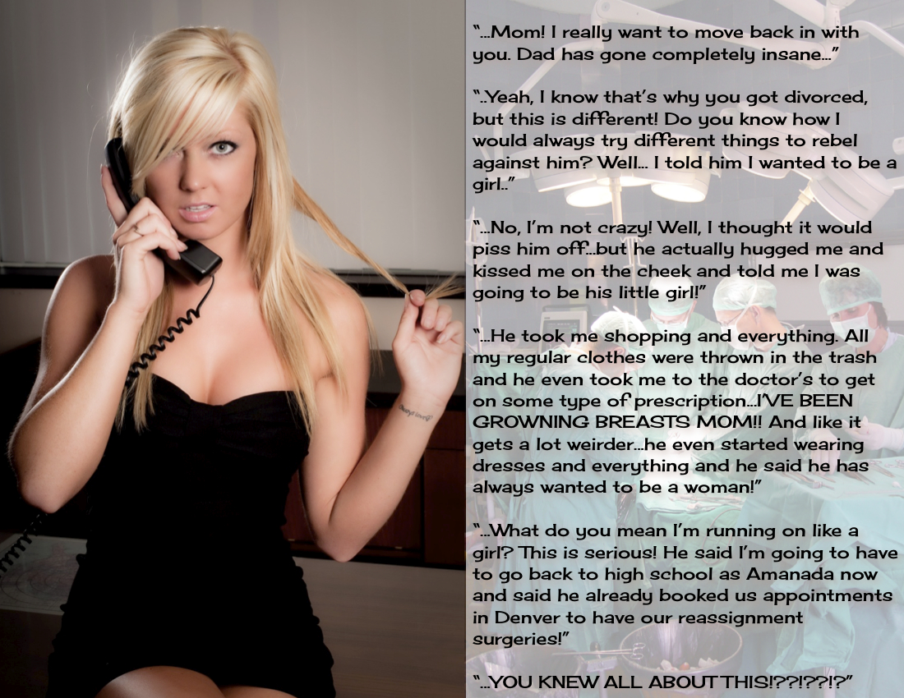

I spent all my life fighting these urges and then everything changed the day that my son told me his secret.

He was a difficult child, the youngest of our three boys. My wife gave up on him. Shortly after we divorced, she sent him to me.

“You can deal with him,” she said. “Perhaps you can put him in dresses and be sissies together.”

That was cruel. I had never worn a dress in her presence. I Had made the mistake of telling her about my gender dysphoria after years of hiding that secret in our marriage. I told her that it would change nothing. The boys need never know. I would continue to live as a man, the best husband and father I could be, but I felt that she needed to know something about my personal struggle. She was less than understanding. Her clear disgust grew and was a major factor in our deciding to part.

But still I could not face transition. I had work commitments and friends who thought of me as being 110% male. Perhaps because of my inner torment I brought the boys up to be as manly as possible.

Perhaps that just made matters worse. Now I could never change, even when the marriage was over. I could not face the thought of rejection by my friends and my family. I faced the prospect of living alone with my internal burden forever shrouded.

Then my wife called and told me about the problems she was having with our youngest. Perhaps he was spoilt the way the youngest child can be, but he was constantly rebelling. If there is anything that either parent might dislike, he did it. He grew his hair long because I disapproved of long hair on a young man. At least that is why I thought he did it.

So, he came to live with me. I think he was glad of the change, but it did not make him any less ornery.

Then, a few days after he moved in, he told me, and I understood. He said: “You will never understand me, Dad, … but I am just don’t belong in this body.”

Of course, I was shocked. I had no idea. He seemed interested in everything that a boy was interested in. But at his age, I was the pretty much the same. You follow your friends.

It was as if that burden, I spoke of, fell on the ground and shattered. I just hugged him, perhaps for the first time in his life. I felt the stiffness of the uncertainty that created, and then it relaxed, and he hugged me back. It was the closest I had been to any of my children, in fact maybe anybody ever.

We shared something, and I think she knew it. Yes, she. Because at that moment it became clear that we could both realize our dream. I told her that from now on, she would be my daughter. And to her, I would do my very best to be her new mother.

I arranged to get hormones enough for both of us. We shared a special smoothie for breakfast every morning, containing not just the drugs but a whole range of natural phytoestrogens like peaches and flax seed. We colored our hair and went shopping for clothes.

Of course, I saw moments of doubt in her face. That is to be expected. But for me knowing that I was not going through this alone, removed all the questioning that had existed. I was clear on the course before us and determined that we would both get there.

Can the bond between two people who share this awful curse of being in the wrong body, be any stronger? Add to that our family bond, now becoming a mother daughter bond. I could see it in her face. In those moments of uncertainty on her face I would hug her, until the smile returned. I would assure her that we were both going to come out of this so much happier.

Now I have surgery booked for both of us. She looks so beautiful these days, with her blonde hair and well-developed curves. She will win the heart of some young man. The thought of that has me revisiting the question of my own sexuality.

I just can’t wait for us both to get our new vaginas.

The End

|  |  |
| --- | --- |
| New Identity  Inspired by Milshy  By Maryanne Peters  I thought: How bad could it be? It is just a haircut. Sure, six months is a long time to keep it like that, but I could conceal it. My hair was longish and she was always going on about me getting it cut.  It was a stupid bet. I was always doing stuff like that with her. I just could not accept that just a hair cut would cease to make me look like a man. I just felt confident with my masculine appearance. I thought that she was going to put some curls in it or something. I figured that once we got home I could tie it back and still look like a guy.  She said that I should go to the salon dressed in some of her clothes, so I would not look like a guy on the way home. I thought: ‘What the hell, you are going to lose’. | *Diana absolutely ADORED her boyfriend’s new look. Sean finally lost a bet to her and she really capitalized on it. She did his makeup, put him in a dress, and took him to the salon. The had the stylist give him an ultra-feminine bob. It was past his chin in the front and really short in the back, making it a perfectly girly angled bob. For the finishing touch she gave him lovely blunt bangs that framed his face perfectly and gave the look an extra girly touch. As agreed, Sean has to wear dresses and skirts, and also keep his bob for 6 months, with a trim every 2 weeks to keep the lovely shape his bob was cut in. Diana decided he would go by either Sarah or Samantha, his choice. Diana couldn’t stop smiling, she loved his new cut, but most of all, she knew by the end of the 6 months he would give in to his new identity, and that he would be his true, gorgeous, feminine self forever.* |

But then she did this to me. How can you hide a look like this? One of the girls in the salon suggested the necklace for the photos. If I look like I am shocked, well, I was. I had so much hair cut off the back, and the bangs cut in the front.

All the girls in the salon were gushing about how good I looked. Even Diana – she actually started crying. She told me later that she knew from that moment that she had lost me. I would never be the same again.

I thought I could be. I tried to real style it somehow, but this is a cut that never looks anything but feminine. Even without makeup I just looked like a girl without makeup. That meant dresses and skirts, and regular maintenance of my do, until I could call for the buzz cut she always wanted me to have.

But did she ever really want that? She keeps telling me how pretty it looks and asking me to turn my head suddenly, to watch it fall into place. It is that kind of cut. Provided you keep your hair clean and use a few tricks to keep the volume, it always looks good. I think Diana might have been a little jealous, but her face is just not right for an angled bob.

I never got the buzz cut. I like my style too much. When you dress like a woman just so your hair does not look weird, and you go by the name of Sarah, and you catch up with the girls every two weeks and they insist on further beauty treatments, well, you just grow into the person you look like.

The six months was over ages ago. I just could not go back to Sean. He was so ordinary. Sarah is just so fabulous.

I said that Diana wept when she first saw the new me. I didn’t understand at the time. But Diana is not a lesbian and so it seemed to her that our relationship was doomed. She said that she saw then that I would not be cutting my hair.

But I am not so sure that I will keep this style always. Ted says that he would like me to grow it longer, maybe down as far as my breasts. I suppose girls have to give in to what their men like, at the end of the day, even though I think the angular bob really suits me. What do you think?

The End

|  |  |
| --- | --- |
| Sensations  Inspired by a Cap Image  By Maryanne Peters  There is a lot of nonsense about hypnosis out there. Hypnotic suggestion is just that, a suggestion. Hypnosis cannot force a person to do anything. They have be at least open to the suggestion. It is really about breaking down inhibitions and allowing people to see that their habits and modes of behavior can change, if they are willing to let it happen.  I offered hypnosis as a means of improving sexual sensations. Almost everybody is willing to improve their sex life. I offered consultations over skype to individuals and couples with suggestions that allowed them to experiment with new means of sexual expression. I had a very high level of success.  I also offered services to people who were in the grip of a sexual obsession – people who considered themselves sexually crippled by a fetish of some kind. I had never worked with promoting improved sensations for fetishists, before I was approached by Max  Certainly, I did not regard transvestism as being a particularly negative proclivity. So, I agreed to offer suggestions about how Max might achieve more sexual satisfaction from his fixation.  “She” appeared before me “in drag” every time we skyped. In fact, I have never seen her dressed as a man. Even at the beginning she was very presentable. |  |

My first thought was to make suggestions that would deprive Max of regular thrills to heighten the sensation when he did permit himself to dress. But he reacted badly to this. He felt that he needed to be dressed more and more, and that he could not live without being in dresses and pantyhose.

I suppose I realized at that point that Max was not a transvestite at all. He may have thought that he was. His mind was a little muddled, but it had nothing to do with me. I did want to help him, so I agreed to go to his place and take away from his apartment every piece of male clothing that I could find.

I had suggested to him that he could still find some clothing that was gender neutral, but he simply threw out everything that was not ultra-feminine dresses or little miniskirts. He did have the legs for those.

I had always thought of him as being a rational person, but he became increasing silly, and I do not mean that in an unkind way. He expressions became more non-verbal, and overtly effeminate. It was clear that these significant changes, but I had no hand in them.

I thought that it might be something to do with the female hormones that he was taking, but I spoke to some experts in this area and I ruled that out. What was clear was that Max had rendered himself totally incapable of functioning as a man. He lost his job and spent all day in his apartment turning it into some kind of crazy temple of womankind.

He had been a successful trader and had accumulated enough money to live without working. He spent some of his money on breast implants. I have to say that they were tasteful in size, not huge and just adding to the general plumpness of his womanly figure. He was very comfortable with his new body and he was very happy to show it off, to me anyway.

He talked about facial feminization surgery. I humored him on that, but it was really not necessary. He was a very passable woman without that. His hair had grown, and he had extensions woven in to have it down his back. He was always playing with his hair and simpering and giggling.

I am not attracted to transwomen, but it was very clear that Max, or Maxine as he preferred to be called, was attracted to me. He started to refer to himself as being my wife, and his apartment as being our home, his bed as the marital bed.

When mentioning the bed, I suppose that I should confess that I may have stepped outside proper professional conduct for hypnotherapists on one or two occasions. Certainly, Maxine could be very forceful and lascivious at times. No man of vigor is beyond temptation.

But it is troubling that Max appears to believe that his progression to this point has been through my conduct. As I said, there is a lot of nonsense about hypnosis out there. There are a lot of stories that hypnosis can be used to fundamentally change people, when in fact it is just a suggestion.

The End

|  |  |
| --- | --- |
| Jennifer Now  Inspired by a Captioned Image  (Please help to identify the author)  By Maryanne Peters  It was not that I thought my parents would really throw me out. They are religious, but I thought they would still love me.  The truth is that I am a bit religious too. I always wondered why God had given me the body of a boy and the mid of a girl. I suppose that I treated it like many Christians have to – he is testing me. He has a plan for me. I just need to have faith that it will all work out.  And then God gave me Caleb. If I had thought that I could have lived a life as a man and setting about finding a wife, the gift of Caleb meant that was clearly not the path He had laid out for me.  A big, strong hunk of man, with a brain not well given to thinking, but a good heart and an obvious longing for the right woman. |  |

I thought that I could be that woman. All I needed was for him to catch me dressed, with my hair freshly washed and blow dried in my femme mode, rather slicked back, and just a little makeup on. That was just too easy.

I had guessed that he would take a photo, and I was OK with that. But then to have him ask me for all my contacts so he could tell them all, and then expect my parents not to learn – what kind of a ‘or else’ is that? Sometimes he is just so dumb. So why am I smiling? Because he did not call me a sissy – he called me ‘a pretty little princess’.

“Do you really think I look like a princess?” I asked him. I knew exactly how to deliver. I had been practising the look in the mirror and the simpering voice on my sound recorder. I saw him gulp.

“Well you sure don’t look like …”. But I had to stop him with a raised hand – thumb crossed so he could see my nail polish.

“I’m Jenny, Caleb,” I said. “I have always been Jenny. Please don’t tell anybody. It can just be our secret. What do I have to do for you to persuade you to keep this just between us?”

I had been creeping towards him as I said it. And there I was close enough from him to smell my perfume: “Doe Musk 45” – said to make a man grow an anther; guaranteed to drive him mad with desire. And he could see my fake tits in the see-through top – a realistic cleavage between two glued on forms that move just like the real thing. So of course I let them move.

“Maybe you could give me a blowjob?” It was like question. How cute. He did not demand it, although if he believed I was so scared of being outed, he would have.

I stroked his rough face with the back of my hand. I liked to feel a man that way.

“That is not the way I was brought up, Caleb, and you know it. We haven’t even dated!”

The look on his face was why I want this man: Puzzled and lustful.

So I added: “Maybe just take me out to the diner for a burger and a shake. I am dressed to go out. Then, since you would be paying … well, a girl has to recognize generosity like that. Then well I guess I would be obliged to suck on this.”

My other hand dropped to feel the growing tent in his crotch.

I am the one who posted all my contacts on Instagram. Me and Caleb on our first date. Him kissing me in the booth at the diner. Even placing my phone carefully to record as a video me bringing him to orgasm on my first blow job.

Of course my parents saw it. So did Caleb’s. Everybody now knows that we are together.

God willing, they will come to understand why.

The End

© Maryanne Peters 2020