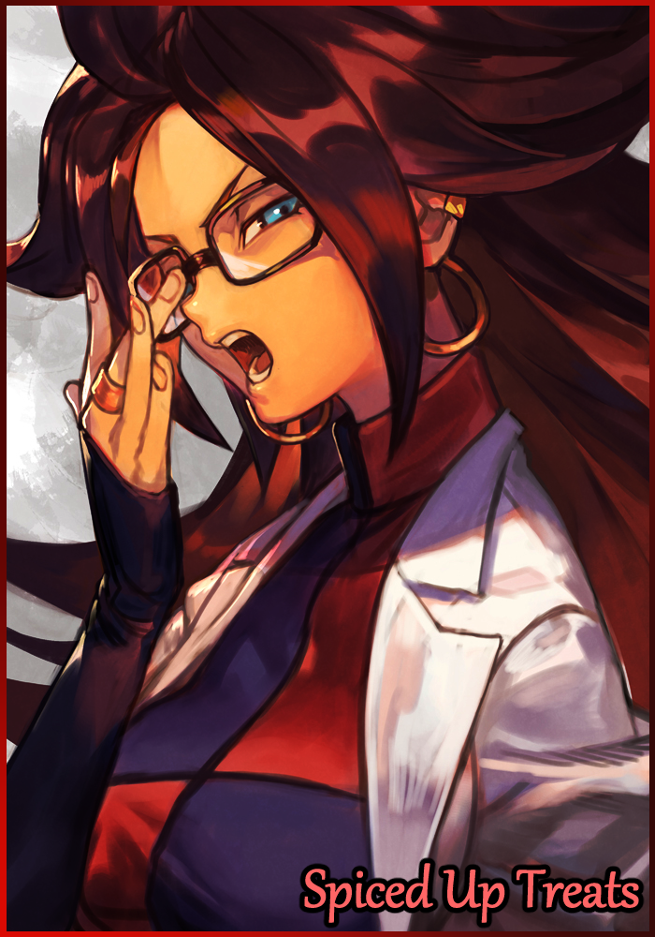

Samuel was a straightforward man operating under a simple law; always be on time for everything you'll do in life, and never dissapoint. These words defined the man, who had never once turned up late or early for any appointed meet or scheduled assignment while always keeping track of time as if his life depended on it. Cook a meal and he'd always follow the recipe to the letter, set an alarm, and he'd sync it perfectly to the global clock. It had been ingrained into his mind at an early age thanks to a strict parentage and his family's minimalist lifestyle. Without the distractions of life to tempt him off the straight and narrow, Samuel had dutifully obeyed, prioritizing studies and his future before everything else, something his parents would eventually come to regret just a little when the cold persona they had nurtured within their son never seemed to smile or laugh that much. A stagnant part of Samuel that would remain well into his early forties where he had already made a name for himself as one of the brightest minds in the world to work on a particle accelerating machine supposedly capable of generating limitless energy enough to power one entire city for a few weeks on end. But until the machine was completed, his fame was short-lived with many rivals and skeptics following soon after to discredit his colleagues' work, doubting it was even possible in the first place. Not like he cared much about reputation and backpack anyway.

Except he didn't seem to know what the end goal for the project was. When Samuel had been roped in to work on it, there was only one thing he needed to know; the final product. Whether it was a critical component or vital formula, he never bothered to question what it was going to be used for. Because without any curiosity to begin with in the first place, he didn't feel compelled to ask any questions. He simply needed to know what was needed of him and he would do so without hesitation. Not to say the man was completely bereft of a yearning to find out, just like all the other scenarios he had faced ever since coming of age and setting out into the big bad world alone to make a living.

An easy way to put it was that without that spark or drive everyone more or less would've nurtured at a young age, Samuel just didn't know what that tickle in his chest meant whenever his eyes gazed upon entertainment media or whatever it was the average American did to keep themselves sane and functional.

Eventually though, a minute fire would stir within him when a new hire to the team would inevitably expose him to the world of videogames and Japanese animation. Although he didn't quite know just what he was looking at, the furious yelling and testosterone fueled fights between burly men and sometimes even women was enough to get him hooked. Not enough to distract him from work…but definitely enough to get Samuel thinking on just what it was his parents had been so afraid of exposing him to when he was shocked to hear from his new junior that this anime franchise was basically a household staple for many years now, long enough to have been around slightly before he was born. A cultural icon, something that made waves in his generation…and he had missed the experience for studies…

Needless to say, Samuel was quick to accept the friendship offered to him by his understudy. Becoming fast friends of sorts through their awkward conversations with each other during breaks or the occasional train ride back since they lived along the same line. And when the conversation shifted to their individual lives, the young man was of course, shocked to hear about his superiors stringent upbringing.

**"Damn…not to be rude sir but you must've had some really strict parents huh? I thought you would at least have heard of this sort of stuff before. Not even my grandpa was this bad!"**

He told the man that it was alright because at the end of the day, it wasn't as if he couldn't experience all he had missed from start to end…or wherever it was the series had progressed to in the modern age. Aside from feeling a little ticked off, Samuel's work efficiency held strong, and his daily life of coming to work, putting in the effort to complete his tasks before going home on time remained the same. Only instead of spending uneventful evenings alone before heading off to sleep, Samuel busied himself with this new piece of the world he had been missing out on for almost half of his life. Wondering with mild amusement on how drastic his life would've turned out if he had gotten exposed to stuff like this at a younger age.

And the more he watched, the more he began to notice changes in the art style as the show ran on. And as it matured while still maintaining the unique charm the creator brought to the table, Samuel would soon begin to harbor a fascination for one of the characters. An android, born into the world with a mature body and mind but with a soul young and curious. Forced to bear the burden of an immense power she never asked for. All while wishing she had an adolescence to experience for herself. It reminded him of what he had missed in his own childhood due to uncontrollable circumstances in the form of overbearing parents that had drilled the same stringent principles he still followed up to this day firmly into his psyche. He associated strongly with her in that way; with them both having no memorable childhood of sorts, although hers was thanks to her beginnings as an android in the shape of a fully grown adult woman, and machines didn't grow old…that and he didn't have an evil alter ego hell bent on the consumption of every living soul in the universe.

But while Samuel continues to dream about what-if's and pondering a more adventurous life much like the one depicted in the anime , the half assembled machine he had helped to build was being tampered with back in the empty labs. Without proper checks beforehand and an eagerness spurred on by stress and ridicule from peers, a test run had been scheduled by the project leads in an effort to see if they could rush it out the door despite warnings by the rest of the team besides Samuel, a move that would place unnecessary stress on the shoulders of the less capable ones in the team. And a stressful mind produced laziness, rushed work and skipped steps in a tried and true work routine, as evidenced when the disgruntled engineer haphazardly slaps the component he had been trying to refine all day into the machine before leaving in a hurry.

As expected of such recklessness, disaster would soon follow in the form of an undecided burst of alien energies not native to Earth or anything else humanity had encountered elsewhere across the limited scope of the Milky Way as a direct result of the shoddily made component being installed into the machine resonating with a brief power fault in the building's electrical system, causing a small scale rupture that inadvertently opens a gateway into another dimension for a split second, time enough for a hefty amount of spore like particles to leak through from the other side. Although the resulting burst had been on the miniscule scale and the foreign matter had an incredibly short half life, the machine had been placed near a certain man's workstation…close enough to provide a warm organic source for what few particles remained to subsist and survive in as they seeped through plastic before embedding themselves within the still warm body of a delicious pandan flavored cake with coconut flakes…if only someone had remembered to unplug volatile equipment before closing shop for the day…

Like a primed mine waiting for someone to step down on it, the sugary cake had been turned into a booby trap, posing as an innocuous confectionery treat much like how the infamous leg wreckers hid beneath sand and mud. Waiting patiently in the hopes of an unwitting human to come by and chow down on it to deliver its potentially lethal payload…that is, if it was even harmful in the first place.

Because when said payload wasn't even from this Earth with unknown properties? Who knows what could happen once it entered the flesh and blood body of a human? That was something that would be answered in a few hours time however, for the contaminated treat laid atop the desk of none other than the lab's resident work mule; Samuel himself. And with the clock close to striking 8, it was only a matter of time before the brooding scientist finds his life flipped upside down, all because he had decided to snack on some leftover cake he forgot to take home with him.

**"Hmm, something smells off here…did someone…well this is going to be a problem…"**

The moment Samuel had crossed the familiar cold metal corridor to stand before the locked doors leading into the lab, he knew something was afoot. There was a stale artificial scent in the air that stood apart from the usual aroma of freshly printed paper and new machine components being worked on. It smelled heavily of charcoal for one, and in a lab like this, something burning usually meant nothing good at all.

Rolling up his collar before bundling a makeshift mask over his mouth out of a ragged handkerchief, Samuel wastes no time in investigating as he raps his keycard against the scanner, not even waiting for the doors to slide open before he pushes his way into the darkened lab. Only to find his worst fears had come true in the form of a subtle plume of gray smoke and the occasional spark leaking from a broken port in the half completed machine propped up near his workstation.

His eyes told him all he needed to know about the culprit; laziness and a tiny bit of recklessness. An incorrect alignment, or maybe shoddy work in the creation of a critical component. Whatever the fault was, irresponsible hands were behind it all, and although he normally wouldn't busy himself fixing other people's mistakes, he knew from gossip and backtalk that the project's deadline had been pushed forward after peer pressure and mockery from both their rivals and backers who looked about ready to pull their funds from the project entirely.

And if funding was cut before they finished, all their hard work would have been for naught…

*'And the vultures would be free to swoop in to scoop up what remains. The pot that called the kettle black…'*

No, this couldn't stand. He wasn't sure what spurred his strong feelings on the matter, but Samuel didn't like the idea of their supposed rivals stealing all their work, work they had ridiculed and belittled them for. It was disgusting just thinking about it. The project was going well so far too, they didn't need one minor mistake to be their downfall, not after so many years spent working on this thing.

Normally he wouldn't have felt a thing about moving on to another job if the need arose, but now he didn't feel that same unwavering cold, he felt the warmth of anger and compassion. Whether it was because of his recent efforts to break out of his shell after befriending the first person ever who had to come to him in order to do so or something else like basic human emotions surfing within his weathered body, he didn't know, nor did he care. His only concern right now was fixing the faulty machine.

Arguably for the first time in his life, his bullheaded will was being put to use for the greater good of the people he knew. And it felt strangely exhilarating, a feeling unknown to Samuel until now as he sets his bag down before hobbling over to the steaming machine, unplugging its power cord before popping the hood to begin his work. Strapping on the usual safety gloves before poking around near the gap in the casing where the smoke was escaping from.

With the insulator layer removed, Samuel's sharp eyes instantly lock on to the cause of the malfunction; a half melted component that wasn't there yesterday jutting out irregularly amongst the neatly arrayed innards of snaking wire and blocky machine parts. And if he didn't get it out soon, the damage it was doing would only spread further when the molten slag and cindered bits had already consumed the parts in its immediate vicinity.

And so the lone scientist begins his meticulous repairs, slowly extracting cracked pieces and liquefying plastic in the peace and silence of a rather empty lab…which wasn't much of a surprise considering it was a Friday, and the last day before the next week where crunch would inevitably set in. Before they dropped feet first into hell, they understandably wanted to relax. The calm before the storm so to speak.

But with nothing else to do besides laze around at home, Samuel had decided to come in to work today to finish up more of his assigned tasks. And thankfully for the project and his team, he had arrived in time to detect the fault before it could get any worse than it already had.

As he worked and tinkered away, hours would pass, trickling by steadily in tune to the man's gradual repairs while he left new component molds running in the printer to replace the damaged parts now lying in a small pile on the floor. But Samuel, unlike the artificial construct he worked on, was not a machine. So when a fearsome rumble echoes forth from his empty belly, he knew it was time to refuel and rest. And it just so happens that he'd forgotten to bring home the innocuous green cake still wrapped up nicely in plastic wrap, ready and waiting for him to eat on his table. Not one to waste food, Samuel sits himself down on a crinkly leather chair before unwrapping the thing, taking a deep breath to savor the fresh and unexpected smell of raw pandan paste wafting into his sensitive nostrils. Mixed in with the grainy coconut and buttery cream, it was a heavenly aroma that needed as much appreciation as the taste of the actual product itself. A strange thing indeed considering the dirt cheap price he had gotten it for at a local bakery.

*'This store might be worth checking out…if it tastes just as good as it smells, it's almost a crime to sell it for this low a price.'*

Little did he know that all of this was simply a ploy by the otherworldly particles who were more than aware of the use of bait in luring a prized catch. And in this case, their eyes were set on the towering human peeling off the rest of the plastic wrap around the enticing Trojan Horse that was the pandan cake they had purposefully 'spiced' up in anticipation of invading Samuel's body.

Blissfully ignorant of the microscopic stowaways lurking within, the hungry man tears off a piece before bringing it up to his mouth, not noticing as the fingers buried deep within the dough begin to change starting with his withered nails slimming down alongside the contours of his blocky hands, cracking and shifting silently to take on a waifish new configuration that ends with baby smooth skin cleaned off of hair follicles and calluses. Left as dainty twigs tipped with polished raven black nails extending out from gradually feminizing arms as the changes continue to travel up the length of Samuel's forearms and shoulders, leaving just enough muscle behind to complement the toned outlines of the womanly arms Samuel's thick branches had been replaced with.

**"Mmnh! Sshtuff's good!"**

And as he chews noisily away at the sweet morsel of crushed cake in his shrinking canal of a mouth, Samuel's dried lips that once looked like dried raspberries fills in with lovely meat and soft slick membrane painted a natural crimson that were twice as sensitive than they had been moments before, further distracting the changing man to the continuous change his body was undergoing at the hands of the alien particle which by now had already transferred most of their collective mass over into the human's body alongside having their minds made up on what to do with their host, working over time to grant the man's innermost desires and wants…which were surprisingly lacking considering most beings they invaded usually had a bevy of dreams and wishes to exploit. But in Samuel's comparatively boring genes, they found nothing to take advantage of with the exception of an…animated Japanese cartoon lady? Not like it mattered to them either way, if that was what his subconscious mind was preoccupied with then that was what he would get. They weren't malicious in nature, but the way in which they went about granting a person's innermost desires was certainly enough to make most think of them as such…if they were even aware their bodies had been infiltrated by the tiny buggers of course.

With the first few blocks of mashed up cake running down his throat, the resultant residue spreads the changes further inward, leading to a recession of the bulge in a tightening neckline framed by slender shoulders that connected nicely to a compact torso that had long since been consumed by the creeping wave of peachy skin that had begun their travels up his arm, leaving empty gaps and creases in his coat once the bulk of Samuel's aging body begins to straighten out and conform to the new order the rest of his upper body had already succumbed to, including his face that no longer looked like the face of an almost middle aged American man but rather that of an attractive far eastern woman with slant, narrow eyes. A cute button nose atop full, kissable lips smacking away at the tainted food all while his graying head of stiff black hair lengthens into soft, luscious locks of deep oak, tickling the back of his ears while sliding down his fringe in wicked curls that didn't seem to want to stop any time soon, even as they began to pool and push past Samuel's now loose and baggy collar. With his perfect black steel rimmed glasses to frame and accentuate his pearly cyan blue eyes, Samuel's face had gone from looking like a distant man with a mid life crisis to a gorgeous babe enjoying a delicious meal.

After finishing his third cut, the oblivious man was, at this point, too enraptured with the godly taste of the spiked cake to notice any of the changes, even when his formerly flat chest began to tent the surface of his scientist overalls with the sudden but steady growth of twin mounds led by the twitching arrowheads that were his inert nipples as they shed dead skin like molting snakes, peeling dull brown flakes to reveal succulent pink areolae that had their sensitivity tuned to the max, painting a euphoric blush on Samuel's rosy cheeks as his enjoyment of the meal is unexpectedly interrupted by juvenile lust as a twinge of pleasure shoots through reactivated nerves connected to pumped up mammary glands that waste no time in staining the fabric of his clothes with a tiny spurt of sweet mother's milk, transferring some of the alien particulate as they speed through the absorbent material, tightening the build while altering their atomic makeup just like they had done to the meatsuit beneath, or rather, were about to be done considering the fact that they had just finished doing away with Samuel's unhealthy gut. All that fat and bodily toxins accumulated from years spent sitting down. Gone, just like that. Replaced by a toned navel that would leave most women shrivelled with envy at the perfect curvature and indentations that flexed and moved with each movement, applying an unintentionally erotic factor to Samuel's new figure as his waistline snaps inward to the tune of his pelvis cracking apart to make way for fresh organs signature to a female alongside other strange components that were indiscernible from the rest of the man's changing biology.

*'That was…strange…can something taste so good to the point that it…no, what am I even thinking?'*

But as his fourth mouthful settles inside his tummy, a low rumbling groan cuts Samuel's reverie short as his thighs begin to bloat and thicken with baby fat and soft meat alongside hardened layers of trained muscle slotted nicely to lend his broad hips a pronounced curve to complete the hourglass figure Samuel had steadily been growing into, topped off with his pants shredding under the weight of a dump truck ass sagging out from where gaunt cheeks once were.

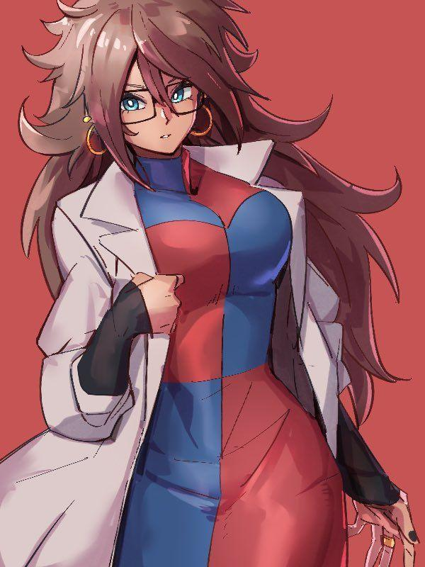

In stark contrast to his bellowing buttocks, Samuel's twitching member that by now had already lost their testicles to the growing slit that had consumed them whole, repurposing wrinkled sacs into warm, juicy lips while testes warp and change, emptying themselves of semen with their purpose outlived in exchange for something more; pumping estrogen and other *'bodily'* enhancing hormones throughout her body just in time for her former penis to stiffen up as if in its final throes of life, defying the invading particles pulling at and reshaping it until nothing but a tiny clitoris dripping with cum and vaginal juices is left atop a throbbing labia, clearly aroused and heated from the faint reddish hue of the hairless skin that made up the sleek downward slope of Samuel's brand new pussy, twitching just a little as it's excretions begin to alter the former man's pants just like it had done her undershirt, which by now had already been turned into a checkered turtleneck dress with barely any gaps within to emphasize just how drastic the changes to Samuel were as her lab coat buttons finally give up, popping apart under the burgeoning weight of her boobs as they jiggle momentarily before coming to a stop, slightly sagging down atop her eye catching torso lined with plentiful bumps and enticing indentations of bone pressing up against soft tender skin, eliciting a foxy sigh from between tender lips as Samuel gushes to the strange sensations assaulting her in both body and mind.

With her former life being uneventful and stale, the concept of pleasure and joy was a foreign thing she only ever got to experience in mild bursts recently. So when her feminized body begins to drown and ferment in hormones meant to up one's libido and sensitivity, she could do little to resist the intoxicating pleasures of the female form in addition to the druglike addiction she was starting to adopt for sweet stuff like the cake currently sliding down her moist throat, completely unaware of the elimination of her manhood as she takes her time to finish chewing the last chunk of delicious cake in her tender grip. All while the particles within her begin to lose steam, vanishing from her body as they finalize changes such as expensive accessories in the form of matching golden hoop earrings in her soft lobes and a thick ring slotted into her middle finger, arm sleeves with shoulder cutouts and similarly colored heels like her dress wrapped around dainty feet sporting toenails painted in the same mesmerizing darkness her nails were done up with.

**"H-Hello sir? I heard you usually come in on off days? So I thought I'd…wait, who are you? Some kind of cosplayer? Look, you're not supposed to be here!"**

**"Hmm? What're you talking about Zack? I'm…what? Are these…breasts? And my voice…oh dear…"**

Gaping in shock and awe at the sight of her own pair of breasts jutting against a skin tight dress, Samuel nervously swallows the last batch of ordinary cake before breaking out into a nervous fit. Now that she was aware of the state she was in, her new center of gravity and the feel of her new 'equipment' were enough to throw her off guard, sending her stumbling midway through her exploration of an unrecognizable body, a blessed one renewed in age and capable of ensuring the immediate attention of any man like the young fresh out of college scientist standing before her with a mixed look of excitement and confusion written on his handsome face.

Amidst the fear however, Samuel couldn't help but feel…elated, excited. As if she had received a major promotion or won the lucky draw…but once that thought stirs in her mind, her eyes widen at the realization of something else that would aid in the decision she would soon have to make.

Walking in after a silent entrance expecting to find the man he had introduced anime and manga to. Zack was initially afraid when faced with the situation of dealing with an illegal visitor all on his lonesome, but that fear wouldn't last once the sight of Samuel's belongings lying scattered around the bodacious woman examining herself while dressed suspiciously like a well known character from his favorite series draws his eyes over the fact that she was wearing Samuel's labcoat that had remained intact over her voluptuous form with the exception of a few missing buttons that left her front exposed. And with the machine semi dismantled with a pile of liquefied scrap nearby. Could an accident have occurred that changed his superior into…***this?***

**"D-Doctor Samuel, is that…ahh, scratch that…the heck was I even-"**

**"Wait!"**

After a tense squeeze of her bosom and a twitch of her stained hands, the reborn Samuel straightens her back with a flushed look of confusion on her adorable face, tucking a stray lock of hair behind her ears while making it hard for young Jack to meet her awkward gaze seriously when she was just so beautiful to look at…but if she was truly Samuel…then wasn't it wrong to feel this way?

**"I'm…not entirely sure but...yes Zack, it's me…I’m Samuel…as strange as it is to call myself that when I look like this now. Thank goodness you came! I wouldn’t know what to do by myself…and umm, I know its sudden to ask this of you but…”**

**“H-Huh? You…I mean I, I’m fine with anything sir-ma’am…whoever you are…what do you want me to do?”**

**“…you wouldn't happen to have any sweets on you now would you? I’m…ashamed to say this but, I think i’m starting to get addicted…"**

**“Ahh, sweets, right, got it…wait…addicted?”**

Once the brief tension between the pair had evaporated and Samuel had calmed herself enough to relax, the newly arrived Zack would sit himself down to chat with his afflicted superior, going through the events of the day right up till the point he had made his appearance at the climax of her supposed transformation. And the more she spoke, the more convinced Zack was that this has to be the same Doctor Samuel he had known ever since starting work here.

And by the end of her tale, the pair were beginning to eye their in progress unlimited energy generator with a shared look of distrust. Was the cause of her change the broken machine? Or was it simply a case of…magically tainted cake? Neither of them knew, and a spontaneous change in gender, clothes and even preferences was something modern science had no answer to.

For one, Samuel had immediately taken to devouring sweets of any kind as long as they were sweet. When Zack's minor offering of a case of Mentos was instantly downed in one go, Samuel would proceed to ransack her subordinates drawer, emptying his sugar reserves in a minute flat. Normally he'd be pissed, but when the one stuffing their face with sweets and snacks bought with his hard earned money was an oriental beauty young enough to be a mother who looked to be enjoying them greatly…he just couldn't say no, much less raise his hand against her.

But setting aside the cause…that still left what to do an equal mystery that, unlike the first, could be solved with a choice. With her very being warped beyond recognition, she could do two things. Either try and find a way to return to her old form or resume her life as it always was while coping with the fact that she would now and forever be a woman. But when Zack brought up the matter to Samuel, she had simply bit her lower lip before sighing, remaining silent as she clasps her hands together, seemingly struggling to make her thoughts known all while her bobbing mane of curly hair wiggles behind her like the tail of a nervous pup.

**"Umm..if it's too hard to make a decision now…we can talk about it later sir?"**

**"Ma'am…just ma'am will do…calling me sir, it just doesn't feel right to me."**

**"*Doesn't feel right*? So…does that mean you're…y'know? Not gonna find a way to turn back?"**

Exhaling sharply before turning her head up to gaze at the ceiling, the subtle crease of a frown fades as her eyes lighten up before turning back down to face Zack, feeling an instinctive urge to break a smile as she watches him struggle to maintain his composure. Normally she would never look at someone, much less a man, in this way; where she could read his feelings simply from examining Zack's body language and facial expressions. It was as if this was some soft of primal knowledge embedded within her brain, activating upon the complete inversion of her gender. She knew there should have been feelings of doubt and uncertainty, but the longer she spent sitting here in the company of the one friend she had managed to make, the more she felt that this was meant to be.

*'And these clothes…I remember them! From that android girl in Zack's show~'*

She felt relaxed like never before, free to do as she pleased with the invisible burden her parents had placed upon her shoulders, lifted by the hands of whatever it was that had turned her into a young Asian woman. Renewed youth in the form of a beautiful body cured of the creeping ailments of old age and a cleared mind with which to view the world though. Even if she hadn't been some reclusive workaholic in the first place, could she or anyone else really stand to say no to a chance like this?

With her confidence to speak her feelings bolstered by the unusual emotions of exuberant joy and roiling excitement filling her chest, Samuel leans forward, taking Zack's hands in her own before bowing her head a little. Surprising the young man at her sudden display of modesty.

**"Yes…I feel right at home in this new body of mine…as for this sudden gesture…think of it as thanks. For I'm sure you're more than aware of who I'm dressed as?"**

**"Y-Yeah…Android 21…but what does this all mean though? It couldn't have specifically turned you into…ohh! All that stuff you said about your childhood…"**

**"...is all in the past now. Literally and figuratively…now then, let's get back to work shall we? I've a need for you now that you're here. If we're quick, we might just be able to fix the machine before nightfall!"**

**"W-Wait a sec! You're still gonna fix the damn thing? W-What if it breaks again? What if it turns me?!"**

**"Oh don't worry so much about it! Haven't they taught you this in prep school? As long as you follow the rules, nothing can go wrong. The fault was caused by someone's rushed work last night…that and they forgot to unplug the machine, and a power fluctuation did the rest…at least, that's what I'm able to surmise from all the evidence when I walked in here…and in the off chance you do get turned? Well, it’s not so bad, trust me~"**

Rising from her seat before flicking her finger over Zack's nose, Samuel giggles before swaying her wide hips and bubbly ass in a generous showing of her new assets and bolstered confidence, bending down a little to let her bosom fight against gravity while she collects the newly made parts from the printing machine before turning to stare back at her junior with a warm, motherly smile on her face that stirs Zack’s number two alongside painting his cheeks a bright red.

**"Well? C'mon! You aren't expecting me to carry all these things on my own now are you?"**

**“Y-Yes ma’am!”**

With a reinvigorated energy to get work done and an unexpected pair of hands to help, Samuel and Zack would soon get the machine repaired with its damaged components replaced with brand new ones built to specifications and tested before being reinserted into the whole. From there however, things would soon begin to take an interesting turn when after the following week had come and gone. After all the boring matters related to identification and personal details were handled, Samantha would have a smooth time reintroducing herself to her colleagues, loving their reactions when the sexy new piece of asss in the lab told them all she had once been the silent hermit, Samuel. Reciting every single detail about his life that only Samuel or someone close to him would have known about. And considering the fact that he had no friends besides Zack, it didn't take much for her to turn them to her side, but not before she made sure to give a stern talking to to engineer Pederson whom she had singled out after tracking down the one responsible the damaged component that led to the machine's breakdown.

**"Sure, I might’ve had it good, but that doesn't mean you can disregard workplace safety protocols! Especially not when we're working with something thus dangerous! What if someone were to be harmed or worse?! Seriously Pederson…"**

It was hard for the men and women to believe that it was Samuel in there. From the way Samantha took charge and addressed her colleagues with an equal level of seriousness and familial warmth, it was like her transformation had helped in making her someone who seemed heavily invested in both her fellow teammates and the project compared to the cold and distant man that had been subsumed to give rise to her. And while she remained a stickler for schedules, her outgoing personality and motherly aura immediately made what was going to be weeks of hell a bearable sauna thanks to her ever present eyes and equally sharp mind, whose boosted IQ had helped speed the project along nicely enough for them to rescind their warnings about the rushed test activation and proclaim with confidence that they could do it. All thanks to the sugar loving Momma Samantha, as the lab had come to affectionately call her.

But outside of her usual self, Samantha had begun to partake in other activities heavily related to her new body, spending less time at her own home when she slept over almost daily at Zack's house instead. Continuing her Dragonball binge alongside the man that had introduced her to it in the first place alongside testing out the capabilities of her new body in the hopes of reproducing the superhuman acts Android 21; the character she had been modeled after was capable of. But besides her voracious hunger for sweets and snacks alongside her boosted intelligence, it seemed she was simply an ordinary human female, incapable of firing off kamehamehas or turning people into sweets which the pair were sort of relieved to know after realizing said character had met her untimely end at the hands of such power. But the prospects of cosplay and character likeness wasn't the only thing Samantha had in mind whenever she came over to Zack's house. In fact, she was feeling rather adventurous thanks to Android 21's innate curiosity to learn more, influencing her thoughts and actions somewhat.

It started off innocently enough with Zack unsurprisingly being the one to propose the idea; that he'd be there if she needed him if things got too tough handling in that new body of hers, still unsure in her ability to take such a sudden change with positivity despite all she had shown him. And so, in a minor act of frustration to show she could stand on her own, Samantha had countered his offering with a plan of her own.

**"If you're so…concerned for my well being…would you be kind enough to let me stay over a couple of days?"**

**"H-Huh?! S-Stay over?"**

**"Hm? What's the matter? Didn't you say you wanted to 'be there for me'? Is a lil girl like me too much for you to handle Zack~"**

**"Alright! Alright! I get it…jeez ma'am…you're like a totally different person when you talk like that!"**

And so she would begin the first of what would become many sleepovers at her precious understudy's home. And while it had started off rather tame for a mature woman living alone with a man, things would gradually escalate once the two began to grow aware of each others…finer qualities.

While Zack stole glances at Samantha's alluring figure as they sat together on the couch watching TV, Samantha too would eye the man's massive tent and bulging pecs, utilizing her incredible brainpower to envision its full girth in all its glory…as well as calculating the time she would need to last against someone with that muscle in a unique form of pillow fighting most grown adults would experience at least once in their lives. And after an especially tough Friday at work that left Samantha silent and Zack with no energy for conversation, the sexual tension was too much for either side to take after having abstained from sexual pleasure in an effort to conceal their want for each other considering they now spent almost all their time together, whether it was in the lab or at home. And even then, the only privacy they ended up having was toilet time.

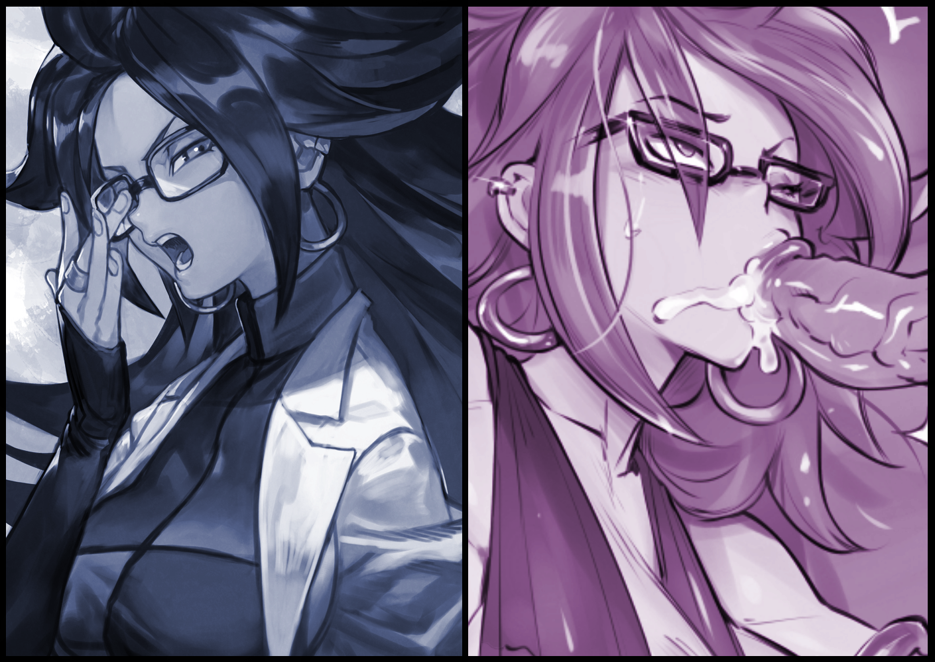

That was the night when Samantha's sweet tooth gained a new favorite food to snack on. Something exotic yet forbidden, likened to a lollipop she could only ever be allowed to savor when Zack was around. It tasted salty yet fulfilling as she fills her lasting mouth with its entire length, long and hard enough to force her gag reflex to trigger as it thumps against the back of her throat. And once it had enough pistoning in and out of her heavenly innards be it either of her sopping lips, the resultant release of bitter spunk was the icing on top. She didn't know why. Maybe it was the thrill of the act, or maybe it was because it was Zack's cream, but it was like the ultimate dessert to her. The greatest phallic treat to grace her lips and satisfy her body. There was nothing else like it.

And so begins a deep, fiery bond between Samantha and Zack. By day, they were simply teacher and student, scientist and assistant. But come night when they had the privacy of a house all to themselves? They were bondmates; destined for each other whether it be in coital bliss together in bed or their everyday lives. Although she still had to break the news of her transition to her parents, Samantha would soon find herself pondering whether or not to delay her plans to propose to Zack until she did. Would her parents take it nicely? Or would it all blow over without pomp and excitement? Just like they had always been, like how they raised her to be…

**"Grrr…thinking about this is making me hungry…"**

**"I might have something that could fill you up~"**

Cooking her head over to stare Zack down with the stern look she gave everyone who took her lightly, Samantha sighs before moving to flop over at his side on the couch, leaning on his shoulder like a hard pillow.

**"Are you alright there Sam? You're looking down…"**

**"Oh…it's nothing really…just stuff about my parents…and this and that…"**

**"'This and that'? Somethings rest wrong with you Sam!"**

**"Oh just shut it you dummy…"**

With her heavy eyelids drooping shut midway through, the troubled scientist would shake those thoughts off her mind, at least for now. With the upcoming test for the machine, there was little room for error. And a distracted mind was a terrible mind to bring to work.

And so they would lay there on a cold evening weekend, comfortable and happy with their lot in life. With Samantha uttering another silent thank you to whatever had seen fit to spice up her bland, boring life on Earth…

*THE END*