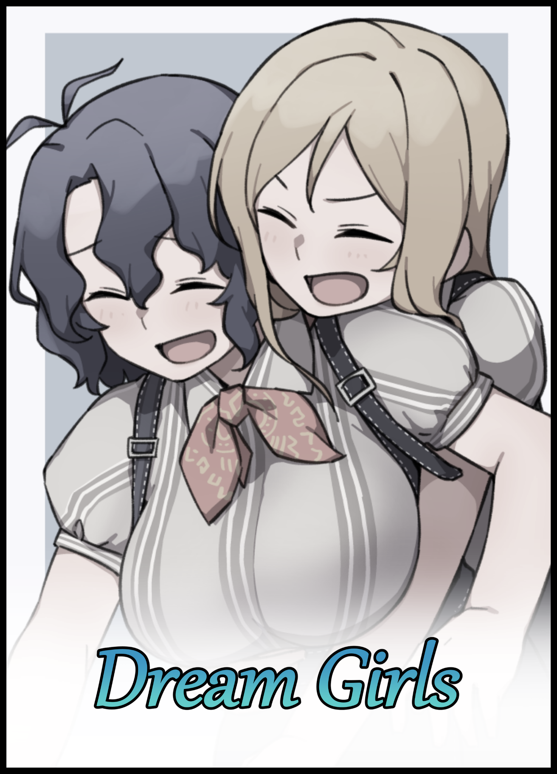

A month had passed since the introduction of an initiative spearheaded by a relatively unknown medical group that had since taken the spotlight, aimed towards revitalizing the local population through the incentivizing of attaining one’s ‘dream partner’. The program had become an extremely sought after service, mostly by men and women who had grown tired of searching for their one true love. Choosing instead to let the government backed pharmaceutical giant do the work for them…and judging by the explosive growth in popularity and nothing but positive word of mouth. Project Soulmate had been a major success in both the eyes of the public and those responsible for its inception after having achieved their true goal of kickstarting a slow but gradual growth in the population after years of steady decline.

Despite its success however, many people still seemed to misunderstand the way Project Soulmate functioned. A misconception that had understandably been ingrained into the minds of the public thanks to a horrible marketing campaign and misleading advertisements that made it out to be a miraculous invention capable of creating their ideal lovers.

In truth, Soulmate was something more akin to an intricate matchmaking network. A database managed by a futuristic computer intelligence capable of selecting and pairing together two unlikely individuals without them ever knowing about the ‘higher power’ responsible for shifting them around like pieces on a board. And if there were any edits required to fill in the blanks, there was nothing better than a state-of-the-art autocloset working in tandem with a nanite bath to help the two pieces gel together that much more. An arguably intrusive process that most found harrowing to endure…but when the end result involved spending the rest of their days happy and content with the men and women of their dreams, there was little they could complain about. Especially when certain individuals ended up discovering a new side to themselves they never would’ve known about if they hadn’t gone through with it out of fear or hesitation had they known the truth behind Soulmate’s inner workings prior to taking the dive. A sentiment shared by a certain couple borne from Soulmate's intricate designs with some subtle influence from the sly foxes over in the marketing division.

They, like many others before them, had assumed that they would each be walking out of the newly established Soulmate branch with the women of their dreams slung around their arms upon receiving the news that they had won the lottery; the prize being a ticket that would secure their entry as one of the lucky few to experience the life-changing program before it's shiny doors were open to the public for a couple hundred dollars. A chance they had eagerly jumped on without hesitation and a decision that occupied the mind of the azure haired woman doing the laundry out on the balcony of a high rise apartment building. Reliving the excitement she had felt after unveiling the scratch ticket to reveal a winning number, the thrill of walking through those squeaky clean halls and then the moment it all came crashing down shortly after being ushered into a side room down a split in the path away from her best friend and the person she had chosen to share in the glory as ordained by the ticket entitling one other person to tag along as a freebie. None the wiser to the corporate shenanigans unfolding before their very eyes until there was no turning back. But despite her initial reservations about acquiescing to more ‘lucrative offers’ shortly after experiencing Soulmate’s touch, her friend had gone ahead with the whole shebang; photo shoots for adverts, interviews, written accounts…and in time, any lingering doubts about the pros and cons had all but vanished from her mind. Not when the program had made their lives all the more better after forcibly intertwining the two into one firmly etched path in an unexpected way.

But just before she could finish hanging up a singlet, an eager set of hands emerged from behind. Looping around her pencil thin waistline to tickle her vulnerable sides, refusing to budge from her jittery motions as uncontrollable giggles begin to leak out of soft spoken lips. Interrupting the solemn tune she had been humming to herself as the assault on her sensitive spots elicits shrill laughter and a spasmodic dance of flailing arms and trembling legs as she struggles to compose herself against the mischief of the second individual emerging from beyond parted curtains to join her companion on the sunlit platform. Stopping only to tackle her into a backbreaking bearhug that threatens to send the two similarly dressed women barrelling toward the edge of the balcony as blonde threads mingle with wavy locks of blue.
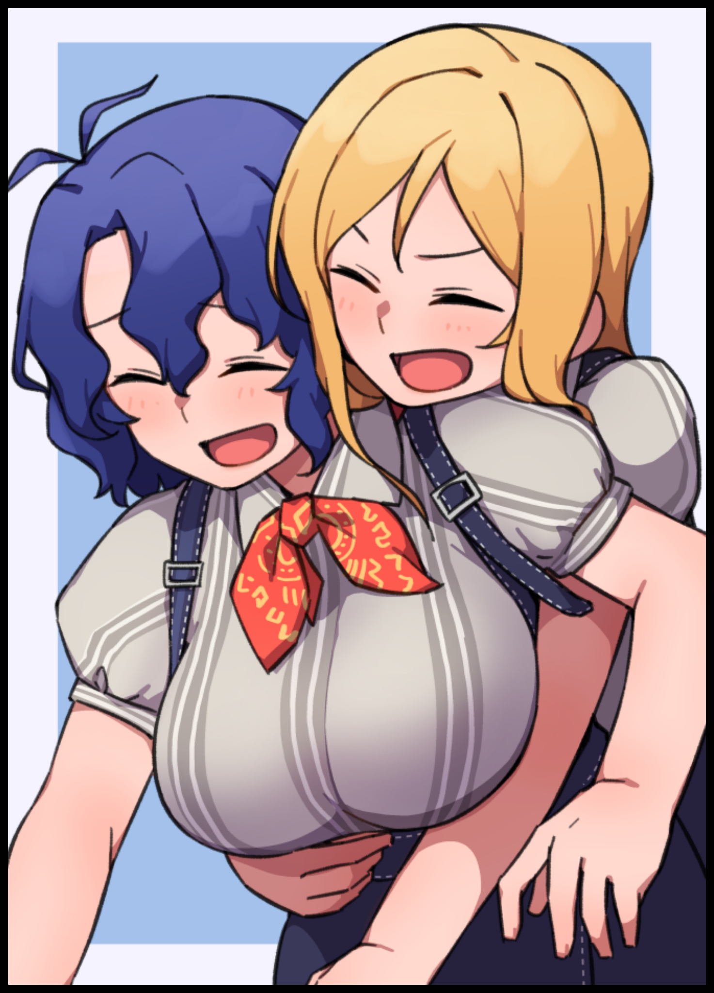
“How’s my sweet little angel doing today~? You really should sing more y’know? That voice of yours is going to waste otherwise!”

“C-Careful! I could lose my balance, y'know?”

“Oh puh-lease! You never do! The only time I’ve seen you all tipsy’s when you’re too done in to stand upright…like last night?”

“N-Not so loud! T-The neighbors could be listening!”

“Haha! No way! Not when I get to see you act all cute and fidgety like that…and you like it when I tease you don’t you?”

‘Of course I do…’ had been the words flitting through her mind at that moment. A shameless admittance to the fact that she was indeed starting to get ‘excited’ from the husky and commanding tone her lady friend had whispered those words in. But a tightness in her chest and a throbbing heat in her skull had stopped her from saying it. Leaving the embarrassed woman to squeeze the hand that had been dangerously inching closer and closer toward her bosom ever since the tone of their conversation had begun to shift to a more personal level. Conveying her emotions through a firm grip whose warmth seeps into the blonde’s arm to paint a wry smile on her face as she steps back into the apartment after releasing the quiet girl from her embrace. Leaving her to stand sheepishly on the balcony with a clammy hand over her racing heart and the other on crumpled clothes that would definitely need ironing out once they were done drying.

“I’ve got hot chocolate on the table whenever you’re ready! Drink up while it’s hot, yeah?”

It was moments like these that served to remind her of the time when she hadn’t been so meek and girly while the boisterous voice calling out for her wasn’t quite so effeminate and energetic. A few months back when she had been a more outgoing and laid back fellow who wasn’t afraid of what laid on the metaphorical road ahead of him and the very same man whose face had briefly appeared in the local news outlets and rumornet as the lucky one to win early and free access to Project Soulmate.

“C’mon man…It’s free and you know we live barely a street away from each other right? We could pool our money and make it there without a sweat. And by the end of the day we’ll both be walking out hand in hand with our dream girls. Why the hesitation?”

At that point in time, she had been a man, going by the name of Alfred. A lax, easygoing spirit taking one step after the other in life. Treating it like a trip to be enjoyed and savored instead of being hurried along like someone who couldn’t appreciate the sights and sounds of an attraction ride. And despite being the polar opposite in some aspects, Maxwell had been the second soul in the boat that was Project Soulmate. Tagging along for the ride after having been convinced to do so by Alfred and his own intrigue at attaining the love of his life after a long string of failed attempts far in an embarrassing past thanks to his effeminate appearance and meek personality. Two ingredients that made for a recipe most girls out there weren’t the least bit interested in when it came to looking for a man to be with for the rest of their lives, so when he realized how big of a chance this was, Maxwell knew only a fool would refuse. An outcome he needed quite a bit of time to reach before acquiescing to his friend’s request.

“A-Alright, alright…I’ll go…”

So when the day finally came for them to meet their dream girls, the two men had been quick to meet early in the morning before heading to the appointed venue an hour early, winning ticket held tight in white knuckled hands as they made their way into the building before being ushered into the waiting hall by equally punctual staff. A cavernous chamber that would no doubt see much traffic in the coming days once the main doors were open to the public as they were seated near the very front before a bubbly woman would approach them less than a second after being deposited there by the far more stringent looking guards that had escorted them into the hall.

“Alfred and…Maxwell correct? I’m Lisa! Your guide for the day! My apologies for the delay but the lab techs still need some time to set up the equipment so a short tour of the facility should suffice till then. Shall we? I hope I’m not being too demanding?"

Neither one could muster the will to say no to the pretty lady’s cheeky invitation despite the lethargy of waking up early in the morning coupled with the excitement of what was yet to come as the two men pushed themselves off of the posh leather they had planted their rosy derrieres on with a huff. Falling in line with their guide as they began to move deeper into the unsuspectingly immense facility. Losing more and more of its accommodating design to industrial flair and the stale air of a medical lab the deeper they went. All while the top secret stuff most men their age would take an interest in remained behind closed doors, and understandably so; for they were being shown a tiny glimpse of the technology and infrastructure behind the renowned project. Any more and they would probably never be allowed to step foot out of the building or worse. A feeling firmly cemented in the minds of the duo as they matched gazes with their unsuspecting guide, smiling with a small hint of shark at the corner of upturned lips as she points out a specific room to their left stuffed full of servers and other strange machines of unknown purpose hooked up to a larger structure that remained hidden behind another set of locked doors.

"That's the brain behind our operations here in this city! The hardware that's gonna be responsible for matching lovebirds like the two of you come tomorrow!"

"That's cool and all but…if that's the 'brain'...is there a heart?"

"Mmm~ Good question! Because that's where we'll be heading in…ooh! Right now actually. The techs say we're all ready to go. Buckle up you two, cuz you're about to meet the love of your life!"

"Y-You speak of it like something we're gonna be put through…I thought Project Soulmate was just like…like a meet and greet or something?"

"I guess you could put it that way…but trust me when I say it's a whole lot more exciting than that. You'll see when we get started! Now hop to it and turn that frown upside down, you should really take more from your friend here. You’re about to meet your darling one and only! Looking all sad and nervous isn’t gonna cut it now, don’t you think so?"

“She’s got a point there Max! Though if it’s your dream girl…I guess she wouldn’t mind a pouty man like you huh?”

Thinking back on it now, it was no mere coincidence that Lisa's wording had sounded strangely off at that point in time. Making it sound as if the two of them were about to be paired up for life instead of being met by their respective lovers while alluding to the engaging procedure that awaited them as they were led down a separate path running parallel with the main corridor connecting the waiting hall with the ‘heart’ of the facility where Project Soulmate’s magic would take place in; a crossroads-style split leading to two rooms that could only accommodate for one individual on either side.

“Do we go in there one by one or what? Doesn’t seem quite right if it’s supposed to match us up with our lovers don’t you think?”

“Y-Yeah…how’s this supposed to work out?”

“There, there, one question at a time. Soulmate isn’t some one and done deal y’know? There’s a procedure to everything, and this is no different. Those rooms are autoclosets, fitted with the latest in security measures and state of the art tech, they’ll help ready you up for the pairing to follow right after…oh, that reminds me. Leave your phones and other valuables right here, you two can pick them up on your way out. The process isn’t too particularly delicate with expensive belongings if you catch my meaning. And Mister Alfred? I’ll have you know nothing, not even Soulmaker can make authentic love blossom overnight~”

Neither one had found reason to view Lisa in an uncertain light after finding her statement to be acceptable. Doing as they were told by relieving themselves of their wallets and phones before stepping into the parallel rooms with one final glance shared between men; Alfred with a grin on his face. Maxwell with hopeful uncertainty…unknowingly looking upon each other for the last time as they remembered themselves in a now distant past, sealing their shared fates as they stepped inside the sturdy, airtight rooms. None the wiser to the rug that had been deceptively pulled out from under their feet as automatic doors sealed behind them with the faintest of clicks. A trek through time that was cut short as a loud and sudden series of blaring beeps and shrill pips shocks the dazed woman that had since returned to the living room. Giving her companion a fright as her high pitched scream extends the temporary fracas, shattering the peaceful silence of a serene morning…

“EEK!”

“Woah…calm down girl! It’s just a ringtone…what’s the matter? Didn’t you rest well last night?”

“H-Huh?! Oh…of course I…it’s just…I was thinking about the day we…y’know? And that sound…I just can’t get over…s-sorry…”

A slightly muted sigh borne of mild annoyance and concern slips free of the blonde girl’s lips as she pours through the contents of the message she had just received. Leaving her companion to sheepishly sip away at the soothing mug of hot cocoa in her shivering hands that ultimately did little to douse the raging ball of awkward shame smashing around inside an aching heart beating so fast an MRI would probably unveil the silhouette of a miniature rock band pounding away somewhere inside.

As Alfred, a loud noise like that would never have elicited such a panicky response. Even if it had become associated with the series of events that had left her in her current state…a procedure that had changed her so drastically to the point where her psyche had become a frail, brittle core. Deepening the impact left by that memory in the form of a sizeable dent that could still be felt in her ego despite Maxwell’s attempts to ease her out of it just like she had moments after leaving that confined space thanks to a similar 180 in personality that had, for all intents and purposes, swapped their places around…something she still couldn’t sit right with to this day as frustration and envy begins to join in the bog of shame and uncertainty within her head, gritting her teeth unbeknownst to herself before a warm hand settles over her wrist, easing the quaking fit that had consumed them before they could spill the piping hot contents of the mug she held on to.

She didn’t feel relieved, not one bit. In fact, the kind gesture only seemed to widen the hole in her heart that much more as her fingers were separated from the mug, Leaving her to ball her hands into fists as they trembled on her lap with nothing to channel their frustration into while salty specks began to make her eyes sting. Blinding her somewhat to the approaching figure closing in from her sides until it was too late as air suddenly vacates her chest from the forceful momentum of being pushed over onto her back, followed shortly afterward by lurching movement as she feels herself being lifted up into the air by slender arms struggling to maintain a steady grip around her neck and the pillowy girth of her thighs. Tickling her to provide enough stimuli to realize she was now caught in a precarious bridal carry by her companion despite the obvious strain of such a feat.

“H-Holy cow! You’ve…definitely put on some weight!”

“D-Don't call me fat! Wait, that's not the point! P-Put me down!”

Panicked hollering would go ignored as shaky legs rush to deposit the flailing beauty on the safety and comfort of well done sheets that had since gone cold and stiff. Crumpling them as the blonde tosses her friend onto the bouncy bed in a confused mess. Giving her barely any time to recover from the fall before eager hands fell over the front of her dress, undoing the buttons and clasps of the dress to loosen their grip in an effort to undo the tightness of her blouse to easily pull away the encompassing top. Revealing a whole swathe of creamy skin coating the length of a pudgy tummy that jiggles to the spastic movement of the flustered maiden upon realizing what her friend was trying to do. But a panicked mind would prove no match against her aggressor's swift movements. Making quick work of the rest of her clothing, leaving the shivering damsel barren save for a fluffy white bra cupping milky breasts while a matching set of frilly panties below did little to conceal her modesty. Not when the exciting rush from a few hours ago had left the fabric crumpled and taut in certain places. Enough to highlight the subtle curves of her womanly bits beneath. A sight that had her friend clicking her tongue in dramatic fashion as an analytical gaze lingers over the naughty spot nudging up against her own from her insinuating position mounted atop the immobilized woman's hips.

"You never were big on hygiene huh? I guess some things just can't be changed no matter what…don't you think so Kylie?"

“What’s with you all of a sudden? D-Don’t we have an interview coming up soon? Stop fooling around!”

“Oh…that? I figured it can wait…and besides, do you really think you’re fit to go out right now? You’re a mess…and that thing from earlier? Who knows what else might trigger it again?”

“I can’t just…it’s not…it’s not something that’ll just go away on its own and it scares me alright? I said it! Why are you being such a dick about it?!”

“Yeesh…talk about loud…and I have a name y’know? Hate it when you start acting up like this…I thought we were over this months ago Kylie…”

Shying away from her companion in a mix of shame and embarrassment from her outburst. The momentary air of mischief becomes tense and strained once the room goes silent. Interrupted by the occasional sniff and sob from a devastated Kylie, struggling to find it in herself to apologize for being so childish when she knew Millie was just trying to help in her own way. But as that accursed tightness in her throat returns to silence her once more, she knew her efforts were in vain. Forming a sizable crack in her already vulnerable psyche that begins to fan the flames of negativity in her mind.

But before Kylie could indulge herself in those dark thoughts, warm hands find themselves caressing her woefully cold body. Despite the copious amounts of supple flesh adorning her body and flustered temperament, her internal temperature was so cold to the point where the feeling of Millie’s body heat flowing into her was enough to jolt her out of her hateful stupor, crying out in shock and unabashed euphoria as dainty fingers and trimmed nails ran the length of her sides, triggering the erogenous zones beneath her bosom as practiced maneuvers impart pleasure by stroking the sides of her left breast before pressing down against her armpits, stealthily undoing the bonds that kept her bra together. Tracing sweat as they ran up along the knobbled indents of rib bones before applying pressure directly to her core, eliciting a series of gasps and sensual movements from Kylie as her body twists in the throes of bliss. Unable to free herself from Millie’s surprise assault as the single minded blonde begins to gyrate her hips while undoing her own clothes, freeing an impeccable pair of breasts before slow hands drift lower, loosening a skirt that falls to the foot of the bed before unwinding the knots that held a daring thong together in an effort to join her girlfriend in the nude. Keeping Kylie immobilized as a free hand finishes up with removing crumpled panties returns to press firmly against a swelling pink nub inlaid beneath a smooth strip of raven pubes, taking in the rapturous sounds of a maiden’s sinful vocals. Simultaneously tending to her own needs via the titillating act of scissoring, adding to the raunchy ensemble as the soft, wet sounds of lesbian love accompanies Kylie’s rabid squealing and Millie’s soft, rugged sighs….

She despised this feeling, especially when it only served to invoke memories of the events that had transpired in the rooms shortly after being locked inside of them. Stripped of their means of communication with the outside world and other such belongings, the hidden machinery stuffed away within the unassuming walls of the cramped compartments were free to begin their work, spilling out like the hands of the tortured dead reaching from beyond the grave for warm flesh to embrace…

“W-What the hell? Get off of me? H-Hey! Somethings wrong with your machine! Stop!!!”

Alfred’s cries would go unheard thanks to the reliable soundproofing built into the autocloset’s walls as its myriad arms begin by shredding apart his clothes. Doing away with expensive denim jeans, a rugged jacket and a stylish t-shirt in the span of five seconds. Halting any attempted form of resistance from its understandably infuriated subject through the overbearing force of robotics as restraining arms held Alfred down so its brethren could continue to work uninterrupted. Producing a series of strange implements and even a new set of ‘clothes’ for the now naked man to wear…clothes that, as Alfred would soon realize, were nothing more than a one-size fits all, semi-transparent swimwear with abundant cutouts and a style that pointed towards it being a girl’s swimsuit after screaming out in protest as the lower strap slaps itself between his hairy ass cheeks and against the base of his testicles; the last sensation he would ever feel from his manhood once spray canisters and syringe tipped arms begin to administer swift doses of anesthesia and nanite payloads. Beginning a steady series of unseen changes that builds up overtime in an effort to make the ill-fitting giant a perfect fit for the semi-transparent spandex covering his bubbling body…a body that was already looking far more…shinier than it had been a few seconds ago as microscopic changes eradicates swathes of body hair. Leaving the surface slick and smooth for beads of sweat to run across. An excretion of fluids gleaned by a sudden spike in body temperature that also serves to dull a panicking Alfred once lethargy and the effects of heat exhaustion begin to manifest. Leaving him helpless to resist as his athletic frame begins to give way like the ebb and flow of the changing tides once gaunt lines begin to give in, tightening in certain places while expanding outward into gentle mounds and rising curves. Forming a narrow waistline and the beginnings of broad hips that would become the baseline for an eye-catching hourglass figure as the rest of his body races to catch up with the emergence of feminine traits all over…

“You’re enjoying this aren’t you? Don’t deny it Kylie…embrace it…think. Remember that moment when Soulmate first laid hands on you…how it felt…you keep running but you don’t know why. Well, today’s the day we settle that for good!”

“W-What are you ev-ahn! saying? Please! M-Millie! You have to…stop this!”

“Not until we’re all set and ready…now use that pretty little head of yours and think back to that point in time…about the little ‘training session’ of theirs we went through together.”

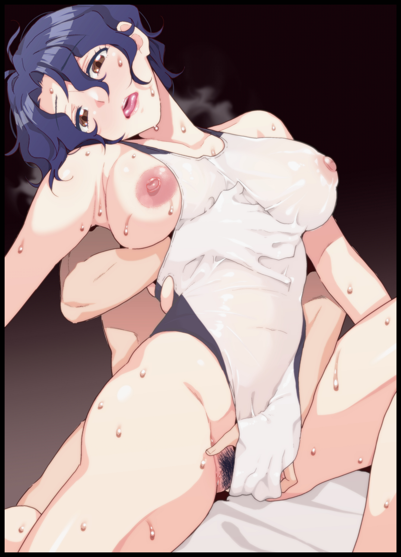
This hadn’t been Kylie’s first rodeo with the female form, far from it. Not when Millie had made it a point to sleep with her beloved every night whenever they could. But this one was different. Spurred by her trauma and Millie’s goading that seemed to spark something in her friend’s lust addled eyes, the memory of her transition begins to distort…taking on figments of reality itself as the confined interiors of the autocloset vanishes. Leaving her past self to float in an endless haze of miasmic smog while continuing to change. Gaining heft in his chest as the familiar weight of twin mammaries begin to pull on strained shoulders, stretching the elastic swimsuit as they shiver and tent against the emergence of swollen nubs set atop the two jiggly melons. Painfully erect and glaringly pink nipples that distanced themselves from the inert mounds of brown wrinkled skin they once were while blooming abs down below coalesces and softens into a motherly core that houses a brand new set of organs central to her altered reproductive system as anesthetics numb the pain of testicles being inverted and reformed into pulsing ovaries to frame a fertile womb. An incubator linked to a tight, organic tunnel leading down to the puckered slit squished between fattened legs, crowned by smoothed back pubes and a keystone for her ascension to womanhood as Kylie collapses to her knees in the synaptic abyss, replacing Alfred as the memory shifts once more, illuminating the warm sheets of a bed in a narrow, circular space around her and only her…no Millie to be seen elsewhere in the unlit void.

Until a rough pair of hands emerged from directly behind her, not the warm, gentle touch she had grown used to but the coarse grip of a man’s hand as it roams across her body. Slipping beneath the swimsuit to access her g-spots in an act that had her tossing her head back from the shock of it all, only to come face to face with a mirror instead of the handsome man she remembered seeing back when the autocloset had begun implanting new memories and personality subsets in an effort to better aid them in their new bodies. And in its dark reflective surface, she didn’t see herself, just an oddly disproportionate head on a pencil thin neck…

‘Do you get it yet Kylie? You haven’t fully moved on from that moment, have you? Still not fully sure if you’re my best friend or my quiet little angel? I find myself thinking the same sometimes…you can’t be both…but is it really so bad to be one or the other? It’s the same thing isn’t it?’

Looking directly into her reflection only served to cement the truth conveyed by Millie’s ethereal voice ringing all around her. An undeniable truth that leaves an exhausted Kylie stunned and speechless as the mirror man begins to move, returning her to the very last moments spent within the suffocating autocloset as the nanites that flooded her body began to fiddle with her mind. Essentially swapping out her lackadaisical persona for that of Maxwell’s. A switcheroo made in compliance with a hidden brain scan performed the moment they stepped into the building that told Soulmate’s algorithm all it needed to know about the two men’s dreamgirls and where they could be found; one inside the other.

But theirs was a unique first case scenario for the company in a bid to show that not everything was an automated process that made the act of discovering true love a one-and-done type deal through Soulmate, and while it might’ve seemed like the two had left their closets unharmed and changed for the better as wide, curious eyes fell upon each other’s scantily clad bodies. Alfred had come away with mental scars. Residual stress from how sudden the entire process was in combination with the fact that she was no longer a straightforward man who wasn’t afraid of anything short of a gun or a ghost. Rendered submissively shy and obedient against her will thanks to her new place in life as Maxwell’s ideal woman. Someone who could basically be considered his female counterpart and the only one to truly understand him.

She couldn’t make her opinions about their treatment known. Horrified to see Maxwell embrace her new identity with open arms so willingly as she gladly accepted Lisa’s terms with a broad smile and some choice insults she never would’ve had the guts to say to someone else so brazenly before the changes. Leaving Alfred confused about what had become of her friend as they were led out to the next room where they were to receive their belongings. All edited with the proper information to reflect their new appearances with a whole array of paperwork and contracts signed by Maxwell’s hand that would basically seal their fates as Kylie and Millie respectively for the foreseeable future. All while her inner voice’s protests would go unheard as they went to spend an awkward afternoon together, getting to know their new selves and each other better, preparing for the eventual move to their new, shared apartment flat. A perpetual cycle that seemed without end despite the pleasure afforded to her through the realization of her dreams and the cozy, posh life they had been given; doomed to live as someone else with an identity crisis and borderline PTSD plaguing her every waking moment with an ideal love life that didn’t feel the least bit believable…but as her blurry eyed vision comes back to focus on Millie’s sweaty face pressed lovingly against her neck in a sweaty heap, only then had she realized how wrong she had been in her assumptions.

“I think back to that day too y’know? Don’t you remember what Lisa said back then? About…love…I mean…”

"That ‘true love’ isn’t something that just works in an instant? Yeah…I remember…but…do you really have second thoughts about…what we have now?"

“Well…it took up my head like…a whole lotta headspace, but that was awhile ago…I assumed you got over it too..but…I was stupid. I didn’t think you were actually still stuck…still confused over the whole being a girl thing…it should’ve come to me sooner. But being able to speak so openly without feeling like the sky might just collapse on me all the time…it got to me y’know?”

Silence falls over the room save for the distant squawking of birds flying by the window as the two women take a moment to process their thoughts. With Kylie lying still and motionless beneath Millie, enjoying the scent of her luscious blonde mop while listening to a muffled voice fade after imparting her side of the story, ruffling damp locks of moody blue hair with lazy strokes and gentle ruffles over the next few minutes until not even the likes of Kylie could wait any longer, shifting her arms slowly across the sheets beneath Millie’s notice, closing the distance between the bed and her squished up chest before…
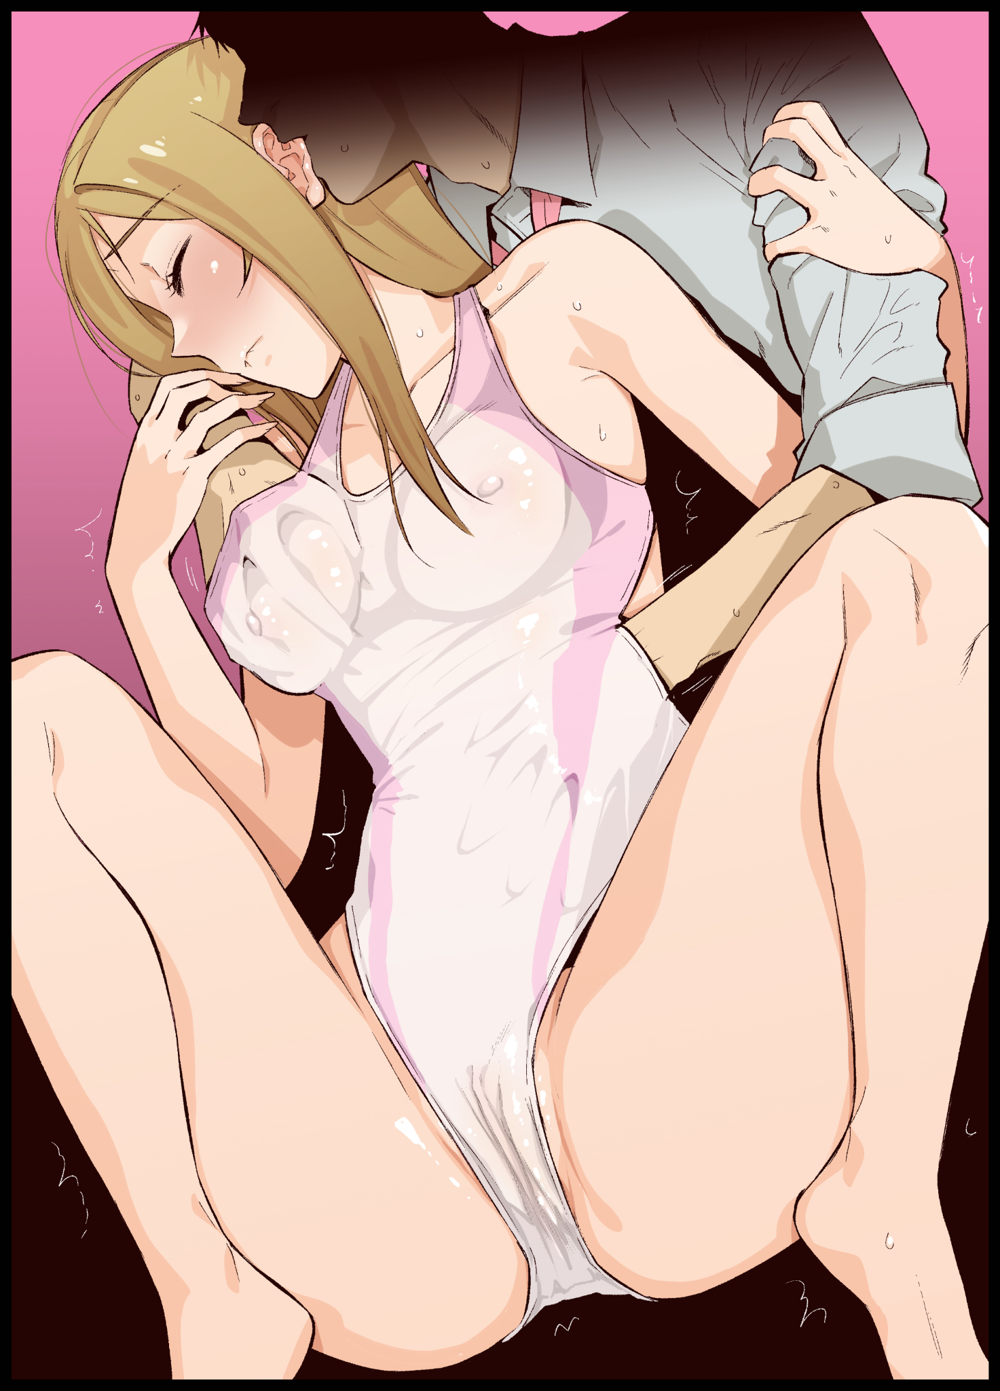
“Mmm~ K-Kylie~ Not…the chest! You don’t get to play with them after-kyahn!”

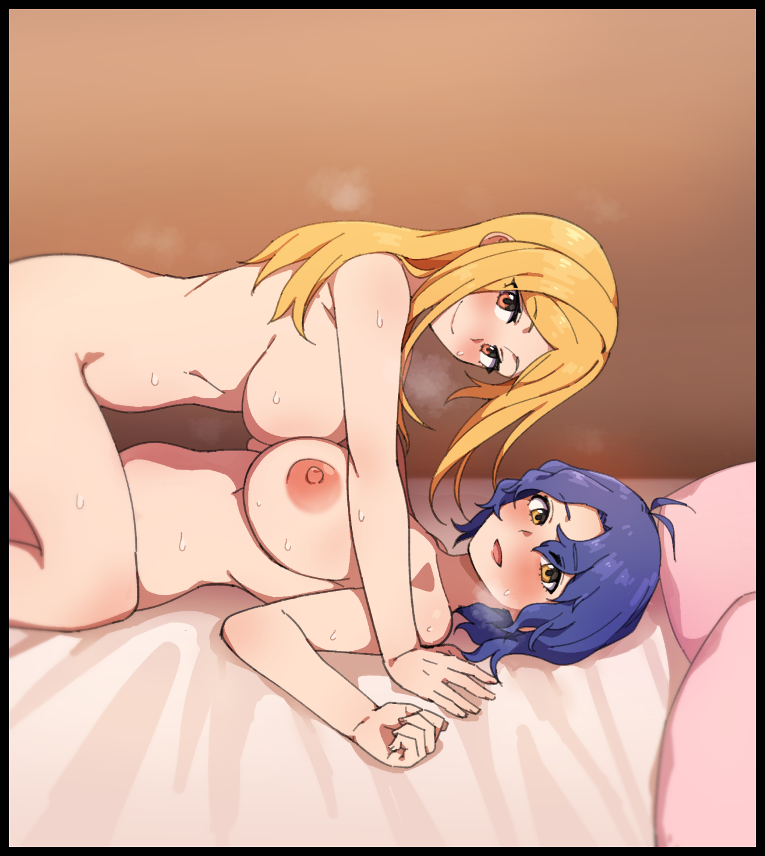
Just like the blonde haired vixen knew which part of her to press and pull on to make her squeal like the back of her hand. Kylie was equally versed in Millie’s G-spots and what exactly she would need to do in an effort to earn the same response; watching as her titillating body lifts itself up and into the air just from the electrifying sensation of having her hyper sensitive breasts played with as Kylie’s breathing quickens at the sight of Millie’s sensual dance, thrusting her hips and writhing in the throes of orgasm as simple squeezes and subtle pinches are all that’s needed to make her move at her command like a puppet master playing with their dolls using string and wood. A strong response that had been ingrained into her very being through the very same nanites that had remolded them from the ground up. Except instead of the more elaborate and ‘graceful’ maneuvers that would turn Kylie into a quivering mess. Millie’s was, in a mockery of her upfront persona, more direct and simple; a simple squeeze of her mammaries…seeded into her flesh by the barrage of fabricated memories and experiences that didn’t usurp but rather, merged with what was already there. Allowing the two to become the other’s perfect girl without much conflict as the mannerisms and know-how of being women took to the forefront of their minds by the end of the procedure…and as Kylie could attest to; it wasn’t always going to be perfect.

But that didn’t mean their woes weren’t solvable, and as a final squeeze forces Millie to arch her flexible form all the way back like an experienced contortionist. The first of many sincere smiles paints itself across Kylie’s face as her arms fall to the bed in tune with Millie’s return, planting shaky arms right beside her demure partner’s cheeky visage to catch her fall as the two take a moment to catch their breaths, The surrounding sheets dampened by their combined juices while the floor was strewn with abandoned underwear and clothes to fill the empty wash once they were done.

“Thanks Millie…”

“F-For my boobs?”

“For everything…o-oh! Your phone…it’s ringing…”

“And you didn’t scream…that’s my little angel~ Let’s see here..ah, it’s Lisa…just reminding us about the interview later.”

“For another news segment about Soulmate? It’s doing really well isn’t it? Why the need for more?”

“Apparently, there’s been some naysayers who don’t think we actually are a couple. Lisa wants to fight that by giving the public more bits about us…although I don’t think that’s gonna work…will it?”

“Hmm…I think it might actually…especially after our little moment of ‘self-discovery’, people might just realize Soulmate without all those assumptions messing with them…so…shall we? We still have a few hours until the interview, right?”

“Oh my, how could this be? My sweet little Kylie propositioning me for sex? Color me surprised!

“I think I’ve got more up my sleeves where that came from~ And…I might still need some help being me again…and I know you’ll be there…just like I will for you!”

“Brave words~ But careful now. I won’t hold back after what you did to me!”

Sharing a giggle, the romantic couple would take a second to look each other in the eyes as they gradually draw close to one another. Ready to take the first real dive into their lives as a bonded pair together…

THE END

Image Sources

Images 1 and 4 by Kwaejina : https://www.pixiv.net/en/users/2669050

Images 2 and 3 by Humiyou : https://www.pixiv.net/en/users/879378

