RUNS IN THE FAMILY
BIWEEKLY STORY #64
BY CHALDEACHANGE
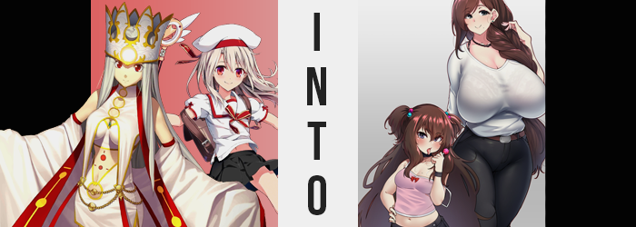

It was unusual for the Einzbern family to have an argument, but not even they were invulnerable to the occasional spat. Perhaps in this case it was an issue born more from the fact that they weren’t a traditional family. Related by blood but separated by time and space, Chaldea truly was a fearsome place in how it could collect Servants from completely different timelines, reunited family once thought lost.

In the case of the Einzberns, Irisviel had been summoned from an improbable outcome of the Fourth Holy Grail War of Fuyuki, when her daughter was only a babe. On the other hand, Illyasviel came from a timeline where her parents didn’t participate in the Holy Grail War altogether, and she had grown to the age of eleven and had become a magical girl of all things.

But they made it work.

Family was family, and if fate itself ordained this reunion, then they had decided to treat each other like mother and daughter while their stay at Chaldea persevered. For better or for worse.

“I don’t get why she scolded me. I gave her the gift Chloe suggested!” Mother’s Day had come, and Illya had really wanted to give her ‘mom’ a gift she’d really enjoy. But she didn’t really understand what adults liked and had gone to Chloe for help. Chloe… she’d seen it as a chance to prank her ‘sister’, and suggested Illya buy her a bra because ‘women always need new undergarments!’. But she’d also coaxed her into buying one meant for a pair of J-cup breasts – the largest size available.

Illya had ended up scolded because the bra was way too big, and even then Irisviel hadn’t really scolded her. Illya was simply overreacting to her mother’s confusion and had ended up sulking in response. She’d even run off with the gift in question and was now locked up in her room. Minutes turned into hours, and after taking a nap the child finally felt up to apologizing to her mother for her earlier outburst.

Except, when she woke up? “Eh? This isn’t my room…” It was Irisviel’s, wasn’t it? She’d styled her own after her own tastes – which were admittedly quite childish. But the minimalist design of this room, lined with mahogany furniture, was undeniably to her mother’s tastes. But other than herself, one other item in this room had been brought along from when she’d fallen asleep. The gigantic bra was sitting on the nightstand. “Did mama bring me here while I was sleeping?” That made the most sense, right?

It was easy enough to handwave her relocation this way, but there wasn’t any truth to this reassurance even as the child rubbed her eyes and tossed her feet over the side of the bed. Short as Illya was, they naturally didn’t touch the floor. Initially.

“Hueh? Something feels off here…” The girl couldn’t put her finger on it, at least not right away, but after sitting there to wake up for about thirty seconds something struck her as wrong. Her toes were pressing into the fuzzy carpet at the foot of the bed, toenails occasionally getting caught on fibers because, quite simply, they’d grown longer… just as the toes themselves had.

Still wearing a sleepy expression, she glanced down at herself. That was enough to force her to freak out, and she jumped to her feet with a cry. “HUEEEEEH!?” Standing straight, arms out to the sides in shock – she had plenty of cause to be surprised. Because, after all… “I’M TALLER!?” At best it was about five inches so far, and this was already enough to stress the school uniform she’d brought with her from her own world.

The bottom of her shirt had already lifted to show off her belly button, and a pleated skirt that was meant to cover her thighs left them on full display. Illyasviel wasn’t simply growing up though, she was also growing out; her body’s proportions becoming more adult, like she was being fast-forwarded through puberty.

“Ow!” Misinterpreting discomfort for pain, this included the breadth of her frame. Shoulders pulled wider, tightening already tight sleeves around them, and her hips pulled wider in a way that tested the fabric of her shirt. Both gave way no sooner than the beginnings of adulthood began to show in the girl’s face, and tatters fell to the floor all around an Illya that was roughly eighteen by this point. “Ah!? My clothes!? My… Oh!”

Shock for the fact that her outfit had basically just exploded, leaving her naked short for the children’s panties that were digging into the crack of her butt, was subdued by, well, realizations like the fact that her butt was now big enough for her children’s panties to dig into. Her figure had filled out naturally, leaving her with a rather sizable rear. Where Illya’s hands went to was her chest though, lengthened fingers bouncing them with interest a moment – observing their weight at least until her panties snapping pulled her away from her surprise.

Her figure continued to swell just a bit bigger before stopping, and the girl – woman – assumed that her changes had come to a halt as well. “This is impossible, right? I look like mama!” She could barely make out her reflection in the full-length mirror in the room’s corner, and her assumption here wasn’t quite off the mark. It was just a testament to the fact that Illyasviel would look a lot like Irisviel when she reached adulthood. But what she couldn’t see from this distance?

Her figure had stopped growing for now, but her face was continuing to change. Lips, already swollen, grew more so. Signs of age grew apparent across her skin as well, but this wasn’t exactly isolated to her face – it was just easier to see there. Crow’s feet indented themselves in her eyes’ corners, pores across her nose closed, and it looked like a great deal of product was required to keep her skin soft. There was even a slight sag to her breasts and ass as increasing age caught up to them.

“Wh-Why am I sagging so much? But I suppose when a woman gets to my age… Hueh? My age? Why am I talking like an old lady!? I’m still… Uh! My age was… forty? Wait, really!?” No, no, that sounded wrong! Hadn’t she just been a kid!? All of her joy quickly washed away as her old identity struggled with a changing reality.

Yet this only seemed to exacerbate the issue. If Illya’s old identity was causing problems with the magic, then it went without saying that pulling her farther from that identity was the more ideal scenario. Well… that had been the intention of the curse that was affecting her in the first place, it had just taken longer to kick in.

Because Illyasviel’s beautiful, white hair? Its ends began to darken. Not to gray, but all of the way to a rich brown. Length had grown as she’d become older and it now reached halfway down her back, but everything that darkened appeared to stretch as the color moved up towards her scalp. This meant falling longer still, and it fell even past her butt before all was said and down. Not simply a matter of color and length though, her hair’s quality just became incredibly thick and heavy. It seemed to have a natural curl to it as well, one that might be better braided.

“My, oh my! Why is my hair like this!? Mm… Hasn’t it always been? N-No!?” It almost sounded like Illyasviel was arguing with herself as fingers ran through her hefty hairdo, feeling just how soft and silky it all way – but smelling of far too many hair products. ‘If I’m going to turn heads, I need to keep my hair as young looking as possible!’ Her thoughts had begun to take on the same airy feeling as her voice, which on the whole was carrying a much sweeter tone.

The woman’s face stopped aging around the forty mark, but that did not spare her from changing there further. Lips pouted naturally, their thickness almost seeming falsified while glossy, and her cheekbones rounded. What really spelled doom for her old identity on the other hand were her eyes. The red so typical of an Einzbern homunculus drained away, leaving a much more mundane silver. More than that though, the slight Japanese slant they had from having a Japanese father became more defined, making her look like a pure-blooded Japanese woman.

Fingers, long, bony, and now topped with acrylic nails, traced her figure almost expectantly. Illya – was that even her name? – almost seemed to be expecting something, and her panic was dissipating slowly but surely. In fact, she switched between a hum and a giggle after giving her nipples a twerk. Her mental age had been growing into her body’s age, and her ego had been growing into the ego forced upon her by the curse. She didn’t have much means of resisting, even now.

“Why is my figure so…? No, didn’t I feel like I’d grown a lot just a moment ago? But my! My curves are usually so… No one can compare to me!” It was clearly that this new self, of a forty year old Japanese woman, was winning out in terms of wrestling control. And as she’d deduced, the curves that she was speaking of promptly came out in full force.

Nipples stood erect expectantly, and before long the areola around them engorged almost gratuitously, their pinks becoming even pinker. Now, Illya’s breasts had initially grown to be around the same size as her mother’s; a respect C-cup sizing. But lurching forward, for she was given no immediate choice, it was clear that what was being placed upon her was far more gratuitous. Yet, not wholly unfamiliar.

After all, it was a breast sizing that would fit perfectly into the J-cup bra Illya had gifted her mother!

“Ara ara!” The Japanese woman cried out with a mix of disbelief and arousal, fingers sinking into the flesh of her bosom as it expanded towards its intended size. Under no circumstance could this be considered a conventional breast size, and their excess weight forced her to lean forward while the muscles on her back tightened to keep up. So quickly they grew that they bounced and jiggled, teats sometimes slapping against her belly both from the suddenness and Illyasviel’s own fondling, which had become both depraved and rapid enough for her cheeks to burn and her breathing to turn to a panting. “Yes, yes! Just like this! Ohhhh!” They were so utterly huge in the end that they didn’t have any roundness to speak of. Weight as they were, they hung down like ovals, nipples inches long while erect and areola as ample as a pair of cookies.

Evidently, continuing at this pace would still see her topple over. Her lower half had yet to grow at all to accommodate her J-cup jigglies, and that had to change if she were to stand upright again. Fortune shone, weight rippling further through her legs and ass. Hips were forced wide so fat could bleed in, see a plumpness beset her entire figure as thighs grew immensely wide and rubbed up against one another, while her ass ballooned gratuitously at her rear.
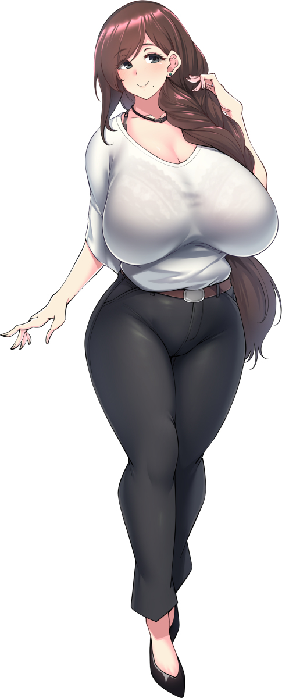
It was all a plumpness born of fortunate genes and her older age, made clear by how even the flesh around her pelvis became a little chubby, and while her waistline was thin, a belly bump would blend into that. If you threw a pair of mom pants on her, she undoubtedly appeared insanely hot. “Better~! The appeal of a healthy mother truly is unbeatable, isn’t it?” Gone were memories of a childhood. Or, rather, her childhood memories were different. She had been the daughter of a magus family and had lived a fairly standard life? She’d met a man, had a child, and he’d passed not long after. Now, she worked with Chaldea as a nurse, taking care of her daughter…

And flirting with men and women alike, laying with whoever pleased. This nurse was something of a nymphomaniac, but considering her body there were few that had any complaints about that! As if to add one final touch, a single mole appeared beneath the left side of her mouth.

The woman stretched, and in doing so her massive, J-cup tits lifted and fell, slapping against her belly without any support to their name. “Mm! I feel so good! Who knew that being an adult could feel this great? Heehee!” Minako’s personality had become floaty, and her understanding of the world had shifted to fit a woman in her forties as she now was. Not only was she familiar with the ins and outs of a woman’s sexual life, all of the fondling she’d done to her body made her desire more.

Had she just been a child? That couldn’t truly be the case, could it? Not with a body so big and so finely aged. Still aroused, her huge ass collapsed against the bed (with her weight making it creak) and she both leaned back and spread her legs, drawing fingers down and past her thick bush. “I can look for Rini-chan after!” Who was…? Her daughter? Yes, that sounded right!

But first, her second hand reached towards a drawer in her night stand. There was a dildo in there, and mama was horny!

“Hm? How on earth did I…?” Earlier in the day, while Illya had been napping, her mother had suddenly found herself in her daughter’s room. She felt as if she’d accidentally upset her daughter earlier, but she truly hadn’t been certain about how she was supposed to react in response to being gifted a bra of that size… Illya had run off, and Iri had been torn on pursuing or giving her space.

But she’d felt it. Magecraft of some sort had been crafted, and before she knew it, she’d been warped into the room directly beside her own – the room Illyasviel used. Her fingers traced the made sheets of her daughter’s bed as she trailed around the outskirts. Was she not here? But there was an indentation from where she’d likely been napping. The sheets were even still warm.

She hadn’t realized that the girl was sleeping even now in the next room.

But there was something else. Iri couldn’t place her finger on it, but she felt strange, personally. There was something lingering in the air, like an invisible weight that was pressing down upon her. “Magecraft? Wait, no, this is… A curse!?” Whatever was controlling its influence realized that its target had caught on, and before the woman could do anything she felt her body lock up. “Ngh…!?” Even Irisviel’s voice was stolen from her, meaning she could not cry out for help.

The homunculus could feel it. The effects of whatever it was grazing against her skin and burrowing into not only her body, but her Saint Graph. No, perhaps it was better to say that it was intent on fully eroding this Saint Graph? She could feel her abilities as a Servant being scraped away like excess ketchup on a hotdog. Bound by invisible forces and fixated on what was happening internally however, one could hardly blame her for not immediately realizing there were external effects as well.

Her hair. Strands of white had already taken on the same shade of brown that her daughter would earn later in the day. Before long almost half of her hairdo was done up in this color and given just a little more time this was entirely true. This hair didn’t grow or shrink at all, but with the color change came a quality one at the very least. Iri’s hair was typically so straight, but now there was a messy waviness to it all that almost made it look unkempt. It was all just so thick, and her bangs were messiest of all with how they danced here and there and were very bushy around the sides of her face.

It almost looked like a child’s hairstyle had been forced upon a young woman.

Silver slid into her eyes next, stealing away the crimson entirely. But as would be the case with Illya, Iri’s racial features were left to succumb. Eyes took on more slanted designs as Japanese DNA ultimately slithered in, and with this likewise came softened cheeks and pouty lips. They made Irisviel look younger than she was, actually. Well that, and absolutely nothing like herself.

‘I need to break free of this… I need to… Show Nursery Rhyme that I’m still the cutest kid in Chaldea!’ That had been a very strange thought to have, and the woman knew it. Unfortunately, it was foreshadowing a fate that was quite rapidly being forced upon her, and that was made no clearer than when a sensation of falling stole her attention away from this unusual line of thinking.

The height loss was quick and drastic, forcing the Dress of Heaven to not only loosen around her, but disappear entirely into golden particles as it realized its host was no longer of a suitable nature to act as a container for its powers. All of Irisviel’s potential as a Servant and a Holy Grail had been sapped away, and her body’s state was best likened to one of a regular human now – or a human with the potential to be a magus, at any rate. ‘Of course! I’m just like mama after all!’

Like mama? Irisviel had been created, she didn’t have a mother. Yet what were these memories of being babied and spoiled by an older woman? They grew more vivid as her height deteriorated further, along with her figure as well. Breasts and ass underwent a curse-born reduction, diminishing to developing forms that would someday amount to something special if memories of her mother, Minako, appeared to suggest. Her mom had the biggest boobs in all of Chaldea! She was weirdly proud of it, mostly because her mom was proud of it.

“Wait… No… I don’t have a… I’m not!?” Clearly some control had been returned, because Iri found herself able to talk now. Her voice was so high and girlish, almost like her daughter’s- “H-Huh? I can’t have a kid! I am a kid!” She wasn’t wrong here, actually. The shrinkage had subdued; her height had bottomed out at around 4’3”. Breasts were clearly beginning to come in, and she even had a mole on the inner left, but it was clear that she had only just hit puberty.

As more and more control came back to her, the child waddled in place without clothes while a child’s weight found itself into her frame further. Cheeks were puffy and cute, arms became a little chubby, and her stomach grew so soft that it was both bulging with a bump and quite broad horizontally as well. All of this was saying nothing of her thighs, which looked quite shapely for a girl of only twelve.

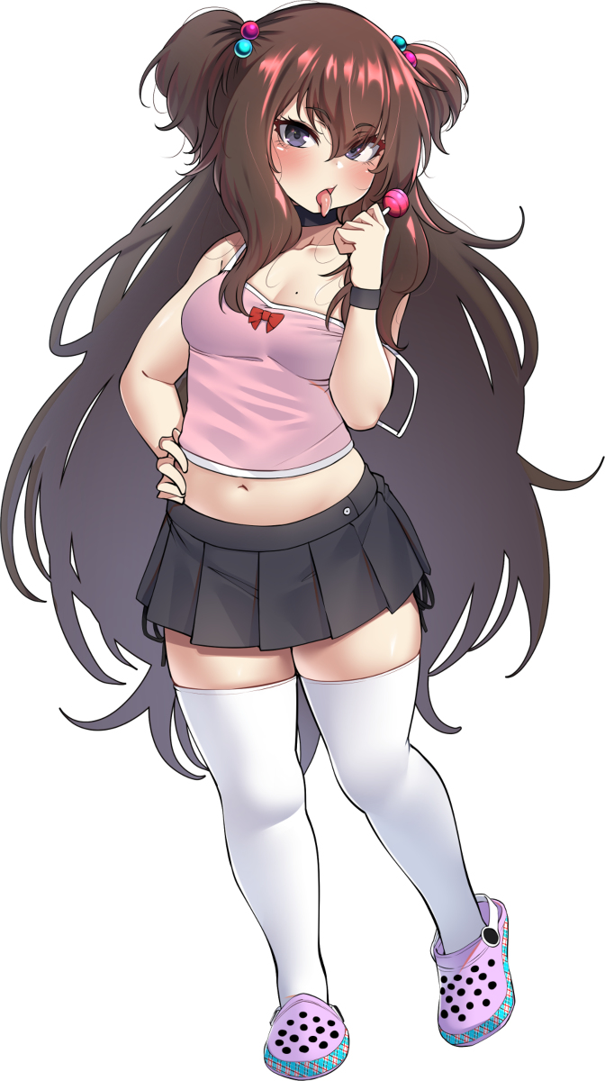
“Where’s mama? I want a snack! I wanna go show the other girls and brag about how tasty it is and show them how I’m growing! Heehee, they’ll be so jelly!” Irisviel’s gentle disposition had collapsed, giving way for a much more childish demeanor that came across as spoiled and haughty. She’d become the kind of insufferable child that thought she was popular even though she had trouble making friends, that flirted with kids her age and even adults not knowing what she was doing was flirting in the first place.

She was just mimicking how her mother acted. This mother wasn’t a great role model for a twelve year old.

With her transformation complete, the girl, Rini, had no complaints to spew as she fished a variety of ill-fitting clothes from a closet that certainly didn’t contain anything Illya should have been wearing, ultimately putting them on with only panties and no bra. The result? A pink tank top with white spaghetti straps that didn’t even cover her pudgy bellybutton left much of her young chest exposed, while a dangerously short skirt saw her bulging thighs exposed as well. The final touch came with the blue and pink hair ties, pulling her mane up into a very bratty style.

There weren’t many parents that would let their child dress this way, but Rini wasn’t a conventional child. Her mother was kind but sexual, and that had rubbed off on her bratty daughter in the way she dressed and conducted herself. She had confused sexiness with cuteness, unfortunately. Fortunately, she wasn’t old enough to have developed a demeanor that was anything more than teasing, though.

“Hmph! When will mama let me buy new clothes? I like how these show off, but they still look too childish!” She pouted into her mirror as she applied lip gloss that tasted like bubble-gum, pushing out her chest by arching her back in a way that showed things off more. She just liked getting people to react at how ‘promiscuous’ she was, she didn’t really understand what the big deal was. She was also spoiled and selfish, a huge brat all around.

“When’s mom even gonna wake up? She’s been sleeping foreveeeer!”

Elsewhere in Chaldea, Chloe von Einzbern was admiring her handiwork through a camera screen. This had started as a prank idea, but with Tamamo-n0-Mae’s assistance it had turned into something special. Maybe she’d change them back someday, but for now? Having a mother and sister that were more like her in nature? She could definitely make the best of this!
“W-Wait! Why is my body changing too!?”

She wasn’t even sure if it was reversible!

