ZERO ESCAPE FROM TF
COMMISSION STORY
BY CHALDEACHANGE
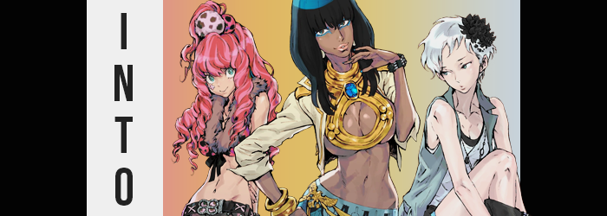

“Huh. How in the world did I end up here?”

Of all of the ways Joseph had expected his day to go, he couldn’t have imagined it would go this way. Especially when it had opened with such a normal, humble conversation with his friends. He’d been very excited to have a day off and had gotten up to chat with Kay and Axel on Discord. The topic of older games they had enjoyed eventually came up, and what name was thrown out there?

Zero Escape. It was a trilogy of games told in a visual novel style, each one generally revolving around ‘game’ of sorts where the participants were killed off one by one. Some of them had special powers and others didn’t, adding a layer of intrigue to tales that spanned both space and time – but especially the latter. In particular the second game, Virtue’s Last Reward had come up for its memorable narrative and characters.

“We’d been talking about VLR and then… I was shocked?” Not in the sense that he had been surprised. It had been a much more literal. Joseph could remember an electric shock and then? A singular second of darkness before he found himself standing in a cramped room with some very unusual décor. “Is this supposed to be an Egyptian tomb? Is fate playing a cruel joke on me?”

This line of reasoning came from the conversation he’d been having with his friends, where he’d commented on how the Egyptian-themed character from Virtue’s Last Reward, Alice, was probably one of his least favorite characters. Meanwhile Kay had liked Alice’s design but didn’t have much to say when Phi came up, and Axel really seemed to like Clover.

It was easy to assume that perhaps he’d fallen asleep. Suddenly finding yourself in a dimly lit and sandy tomb with a locked door? It felt a little too much like something you would find in the game series they had been talking about in the first place. And if you eliminated the idea that he had actually been teleported, because that should have been impossible, then a dream was all that really remained. Even though it felt real enough.

“So what? Do I need to solve a puzzle to get out, or…?” Something then lit up above the door. A series of red lights that helped illuminate the vague space a little more clearly. A timer counting down from two minutes. Wait, was this timed!? But if it was just a dream then there was nothing to worry about, right? He couldn’t die! But what if it wasn’t a dream? Panic set in. “I could die?”

No, there wasn’t actually any risk of that. But the room was filling with a transparent gas that he was inhaling. It carried a substance that was about to evoke a great deal of change.

This ‘gas’? It carried microscopic menaces within it. Thousands of tiny nanomachines that could break down and alter physical matter in any way it was programmed to do. And these particular nanomachines were programmed largely to (harmlessly) alter the bodies of those they came into contact with. And Joseph was right there. As they began to invade and get to work his entire body began to tingle, and yet…

“Is there a key or something hidden in the room? In the sand?” He was understandably worried by the timer, so much so that any differences didn’t immediately stand out to him – even though there were some that absolutely should have. Such as? Well, Joseph had always sported an olive skin tone that was certainly darker than Kay or Axel’s, but as he looked around the room? The nanomachines were toying with his melanin, injecting a surplus that darkened his skin more towards a chocolate brown that spoke more to an African complexion than anything.

This was something that was appropriately harkened to by the tiny robots’ programming elsewhere. Joseph’s face both thinned and lengthened, raising his cheekbones and compressing his jaw until it was longer than it had been previously. It was clear that his racial profile was being altered in a big way, and it likewise included a longer nose and thick, puffy lips that practically seemed bee-stung compared to how they had appeared before, even completed with a new layer of pink gloss. Even his eyes had narrowed, but they likewise carried new color with them. A mix of green and brown permeated through his eyebrows, whereas a blue eyeshadow drew attention to them.

You might have astutely realized something about this description, and that while it did sound like he was now Black, it also sounded as if his face shared more in common with a woman’s than a man’s. This was true. “Hm… I should keep a level head about… this?” Joseph spoke as already dark locks of hair darkened further and slithered down the sides of his head, and he trailed off both because of the sensation of the hair tickling his neck and the deeper, sultrier, and effeminate sound of his own voice. He lifted a hand to touch some of his hair, and in doing so realized his skin tone was darker, his fingers and their nails were longer (and painted blue), and eventually came to pull hair as long as his shoulder blades forward.

“What is happening to me?” His body had changed? No, it was changing. And there was something familiar about it. Maybe not from a first person visual perspective, but deep down he had a feeling. Memories were appearing that didn’t exist before and they seemed to suggest that— “Oh no…” Was he becoming the character he wasn’t even that fond of? Without thinking he ran his slenderer fingers down the sides of his body, it not registering how his waistline had pinched in substantially nor that his body was thinner on the whole.

It was hard for him to keep his footing in the sand, but a number of shifts that altered the distribution of his body weight only amplified those issues. “Tch!” He had to throw his hands out at one point to stop himself from stumbling, noticing in time that it was partially caused because his viewpoint was dropping. The room felt bigger because he was becoming smaller. A height of almost six feet dropped down to roughly 5’5” extremely quickly. But losses were made up for with gains.

They just weren’t gains that he would have wanted as a man. A man? How could I be…? “N-No! I’m supposed to be a man!” A voice in the back of his head argued that he’d been born a woman and, truthfully? He did have new memories to back that up. He didn’t want to become a woman. He didn’t want to become her! But would it have really been all that bad if it became true? To be such an attractive and assertive woman?

Clothing that had become oversized as his height had plummeted did slip, but they were ultimately caught by a combination of growths that expanded his body outwards in a number of ways. Joseph’s hips had flared for one, catching his hips and boxers while plush fat filled the pant legs. Joseph’s ass was quick to become quite eye catching, inflating into a bulging heart shape that pushed the backs of his pants until you could see her ass cleavage.

Since everything else down there was changing, it was only natural that her sex would eventually fold in kind. Her womanhood was confirmed and the woman resisted the idea of probing into her pants with her fingers to confirm. But why would she need to confirm it? I’ve always been a woman! What an odd thing to think! And with her acceptance made? Weight then pooled upon her chest, stretching dark skin around gratuitously large and bouncy breasts with thick, long chocolate-colored nipples that all stretched out her shirt. Their weight was substantial but familiar.

And the were then exposed. Mostly. Nanomachines chewed up the clothing she was wearing and repurposed it into a new outfit. A frilly, blue skirt overtop dark tights and golden sandals. A cream colored jacket with golden bangles that was open… revealing that there new tits were covered only big a thick, golden necklace that was bound to a collar with a blue gemstone in the center. It certainly wasn’t a conventional outfit by any means.

She also didn’t really seem to care.

DING!

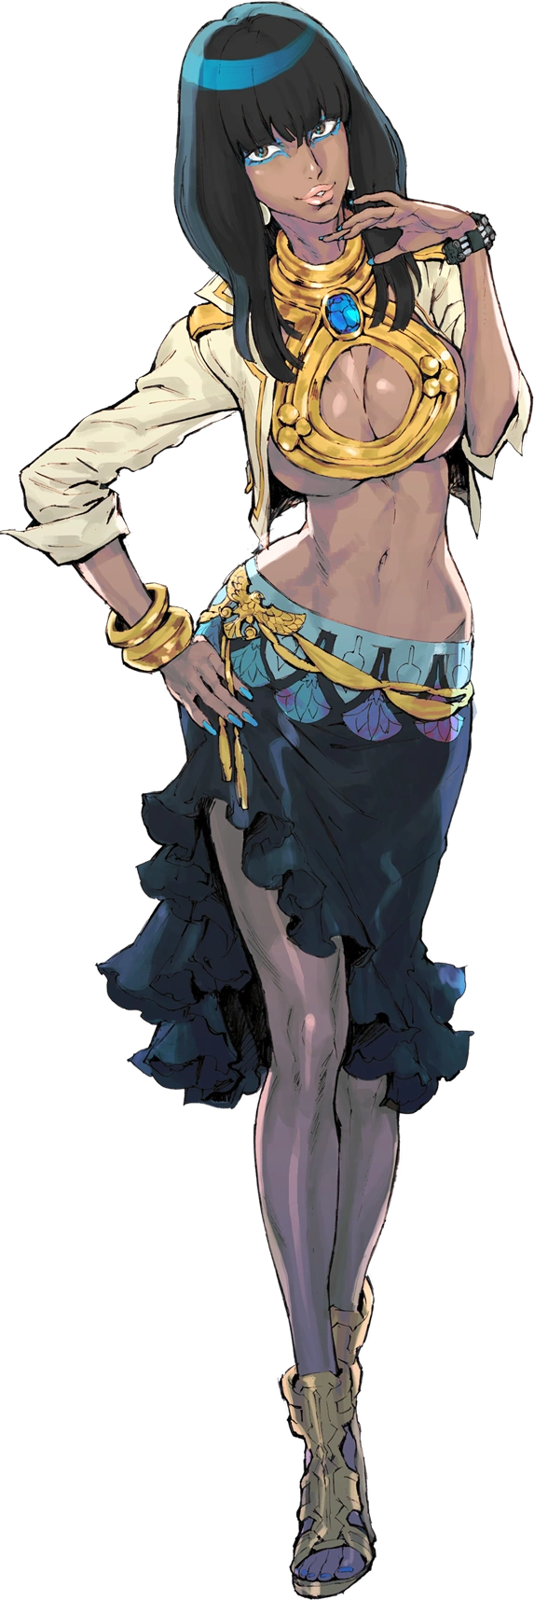
The timer finally hit 0:00 but, rather than commit to anything that might have killed the new woman that occupied the small room? The door opened, leaving her to utter an unconcerned “Oh”. She had been so concerned about the idea being trapped in a room with a timer from past experiences that she might have assumed the worst, but then why go to the trouble of trapping her in a tomb? “Was this all someone’s sick idea of a joke, then? I hope I don’t have to deal with another situation like that again.”

Alice was flippant about it all as she stepped out of the sand filled room and into a hallway that was strangely familiar. Something was nagging at the back of her mind that something was wrong, and realistically? That was obvious enough. “This building again…” Wait. Her memories weren’t as hazy as they had been. She had come here with someone to check things out and had stepped into that room on her own? Her eyes traveled to another closed door nearby.

“Oh, so it was my fault in the first place. Did it happen to her too?”

Axel could do nothing but bang on the door of the room he had suddenly found himself in. It was similar in size to the one that Joseph had appeared in, but it was modeled more like the cabin of a ship. There was even a window that showed off a view from underneath the ocean outside. Which meant he was on a ship and that ship was sinking? Not to mention the two minute timer that had appeared over the door making him think he was about to die.

“What the hell!? Did I end up in Zero Escape!?” That was what it all reminded him of as he searched under a bed for a key or something that could unlock the door. The environment definitely reminded him more of the first game, 999. Sure, the heftier man could’ve dismissed this all as a dream or a joke, but he was far too concerned by the potential consequences of that timer hitting 0:00.

Of course, since he was so panicked and was moving so much, he was quickly inhaling the invisible, nanomachine-carrying gas that was filling the room.

And it targeted his body mass first. Axel wasn’t a thin guy by any means, but the form that had been programmed into the machines to give him was the definition of trim. And so little by little his bulging tummy and jiggling man boobs faded away as skin tightened around them – this, of course, including his cheeks, arms, and thighs as well. This was all difficult to ignore (especially for an early change), and all it took was the man’s pants and boxers hitting the ground for him to look down sharply and realize.

“Whoa~! I’m so thin! …W-Woah?” There was nothing inherently odd about being surprised about this change, but the inflection the man had initially used? Why had he sounded like that? Like he was a trendy teenaged girl making a point to be a little silly about her reaction? He had to put that aside for the time being! “Maybe this really is a dream… or a hallucination… or something. There’s no way I could just shed all of that weight so fast.” He was confident about that. There was no technological nor medicinal feat that worked that way, else obesity would have been solved worldwide!

Unbelievable or not, Axel soon had to face the reality that he would have to suspend his disbelief – because his knees seemed to buckle out of nowhere, causing him to stumble forward a bit in the room. “What the hell—!?” The culprit behind his sudden stumble wasn’t actually immediately clear to him. The truth was that his hips had suddenly shoved themselves wider while his waistline had pinched in with gravitas.

But what had caught his attention was the room itself, at least when he had corrected his posture once more. “The room didn’t get bigger, did it?” Not to mention cracks in his voice that were becoming more common. But it wasn’t surprising he was fingering the room itself as the culprit rather than the true one: his body. He was already only wearing just his shirt after the sudden weight loss, and the forward stumble had knocked him off balance. It had all perfectly disguised any very obvious signs of him getting shorter, namely dropping down to 5’2” from the nearly six foot mark.

So, standing up straight again, why hadn’t it registered in the end? I’ve always been this height! Or that’s what his brain would have told him had he questioned it. The mental changes were moving just as quickly as his physical ones and the things that should have seemed odd just… didn’t. Not even the tickling of his hair against his neck and shoulders went noted, and he had been very meticulous about keeping his hair short in the past.

Mind you, this was part of a wider set of sweeping changes above a smoothed away Adam’s apple as his face shrunk and took on cues that were both cuter and more effeminate. Raised cheeks and a small chin highlighted this in terms of shape, but as eyes took on a turquoise glow and rounded in shape, as his nose became button shaped, and as lips pursed into a thicker pout? It was undeniable the face of a woman. A young woman. A women who couldn’t be any older than nineteen.

“I’m feeling kinda weird, but…” Axel couldn’t seem to place why? He was twirling a length of curled, swirling pink hair now and it didn’t even occur to him that this was unusual. This hair, fashioned into drills, reached the base of his back and was extremely fluffy on top. You could easily liken it to the hairstyles you saw on some gyaru women. There was likewise the emergence of a pink, four-leafed clover tattoo underneath his left eye. It was just a temporary tattoo though!

With shoulders narrowed and his waistline even more so, the expected femininity that his head now suggested was lying in wait finally went on attack in its totality. His shirt was practically hanging off his shoulders now, but it was so loose that it disguised how weight was pooling beneath his nipples. Bit by but these forged handfuls, which then accumulated into mounds peaked with perky, widened nipples. Ultimately this culminated in a pair of moderate but perky B-cup tits that felt right at home on her body.

Because she shuddered in tandem with her sex changing, genitalia swapped for a pussy after her dick and balls had been yanked back inside and parted. She didn’t appear to think much about this, nor of the changes that followed in the surrounding areas. Neither expanded thighs nor a perkier bum alarmed her. Because after all… Thin and perky! That’s how I’ve always been! She had no reason to question it, at least not anymore.

If anything bothered her? “Huh? What the heck am I wearing? A man’s shirt? But I’m not seeing anyone…” Axel had never even considered being with a man in the past, but now she’d been wired to be bisexual. She blinked with confusion as the nanomachines finally appropriated her outfit for her new body. A pair of really short shorts with a big belt above fur-lined, black thigh high leggings and leopard print high heels. All beneath an almost entirely exposed torso, showing off her tummy under neath a hot pink, leopard print brassiere with a low neckline that also had a furred trim.

Her curled hair was also pulled into a single high ponytail with a hair decoration composed of two, pink, leopard print orbs.

DING!

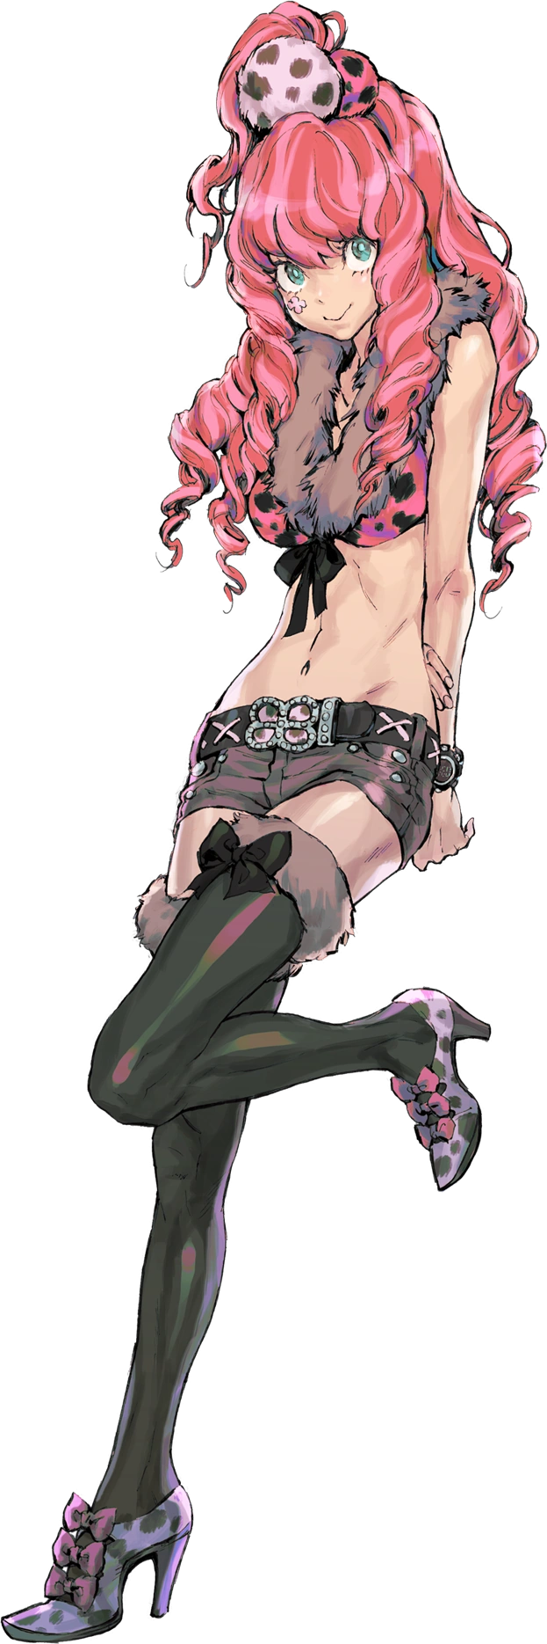
A sigh of relief left Clover Field’s lips as, instead of breaking the window behind her or something dramatic that might kill her, the door slid open when the timer finished. “I didn’t need any reminder that my past experiences have given me PTSD, thank you very much…” The nineteen year old woman clicked her tongue and shoved her thumbs in between her shorts and her hips before she slipped out. She was relieved that she hadn’t been in any real danger, but why had she…

“AH!? I went in there myself!?” She remembered almost the very second she had stepped out of the room. As someone who had survived three Nonary Games she probably should have known better. This was the SOIS building they had been using as their base, wasn’t it? And she had come there with Alice after they had been summoned. “Kind of a mean prank… I thought they were just gonna let us get on with our lives for now?”

It was then that she looked down the hall and saw Alice, likely having just emerged from her own room. “Heeeey! Alice! We’re done here, right? So let’s go get a bite!” She was quick to flag her down, putting all of the questions about the individual rooms herself.

In a matter of speaking Kay was in a similar building to the one that Joseph and Axel had. But rather than just being a matter of place it was also a matter of time. He’d been sent to the same world, just in a different year. He couldn’t have known this, of course, and instead was stuck in a similar position of panic as he found a timer above a locked door of the room he was trapped in. “That’s space outside the window, right?” In a sense. Much like the water in Axel’s room it was just a very convincing display.

He didn’t want to believe any of this, especially considering how closely the circumstances matched up with the game series he’d been talking about with his friends just moments before. Was this a dream? A trick? He couldn’t really be in outer space, right? Especially not just because of a static shock! But Kay was ignorant to his circumstances, of course.

And that included the nanomachines that he was breathing in.

“I should probably figure out how to get out of here, but that timer…” Somehow Kay felt like he could understand the nature. He could recognize that he wasn’t in any danger and he didn’t know why. The nanomachines had already burrowed into his mind and were vaguely shifting his perception, and a vague familiarity with the room was among the things he could now perceive. It was a shame that he wasn’t perceiving other things, however.

To be perfectly fair, part of one of the earliest changes wasn’t one he could really catch with his pants up. His pubes thinned and shortened into a neater cut, but stranger still was how their coloration lightened to a silvery white. The color change was at least something that could be perceived outside of his clothing, however. Because it was bleeding into all of his hair.

This certainly included the hair atop Kay’s head, which grew a little shaggier as the paling color sapped away its usual dark brown. What the style was rendered in was a messy but short bob that sported longer hair on top than it did on the sides or in the back. You could argue that it was a tomboyish cut, but… Hair like this is easy to maintain. I wouldn’t grow it long. That more or less meshed with his usual belief on the matter as well.

Like the others, he was also privy to a loss of weight – although more like Joseph, it wasn’t really too substantial. The bit of excess mass that his body held was drained away and the skin that had contained it tightened against his body as opposed to hanging loose. It was a phenomenon that had to work overtime when a sharp falling sensation prompted him to place his hand on the nearby wall to stabilize himself… only for that hand to gradually slide down the wall. “Am I shrinking!?”

Kay didn’t really need to ask that. He could see it with his own two eyes and feel it with his own body. Not only did his clothing feel progressively larger against his person, losing pants and underwear in the process, but his hand was sliding down the wall because of it. He looked at this hand with added curiosity, noting how his hands themselves were becoming smaller along with the rest of his body. Fingers thinner and nails crept longer until they were downright delicate and feminine in their designs.

And once the sensation of a vertical pull eventually waned and he stopped at the 5’1” mark? He removed his hand to flex his fingers. “This is so weird. It’s like I’m becoming a chick.” The man winced. Was his voice cracking? And the way he was speaking didn’t sound right either, did it? The correlation between all of this and the conversation he’d been having with the others just wasn’t clicking, perhaps because the changes didn’t seem as dramatic.

Shuffling on feet that were smaller and daintier themselves led to his socks slipping off and adding to the pile of clothes that had already fallen. He was lucky that his shirt was big enough to cover his bare essentials, but a growing curiosity prompted small hands to lift the base to see his crotch. “Everything is still there.” But was it supposed to be there? Eyeing his own dick, it somehow felt out of place.

But looking at his face? You could kind of understand how he had come to that conclusion. Kay’s complexion was a touch paler than it had been before and his skin smoother. He definitely looked younger, like he was around the age of twenty or so. But like with the other two there was a pointed femininity to his face that also proved his identity was shifting. He didn’t look like Kay much at all, not with a petite jawline, smaller nose, and narrowed eyes with longer lashes. The browns of those eyes had even brightened to blue. In fact he looked much more like a certain VLR character…

One that wasn’t a man.

“Oh.” She remarked incredibly calmly at the sight of her dick shrinking and, eventually, folding in between her legs as legs wriggled a little from the stimulated sensation of a pussy taking shape beneath the white pubes. She was immediately struck with the thought of ‘Why would I think it’s weird to have a pussy?’ which was just one part of her mental changes. Her voice had already changed and she hadn’t even acknowledged it after all. Nor had she acknowledged her head filling with an abundance of advanced knowledge she hadn’t possessed prior.

All that really remained at this point was for her curvature to grow in, but in the end her figure would be closer to Clover’s than Alice’s. If anywhere, it was her thighs that received the greatest bloat. She had dropped her shirt to cover them again seemingly just in time, for they ballooned a number of inches until they passively met in between her legs – the slightest of thigh gaps present between them.

Big thighs typically meant a plump ass though, and this was true. Her butt bubbled until it was nice and perky, at least relative to her height, without becoming too much so. Maybe it was because her lower body flourished but the weight that pooled beneath her shirt didn’t seem as enticing. Breasts did grow, nipples and all, but those B-cup tits were easily forgotten comparatively. Not that I want big breasts, they’d be annoying.

If it was any consolation to Kay the slightest bit of her cleavage was exposed by the time the nanomachines repurposed her clothing. A loose, sleeveless shirt with a low neckline was worn beneath a long and equally sleeveless jacket. The shirt was worn overtop a black dress with a ruffled, black skirt with blue trim, and comfortable black slouch boots covered her feet and shins. A black flower hairpin was nestled in the left side of her hair as well.

DING!

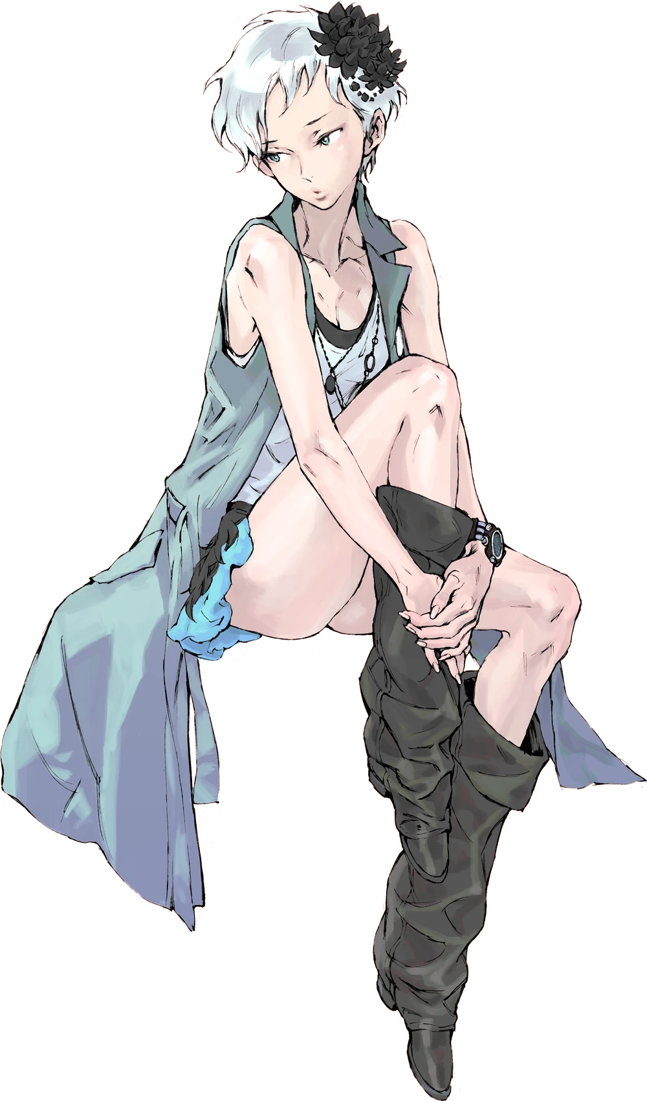
“Ugh, what a pain in the ass.” The twenty year old woman didn’t mince words as she pushed her way through an open door and into an open space that featured an offline cryo pod. A pod she could remember stepping out of earlier that day. Having freshly returned from the future, Phi wasn’t exactly thinking about how she had just transformed – and couldn’t really remember that anyways. “Why did I step into the simulation chamber? My mind must still be groggy…”

It made sense. Having your ego flung forward and back in time as an esper was a taxing ordeal. She must have just been a little disoriented from the experience and forgotten where she was. But now that she could recall things more clearly? “My mission…” Right. She could remember exactly what it was she had to do now. She had a mission that was more important than anything else. One she’d have to stake her life on again. Phi didn’t have the liberty of living in peace now like Alice and Clover did.

“I need to prevent the Radical-6 apocalypse.”

