**Nanami and the Mask of Izanami – Chapter 8 – Akira the Kitsune Goddess**

**“Yeah, you’re right Nanami but I’m just amazed how sexy you now look.”** said Akira.

**“Oh, trust me Sister. I’m also amazed how I look, but now I’m curious how you will look as a Kitsune.”** said Nanami in her Super Form with a sexier sounding voice.

**“Ok here we go!”** said Akira as she put her new Kitsune Mask on her beautiful Face.

Suddenly the Mask latches onto her Face and instantly Akira started to moan in pleasure as she starts to feel very good. A few seconds later she starts to change first her already long Model Legs gets even longer and even sexier with a perfect amount of sexy muscle. Shortly after that her hips expanded a little bit and then her firm Ass started to grow a bit and firms up even more. Then Akira’s waist shrunk a few centimeters and her already flat and sexy abs firmed up into a solid and very sexy six-pack. Finally, her D-Cup breasts started to firm up and grow into a set of full and perfect E-Cup Breasts. Then a few seconds later her hair color changes from golden blonde into an amazing Orange Red. Suddenly Akira started to moan even louder in pleasure as right above her Ass nine Fox Tails are growing out of nowhere. Shortly followed by a pair of Fox ears.

Suddenly Akira begins to screaming lustfully the pleasure was too much for her and she exploded into a massive Orgasm but suddenly she was engulfed by a Mini Twister and started to spin around Nanami’s Room and as the Twister stopped there stand a completely new Kitsune Form of Akira in the Room.

Akira has now Orange Red long hair like Nami from One Piece with a hairstyle that looks like a mix of the hairstyle of Akeno Himejima from Highschool DxD and Erza Scarlet from Fairy Tail but without the black haircolor from Akeno. Her legs are now longer and sexier and perfectly toned making her 1,94m tall. Her ass is now even firmer and perfectly trained. Akira’s waist is now slimmer too and she has an amazingly sexy six-pack. Her D-Cup Breasts where huge before but now there a perfectly firm E-Cup. Her Face is now in a similar light red as when she wears the Izanami Mask but mixed with a bit of green of the Loki mask. Akira has now one blue eye and one green eye.

But that was not all Akira now has nine Fox Tails which are also Orange Red in color but with light blue Tips also the tips of her Fox Ears are also light blue. Akira now wears a very Sexy Green Chinese style evening dress which reveals her very long Legs through a slit on the sides and the cleavage of her now massive E-Cup Breasts is also visible.

Akira then Strikes a Sexy Model Pose and said: **“Looks like a new Sexy Kitsune Goddess is here and want to have much fun!”**

**“Oh my! Akira you’re looking Amazing!”** said Super Nanami.

**“Thanks, my sweet Sister! Now put your Loki Mask on and then we visit Kasumiko for some Fun!”** said Kitsune Akira

**“Yeah, but maybe, I should put off the Ring first.”** and with that Nanami removes the Ring from her finger and returns back to her cute self. Then she grabs her Loki Mask and puts it on her face and instantly Nanami starts to transform back into her super sexy Kitsune Form. First her Legs grow longer and her hips gets a little bit wider. Then her Ass grows a bit bigger, amazingly firm and round. Nanami’s waist slims down a bit and her Abs firm up and form a perfectly well-trained sexy six-pack. A few moments later her C-Cup breasts started to firm up and growing into perfect Double D-cup breasts. Suddenly Nanami feels a pressure above her perfect Ass and then Six Fox tails started to grow out of her back shortly followed by two Fox ears on her head. Finally, Nanami’s hair changed its Color from brown into a very beautiful silver/white haircolor. Then Nanami moans in pleasure as she was close to an amazing Orgasm but suddenly, she was engulfed by a Mini twister and started to spin around the Room and in the Twister, she explodes into a massive and very powerful orgasm and screams: **“Yes! Yes! Yeeeeeeeeeeeeeeeees! M-more More! This feels s-soooooooooo g-good!”**

Then the Twister comes to a Stop and Nanami stands there in her sexy Blue Dress striking a Sexy Pose. And then she said: “Oh yes big Sis! Now let us Visit Isserlyn and Kasumiko and have some Fun with them!”

**“Ok let’s go! I bet they will be surprised to see a new Sexy Kitsune. ^^”** said Akira.

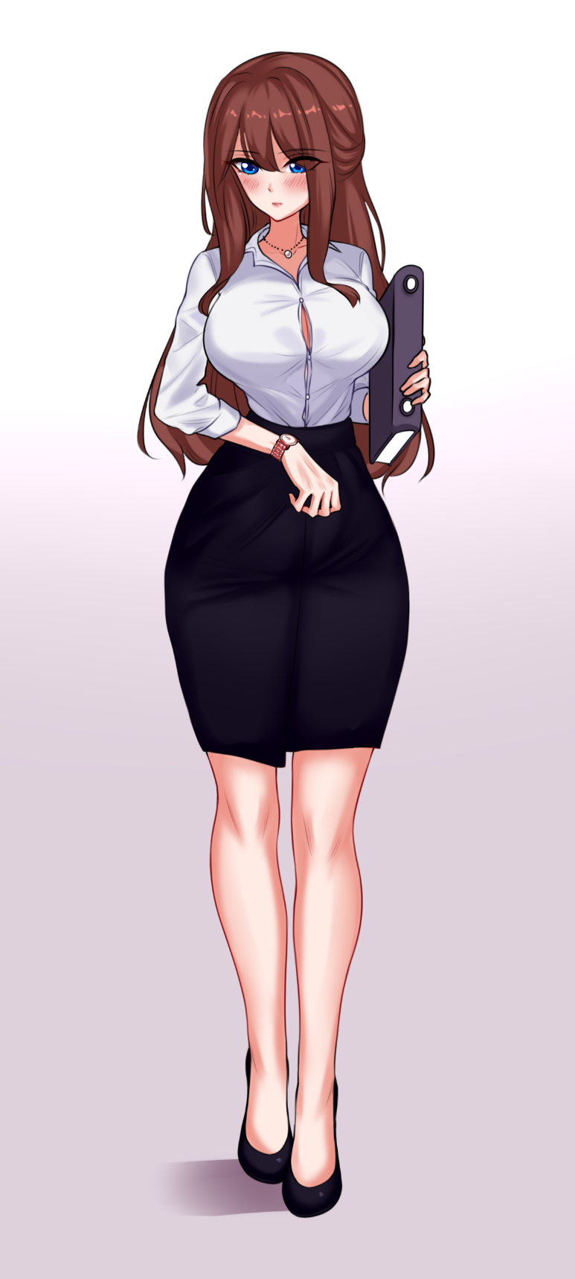And with that the two girls rushed away in a mini-Twister but it looks like Nanami has forgot her Izanami Mask in her Room.

**“Oh, look like Nanami has forgot me but that is no issue because I have Idea how to join them as well. ^^”** said Inari.

Then a few seconds later Akira’s and Nanami’s Mom Miku comes back home and said **“Hey Girls, I’m back!”**

**“Huh no answer maybe they are playing a Game or Watching some Anime.”** said Miku.

Then Miku goes Up to Nanami’s Room and opens the Door and she sees the two are not here.

**“Oh, looks like the two went out for some shopping together or they visit some friends. But I wish I would know because I want to see them so bad.”** said Miku

**“Oh, perfect timing!”** said Inari

**“Huh? From where comes this Voice?”** asked Miku curiously.

**“Hey there it’s me! The Mask on the Table.”** Said Inari and she lets the mask glow a bit.

Miku then sees the Mask on the Table and picks up the Izanami Mask.

**“A Mask? Oh yes the Mask that Nanami has bought b-but why can you Talk?”** asked Miku.

**“Because why not? I’m a Magic Mask after all also I know where Nanami and Akira went.”** said Inari.

**“Oh, you know it? Can you tell me because I would love to join them?”** asked Miku.

**“I can, but you have to make a small deal with me. I bring you to them but in exchange you put me on and let me have some Fun with your Sexy Body.”** said Inari.

**“This sounds like a strange deal but yeah why not let’s try it. I really want to see Akira and Nanami.”** said Miku

“Okay, all you need to do is put me on your face and then we can start.” said Inari

Then Miku brings the Izanami Mask close to her face and suddenly the Mask jumped out of her Hands and lands right into her Face. At first Miku was in shock but she quickly started to enjoy the feeling that the mask was giving her.

**“Oh, you have an amazingly hot Body my Miku-chan! I will make sure you won’t forget the feeling.”** said Inari

In the meanwhile, Miku started to moan lightly as her Body begins to change. First Miku’s long legs grow a bit and also leg muscles toned up a bit giving her amazingly sexy long Legs. Shortly after her legs her hips gets a bit wider and then her already nice Ass grows a bit bigger and firmed up into a very sexy well-trained Ass which many Girls would die for to have such an Ass. A few moments later her waist shrinks a bit and then her flat belly gets a very well-trained sexy six-pack. In the meanwhile, Miku started to moan heavily in pure pleasure and said: **“O-Oh M-My! This f-feels amazing!”**

**“Trust me that was not all my sexy Miku.”** said Inari

Then suddenly Miku’s already big E-Cup breasts started to grow and firm up even more until they were a massive G-Cup. But then the real changes begun and Miku gets two Fox Ears and then a few seconds later she gets twelve Fox tails. Lastly, she gets two long horns of an Oni Girl and her haircolor changes from brown into a deep Red the same goes also for twelve Tails but the Tips of her Tails are white in color. Miku’s outfit changed into a very Sexy pink Kimono which shows off the cleavage of her massive G-Cup Breasts and her long and sexy legs perfectly.

As the Transformation was close to the finish Miku can’t hold herself any longer back and she started to scream in pure pleasure as a massive Orgasm hits her. The Orgasm was so powerful that Miku had the feeling that she experiences the Orgasm of ten Girls at the Same time. Then suddenly Miku started to spin in a mini twister around the Room and when the Twister stopped a completely different but amazingly Sexy Miku stands in the room in a very Sexy Pose. And then she said: **“Oh My! I’ve never felt so good before. Now its time for some Fun with my two lovely Girls! Speaking of them I now know where they are. I bet they will be amazed how sexy her mother now looks.”**

And with that Miku rushed out of the room towards her two Girls.

**To be Continued in Chapter 9…**

Thanks to all Supporters and sorry to all because e the Story comes very Late but work has stressed me out a bit so I hope you are not mad at me.