NO MORE III
FEBRUARY 2021 REQUEST STORY
BY CHALDEACHANGE
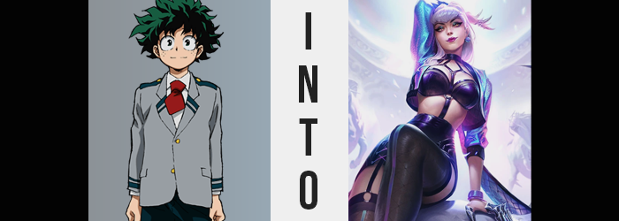

The fact that not one, but two U.A. students had now gone mysteriously missing at the tail end of its School Festival was something that weighed more and more on the community with each passing day. For the faculty of the school itself, it was an issue that wasn’t only personal but public as well. They were working to rebuild their reputation after multiple villain attacks, and after Bakugou Katsuki had been taken the first time it looked terrible that he’d gone missing once more.

But for the students themselves? There was a feeling of failure and dread. Because of the incident where Bakugou had been taken before, they were personally pained to hear that it had happened again, even more so now that Kirishima had gone missing as well. After they’d taken matters into their own hands last time, they were also under strict orders not to investigate and had been barred from leaving school property for the time being.

As he ran down the street that night, Izuku Midoriya knew he was going against the wishes of his teachers. He knew he likely should have told his peers as well, but in the end had only opted to tell Iida just in case anything went sour. But Deku? He had a clue. Kirishima had sent him a text about a potential lead the day he’d gone missing, something about a convenience store not too far from campus.

Of course, he’d passed it on to the teachers and they’d supposedly investigated to no avail, but… Maybe there was something they had missed! There had to be, right!? “I’m coming, Kacchan!”

“Kacchan? Hmm. That name sounds familiar somehow, but I’ve never seen you before, kid.” Deku had been about to continue on his way when a voice had suddenly caught his attention from a passing alleyway. It was dark, and he couldn’t make out anyone inside because of it. He was left squinting, but in that moment, he’d let his guard down, until…

THUD!

The next the boy had any awareness, he found himself within what looked to be an abandoned warehouse. Standing upright, he was both naked and incapable of making any movement other than his eyes. Not even his mouth would work!? “Oh, you’re awake!” But he wasn’t alone. A voice had stirred from in front of his feet, in front of… What was this? It was like some kind of box-like barrier. Was it a Quirk? Was that what was binding him?

It was a girl, a little younger than himself. She was done up in a bunch of glitter and bling (a notable difference from the condition she’d been in when Bakugou and Kirishima had bumped into her) and sported a mischievous smile. “I didn’t expect Kai’sa and Ahri would recognize you, but I guess this is fate, Izuku-kun!” She knew who he was? Was she a villain? Was he in danger? Considering his known circumstances, that was probably the case.

“Buuuut!”, she went on, “I want to see your reaction if you don’t know what’s going on! Enjoy the show! I’ll talk to you soon, Akali!” Spewing another name he didn’t recognize, but this time pointed at himself, the girl hopped up onto her feet and disappeared deeper into the warehouse. He couldn’t call after her or anything, all he could do was watch with concern as the color of the translucent barrier changed from blue to pink.

Deku knew that he had to struggle, but regardless of what signals his brain sent to his body, there wasn’t any meaningful response. Rather, even his ability to think felt to be a jumbled mess. He wasn’t exactly confused, but on a sensory level there was just far too much tugging his brain here and there, and while most of the feelings came from below, he was powerless to crane his neck down to see.

But that didn’t change the reality of the situation. Areas of his body had begun to remould themselves as if they were a fleshy putty. Fingers, hanging loose at his sides, regressed in size while the nails themselves grew longer – but those nails also earned an external paint job as well. A sparkling, glittering blueish purple that shimmered even under the slightest bit of light.

Similarly, his bare feet conformed to this repurposing as well. Toenails naturally gained the same polish after extending just slightly, but on the whole it was like witnessing increasingly smaller shoe sizes being placed on top of each other… although it was simply Deku’s feet collapsing in size, while heels became soft and smooth.

It was strange, because while his hands and feet had become smaller, his limbs had not followed suit – at least in regard to their length. On the other hand, their thickness was certainly something to consider as far as his muscles were concerned. Izuku had spent a long, tireless time training his body to make sure he was up to the hero work he had so desperately wanted to commit himself to. But at least, at a surface glance, it appeared all of the hard work was being undone.

From his arms to his legs, to his abs; his skin was left to flatten as earned strength diminished visually. At no point was it fully erased, but there definitely seemed to be less there. Had the boy the means to recognize that it had even happened though, he actually wouldn’t have felt all that much weaker. It was like there was a latent strength resting in his bones regardless.

But then came the most uncomfortable change yet, one forcing the boy’s facial features to writhe even though he couldn’t do much else. Although, it was worth noting that there was already an androgynous aesthetic that had been applied to his facial features and head in general. His face was just softer, accompanied by wider eyes and softer cheeks. Lips were ever so slightly more abundant, and his hair? It had fallen to his shoulders, still trapped within the mess of a natural perm.

Though it was really of little concern considering what had just happened, for there was no denying that his junk had, well, just been taken to the trash. If she could have squirmed, she absolutely would have as her dick gave way for the counterpart of the opposite sex, but with that came a new abundance of flesh as well. Both her butt and thighs plumped up, hiding her muscles beneath a guise as hips increased just slightly in width to accommodate these new assets.

Of course, you can see where this is going. Abundance danced upon her torso as well, seeing a spark of flesh beneath engorged nipples sprawl into a pair of B-cup breasts. The sensation was delightful in terms of feeling, but of course Deku herself couldn’t really process what had just happened to her body without seeing – she now looked as one might imagine Deku to look as if he’d been born a girl.

Even internally, it was like something had switched. She didn’t realize she now regarded herself as female, or that such a thing had even changed. Rather, instead of allowing her to dwell too much on the panic of what was happening, a catchy beat had spurned forth in the back of her mind. It was distracting, intoxicating. It was, undoubtedly, K-pop.

As her fixation grew more focused on the song in her head itself, additional change began to reflect itself upon her body in a much more drastic manner than it had previously, at least speed wise. It was immediately made clear why a distraction was needed, for the bones in her body that defined her height all stretched upwards. Only natural that her point of view would change, she’d sprung up a full three of four inches by the time it was completed.

Despite the stretching, Izuku’s body didn’t look uneven as a result, however. The muscle that remained spread out, and maybe even became just a little more ample as a result. One could make out definition in her limbs and tummy, at least. But other adjustments had been made to the girl’s figure, least of all being an added extension to her hips, bringing them out a few inches wider once more.

But these inches were necessary. For volume was applied to her ass and thighs without discrimination on this occasion. The arch from her back to her rear became rather well defined thanks to cheeks become full and practically doubling in size, while retaining a tightness that came with a trained body. And despite the increased gap between her legs thanks to her hips? Thighs swelled in such a way that there was little space for a thigh gap in between.

Breasts swelled in kind as well, but their growth wasn’t anywhere near as excessive. Clearly, Deku had become a woman that was more ass than tits, because even though they did grow, it was only a single cup size up towards C. When they lacked in size, however, they absolutely did make up for in perkiness, and while they bore a natural bounce, they would never seem too jiggly.

The final wave of intended change crept above her neck, and that tangled perm of hers was miraculously straightened out within a matter of moments. Likewise, a shimmering paleness claimed the natural green of her hair, a mix of silver with purplish undertones bearing fruit in a way that would sparkle beneath the light above while the length fell halfway down her back. Though, paired with her nails (which now rested against fingers that were slightly longer), it was evident that ‘sparkly’ was an aesthetic choice that had been made consciously.

Nothing sold this point harder than the makeup that was applied to her facial features as if by invisible hands – but even then, the design of Deku’s face was now leaner by design. Lips had grown plumper still, and the dark colored gloss that spread across them made sure that they earned focus against her porcelain, now freckle-free, complexion. Black eye lines were etched around her eyes, which somehow seemed just a little smaller, a pinkish glow reflected from her irises, and dark, sparkling eyeshadow found its way upon her lids.

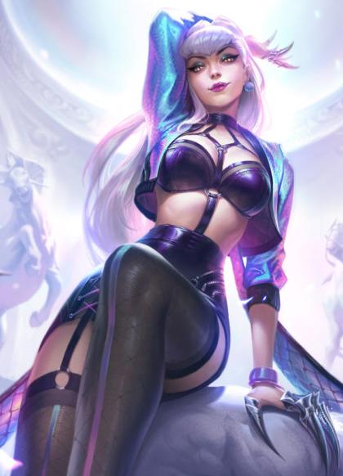
Transformed in flesh and blood now, all that was left to convert was her mind. But that wasn’t all that difficult and had been slowly progressing as her body had changed. A spark of confidence, born of talent and awareness of how attractive she was, had taken root alongside the addictive K-pop tune. As lyrics for the song came to mind, so did memories of studying and helping write them alongside the other girls in her group.

Hero work? What was that? Sounded like a bore.

With everything else settled, all that remained was her lack of clothes. What took shape to cover her up, though? Could it really be called clothing? There was a black, leather skirt with a pencil-like design at least, but garter straps reached down below and onto black thigh highs. An additional strap reached upwards and attached itself to what was essentially just a dark colored, leather bra and a strap extension continued upwards, holding her body like a harness with a choker around her neck.

A pair of ties appeared in her hair to bind the style into a pair of tiny buns, but otherwise? A short but shiny, purple jacket – open by design to show off her skin – was draped over her shoulders and a pair of blue earrings found their way onto the sides of her head, all while purple bangles found their way onto her wrists, and claw-like accessories ultimately decorated each finger. Her point of view suddenly rose once more as a pair of black heeled shoes appeared beneath, and with a steady CLACK she realized… she could move again.

The barrier, too, disappeared. “Finally, I thought I’d be trapped there forever.” Honestly, though? She couldn’t remember how she’d ended up within that thing to begin with. Evelynn wasn’t afforded much of a chance to dwell on it, for some familiar faces were approaching from the depths of this sketchy venue.

“How do you feel, Evelynn!?” The girl had returned, and this time with two much more glamorous and taller women at her side. The K-Pop star’s mind was something of a mess, the pieces still being picked up one by one, but she recognized these two. Ahri, the one with the fox tails, and Kai’sa, the one without. They were her groupmates? Her friends? Somehow by seeing them, her concern about everything seemed to melt away. If they were here, in this shoddy warehouse, then maybe the situation wasn’t as dire as she’d thought it was.

The woman blinked, and after a moment of reflection licked her painted lips to moisten them before speaking. “I thought I was in danger, but I guess not. But who are you?” Her words were pointed at the girl, but Kai’sa immediately stepped between the two of them, much to Evelynn’s agitation.

“She’s a friend, Evelynn. We wouldn’t be here without her. She’s a… manager of sorts.” The girl beamed at Kai’sa’s reassurance, but Akali arched an eyebrow.

Maybe things were more dire than she’d thought?

