I’M ON A BOAT
COMMISSION STORY
BY CHALDEACHANGE
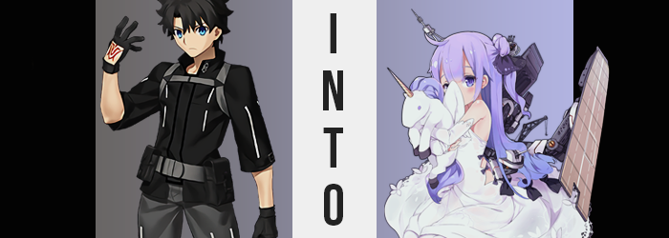

“Christmas in July? Sounds like a weird concept.” Chaldea’s singular Master, Ritsuka, mused in response to a bit of news he had received from da Vinci-chan while they rested aboard the Wandering Sea. He’d asked the shopkeeper and assistant how the spirits of the other Servants had been, what with their continuing battle against the Crypters and all, but he hadn’t expected to hear about Christmas consider the year was only half over.

Apparently, the child Servants had heard of a trend that some people in the West indulged in. A second Christmas that was held during the summertime. The point was the bring the good cheer and togetherness of the holiday season into a time that was surprisingly lacking in such celebrations. But along with the explanation, da Vinci had also presented him with an invitation that had been handwritten by Nursery Rhyme.

The summer sun beat down on the young man’s face as he stared up at it the next day. Nursery Rhyme’s invitation had been one asking him to go to this Singularity for the Christmas in July party the kids were throwing, and he certainly wasn’t so heartless is to reject a personal, handwritten invite. So, here he was – and he was regretting his choice of outfit. Why hadn’t she mentioned that it was on the beaches of Hawaii? He definitely would have come in his swim trunks if he’d known that.

“Master! There you are!” Before he could even meet up with the group that had gathered for the party, and it wasn’t only child Servants in attendance, Nursery Rhyme had cut him off at the beach’s edge with what looked to be a plush unicorn with a purple mane wedged underneath her right arm. “Oh! You didn’t dress for the occasion! That’s alright, Miss Unicorn will see to it that you’re properly changed in that hut there!” The doll girl was being a little pushy, shoving the toy into Ritsuka’s hands before gesturing to a changing hut only a few feet away. “I’ll meet you at the beach when you’re changed!” She skipped off just as quickly, leaving the boy alone with the plushie.

“Uh… okay.” He held the toy between both hands and held it up to his face. “I guess it’s just you and me now, buddy.” Caster’s words had been a little cryptic, but his best assumption was that there was a change of summer clothes for him in the changing hut. So why not investigate? He was among friends here, so it wasn’t like anything in particular would harm him, right?

What the Master was unaware of, though, was that there was a Holy Grail at play in this Singularity. Chaldea’s systems hadn’t sensed it because it had already been wished upon by Nursery Rhyme of all people, and her wish?

She had desired more friends that were close to her age.

The Master locked the wooden door of the changing room behind him as he stepped in, placing the unicorn doll on the bench in the back. The space was windowless, but its small room sizing was lit well enough by an overhead light. Other than a bench, there were some hooks and open cubbies for storing your spare clothes, but much to his confusion there wasn’t anything inside them.

“Is there really nothing here for me to change into? Nursery Rhyme had said I would be able to change here…” He couldn’t imagine the child lying to him, it wasn’t in her nature. Had someone stolen them, then? But the child really hadn’t lied. ‘Miss Unicorn will see to it that you’re properly changed’. She never specified his clothes.

And the unicorn’s beady, little eyes? They were glowing.

Ritsuka took no notice of that fact however, namely because they didn’t grow all that brightly. He was too busy wondering if he was missing some clothes that were laid out, or if he should return to Nursery Rhyme to see if she had any answers for him. But, you know what they say. Ignorance is bliss. And, at least for a short time, he remained ignorant of the fact that there were some very real consequences for bringing that unicorn plushie with him.

Even as he paced around the changing space, things were changing. Not in the sense of the word he had assumed, though. Rather, his frame was thinning at a rate that would have been alarming had he immediately noticed, largely in reference to his muscles. Of course Ritsuka wasn’t as strong as any Servant, but his journeys had earned him a set of well-defined muscles for a boy of his age. …Only for them to deteriorate. Whether it was his arms, his legs, or his torso; all of the strength was erased from his body, so much so that he now felt fatigued just wandering around this limited space.

“Did I just run a marathon? Why do I feel so exhausted?” Could it have been the summer heat? That made the most sense, right? It was pretty warm in this room. Not helpful to his internal temperature was the cut of his hair, though. He usually kept his black, wavy locks so short. But beyond his notice, they had not only fallen to tickle his neck, but they’d also fallen far down his back almost as if he were wearing his hair like he had during the Shinjuku Pseudo-Singularity with his woman disguise.

It certainly made him appear more feminine, but that was the trend he was now faced with. For a brief moment, the boy had felt like he was about to sneeze only for the feeling to pass. The feeling had not been without merit, however. Over the course of that tingle, his nose had shrunken slightly – as had its surrounding features. His face ultimately appeared much more girlish, with swollen lips and softer eyes. Almost like he was becoming a feminine version of himself.

That was actually the case, at least for now.

The time for ignorance was running out, for the changes became more noticeable. A several inch drop in height certainly did it if nothing else would. “Woah!?” He’d almost fallen over from the suddenness of it all, and while his height certainly diminished, the width of his shoulders went with it. His pants would have fallen off not long after if not for one tiny problem: his hips, on the other hand, had widened. His belt got caught on these hips, which were now wider than the boy’s shoulders, which then paved way for further discomfort to come within those pants.

If only because a bloating ensured, one that saw the thickness of his thighs swell, pushing the pants to the limit as they stretched around this new weight just as it had stretched his skin. This left the thigh gap that had been forged between his legs thanks to his widened hips much narrower, but didn’t become so thick that he had to worry about the junk in his front.

The junk in Ritsuka’s trunk, on the other hand? That was more debatable. His belt remained resilient to the growth thus far, but it certainly dug into its hips with a greater intensity as his ass inflated, growing round and taut, so much so that the depths of his crack could be perceived through the pants themselves. “Wait, what’s going on hERE!? My voice!? I sound like a chick! I look like a chick!” Looking down at himself, he’d thought to cry out with surprise only to be met with a voice crack that jolted his voice’s pitch higher. Ritsuka’s cry turned quickly into a whimper as the space between his legs soon vacated itself, leaving her with a woman’s pussy. “No, I am a girl!”

Of course, her girlish shape wouldn’t be complete without breasts, and the front of her jacket promptly bulged forward as a B-cup bosom shaped itself with glee. Her breathing was restricted somewhat as a result, and while she fumbled with the straps of her jacket to help with the air flow, but she ultimately ended up fondling herself a little.

Why? Why was this happening!? She’d only come into this room on Nursery Rhyme’s instruction. Wait, was she involved? She was a Caster, so was this the work of some sort of spell she’d cast? But why would she want her to be a young woman!?

If only Ritsuka were luck enough to get off that easily.

But she wasn’t. A familiar sensation plagued the Master, for she had already felt it in some capacity prior. But in this case? It was much more intense, almost as if she were falling in place with her feet planted on the floor. “Oh no! Not again!” She was shrinking at a much more dramatic pace, her newly presented womanly figure stripped from her body just as quickly as she’d received it.

Her height ducked beneath five feet, and with it her pants finally fell from her hips for they had narrowed as well. Her new ass and thighs? They deflated, stripping her of any adult sway just as her breasts flattened to the point that their A-cups only looked large because her body had become so small. Yet, despite her curves unwinding, it was clear that Ritsuka was remaining a girl. She was simply regressing into childhood once more – or at least around the age of twelve, standing at 4’6”.

This was exemplified nowhere as prominently as her face, which grew pudgy and round while eyes became big and innocent. As a result, her resting expression almost made her seem like she was on the verge of tears, even though she wasn’t. Yet mentally and emotionally? Ritsuka wasn’t quite herself any longer.

“Ritsuka became small…? Ritsuka? I mean… Ritsuka is…? Um…?” Swimming in a sea of her own clothes, panic setting in but not expressed with the same enthusiasm it had been prior, the girl struggled with a strange verbal quirk. Not only was she talking quietly, but she could stop referring to herself in the third person? No… It felt much more comfortable to her to talk this way? “Um… But Ritsuka… Ritsuka isn’t a little girl…? Is she…?” Wasn’t she? It was hard to deny, considering her appearance at present. She really couldn’t be anything else, so why was she confused about it? Her intellect and reason had evidently also dropped down to match her physical age, which was causing some issues with her newfound shyness.

In the meantime, tertiary changes were sweeping through her notable physical traits. Her eyes? Not only did they change from blue to purple, but they both widened and grew rounder so that her Japanese heritage was erased. Instead, the little girl ended up looking quite European.

Similarly, the same purple that now shone in her eyes – that was still shining from the plushie’s eyes – found the length of her hair. It washed through it from her roots to her tips, and her locks straightened throughout aside from the tips, where they took a little twirl. Bangs hung between her eyes, while an angled ahoge propped up from the hair that was otherwise flat and smooth across atop her head. In no way did the girl now resemble Ritsuka whatsoever.

“Ritsuka is… Ritsu… ka?” Her eyes peered up at the shed of the ceiling, the girl now confused about her name. That name didn’t suit her. It sounded weird, actually. Her name was something else. Something that suited her better. Something cuter. “No… Unicorn is Unicorn.” Yes! That name sounded better! Cute and gentle, just like she was. Even though she was named after a light aircraft carrier.

No longer could she recall her stay in Chaldea, nor her duty to secure humanity’s future. That was all far too heavy of burden for a girl of her age and personality. She was content trying to protect the seas as all girls like her did.

And to reflect that? The clothes that hung from her tiny body began to glow, quickly reforming into an unbelievably cute ensemble that fit her body perfectly. From the long, sleeveless white dress that hung to her ankles, to the white stockings she wore beneath them, to the long, white gloves that reached almost her tiny elbows – it all suited the child perfectly. Even a portion of her hair was tied up in an adorable, black bow. She couldn’t even recall wearing a stinky man’s clothes just a moment ago.

In fact, she had a genuinely nice and clean fragrance! The other ship girls were always complimenting her on it!

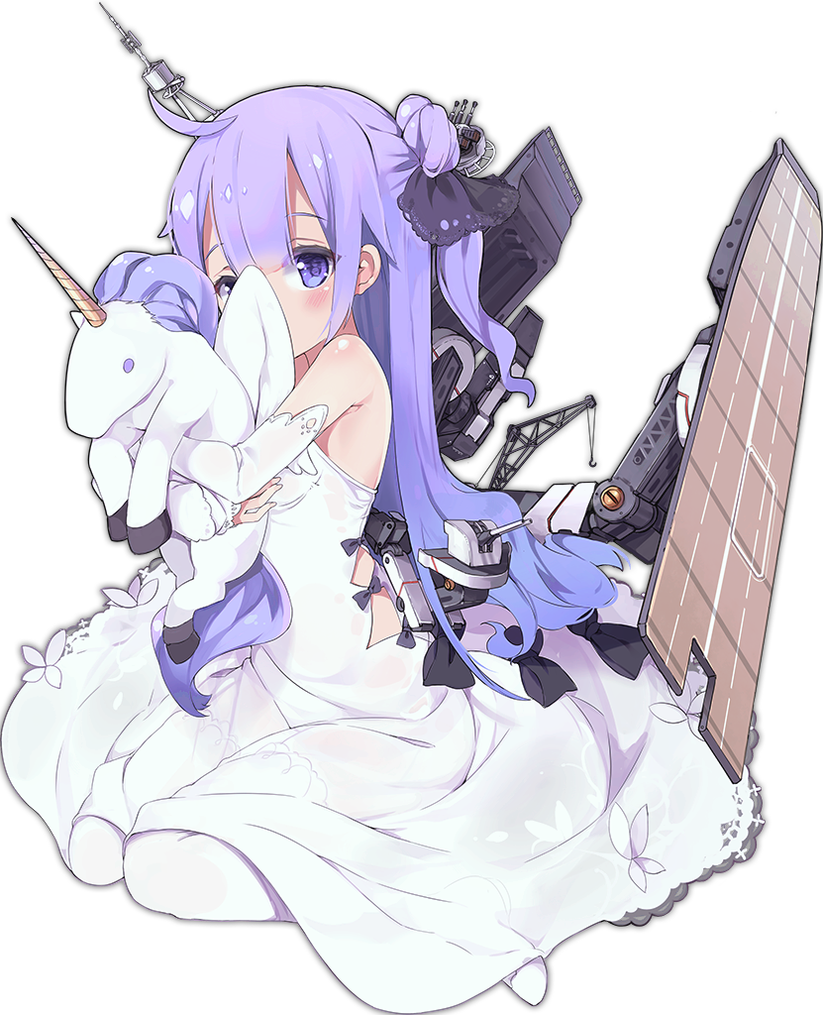
“Muu… How did Unicorn end up here alone?” The young girl, who now understand her name to be Unicorn, looked shyly around the changing room. She was so short that her head rested below even the nearby doorknob, but her short stature and implied fragility were actually misdirects. She was strong. She was durable. She was a ship girl. All of the power of a battleship housed within a child.

Purple eyes, bright and innocent as they were, quivered as she scanned the room. She didn’t like being alone. She was took meek. But those same eyes lit up the moment the saw the plush unicorn sitting on the bench. “Oh! Yuni! Unicorn is not alone after all!” Almost tripping over her white dress in the process, she skipped over to the unicorn and picked it up with her tiny fingers, holding it close to her chest. Apparently, the toy had a name! And its name was Yuni! The plushie brought Unicorn immense comfort while she was alone, and so she always carried it wherever she went.

“Is Unicorn gonna be late for the party…?” She shuffled over to the door next, fingers fumbling while she reached up to turn the lock. It was a struggle, but the child eventually succeeded in her endeavor. Only to almost eat the pavement outside since she didn’t realize the door swung outwards. “Eek!?”

Fortunately, someone was on the other side to catch her. A familiar someone dressed in a black dress, that was roughly Unicorn’s height. “Oh! Miss Unicorn! Good thing I was here to catch you! Ehehe!” It was Nursery Rhyme, tried and true. Even though Unicorn’s transformation had been her fault, the doll child herself wasn’t aware that she had done anything. She couldn’t even remember that Ritsuka had shown up, much less realized her role in everything.

But the moment they’d bumped into each other? Their memories had matched up. The two had met here, on this beach, just earlier that day! Unicorn had been on patrol when one of her engines had malfunctioned, but she’d made a new friend in this… book girl? She’d even been invited to a Christmas party! Even though it was July.

Unicorn sheepishly smiled at her new friend as she stood herself up straight once more, still clutching Yuni in her other arm. “Mhm… Unicorn feels… very fortunate for meeting you…” The child’s friends were few and far between, so she was always happy to make a new one. Nursery Rhyme beamed back and held out a hand for her to take, and Unicorn happily obliged.

It was nice having friends, wasn’t it?

