MAID OUT II.
COMMISSION STORY
BY CHALDEACHANGE
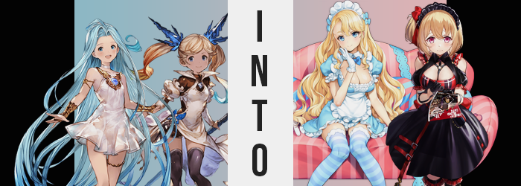

For a few months now, the Grandcypher had been flying without any captain to speak of. It was something that had weighed heavily on the minds of the crew, in part because they felt somewhat lost without their guidance, and in part because, well, it was partially their fault. Having visited a small island off in the middle of nowhere three months prior, a certain maid café had caught their attention. The crew was always open to new experiences and trying new restaurants, and with some of them not familiar with maid cafés?

Well, they had decided to try that one out!

In the end their problems had come about because the crew had been especially rowdy and had caused a series of problems for the staff and management of the establishment. So many problems that both Gran and Djeeta, the captaining duo of the airship, had been asked to stay and work off the debts of the damages done. No one had seen the two captains after they had agreed to work that debt off, but because it sounded like something the brother and sister duo would do? No one had really questioned it in the end.

“Gran and Djeeta were supposed to be working here, right? This is their last day? But I don’t see them anywhere! Did we miss their shift?” Hands on her hips, the young Io scrutinized her surroundings keenly with the intention of picking out at least one of their captains from the staff that were walking around. There was a red-headed maid with a nametag that read ‘U-1206’ (which was a weird name) and a darker haired girl whose nametag read ‘Jervis’, but were those the only two maids on duty?

The maid café actually seemed to be quite empty even though it was definitely lunch time. Considering it was such a small, out of the way island, business was only booming when ships stopped in the nearby port? “The owner definitely said they were scheduled to work when he sent us a reminder and told us to send two people to pick them up…” Lyria replied, looking around herself. It had been a little suspicious. Why ask them to send only two people to pick the siblings up?

Then again, it was probably because they had caused so many problems as a crowd in the first place, leading to the punishment in the first place!

“Oh! Are you two the representatives of the Grandcypher, by chance?” Jervis eventually noticed them and practically skipped over to the two girls the moment she had. Clearly they had been expecting the two, and she was smiling politely after giving a curt bow. “The manager would like to speak with you two! Right this way!”

And so both Lyria and Io had been escorted into the manager’s office where the conversation, well… It had taken a shocking turn. Not only had he refused to let Gran and Djeeta go, but he had decided that Lyria and Io that the captains had been responsible for a financial loss that the two girls now had to help with themselves. By working at the café whether or not they agreed.

“H-Hey! Let me out of here!” After the two girls had been delivered this news, U-1206 and Jervis had appeared behind them and had dragged them off. Neither Io nor Lyria were exactly physically strong in any capacity, and so the two maids had received little issue in moving them aside from the two girls yelling – and since there weren’t any customers, their cries had fallen on deaf ears anyways.

They had been taken into the same narrow hallway, one which was lined with what looked like open doors to various changing rooms that were likely used by the staff. They were then shoved into rooms on opposing sides of the halls so they couldn’t hear each other, and that was where Io now was. Trapped in a changing room without any doorknob or handle that could be spoken off.

All she could do was bang on the door and scream, and that didn’t seem to be making any strides in freeing herself. “That bastard…!” The child uttered a word she knew Rosetta would get mad at her for saying, but that was how ticked off she was about the entire situation. If she couldn’t get out through the door, then… “Is there another way out? A window? Anything?”

It was more spacious in the changing room than Io originally expected. But there were no windows nor closets. Not even a vent she could wiggle through. She was totally, completely trapped. In fact, aside from a makeup table that was presumably used by the maids to touch up their appearances between shifts or on breaks, the only other thing inside was a row of a few lockers. Were those used exclusively for the staff’s personal belongings? Perhaps, but she wasn’t about to pry. The staff weren’t at fault, the weird owner was.

Getting changed should be my priority right now, though.

“H-Huh!?” The thought had crossed the girl’s mind as if out of nowhere, and for some reason she couldn’t take her eyes off of one of the lockers in particular. The one in the middle of the set, almost like she knew that what she needed was inside. But she had never set foot in this room before? And she most certainly wasn’t a member of this café’s staff regardless of how badly the owner wanted to extort them!

Whether or not Io chose to accept the role that had been ‘offered’ to her initially, she would soon find that her cooperation was not something she could choose not to give. At least depending on your definition of ‘cooperation’, anyways. But she wouldn’t be allowed to leave this changing room until she was in full agreement, and based on what had happened to her captains? That agreement would be made one way or another.

The ’another’ way had, in fact, already taken root in the girl, who was utterly oblivious to the fact that it had even begun to happen. Had she the understanding to know what to look for maybe that wouldn’t have been the case, and yet speckles of a paler skin tone had begun to spread across her naturally darker skin tone. They almost looked like erratic, pale freckles initially, but they soon grew in number and size. It didn’t take long at all for them to merge together, ultimately leaving the girl with a complexion that was devoid of the ample melanin that she’d possessed since birth.

“They think they can trap me in here? No way! I’m going to get changed and show… NO!” Her fingers had even slid into the door handle of the door that had caught her attention while she had said this and she promptly whipped her hand away. For a second she wondered ‘is something different about my skin?’ but the question was dissuaded just as quickly as it had come about.

Mind you, it wasn’t even only Io’s skin that was doomed to suffer a change in color. The girl’s hair was usually so unique. Starting with a sandy blonde near her roots, as the hair stretched out into long pigtails the color bled into a green and then a blue closer to the tips. It was an iconic coloring, in fact. Which meant it had to go if Io was to leave this room entirely unrecognizable.

To those ends, the eccentric colors near the tip began to dim, exposing the same sandy blonde as the rest of her hair… for but a moment. Because no sooner than the color of her hair’s entirety was consistent did that blonde begin to radiate with a much more golden glow. A much more golden blonde permeate through all of the hair on her body and, at least when it came to the hair atop her head? It soon shortened the style so that it was a cute and simple bob with fluffy bangs instead.

Io shook her head, the change in weight not even registering. “Ugh, what is wrong with me? There’s no way I-I’d want to w-wear…?” The maid costume in the locker? She had an unusually vivid mental image of its design, actually. All black and red. But there was also this stutter for her to think about. What was going on? Was anything going on?

Speaking of the color red, though? Some of it had surfaced in the child’s visage. Her typically gray eyes had lit up with a crimson that stood out against paler skin and compliments her golden hair fairly well. But those eyes also seemed larger and, paired with some alterations to her facial structure, began to give off the impression of someone who was older? Like lips that were fuller and now bore a glossy texture, or a longer nose. But the age was best highlighted by a broader facial structure. Her face was still round, but it was missing the baby fat that otherwise made her look so young under normal circumstances.

Would I even fit in that maid costume?

Because Io could picture what the costume looked like despite never having seen it, she began to wonder if her tiny body would even suit her tiny body? After all, she could remember the cups being much larger, and the dress overall was designed for a taller individual. Though her concerns would soon be alleviated to the point where she could no longer recall having these concerns in the first place.

“H-Huh?” Her voice now consistently deeper now, Io couldn’t help shake the feeling that something felt off about the clothing she was presently wearing? It almost felt much too tight, and had her tummy always caught this draft while dressed? At least in that case, it was fairly obvious what the culprit was. The girl had grown taller, her height stretching upwards to 5’3” from beneath 5’ – which naturally encompassed her limbs and spine.

This pulled her top away from her shorts, revealing her bare tummy to the world while arms outgrew their sleeves and legs outgrew the thigh high tights that now didn’t even reach her knees. She looked ill-fit for this outfit, and she certainly felt as much. “I-I should…” So her natural response was to, well, strip. This was a private changing room, no one would see her naked in the end.

But the second she started on her shorts, the young woman found it becoming difficult to get them to move. “H-Huh!? Why is it so tight!?” Try as she might, there was a lot of resistance to be felt as she yanked. Like the shorts were getting caught on… her flesh? She internally noted the issue without finding it strange, despite the fact that she probably should have. I guess it’s my fault for putting on clothes that don’t fit…

Even though they had fit when she had put them on that morning.

Her thighs and ass had both gotten caught on those shorts, flesh bulging gratuitously and threatening to rip through the cloth with how plump and round them were. They had prompted her hips to widen to accommodate their new girth, which only made the removal of the shorts even more difficult. Until finally “WAH!?” With one legged kicked up into the air, she almost fell over as the shorts flew off along with torn panties, exposing her rotund and enticing lower half. Befitting of the twenty year old woman she had become.

And if her shorts had already caused her issues? Her top posed similar, yet not as troublesome problems. The cream front of the top could be seen struggling to contain what was occurring within – for Io’s breasts were swelling to triple their original size, nipples and all. But lifting from the bottom? She fortunately managed to lift it all up and over her head, only snagging on her nipples for a brief moment before they slipped out and bounced freely in the light of the room. Pulling arms out of ill-fitted sleeves was a little more difficult, but eventually? “Hah… That’s better.”

She was completely naked, showing off her short but curvaceous figure.

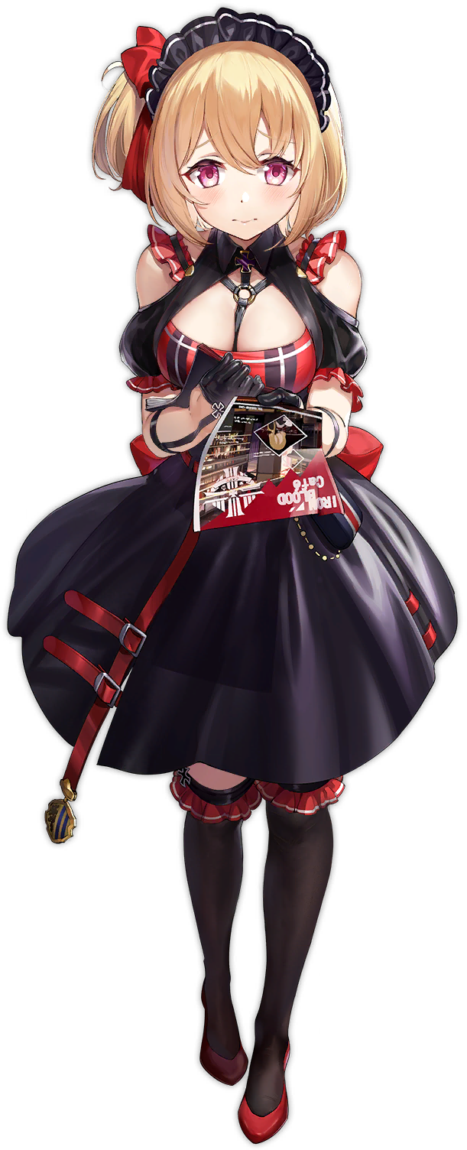
O-O-Oh… Was it nothing? I shouldn’t just stand around like this o-or I’m going to be late…” The young woman felt as if there had been something wrong. Something that had been spiking her anxiety over the course of the past few minutes. But now? She couldn’t seem to remember what it was that had been doing that. Perhaps it wasn’t all that surprising, seeing as memories of her transformation and her past life as a young girl had been purged.

Instead of Io, she was simply Leipzig, a young woman that worked at this café along with some of her childhood friends. She was grateful to the owner for employing her, actually. Because Leipzig? She was a very anxious and skittish individual, yet he had hired her anyways! So she opened the locker that was now marked with her name and pulled out her maid costume for work.

“Mm…” Shy as she was, she mumbled at her reflection in the locker mirror after putting on the black and red maid uniform. It certainly highlighted her ample cleavage and was something she had gotten used to over time. But it still always bothered her before the start of her shift. But she would wear it for the manager! Black leggings, crimson heels, and finger gloves were adorned before a headdress, and Leipzig made an encouraging gesture to herself in the mirror before taking off thanks to the new doorknob.

“E-Everyone is counting on me!”

“Why is this happening? Is this what happened to Gran and Djeeta?” Lyria’s reaction to being imprisoned in a changing room wasn’t as openly hostile as Io’s had been. Rather than worried about herself, she was worried about the two captains that had come before her. Had they been tricked or forced into working here as well? But that still didn’t solve the mystery of where they had went.

…Even though they were the two maids that had dragged them into the changing rooms in the first place.

A hand to her chest, gaze downcast, it took the Girl in Blue a moment to collect herself. Should she just do as she was told for the time being until she could figure out a plan of escape? Maybe Gran and Djeeta already had escaped and that was the debt the manager had been speaking of? She could only hope that was the case, so maybe if they played along they could find out…

I can’t wait to get changed and dance around!

…Wasn’t that a little too enthusiastic?

Had she wanted to just go along with the manager’s plans for the time being just to make sense of what was happening, there was no need to be excited about it. In fact, Lyria mentally recoiled at the moment, the energy so strange that it prompted her to even speak out. “Sacre bleu! What was I…?” What had she just said about a sacred blue just now?

Confused and ultimately disoriented because of this confusion, the fact that the girl’s body had begun to change to better suit her new role escaped her immediate attention – even though her initial changes were much more dramatic than what had happened to Io. After all, this maid café had no use for young girls with no curves to their body to speak of. And those related issues were promptly addressed.

It became clear relatively earlier that the youthful, waifish visage that was so inherit to Lyria’s core being had been compromised, for her body began to grow in every possible capacity. Height was one of these areas of course, and she soon peaked at around 5’5” before the vertical growth came to a halt. And that alone lifted her dress off her hips so that you could see the white underwear and her pelvis completely exposed. There was also a newfound maturity in her face that gave her the look of a young adult.

But it also wasn’t just a look. “Huh?” While Lyria was wondering why the room suddenly seemed so much smaller than it had before, her clothing continued to content with the fact that her body was growing… just in other ways. Ways that completely compromised her outfit, leaving her to eventually look skeptically down at herself and completely misunderstand the problem at hand thanks to the curse that had been placed on her by this room. “Why am I wearing this dress?”

The dress she always wore? Something deep down tried to combat the question with this reminder, but it fell on deaf ears as fingers grabbed the dress’ skirt and began to pull it up and over her head to remove it. But it hadn’t been as easy as that to do, not when her body was still growing. Her chest was one of these key areas where it had continued to increase in size, with a once almost featureless bosom having exploded into a pair of B-cups, and then into D-cups not long after. Fitted with nipples that were just a touch smaller than Lyria’s eyes, these new tits of hers were compacted tightly by the cloth of her white gown as they pushed forward. So it had been a bit tricky to remove the gown.

But boy had her breasts bounced, full and perky, once she had finally found victory.

“Haaah!” A sigh of relief escaped Lyria’s lips once she finally succeeded, voice airier and deeper than ever. “Huh? Even my underwear?” Only for her to notice a different issue. It wasn’t only the dress she couldn’t recall putting on that had been both unfashionable and ill-fitted. Her panties, small and white, were digging into her pelvis from every perceivable angle.

Their waistband was much too tight around her hips for starters, but only because those hips had been forced to part several inches farther than normal while her waistline retained its initial narrowness. In the back? Those panties were gradually pulled into the crack of her ass – or perhaps it was better to say the crack of her ass swallowed them? Her cheeks had swollen, butt tripling in size and consuming the cloth within its deepened crevice in the back. While in the front? It was flossed against a pussy that had aged along with the rest of her, nestled between a pair of gorgeous, rosy thighs.

SNAP!

Even just trying to dislodge these panties forced their waistband to snap cleanly, and with a defeated sigh, the young woman pulled them from their wedgie and allowed them to drop to the floor. “Perhaps it isn’t a great loss… I cannot recall why I was wearing them.” Plus there were spares in her locker, right? Her eyes jumped to look at it and she slowly inched forward, thinking nothing of her nudity.

The blues of Lyria’s eyes had brightened, but on the other hand? The blue of her hair had not fared the same. Taller as she was now, what had once hung to her ankles now only reached just past her ass. Yet it began to look shorter as a natural perm both settled into place throughout her locks, but also brought with it a bright blond color that likewise enhanced its volume. Bangs now fuller and swept to the left, she was looking more and more like a picturesque European woman. Almost like a doll.

Well, if Europe had even existed in the Skydom.

It’s absence certainly hadn’t stopped her from thinking in French as she now was.

She puckered her lips. “Non, perhaps my mind is playing tricks on me? I have no time to worry unnecessarily. I want to move!” The woman certainly felt more energetic, though the puckering of her lips had actually been part of the final wave of changes. Her face had still resembled Lyria’s, and in fact just looked like you might expect Lyria’s face to look like had she been in her early twenties. But now? Fuller, poutier lips and a slightly rounder facial shape took away those similarities. As did bushy, blonde brows, a button nose, and picturesquely large eyes. Again, almost like a doll.

A realization then struck her now that her changes were complete. “Oh wow! If I don’t get onto the floor soon, I’m going to miss my dancing window!” The downtrodden attitude that Lyria had possessed upon finding herself in the changing room had been utterly and totally overwritten by a bright and bubbly personality befitting of a young woman with such bright eyes and such a bouncy bosom. “I’ll have to give the manager a big merci for allowing me to perform on shift!”

The café had been missing a draw lately and business had been dwindling. It didn’t matter how many cute girls were brought onto the team, it just wasn’t attracting new customers. But Émile Bertin’s dances? They had been surprisingly popular. Plus she loved to dance, so there really was no problem on her part getting changed into her sky blue maid uniform with blue and white striped leggings. It showed off a generous serving of her cleavage, but the maid herself didn’t mind one bit!

In fact, after checking her reflection and readjusting some hairs? “Bonne!” White-gloved hands clapped together. She had gotten dressed in record time and was prompt in leaving. But she hadn’t expected to find Leipzig in the hall leaving at the same time! “Bienvenue, Leipzig! Are you ready for a good shift!?”

“Y-Yes!?”

…Was she?

