MASS CONSTRUCTION
FEBRUARY 2021 REQUEST STORY
BY CHALDEACHANGE
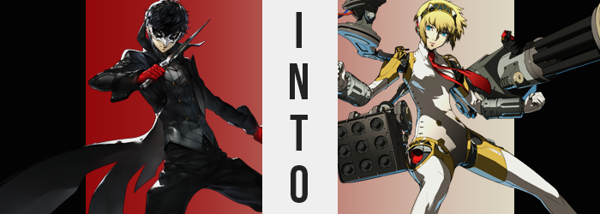

The variety of items you could buy during the Sunday shopping shows was amazing. Joker had found that he could get pretty much anything, from candies to candles to clothing to video games, all for astoundingly low prices. But as of late they had also been including some items that would become increasingly useful the deeper they dug into Mementos. Toy weapons, gadgets, health items… Well, anything could be a health item if you thought about it, really.

But, alone on the uppermost floor of Mementos (for he wouldn’t dare explore deeper by his lonesome), there was an object of interest that he wanted to make sure would work under the rules of this parallel space. It had been advertised as a ‘Gun Glove’, a special accessory that would let you fire BB pellets from your fingertips – but as with all guns, those pellets would translate into real ammunition down here.

Holding the accessory in both of his hands, Joker immediately had his doubts. It was big and bulky, with a silver canister that extended from the wrist to just below the elbow attached to a white glove with silver fingertips. He couldn’t imagine how the bullets might get from the canister to the tips? There weren’t any tubes inside that he could see to transport them.

Questions aside, the young man managed to plant the gauntlet on a nearby subway seat and slide his right arm into it, though it didn’t completely fit. “It’s cramped and heavy. I’m not so sure this is practical after all…”, he mumbled to himself as he tried to lift it off the seat. He could pull his arm up, but the glove was so heavy that it just kind of dangled there. He couldn’t bend his elbow upwards at all.

Despite his initial concerns though, at a moment’s notice the glove, well, it fit like a glove. His fingers had been too long to sit in the glove comfortably, but all of a sudden that cramped feeling all but disappeared. No… Feeling in general had disappeared, all of the way up to his elbow. “What!?” Rather, there was a little feeling. It was just very dull.

In a panic, he’d pulled his hand up without thinking, and it took Joker a moment to realize that he was now able to bend his elbow when the ‘Gun Glove’ had been too hefty to lift beforehand. He had an awfully bad feeling about this.

And that feeling? It was correct!

He’d been forced to remove his right glove and roll up his right jacket sleeve so that he could put that glove on, but a loud tearing sound drew his attention quick immediately to the left as a cold feeling not unlike that which now plagued his right took hold. It began at his fingertips and immediately traveled up his arm, but while the tearing did not change until the feeling reached his wrist, there was still something notably awry with Joker’s glover.

Or, at least, what was resting beneath it. The crimson glove he usually wore appeared to be too big as if out of nowhere, the tips of the fingers hanging just a little loose. Within though? Silver caps had formed atop the boy’s fingertips, and the skin itself had turned bleach white with a strangely soft texture – strange, because it certainly didn’t look like skin. The hand on the left was now a match for the hand on the right, and what rested beneath the surface layers of these hands? It was wholly artificial.

As the numbing sensation moved up to his wrists, the clothing tears arose as a strange, silver substance erupted from underneath the black, leather sleeve of his jacket. Spanning 360 degrees around not only his wrist, but reaching back as far as his elbow, this substance both hardened and moulded until it was quite clearly a matching barrel to the one on Joker’s right, tatters of jacket stuck on its steel. The flesh beneath it felt extremely cold, but that was only because this steel was his flesh.

“This is impossible! Does this mean…?” Waving both arms around, his eyes immediately fixated on what he’d assumed was just a very cramped glove until catching sight of what had happened to his lefty. The glove hadn’t merely tightened, but it had replaced the hand he’d had!? More alarmingly, he could feel the numbing sensation crawling through his elbow and towards his shoulders now that both sides matched.

While not enough to tear anything in this case, the tops of his sleeves did tighten in slight as something beneath them appeared to rise from his skin – skin that had otherwise taken a white, metallic sheen as steel bones and joints replaced the flesh and bone beneath them. These growths amounted to a pair of gold-colored plates that rose slightly from either upper arm. At first their purpose was questionable, but as the flesh and skin of his shoulders began to sink in, things at least became a little more comprehensible.

Skin disappearing from the curves of Joker’s shoulders, as where fat and muscle should have been dipped inward, a black, joint-like existence was exposed from within. It created the illusion that his arms were slightly disjointed from his body, and as a pair of circular protrusions erupted from the sides of each ‘joint’, so too did a golden accessory that leaped oved each one to connect on the opposing side. At the very least, this kept the peaks of his sleeves looking quite puffy.

“It’s difficult to move…!” He was, of course, speaking in reference to his arms. He’d tried moving them, but there was a stiffness that he couldn’t comprehend. They made each movement jolty, and while the boy could not see what had happened to his shoulders beneath the leather, he could at least tell that, at the very least, the rotational movements of his arms felt more fluid than ever.

There wasn’t really time to contemplate the fate of his upper limbs, though. “Whoa…!?” Because his balance was being knocked off tilt by a numbness to his step. He’d begun to sway from side to side without intent, and his artificial arms were thrown out to the sides so he could keep himself from falling. But the cause for this? It was a little more complicated than his first assumption, which was that his feet had fallen asleep.

It was much more dire, actually. Trying to make sure he didn’t fall; he’d lifted a foot to plant it back down again. While that had worked… doing so had pulled his foot completely free of both his boot and the sock inside of it, and the sound his foot made when it hit the stone floor beneath him was more of a CLANG than any footstep ever should have been.

Eyes were immediately drawn down to his foot. But the issue? “Where did my foot go!?” There was none. There were no toes to greet him, no extended foot to perceive. There was a cold, steel heel and nothing else. The shock made him stumble backwards, and in doing so his second foot revealed itself to be the exact same. What remained in the place of his feet had very aerodynamic designs, with a curved, triangular shape, and upon observation he could see that his ankles had taken the same shape so that the flow was preserved. Or, rather, he basically didn’t have ankles anymore, it was all part of the same, solid length. The only difference was that everything above where his ankles had been would turn into an artificial white not unlike what had happened to the bulk of his arms.

The numbing sensation continued up his legs but beneath his pants. Going up from his ankles, the same white plating was hardened out of his skin, but as it climbed higher and higher, the gait of his legs was forced into becoming wider and wider. He was hoisted taller, for there was just more to his leg as it stretched beyond its original mold. Once the white coated Joker’s knees, they remained smooth on the surface while joints were laid bare on their underside – all mechanical, naturally.

Things, however, grew iffy once the changes crept into his thighs. They hardened into the same white, plastic-like substance as the rest of his limbs, but they also grew more abundant in size. They pressed out against the insides of his pants, and while Joker would have liked to call it uncomfortable, the little he could feel from them didn’t amount to a whole lot. At most it made moving difficult, for with legs longer the bottoms of his pantlegs rested halfway down each limb, while the thickness of his artificial thighs bound them beneath his pants at the top.

His pants, quickly, encountered a new issue as a transformation last seen in his shoulders took form in his hips, but not before they suddenly popped and resettled at a wider width, popping the front button of his pants, and straining the waistline of his boxers to the limit. The skin of his hips hollowed out, and in the place of flesh, a pair of black joints were left exposed. Gold crowning stretched across them like guards, as they had with his shoulders, but there was also something else.

Most people generally didn’t have what look like propulsion engines embedded in their thighs, did they?

They were caught on his pants though, so the boy couldn’t really make them out. “Guh! Is this the glove’s fault!? Just how far is it going to go!?” His exasperation was plain and understandable. From what he could tell, her arms and legs had become a part of something that looked like it belonged in a science fiction movie. But he couldn’t possible be prepared for the turn things would eventually take as his torso soon chilled.

It began with the same change in skin color that had plagued the Phantom Thief elsewhere. Well, we’re calling it a change in skin color, but it was a change in skin more or less. Was it leather or plastic? It was hard to say, but the white was both sleek and durable, and every piece of his torso that was swept up with this color ended up completely robbed of its external features. His nipples seceded into his chest, his bellybutton filled in so that his tummy was completely smooth, but most dramatically… His crotch seceded to. Still barely covered by his snugly-fit pants, he wriggled in place thanks to the sensation of his dick being drawn into him.

One of his robot hands reached down to try and feel for it, but there was nothing there at all. Literally nothing. No female counterpart either, just a completely smooth crotch… that looped around to an ass free of any butt crack. The crevice between the two had filled in, and while there was still a bulge that suggested his rear had been designed with a human shape in mind, that didn’t mean he had an ass. “Where did it…!? Impossible! This is impossible!”

No amount of denial could change the truth, and particularly not as he lurched forward thanks to a sudden heft to his chest. To say he was growing breasts would just be inherently wrong, but the front of his jacket constricted around the uppermost part of his torso as a pair of curves found their way into design. It made him look feminine, but he had no reason to consider himself a girl. Very breast-like, but not breasts. Adding to the details, studs lined either side of his white body, and on either side of where Joker’s bellybutton used to be, a set of golden screws emerged.

Of course, he was not hungry, and his heart was no longer beating. This shell did not contain any human organs.

Thinking back to the glove and how this was likely its fault, in a last ditch effort to try and correct things, he reached over with his left hand to try and pull the right off… somehow. It didn’t work of course, for the glove was his right hand, and in the end all it did was allow the changes to travel up his neck. “Come… off!”

Of course, that neck was dyed white. It crept upward, but miraculously did not paint his face short of lipping over his chin and the sides of his cheeks. The bulk of his face remained fleshy by contrast, yet it wasn’t unimpeded by change either. The shape of it shifted, softening to better relay a more feminine appeal, with bigger eyes and softer lips – they shift in size forced his mask to fall from his face though, but doing so did not remove his Phantom Thief costume. A golden blonde swept through his black locks, dyeing it all within a matter of moments, as the length grew several inches, but only seemed drastically longer at the sides of his head.

“GAAAAAH!? AAAAAAAAAAAAAAH!?” With numbness applied, the transformation had been more or less painful thus far, and yet suddenly? The sound and sensation of something drilling into the sides of his head – no, his ears – caused the boy to cry out in agony. The source was what looked like a set of headphones, silver with crimson centers, with a black and gold headband spanning between the two. These, of course, weren’t headphones. They were a part of his body.

The pain eventually gave way, but Joker could feel something burying continuously into the sides of his head. What he couldn’t see was that his crimson eyes, more feminine in shape, were flickering inconsistently between their natural color and a bright, sky blue that bore an artificial glow. This flickering was slight at first, but it became more pronounced after a few moments.

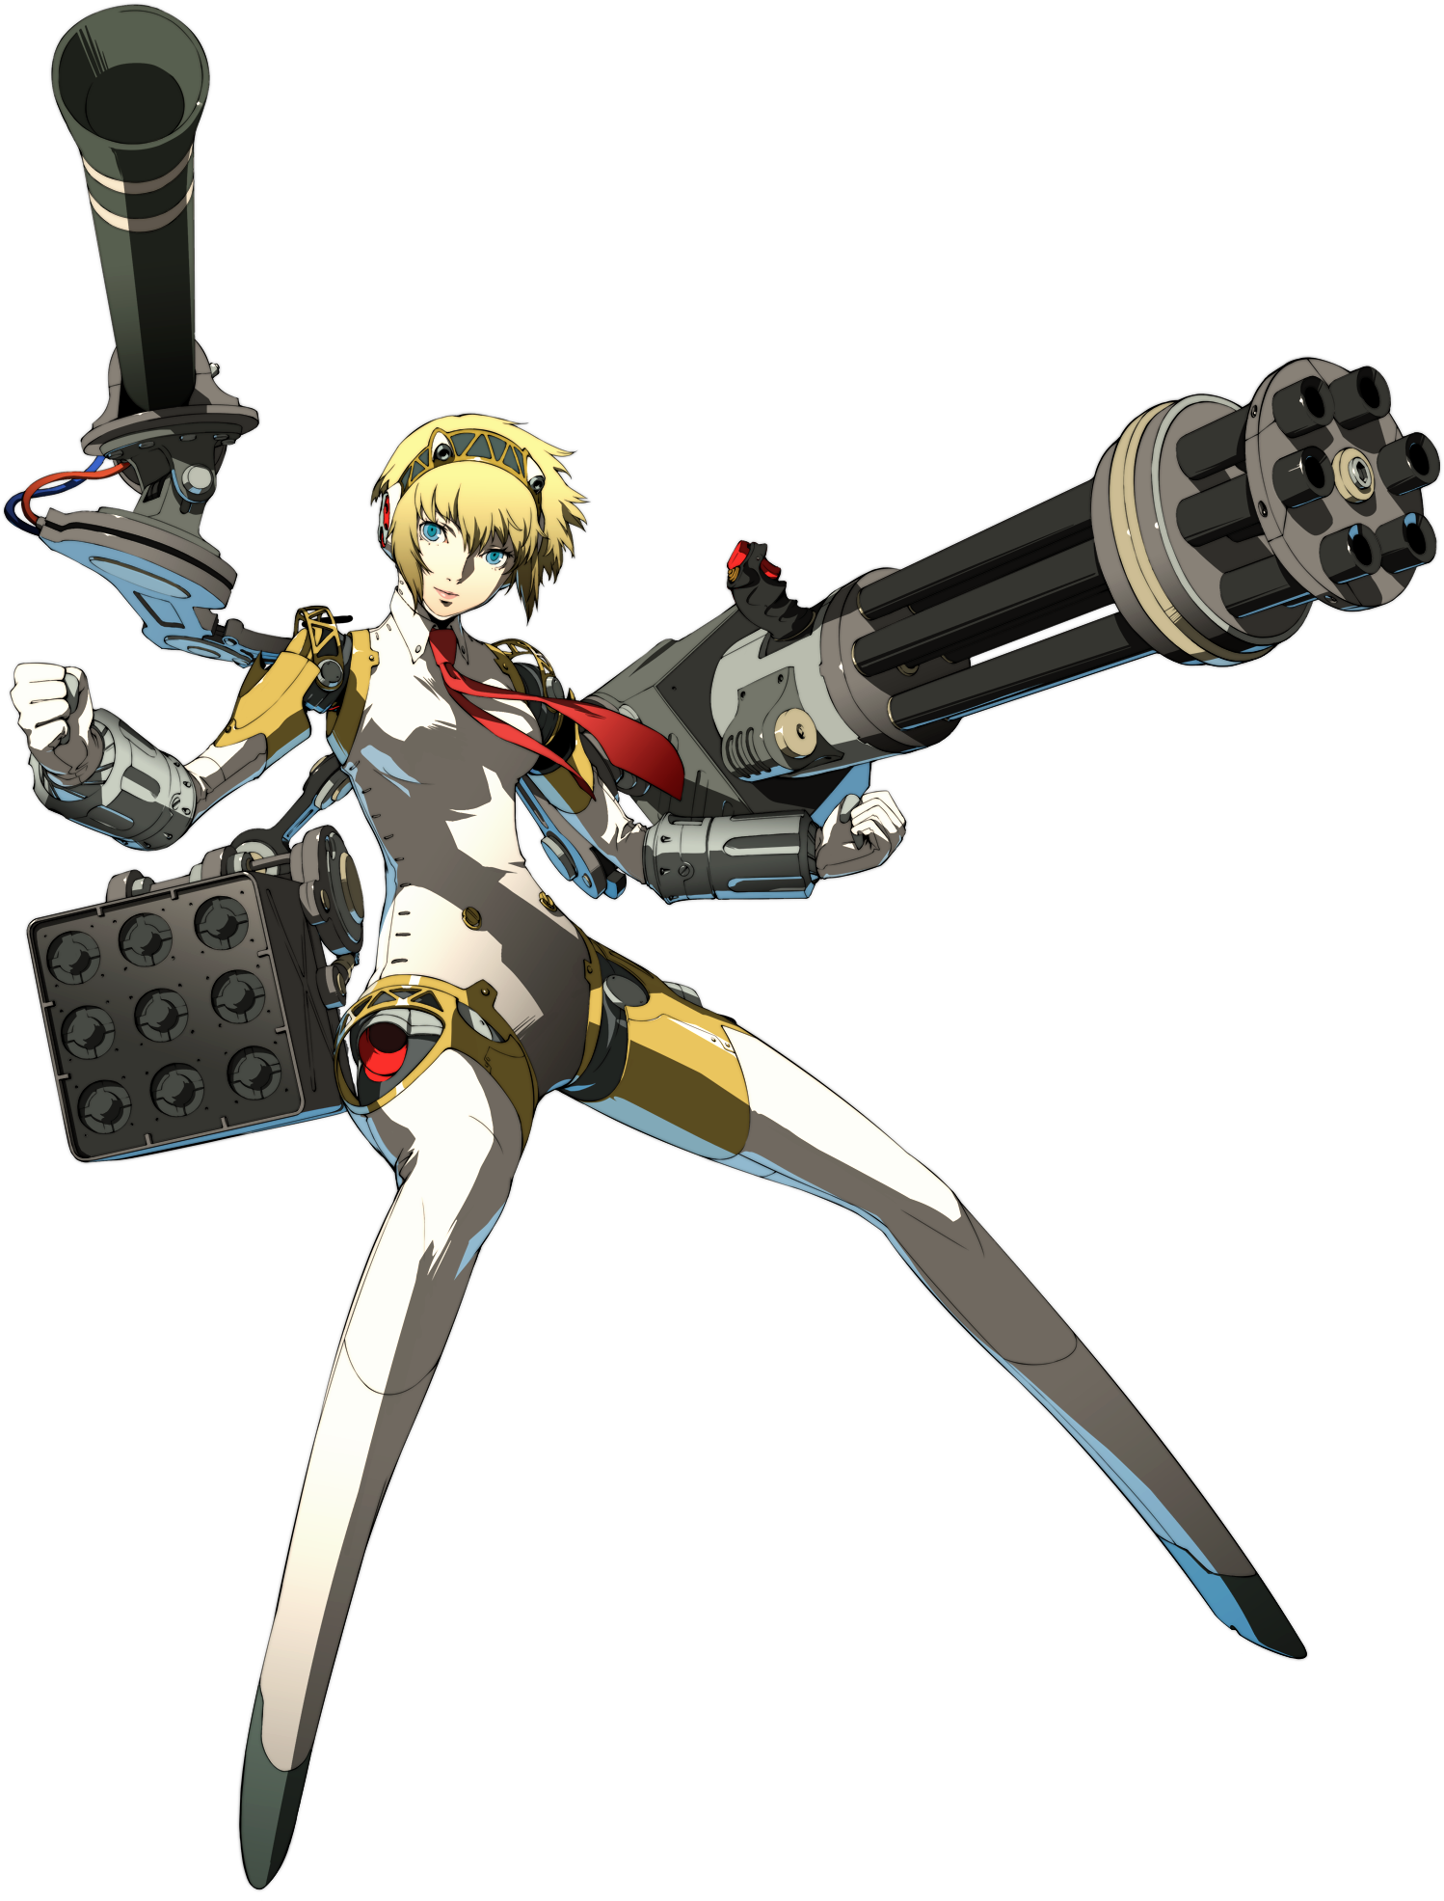
And the more consistent the blue was, the less of Joker remained. Without even realizing, she had begun to think of herself as a woman despite being machine – and even then, she wasn’t sure how she could have ever applicably considered herself a man. Her vision flickered, and as it did so it began to appear more like she was looking through a camera rather than wielding natural eyesight. Markers and statistics sprawled out, and somewhere along the way she became hyperaware of all of the Shadows within this space. Wherever this space was, because while she felt like it was familiar, she could no longer remember.

Until her eyes stopped flickering, resting at blue, and the burrowing feeling had faded.

But there was no longer Joker here. There was only Aigis.

“Activating cooling system. My body has, for some reason, overheated.” Her girlish voice dictated the action she was taking, heat having built up within her as she’d suffered a ‘system error’ (the change in mental state). All at once, her body expelled the excess heat within her frame, and that heat was so intense that it burned away the remnants of the Phantom Thieves costume that had stuck to her robotic body, leaving her entirely exposed short of a crimson tie beneath her neck.

“I do not understand my circumstances. Where am I? This place… it has a similar feeling to the Midnight Hour?” With her mind rebooted, Aigis’ blue eyes scanned her scenery, its stylized blacks and reds unfamiliar to her. She could sense Shadows nearby, but she was not sure how she’d appeared here. The last she could recall she had been… She had… Well, she could not fully recall. Much of her data had been corrupted, and short of her personality data and some key understanding of the world of Shadows (considering she was an anti-Shadow unit), she had no recollection of the Phantom Thieves or SEES alike.

She was merely an anti-Shadow unit, unknowingly having appeared in a place teeming with Shadows. “Is there an exit? If so, I must try to learn of my location. It is a necessity; I cannot throw myself into battle without knowing where I can retreat.” Logic was in the forefront of her mental state. Aigis had been designed to be logical, and so she would not put herself at risk unnecessarily.

Even so, how did she get out of here? What would she do when she escaped?

Decisions had to be made, and fortunately she was programmed to make them.

