THE VALIANT
COMMISSION STORY
BY CHALDEACHANGE
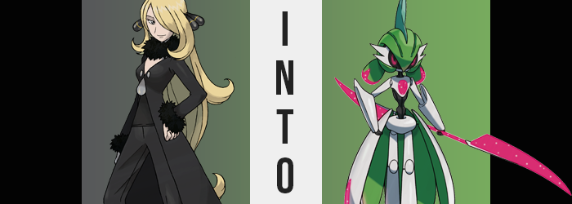

As the previous Champion of the Sinnoh region, Cynthia was an extremely busy woman just in general. It did not matter if she was the currently reigning champ or not, her talents as a Pokémon trainer were coveted by the people of her region. There were few, if any, who did not know her name, and fewer that would like to be jump scared by finding her in a house and randomly challenged to a battle.

It could have been the smallest thing in the world, or an incident of great peril, and Cynthia still would have been called to help deal with it if she were free. Although in this case? The incident certainly leaned into the latter category after reports had come in about an unusual light show that had been seen over the sky of Mount Coronet late one night. The ex-Champion had been sent to investigate first thing the next morning considering her familiarity with the region.

“Now this is something that wasn’t here during my last visit. Not easy to miss, either…” The woman had triangulated the probable location of the phenomenon’s cause before setting out, and while it had been a bit of a hike she eventually came across what had most certainly prompted the visual incident late the night before. After all, a whole piece of the mountain seemed to be missing – replaced by what looked to be a manmade structure of steel.

While it had clearly been made by humans though, something about it didn’t quite seem right. Even from the exterior she could tell that it was not something that modern human society could create. Everything from the cut of the steel walls to the lights that shone outside were unlike anything the woman had ever seen before. Was it something from another era?
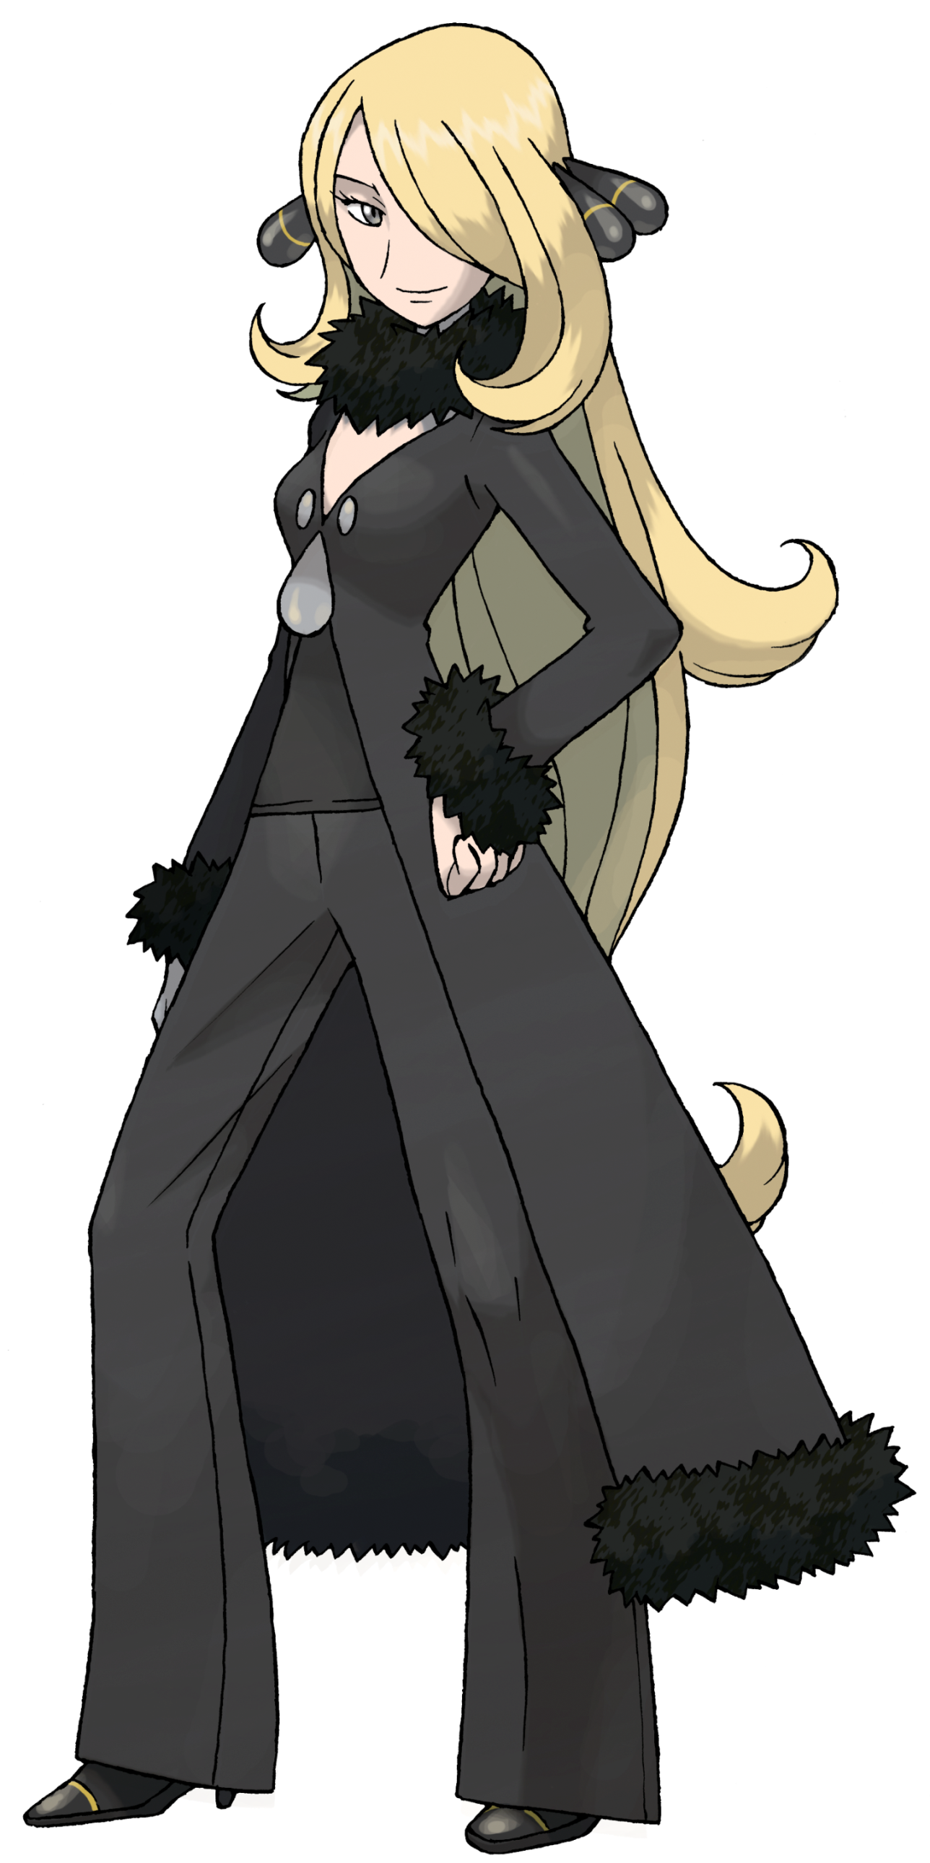
In many places this would have been seen as an impossibility, and yet Mount Coronet had ties to Dialga and Palkia, two legendary Pokémon with dominion over time and space alike. If there was anywhere in the world where something like that could have happened, it was the Sinnoh region. And as someone well read on the legends of old considering her family’s history with these legends, Cynthia was uniquely qualified in this particular case.

“Well, now that I’m here…” There was nothing left to do but investigate the interior of the facility, no? She could return with news of the strange appearance alone and that would surely earn her some praise, but she did not do things like this for praise. It was for the betterment of Sinnoh, and Sinnoh would be better off knowing just how dangerous this facility was, if at all.

For how advanced it was, it was also surprisingly simple to get inside though. The front door was automated and had just allowed her to enter without any sort of fuss, taking her into a lobby not unlike one you might find in most department or office buildings. But this location didn’t exactly provide her with any tips regarding the safety nor purpose of the lab, and so she was forced to push deeper in. “Actually, I wonder just how far into the mountain this goes? How many Pokémon were displaced by its appearance?”

If it actually had been summoned by the local legendaries then she had faith that they would have made certain nothing was harmed in the process, but she was also ignoring the possibility that Dialga and Palkia had nothing to do with its appearance in their era whatsoever. That there was the chance some manner of technology had sent it back to the past itself.

Cynthia would never find the answers she sought, however. Nor would she leave the facility in a state that would allow her to report her findings to anyone.

“Hm.” Ultimately the woman had picked a random direction to set off in, and after wandering down an extensively long hallway had arrived in what looked to be some sort of testing room. Much like the doors she had entered the facility through, the doors into it had swung open automatically. But when she had turned to leave? Those doors would not budge. “Are you telling me I can only go forward?”

There was a door on the room’s opposing side that seemed to go deeper, but she only got as far as the room’s center, surrounded by what looked to be pods of some sort. Although they were empty, it looked as if they had once contained something. Red lights began to flash though, and a robot arm extended down before Cynthia could react – pushing her into one of those pods, upon which the door shut and locked her in. “What!?”

No amount of pushing or banging on the door managed to budge it, and to make matters worse? Had the hand managed to knock her Pokéballs away at the same time!? She was trapped and confused, only able to gleam robotic sounding words being spoken over the intercom.

SUBJECT OF COMPATIBLE STRENGTH FOUND. COMMENCING OPERATION VALIANT.

“Operation Valiant? What in the world?” She was desperately trying to escape the pod she had been thrown into even as she threw a shoulder at the door once more, trying desperately to get the container to budge even a little. But her misfortune grew even stronger as the sound of electronics whirring to life around her filled her ears and, promptly after? A bright pink light filled the pod from both the top and bottom. It was an energy that prompted all of the hairs not on top of her head to stand on end, but more than that?

Whether it was the energy itself or a side effect of the overall exposure, the clothing and accessories she wore were immediately evaporated by this energy so that she was left completely nude within the tube. The Champion grit her teeth. “What purpose did that serve!?” She counted her blessings that the establishment was presumed vacant, so there was no one there to ogle her, but if it had eradicated her clothing so cleanly and quickly so that not even a scrap was left, what havoc could it wreak on her body?

In that regard it had already done something, actually. All of the shorter hairs across her skin, be they on her arms and legs, her armpits, or even her pubes? The were eviscerated next, leaving her largely bald. Even her eyebrows disappeared, but the hair atop her head seemed to remain – yet not unscathed. It was disappearing as well, but was being snipped away inch by inch from the tips so it was getting shorter oh so slowly behind her. It seemed that whatever power this was, it could not completely eliminate long hairs as quickly as short ones.

“Why is it getting… so difficult… to move…?” Cynthia would have continued her fruitless struggle against the door of the pod even nude if she were able to, but it was becoming increasingly difficult to do so. Her movements had begun to feel stiff and sluggish, and her posture was straightening even though that wasn’t the direction that she desired any part of her body to move in. Before long she was standing completely straight with her hands down at her sides, unable to even croak out a single word.

As for why this was the case? Her skin seemed to offer some clues as far as color and sheen appeared to take them. As her body had been stiffening, patches of a whitish silver had begun to emerge, each spot exceptionally shiny. These spots not only grew in number but also grew in size as well, and it was inevitable that they would mesh together. Though it had some additional side effects in some areas, such as absorbing the nails on her fingers and toes. Before long? All of her skin was painted with platinum.

While the hair atop her head? It had turned a forest green. On the (debatably) bright side, it seemed it had ceased to continue shortening after being trimmed up to her shoulders, but a change that was perhaps more concerning took place instead. These hairs hardened and fused, pulling into two nubs akin to pig tails at the back of her head, while on top it smoothed into a single piece that resembled a green helmet. Strangely, this ‘hair’ reached down and over her nose, slightly obscuring her vision in the process.

SHHT… SHHT… SHHT… SHHT…

Cynthia could make out the green metal that ran between her eyes, but she couldn’t make out what was actually happening to her under the pink light. Not only was her body stiff as a board now, but it was also unsettlingly numb, like she couldn’t feel much of anything. But she could vaguely feel, and also hear, that something was grinding across her entire body. And in a way? That wasn’t incorrect, but it also wasn’t correct either.

The shapes of her limbs and torso were being forcibly changed, and the sounds and sensations she was sensing were a testament to these changes. Almost like her body was a piece of metal being reforged into a shape that was similar, yet fundamentally different to what it had once been. When it came to her feet, for instance? Her toes, and realistically anything past the roundness of her ankles were shaved away. The shavings disappeared no sooner than they had peeled away, and a pair of grooves appeared going vertically up the middle of either ‘foot’.

But this all proved that blood was no longer running through Cynthia’s veins – not that she was aware. Especially when enough height was shaved off those arms to help lower her height down to roughly 4’.

Much bigger shavings were peeled off of her legs, to the point that everything below her knees was wider than everything above them and giving the impression that her feet were closer to mechanical hooves than anything remotely human. Exposed ball joints were carved in where her knees were, and strangely? Four big sections were vertically shaved off her legs on the sides and the front. Instead of disappearing though, they were much too thick to do so and fanned out, the peaks seemingly fixation themselves to her ass and hips so that they fanned out like a skirt behind her. The undersides were promptly dyed green.

The woman winced. She could feel this skirt like it was a part of her body (because it was), and once her mobility returned she would be able to control those four panels separately. But she was also wincing because the area around her crotch was being modified next. It became almost entirely a circular tube of platinum around, with her loins smoothed away and her ass forced to conform into this new shape. To be fair, she would have no need of sex nor to excrete bodily fluids in the form she was given.

…………………………………………..

A lot of work was seemingly being done around her stomach and waist, because all of that platinum was torn off of her to reveal the center of a black exoskeleton within, only inches wide. But Cynthia was struggling on the mental side now. Her thoughts were having hitches, and her irises had begun to glow a pinkish red not unlike the light that she was being subjected to. She’d have a thought and it would escape her, and another, and another – to the point that it was becoming difficult to think for herself whatsoever.

Her sclera turned black and her eyes expanded, lids fading into nothingness as tiny panels could soon be perceived throughout the entirety of her opticals. Rather than the eyes of a living being, they looked like LED panels displaying an image of a pair of irises, but from Cynthia’s point of view her ability to see had sharpened significantly. Not only her eyes, but her brain itself was absorbing all of the information she could see and turning it into data in a brain that was growing increasingly digital.

Which didn’t help at all with the mental issues she was already having.

Her fingers had been shortened into tiny nubs, the black exoskeleton exposed once more upon them while the rest of her forearms seemed to thicken into a pair of platinum guards that pushed passed her elbows, or the ball joints that now indicated where her elbows were. The steel was left around her chest, though the black skeleton of her neck was left exposed as the metal there was shaved away too. She still looked shorter overall though, no doubt because excess had been taken from her arms and torso.

THUMP… THUMP… THUMP…

For a time, the part of Cynthia’s mind that could still reason wondering if she was hearing her heartbeat. But every time it thumped, a light flashed on her chest. A pink gemstone. A power module. Every time it flashed, the same glow appeared not only on the lines on her feet, but on the panels of her skirt and the tips of her helmet’s ‘pigtails’. Until the thumping became a continuous sound and all of these areas remained lit.

Whatever facial features aside from her eyes that the woman possessed were promptly erased so that her head was a perfect, platinum orb with LED eyes. Yet from the sides of those eyes silver head spikes shot out towards her back, and a teal horn erupted from the tippy top of her ‘hair’. A blade composed of the same magenta energy that pulsed throughout the rest of her body appeared in the tiny fingers of her left hand, though she held it straight up so that it didn’t damage the pod.

But by this point? Her sense of identity as a human had been lost. The mechanical creature that existed in Cynthia’s stead had not been robbed of all of its previous memories. In fact, they were still stored as data in its digital brain. But these memories were encrypted now and could not be accessed without the correct permissions. Instead, a purpose had been planted where memories had once been.

While the pod door had been forced slightly open from the struggle she had put up prior to her transformation, it wasn’t until this transformation of the robotic creature inside had completed that the motors kicked in and the door finally opened, allowing the bipedal presence to step out with metallic steps against an equally metallic floor.

Borrowing traits from both Gardevoir and Gallade, this Iron Valiant’s body was completely without sexual characteristics. It was, after all, a machine with no need to copulate and was essentially genderless as a result. But because gender was not tied to one’s sex, this Iron Valiant still identified as female in her programming – likely as an homage to the human that had served as her foundation.

The magenta core in its chest whirred as the displayed eyes of red against the panels that had replaced her original eyes looked hazily around the room. Her programming was clear in that she was part of an initiative to spread the future to the past, but her sole role was to be bait? To lead more humans into this lab so that they, too, could becoming part of the overarching project? Operation Valiant had only been a small part of it, it seemed.

Little did she know that a lab for creating Pokémon from the distant past had appeared on the other side of Mount Coronet. She did not need to think about that. It wasn’t part of her memories nor her behaviors. Unless someone else walked into this facility, she would simply serve as its protector. That was the reason that her left hand held that double sided blade of magenta.

That was why Operation Valiant had required a strong trainer. To create an equally strong Pokémon.

And so the Iron Valiant began her pre-mapped patrol route. And she would walk, and walk, and walk. Without rest of course, because Pokémon or not, she was still a machine. And machines did not require rest. She would simply continue to patrol, forever if need be, without complaint. How could she complain when it was her programming to do so? But realistically she wouldn’t need to wait long for another human to step inside this facility.

So that she can make a new friend.

