BEACH-I THE ROCK
CH6: MOO-VE IT
BY CHALDEACHANGE
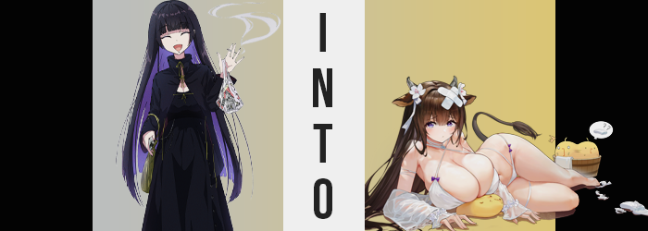

It had been a quiet evening at the STARRY live house in Shimokitazawa. Owned by Nijika’s older sister, it was a very popular place for up and coming musicians to perform and was the place where you could find the members of Kessoku Band every day after school since they both worked and performed there. But on this particular evening? They were nowhere to be seen, having taken the day off to go down to the beach.

“We were lucky it was quiet…” The public address sound engineer of the joint, known by everyone only as ‘PA-san’, was standing out at the front of the building now that they had decided to close early. There had only been one performance on the docket and because it was near the end of summer it hadn’t been especially crowded. This meant that they were able to get by with some of the newer part-timers.

But the potential for things to go awry had loomed.

The dark-haired woman rummaged around in the purse that rested over her shoulder, eventually finding the pack of smokes she had been seeking. It didn’t take especially long for her to fish one out and light it, taking a puff with one hand while the other dropped the pack back in. As she did every night, she liked to wait for Seika to finish closing up inside before they left together. It was more like a tradition than anything more dutiful because the two were friends after all.

PA-san took another drag and blew the smoke out, thinking about her plans for the rest of the night. She was a VTuber in her spare time so she tended to run streams after work at the live house was done. “Actually, I wonder how the kids fared? I’m surprised Nijika-chan isn’t back yet.” It was possible that she had just gone straight home, but usually when the girls had plans they stopped by work after seeing as how Seika was Nijika’s older sister and all.
“They were probably just having too much fun and lost track of time.” Being twenty four years old she liked to reminisce as if she was an old lady compared to the teenagers that also worked at STARRY, but of course she was just being dramatic whenever she did. Having too much fun and losing track of time was the kind of thing that teenagers tended to do, right? It wasn’t looked down upon all that fondly once you became an adult.

While taking another drag of her cigarette, PA-san arched an eyebrow at the sight of a tanned woman in an American-inspired bikini that had walked past the club. She was mumbling to herself about wanting udon or something, but what was just as odd was the item sticking out of the bag she was carrying. A glowing stone that produced rainbow light? It was probably just an arts and crafts project with an LED stuck inside or something.

Or so she thought.

There was no amount of context for our poor PA-san that could have prepared her for what was to come, a victim of the rainbow stone only on the merit of having known Bocchi prior to her transformation. That rock wasn’t going around just changing anyone that Musashi crossed paths with, but anyone that Bocchi had considered an important part of her life. The STARRY employee had barely met the smell test because Bocchi had seen her at work every day.

“That woman was strange… We’re quite far from the beach.” And it wasn’t particularly warm since the sun had already set. There was no need to walk around in a swimsuit so late; in fact she worried about the woman’s safety with such a nice body. It didn’t quite occur to her that she was in the process of developing a figure that not only rivaled the stranger’s, but surpassed it in some ways.

She’d already begun to develop the part that rivaled her, in fact. PA-san obviously didn’t notice as she extinguished her most recent cigarette and rested her back against a nearby wall, her posture a little off as she did so. The lower half of the woman’s body was jutting forward from the wall in a more pronounced fashion than it typically did because of one key change.

Her ass was bigger. Not only was it larger, but it was continuing to find additional padding as it stretched and suckled on the black thong beneath the skirt of her equally black dress. These cheeks expanded out in length and thickness, and in turn their bubbled mass pushed into the wall and forced her hips both away from the wall she was pressed up against, as well as away from each other to give an extra five inches to her gait.

It was a shame that the skirt of her dress was so long, because other than making out the shape of her thickened rump behind her it was difficult to make out what was happening to her lower body otherwise. Widened hips had allowed additional mass to flow into thighs, bloating them until they were wider than a slightly narrowed waistline. They rubbed against each other as she absent-mindedly adjusted her posture to support a weightier lower half.

Like the others, PA-san hadn’t even noticed she was changing. “Seika s-sure is t-taking a while…” It was a little odd from her perspective though. Just waiting alone left her feeling a touch anxious – had she always been like that? She must have been, right? While she pondered this curious detail her fat ass slid down the back of the wall a little bit. Three inches were shaved directly off of her height, rendering her a more average size for a woman of her age.

What seemingly wasn’t becoming a more average size was the weight upon her chest. In fact it had already been average, but a swell similar to what had affected her thighs and butt prompted them to balloon at an almost unsettling pace. Her dress had a low neckline and so it was easy enough to make out her deepening cleavage as the front of her dress was pushed forward, but before long? It became clear enough that her clothing wouldn’t be able to contain them as is.

Rather than ruin the clothing though, her tits instead spilled up and over the neckline of the gown and came fully into view with nipples that already eclipsed her eyes in size. “Awawawa!?” PA-san hadn’t realized she was transforming, but the sight and sensation of her boobs exploding into view was still something she’d notice. She was in public after all! But that noise she had made? It was both out of character in performance and much too high in pitch in tone.

The woman drew an arm across her bare tits to try and hide them, but applying pressure with said arm only saw them jiggle and warp around the arm because they were still growing. They bounced about almost like they were made of gelatin, or perhaps more like they were a honking pair of water balloons? Regardless they dwarfed her head in size before they finished growing, their weight finally pulling her away from the wall she had been leaning on.

The tits of a cow!

She wasn’t exactly sure what that particular comparison had come to mind, although the implications were fare more literal than she had realized when she thought it. Because the back of her skirt was lifted up in slight by a long, ropey tail with brown fur, a tuft of coarser brown dangling from the tip. While atop her head? Short horns emerged, and her ears slowly traveled up the sides of her head as they took the notable, brown-furred shapes of a pair of bovine ears while piercings fell out and onto the goround.

The brown of the fur on these more animal-like qualities began to permeate throughout all of the hair on PA-san’s body, whether it was her short pubes, her brows, or even the hair atop her head. The darker layer and the purple layer of her mane both were swallowed by this same chestnut brown, and while these locks didn’t necessarily change in length, their style was altered. They weren’t cut as straight at the tips any longer, and the hair seemed almost impossibly soft and silky with bangs more erratic.

With a blink? There was no longer any malfunction with the woman’s dress because, well, she wasn’t wearing anything. “N-No!?” She chirped through lips that were notably denser, and as her piercings had disappeared with her clothes the hole that had once been on her lower lip ultimately filled. She didn’t look much like her old self now, something more akin to a soft babyface being constructed over her old one. Her eyes were bigger and lashes longer, irises having taken on a light purple.

Whether or not it would calm her concerns about her state of dress, new clothing did appear just as quickly as it had been lost. But it was a revealing, white bikini with detached sleeves and floral ornaments around her horns. A big bandage criss-crossed atop her head, suggesting a wound that wasn’t all that surprising considering the woman’s build. With tits that huge it wasn’t surprising that she might have a habit of clumsily falling over and bonking her head.

“Hyah!? Why am I still walking around in my swimsuit!?” Kashino was confused. Her best attempt at recalling the day was groggy, but she had gone to the beach hadn’t she? With a group of friends? Even though she didn’t like showing off too much of her body? Because of that alone, the cow woman would definitely have gotten changed into something that offered more coverage before she had left the beach.
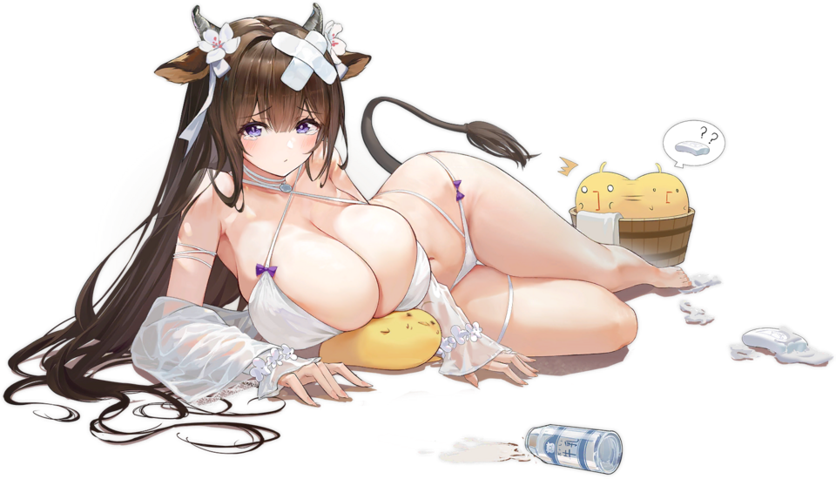
Now it was late in the evening and she was standing outside of… STARRY? Did she know of…? Wait, she did! Memories of her new life had answers. She was a recurring customer of this live house not because she was interested in the music, but… Well she was! The bands that played there were really good! But it was the owner of the live house; she was the reason she visited so frequently!

Seika and herself were dating.

The whining noise she made might have shattered glass if she had been within close enough proximity to some. “S-Seika-san is going to tease me! A-And I haven’t shown her this much of my body before!” She was really soft and heavy even for a Ship Girl, even though all of that mass had gone to her ass and especially her boobs. She was a little self-conscious about it!

Before she could resolve to go change though, the door to STARRY opened and a blonde-haired woman stepped out. “Oh, Kashino-chan. You have fun at the beach?” Seika had only glimpsed her in the corner of her eye while locking the door, but turning and seeing her girlfriend practically naked at the top of the stairs…

“You look good. Coming back to my place?”

“Y-Yes!”

