April the Fool  Inspired by a Tiffany Captioned Image  By Maryanne Peters  Who was the fool? It was supposed to be me, but these days I don’t look so stupid.  She had me, I give you that. When you think about it a “Cross dress secretary contest” is such a crazy idea. But I wanted it to be true. Maybe I wanted the excuse to become her, even for only a day.  Honestly, my hands were shaking as I posed, so maybe I look a little awkward. I did not want her to see how much this meant to me, to be able to walk of the house in clothes like these. It is every secret crossdresser’s dream.  But the whole thing came crashing down when I arrived at the office. I was the only one dressed.  “Oh right, its April 1^{st,”} somebody said. | 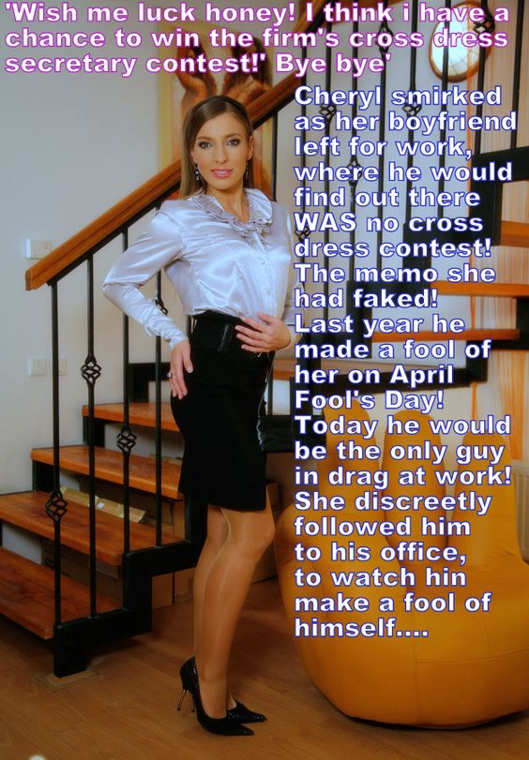

I knew it was her. Things had been going badly for weeks. I had played a nasty trick on her to get her to leave, but it was nothing as awful as this. For a minute I just prayed that I would vaporize and take away all memories of this away too.

But then my boss stepped forward. He said – “This does not look like a joke to me. This looks like a statement – a call for understanding. We are a diverse and inclusive company. There is room for you … what would you like us to call you?”

I was in a state of shock, looking at the date on the wall. I just must have muttered it.

“April,” he said. “Welcome April. Can I say without wishing to sound predatory or even old-fashioned, that you make a very attractive woman.”

Out of the corner of my eye I thought I saw my girlfriend Cheryl slinking away from behind the crowd of onlookers. Somehow she was able to sneak into our general office area just to watch the consequences of her mischief. Now instead of being laughed at people were coming forward to say how much they admired my courage in presenting the true me, and how they wished me well for “my transition”.

And sure, my boss is a little old fashioned. And he could only be considered as a predator if I was his prey, when in fact it turns out that I look forward to him eating me right up with regularity. Since I have moved into his mansion, I have come to expect it.

The End

Pliable  Inspired by a Captioned Image by Tiffany  By Maryanne Peters  I should have known that any man who was that easy to manipulate might become the target of a rival, but I could just never have known that my rival would be a man.  I fell for Vic because he was pretty. Beauty is my businesses, and I suppose that I really do not go for the rugged physiques and bristly faces of other men. I thought Vick was the kind of man for me: Slim, smallish, smooth faced, big eyes. He had fair hair too, although not quite as blonde as I had it dyed to match the extensions.  But above all, he was pliable. I mean that he wanted to do anything to please me, and I fairly soon discovered that anything meant anything. | 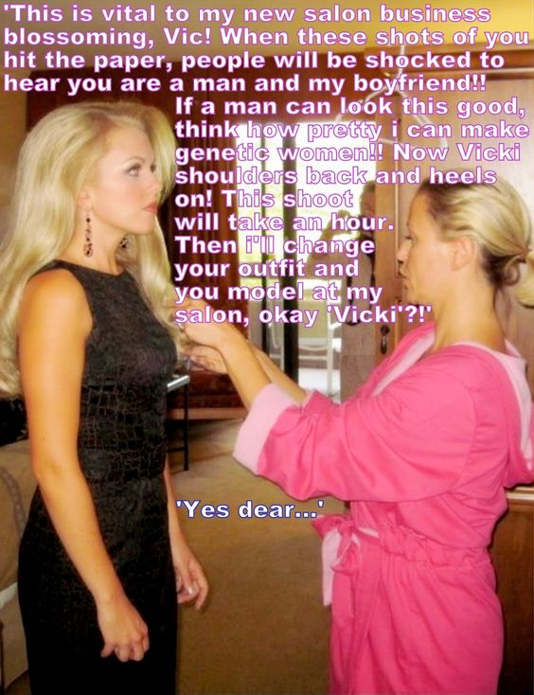

No real man would become his girlfriends hair and makeup model. It was just that he lost his job and so I employed him in my salon business. We were bringing in a new range of natural hair extensions and nothing sells like a walking example. The facial treatments and the makeup too – There can be no better demonstration of your skills than to say = “Look at this beautiful blonde girl here … well that is no girl at all. That is my boyfriend Vic. If we can make a guy look this good, just imagine what we can do for you!”

The dress and heels and the earrings were not essential, but you need to present a complete look. He never seemed to mind. It was like I said – he was pliable. He would just say – “Yes dear.”

But when You are running a business, you can’t keep watch on your boyfriend all the time. He had not real skills we could use apart from being the model so he was the one sent out for coffee orders and lunches. He was happy to do it. I would smile at the other girls when he trotted out in his dress and heels. Some of them may have thought that I was a bitch for treating my guy like that, but what else was he going to do?

But I suppose that he was too pretty and too pliable. One day he went out and did not come back. I just got a call from a guy called Jake the following day, after being worried sick all night. He said – “Vicki is with me now, and that is that.”

I told him – “You are in for an unpleasant surprise because Vicki is not female.”

“Not at the moment, maybe,” he said.

I demanded that I see Vic. This guy Jake ran the realty business on the next block. He told me to come around after work when it would just be him and “Vicki” there.

I went around, and there was Jake sitting at a big desk with Vic in some new outfit – something pink and feminine - fiddling with some papers as if he was an office girl.

“Vic, we’re leaving,” I said, staring at this man who thought he could steal my boyfriend. I expected Vic to come over and stand beside me, as was his way. But he did not move. I looked up and could see the distress on his face.

This lunk of a man behind the desk said – “Vicki darling, come on over and sit in my lap.”

I watched in horror as Vicki walked over and sat in Jakes lap, and snuggled up to him, as I stood there shaking in fury.

But as I explained – Vicki is pliable.

The End

© Maryanne Peters 2022

A Lady  Inspired by a Tiffany Captioned Image  By Maryanne Peters  This is not the kind of outfit that you wear to a bar, as I explained to her. It is business attire that you might wear to an evening engagement after work. It is not the kind of outfit that you would use to pick up a guy. If she was happy to shake her tits in front of strangers then I was happy for her to do that. I didn’t have tits. Not then anyway.  What I did have was my own hair, which I had worn long as a man and which her best friend had cut into a bob and styled beautifully. I had the right face (although a little square in the jaw) and I had great legs.  All of those things were the ingredients for a great look. All that was needed was the right outfit – one that creates the right attitude for the wearer. And the right makeup – business-like and not slutty | 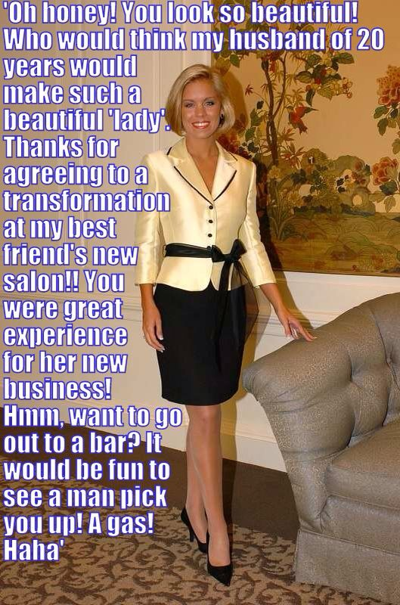

One thing I had learned in my brief experience with women’s clothes (up to that point) was that different clothes make you feel differently, and in this outfit I felt like a lady.

So I joined her at the bar. She wanted to see whether I could pull it off, and so did I. But it was just so easy that I surprised myself. I just needed to look in the mirror behind the bar and catch a glimpse of myself to know who I was, or who I imagined myself to be. I was a professional woman, joining her rather loud and poorly dressed friend for a drink after a busy day at the office.

She seemed to take the adventure as an opportunity to show me how she was still attractive to men. She could never do that in front of her husband, but then tonight I was not her husband – how could I be? She was attractive to at least one man. She waved to me from the end of the bar before turning her back to me.

“Your friend seems a little drunk already.” The words came from a man who had moved in in front of me to order a drink.

“She is out for fun. I am just unwinding from a hard day at the office.” I made sure to adopt a voice that I thought might sound feminine, in a husky way.

He smiled. “You too,” he said. “Do you mind if I take a seat?”

“Please,” I said, only because I had no idea what a woman would say in that situation.

He introduced himself and asked what I did. We were both in finance, but he was clearly better off than I was. Some people might think that what we talked about was uninteresting, but it was conversation and allowed us to share another drink.

My wife had noticed the attention that I was receiving and had come over.

“This is my friend … what’s you name again? Anyway, he is suggesting that we move on the the place next door for the ribs and marguerita special. Why don’t you bring your “friend” with you and join us.”

“Thanks but I’ll be heading home after this.” My voice surprised her. It even seemed to annoy her. Or was it the fact that the man beside me was looking down and her, his poor opinion of her plainly visible, to me anyway.

“Well we are going, and that is that!”

Twenty years of marriage and you have to be dressed as a woman being chatted up by a man for the first time before you realize that your wife is basically trash and always has been. Twenty years to realize that the kind of woman you truly admire is the woman you can glimpse in the bar mirror. Twenty tears to realize that you like being this woman more than you like being the husband of the woman staggering out of the bar supported by the hand of a stranger clutching her ass cheek.

“Would you join me for dinner?” he said. “Not ribs. I know a little French place a block from here.”

“I would like that,” I said, but first I needed to ask – “But I feel that I need to ask – do you consider yourself an open-minded man?”

It turns out that he did. It turns out that he was.

Twenty years of marriage and now my life has started all over again.

The End

© Maryanne Peters 2022

Daddy’s Girl  Inspired by a Captioned Image  by Tiffany  By Maryanne Peters  I always disliked Larry. To me he was completely the wrong man for my daughter Nancy. In fact I always thought that he was barely a man at all.  I suppose fathers think that their daughters should model their partners off their fathers. I always thought that Nancy would. We were close. She was my little girl. | 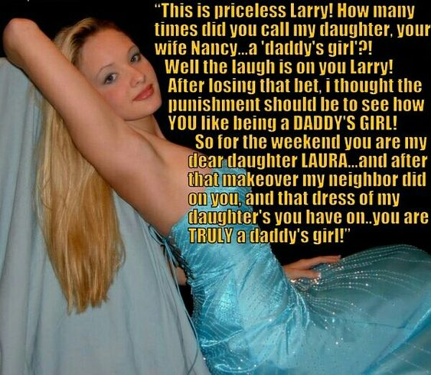

But after my wife died, my wonderful daughter took up with Larry. He seemed the very opposite of me – scrawny and effeminate, and smarmy and sneeringly derisive. He was a very unpleasant young man, but attractive I suppose with his fair hair and slim physique.

My concerns about his seem to be confirmed by the hearing devices I had installed. On the recordings I could hear him calling my relationship with Nancy “overly physical” and “frankly weird”. As if he has any ability to judge without his own daughter. A tactile relationship between father and daughter is appropriate – there is nothing sexual about it, except out of the mind of a pervert.

It seemed to me that I needed to do something to end this relationship, or at least change it. Nancy can be wilful, just as I can be (yet another thing to love for for) so forbidding things would not work. I decided that I needed to make him less attractive to her.

My business is pharmaceuticals. I had access to what was needed. It was just a question as to how it might be introduced into his decidedly unmanly body to work the wonders of modern endocrinology.

Nancy did tire of Larry over time. She seemed a little puzzled as to what was going on. They seemed as close as they had been, but somehow in a different way. They had become playmates rather than sexual partners.

Larry started paying more attention to me. Given what I knew of his private thoughts, I first wondered if he might be taunting me, but then it seemed to me that his attitude to me had changed, and that he was starting to understand why I was such an important part of my daughter’s life. It seemed to me that he had never had a proper father figure.

When I asked him he explained that he was distant from his father and it had been like that for as long as he could remember. He mentioned expectations and disappointments and all the things that fathers and sons get wrong, but fathers and daughters are never concerned about.

“I am starting to understand,” he said.

“I would like to help you to do that,” I said.

To be honest I am not sure if the whole “Laura Idea” was my idea or his, or should I say hers. What I can say is that Nancy had some initial problems with it but is now getting used to having a sister in place of a boyfriend … and I am discerning that a daddy can have more that one Daddy’s Girl.

The End

© Maryanne Peters 2022

Host  Inspired by a Captioned Image by Tiffany  By Maryanne Peters  It was a matter of public knowledge. It was widely known that the previous owner had been murdered there by her boss. He ran the mill down the road, and she worked as his secretary and by all accounts made herself available to him as she liked. He killed her in a jealous rage.  The realtors assured Harry that the carpet had been destroyed and the ceiling, walls and floorboards scrubbed clean of blood. There was new carpet and new paint, but as Harry pointed out, it does not change the facts. Those facts call for a reduced price.  Harry was very happy with the deal he had done. He was not a superstitious man. He was a realist. Ghosts are not real.  He even took the furniture other than what was removed, and the contents of the wardrobes “as is” simply to save removal costs. | 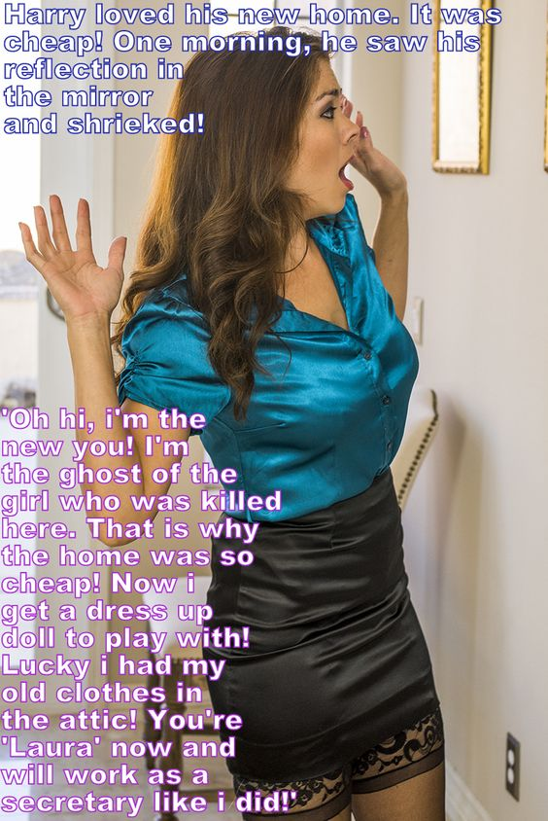

He had a job at the mill but had never met the victim or the killer, even though it was less a=than a years since it happened. Harry worked in the machinery spares department, pretty much on his own. It had its own entrance. Harry just received the calls, ticked off the inventory and dispatched the spares. Nobody noticed the changes in him. Not even Harry himself.

Do you believe in ghosts? Was there a spirit forcing Harry to become somebody else? Or was there something deep within Harry that needed to come out and the whole supernatural explanation was just an excuse?

Growing out his hair over all those months, taking the hormones and polishing his limbs – was all this driven by the spectre of the previous owner of the house?

It is true that when Harry finally reintroduced himself to HR at the mill as “Laura” and requested a position in administration as a secretary, the new career he was proposing for himself had weird parallels to the previous owner of his house, but might that be just up to the plans of the new Laura?

Anyway, Laura seemed to have acquired all the skills of an experienced secretary without ever holding a similar position previously.

Now it seems that her boss might be strangely attracted to her. HR have advised him of her special status as a minority but he seems strangely unaffected by that information. Sometimes attractions can be like that.

Laura seems willing too.

Can it be a case of history repeating itself? Is there truly a lost soul at work here? Let’s hope not.

The End

© Maryanne Peters 2022

