*Pheromonal Urges*

*Siggy Commission for ZypherZai*

Bees have been an important part of Earth's ecosystem for millenia, helping to pollinate and propagate the spread of flowers and plants with their tiny and nimble forms serving as carriers for spores and fine seeds as they flit from flower to flower, stalk to stalk, gathering food, nutrients and raw material for the hungry larvae, soldiers and queen to fill themselves with back at the hive, where that sweet sweet honey they produced was stored. From aerial foes like birds and wasps to monolithic bears, the natural predators of these seemingly innocuous pollinators were numerous. But that didn’t mean they were helpless and unable to defend themselves, far from it in fact.

Armed with tiny stingers that packed a massive punch, bees had the numerical advantage when it came to both offense and defense, overwhelming both foe and innocent trespasser under a relentless black tide of bees armed with stingers laced with burning venom and paralytic fluids. Depending on the size of the aggressor, the time the bees took to put them down would vary. And even if they escaped, these tiny missiles, if aggravated enough, would pursue until either warded away or their unfortunate target was down for the count. Not to say stings were their only methods of attack when they had the ability to swarm a small enough target with the aim of frying them alive under the intense heat their buzzing wings could produce together. Ingenuity in evolution at work.

But all of that didn’t make bees an infallible species, not when evolution applied to their predators as well; sporting thicker skin, shaggy fur and immense size to protect against or outright ignore the painful stings. If they weren’t careful, years of hard work could be wiped out in seconds.

Not all threats were material however, and while bees were widespread and numerous in number, that number was dropping slowly worldwide thanks in part to something out of their control, something influenced by the dominant species on Earth…

With climate change driving down bee population numbers worldwide and other factors from pesticides to predation aiding in that decline, the dwindling bee population was something to be concerned about when over a third of the world's food stocks depended on the work of pollinators like bees to even function. While solutions like new crops of plants to keep domesticated bees well fed and a halt to the use of pesticides were put in place, these were more akin to temporary band-aid solutions. If nothing was done, sooner or later there'd be no more bees left in the wild to provide for their ecosystems, leading to further environmental when there was nothing left to help keep it all going.

With the goal of preventing that scenario from ever happening, research and experiments into a bevy of methods to keep the bees alive were conducted. But unlike previous incarnations of this new project that led to the creation of unnatural and highly aggressive bees from cross-breeding, the focus would be on boosting their productivity and resilience through alterations made directly to the honey they produced, with the end goal being a colony of sturdy bees that produced even more honey than a normal hive ever could, which in theory meant bigger hives and more workers to fill it with. And when combined with their increased potency and ability to function in normally lethal weather conditions, meant that their work as pollinators would improve in turn, doing their job no matter the time of day or how cold it got. Saving the world while boosting income from the increased yields of succulent honey.

Except not every plan would be a fine, smooth road to tread. And in the world of science where hiccups and unforeseen obstacles could crop up at any moment? That statement was far from an exaggeration if history was evidence enough against man's continued attempts to try and control the hand of mother nature herself. It was almost like an ingrained instinct at this point, an urge to keep walking this potentially self-destructive path in the hopes of a better tomorrow (or in most cases, trying to stuff more into already filled pockets), unable to let the hand of time make its move. Maybe the bees themselves would find a way around their own shortcomings? Maybe another species of pollinators would take over their roles? The possibilities were endless but also few and limited, which was what spurred the best minds in the industry to find a definitive fix instead of twiddling their thumbs, hoping for a miracle.

And within the labs of a certain pharmaceutical company contracted to work on such a project, an unwary man fiddling away with test tubes, contraptions and a computer within the darkness of the corporate subterranean labyrinth would soon find out the hard way that maybe such things should be better left alone lest they risk the creation of something that should never walk the earth…an aberrant, an affront to nature itself.

*Or maybe, just maybe. It all might turn out fine in the end…*

**"Almost done mixing…dammit, where'd I put that key again?"**

Rummaging through a messy table while a curious cylindrical machine in the center of the room fills the air with an ambient hum was a man dressed in a baggy white lab coat with a blue undershirt beneath, subtle wrinkles beginning to make themselves known atop his hands suggesting an age of around early to late forties. And on his chest, just over a breast pocket, laid an ID tag emblazoned with the company's logo and an image of a slightly younger version of himself with the name Jack Peterson spelt out beneath in bold.

Serving as the one and only man of science responsible for his masters many successful line of beauty and health care products, Jack was something of an eccentric, known for hushed mumbles and sudden bouts of spastic vocalisations that were seemingly directed at a voice inside his head. The few who had worked with him knew he was a good man but most couldn't stomach the idea of having who they saw to be an autist leading in a project, leading to a metaphorical changing of the guard any time there was a major project the higher-ups wanted Jack to oversee with no 'permanent residents' willing to work there for any longer than they had to under contract. All except for one man who saw no problem working with someone like Jack, entering the lab with piping hot cups of joe fresh from the pantry in each hand.

**"Not working too hard are we Sir? I've got some coffee if you want. Espresso, just the way you like it!"**

**"Ah Timothy, thanks for that. Just leave it on the table at the usual spot…now where are those damned keys hiding…"**

Serving as his assistant, Timothy had stuck fast by Jack's side ever since he had accepted an unusual job offer by email from the company seeking his talents for a project of theirs that, at the time, had been focused on making some strange extract he couldn't wrap his head around for use in exfoliating scrub. The pay was good and the workplace underground was cozy, air conditioned and silent most of the time so Timothy hadn't seen any reason to leave once the project was over. And while his other colleagues told him he'd be working under a man who's judgment seemed questionable at best, Timothy had shrugged them off. His faith in Jack as the project lead was unwavering, and unlike them, he kept an open mind on the mentally challenged, not seeing anything wrong with the way Jack sometimes leapt into furious back and forth with his inner voice. He saw it as a form of stress relief since it usually led to surprising breakthroughs in the moments of clarity Jack settled into after such 'outbursts'.

By the time they started work on this new project for the government sector colloquially called the 'Bee Population Revitalisation Project' by the people that had come to them with the plan, it had been Timothy's tenth undertaking alongside Jack, having grown used to his rants and quirky manner of speech. While he wasn't anywhere near the age to qualify being called an old man, the way Jack spoke reminded him of stereotypical elderly characters in science fiction media. And when combined with the fact that Timothy was still in his early twenties, it was easy to mistake Jack for a young father to the fledgling scientist.

Unbeknownst to the pair however, that comparison would soon come to fruition in a way neither of them could ever think possible as Timothy complies with his supes orders, setting down the piping hot mug of espresso before moving over to fetch the key to the bee storage room he had guessed was what Jack had been looking for…

**"You're looking for the keys to storage? They should be right by my-"**

…before tripping over unseen wires jutting out from under the table connected to the distillery still midway through mixing up the latest batch of a pheromone based concoction Jack had been brewing for his next test in stimulating honey production in bee hives. Stunning the two as they watch steaming smooth trails of chocolate colored liquid fly through the air before landing atop the matte white top of the heavy cylindrical machine with a devastating splat, singeing Jack's exposed skin while staining the clean surface with light stains and subtle smoke rising up into the air by the time Timothy recovers from his fall, rushing forward to clean up the machine before important components were damaged. Only for Jack to stop him before he could get closer with a towel tossed over the top of the machine as it's hum slowly dies away.

**"No! Shit, I'm so sorry sir! I'll get it clea-"**

**"No need my boy, its better if you don't come close, I've got a safety switch here just in case of an accident so the machine should be safely turned off…why don't you go fetch me a new batch of royal honey hm? Thankfully I've still got the formula written down! Don't beat yourself up over this alright? Accidents happen after all!"**

No matter how much the man seemed to shrug off the accident as a minor setback, Timothy knew how much time and effort it took for Jack to put everything together. To have all that hard work washed away in a split second…he must have been furious, or at the very least greatly disheartened. But Timothy knew better than to try and argue with the man, cradling the empty coffee mug before setting it down on the table, picking the key ring hanging off his desk before trotting off without another word, head downcast the entire length of the way.

Once he was gone and headed down the corridor however, Jack drops his strong man face before rushing over to the cloth he had draped over the top, undoing the seal and popping the cover all while muttering incoherent words under his breath with sweat beading his forehead and sliding down his pale visage at the sight of shattered vials and spilled yellow goop all over the underside and interior, no doubt because of the sudden increase in temperature caused by the mugload of piping hot coffee seeping in through the gaps.

But what concerned Jack was the increasing sense of fatigue beginning to creep over him after he had accidentally breathed in the thick yet brief plume of smoke that had puffed out of the machine unnoticed by Timothy. It smelled heavily of mildly burnt honey much like the smells one could savor outside a good bakery, but the heavy metallic tinge of chemicals told Jack otherwise. That this stuff was dangerous, untested, unpredictable. And as his legs suddenly begin to feel like heavy lumps of steel while his innards tighten up like a badly cramped muscle, the experienced scientist knew this was harmful. Or at least, suspected it to be with no positives yet to be gained from this as far as inhaling unknown, possibly toxic fumes went.

**"Need to…get meds from..f-from..ugh!"**

With his knees buckling under his own weight, Jack slumps over onto the table, barely holding on with both hands before they too surrender their strength to the strange chill taking control away from him, leaving the scientist to lie still on the cold floor of the lab with subtle sparks introducing mild pain from the strange changes going on beneath Jack's skin as his central nervous system rewires itself in preparation for the new form his body would soon take on. Filling in empty space as his once baggy clothes begin to strain, then tear along the lines once his burgeoning flesh expands beyond the limits of what his skin, and in turn the fabric, can hold, roiling like angry waves while it expands to contain the added mass bubbling into existence beneath, producing immense heat that leaves his skin slick and slimy with sweat.

And as he laid there, lifeless and still on the floor, small sounds begin to fill the silent lab as his body bulges against his clothes akin to a balloon held tightly by an invisible hand, shredding what little remained of his undershirt as mass continues to accrue beneath skin that thickens into a flexible yet hardened material akin to polished ceramic with seams along the joints to allow for ease of movement. All while Jack could do nothing but wonder just what he had inhaled and hoping Timothy hadn't gotten some inside his system as nervous eyes begin to gain a euphoric slant while an open mouth shrinks into a cute 'O' framed by lips that perk up into kissable cushions, giving them a natural pucker and a permanent look that made Jack look overly eager for a kiss as drool leaks out from and down his chin.

His answer however, would be subtly hinted at when his vision begins to fragment from the sides, filling with innumerable veins akin to the cells of a bee hive before clouding over with a greenish red tint alongside the pricking feel of something hard and sensitive beginning to protrude from atop his forehead just behind a fringe of softening hair. That is, if he could feel the threads extending and pouring down a face that was beginning to look very different in his bedazzled state, unaware of feeling and control gradually returning to him alongside two bony protrusions beneath and around his shoulders, growing from a disturbing opening of flesh beneath a hardened yellow carapace that was once normal human skin.

By the time the growths had branched out into a pair of new womanly limbs that twitch and spasm under the stress of connecting nerves, Jack's old pair were well on their way to becoming much like his new set of waifish arms; losing what little muscle there was as tender fat and firm meat fill in for their loss, lending the pale yellow tensile hide a gentle curving outline that lines up well with a torso that had, unbeknownst to the naked eye, gained an elegant arc to it after poor spinal posture and a portly chest had been forced into shape. Leaving a pleasant hourglass figure that's pleasing to the eyes, following the sexy slope beneath two arm pits on each side down to broad hips that were just finished expanding, sporting solid, girthy handlebars that contained a bevy of new organs beneath a tight, toned tummy, some of which were definitely not human. But all this added weight had to go somewhere, and with Jack's shirt and coat in ruins, all that remained were his tighty whities and formidable trousers. Both of which were tested under the considerable strain of their rapidly expanding wearer until new body parts and enlarged thighs exceed their limits, shredding apart as the globular expanse of a firm bubble butt comes through the rear alongside a spike tipped extension; the inert tailbone most humans had now pulsing and flexing as unknown juices and alien flesh fills in the sagging sac, leaving the thing limp on the floor, twitching with a vigor to fulfill its as of yet unknown purpose as Jack's mysterious new organ.

It didn't take much for Jack to realize what was becoming of him as his numb crotch, which had until now been content with fading away in silence, makes itself known, popping through the front of his still intact trousers, ruined the fabric not as a proud and erect rod, but as a pair of thick puffy lips framed by hairless yellow skin that matches up with the rest of his changed body. Except no man should have a vagina as fine and juicy as the one between Jack's legs; framed by healthy labia while tender sensitive folds leak pale fluids down between slick thighs that begin to pool on the floor, releasing a sweet odorous stench that hangs in the air, saturating it with the very pheromones that had been accidentally created from Timothy's mishap with the machine, ripe to spread the affliction that had, and still was, changing the former human male into something…*more*.

Since the project demanded bees that could produce twice as much honey while boosting their efficacy as pollinators, Jack had seen fit to work right from the top of the hierarchy in any given hive; the Queen. By mixing together a potent serum made from altering the genes and pheromones of a Queen before injecting it into royal honey, the man had hoped to use his miracle honey to breed a new genome of Queen's that could direct, control and enhance their colony in ways never before seen in any known bee species alive on Earth, able to survive in conditions they otherwise wouldn't while operating on a scale that would ensure the planets flora refilled faster than they were depleted. In essence, this was something meant for the little guys, not humans or any other animal species.

So when Jack had unwittingly inhaled a gaseous form of the mix after Timothy's boiling hot espresso had fallen into the mixing machine…the answer as to what was becoming of him, or rather her, was clearer than ever before as sensitive mounds push free of Jack's flat chest, tipped with brown sensitive nips that perk up alongside the heavy growths amassing beneath them until a gorgeous set of melons sagged gently down across her chest, directing curious hands coated in striped skin to poke and knead at them curiously while two others work to straighten out her brand new abdomen that housed her breeding sac and honey producing organs, wasting no time in dousing the floor around her long, slender legs in thick orange goop that reeked of her insidious aroma, oozing erotically out of her second orifice acting as the sheathe for an unyielding blade of bone, arcing her sexy S shaped spine as a womanly sigh unconsciously leaks out from between her radiant lips, planting a rosy blush on soft cheeks beneath blood red compound all while a grossly antenna twitches in euphoric bliss atop her head of still lengthening blonde that had subsumed the former man's matted brown hair, growing long enough for its longest strands to tickle and flick away at the sensitive portions of her inhuman behind.

Where a dreadfully skinny human man once laid sprawled out over the floor now sits a humanoid arthropod far larger than any human male or female, sporting four arms flanking a seductive figure leading down to killer thighs and a slit dripping with wanton excitement. And between lean shoulders where a broad neck should've been was a waifish pillar that looked as if it could snap with the slightest force, supporting a large dainty head framed by mesmerizing strands of blonde that drape down her back and around her fringe, arranged in such a way as to bring focus to her deep red eyes. They had no irises to speak of, but what they lacked in humanity, they made up for in sheer beauty as repeating hexagonal patterns run down across the length of the unfeeling orbs, in actuality a form of pseudopupil taking in the world around her. Lending them an otherworldly luster to mask their disturbing lack of direction. After all, one couldn't really tell if they were directed at them or something else in the distance, even when standing right in front of her close enough to whiff the strong calming aroma wafting off the pristine pale yellow carapace adorning her buxom figure she had for skin. A motherly woman that sported bee like features and growths.

**"I'm…becoming…no, I..am..always have been a Queen? Haven't I?"**

Jack knew she should've been afraid or at least concerned, but the more her eyes gaze over her new form, the more at home she was beginning to feel, unaware of how quick she was beginning to adapt to this body as independent movement of each of her four arms becomes elegant and smooth, losing any jank and unsteadiness after just a few flexes and stretches. Swaying her abdomen and clenching her tight innards to staunch the flow of honey her new organs were already producing alongside the juices in her still human pussy, flaring up at the idea that she now owned one as an itchy finger pokes away at the yellow nub that was all that remained of her former pecker before its mass had been used to form the equally sensitive walls that led up to her built in incubator connected to her abdomen. She wouldn't be giving birth to children in the traditional way but rather, laying the many eggs that would hatch the next generation of beautiful girls to fill her hive with. Letting an unknowing smile creep across her face as synapses in her brain hotwire themselves, pushing her along a new train of thought that had her leaning heavily towards her new instinctual urge to build a hive…no, a family, to make the world a better place, providing food aplenty. A self sustaining haven to cater to her loved ones.

It felt right, no longer a passing thought but her primary drive. In a way, Jack had programmed herself to become the very thing she had been trying to perfect. Uncaring of the smarts and human emotions she was beginning to lose track of in exchange for the simple minded bliss afforded to her by her new objective. Compounded by the fact that she had never before felt such clarity and peace of mind, Jack was rapidly becoming a fading memory in the mind of this newborn entity; a perfect fusion between man and insect.

**"Sir? I've got what you needed from the fuck!? What are you? Where's Jack?!"**

Turning her head towards the open entrance with a little crane of the neck to get a better look at the human she now dwarfed in size, the newborn Queen giggles before spinning around to aim her butt at the door, launching a splurt of thick honey that blocks off the only way out before her former assistant could get any funny ideas, leaving him trapped in with her as she slowly crosses the distance between them, snapping wires and toppling vials and machinery in her wake as threads and organic armor begin to take shape across her nubile young body, forming a leotard that hugs her shapely form tightly with heart shaped flaps barely hiding her aching nipples from view. And around her hips, the flowery hem of a makeshift dress flows down and around her long luscious legs, hugged tight by striped stockings and elegant heels.

By the time the Queen had cornered Timothy, her royal garment had been completed, topped off with a crown fashioned from solid honey gleaned from a certain source as gloved hands escape her lower lips with a vindictive smile on her face, licking them clean while staring down at her prey, who hadn't budged an inch since she sealed off the exits. But his eyes weren't directed at her, rather the discarded and tattered remains of Jack's attire left half consumed in the initial release of goop from the Queen. With no signs of a scuffle besides the mess she had made and not a hint of blood to be seen, Timothy's sharp mind had been quick to connect the dots, looking up into the warm red eyes of the enormous humanoid bee standing before him as a radiant pair of transparent, veiny wings emerge from somewhere behind her, letting a gentle and slightly excited buzz loose every few seconds or so, as if anticipating Timothy's response.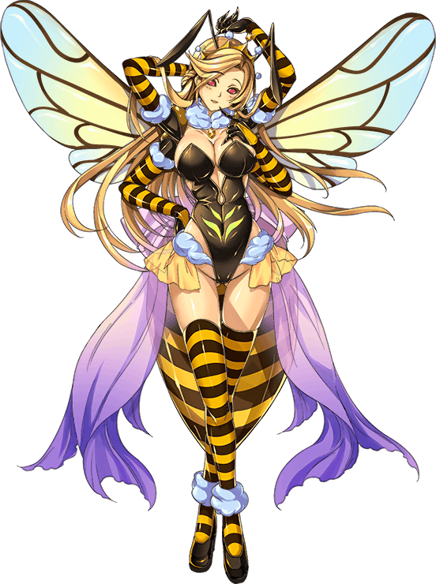

**"J-Jack sir? Is that…are you in there?"**

**"Atta boy~ Mmmhm! It's me…although the name doesn't quite suit me anymore does it? How does Jaqueline sound? Oh! Or maybe Joana? Come my boy, why the long face?"**

**"L-Long face? Why? C-Come on sir we need to be serious here, you can't be this…this thing! We need to find a way to fix this!"**

**"Hoh? Why would I ever want to be 'fixed', my dear? I feel…just right~ Tsk tsk tsk…something tells me you don't get the full picture…"**

**"What're you…sir…Jack! You have to snap out of this! This isn't you!"**

**"And you think you know me better than I do myself?"**

With her voice dipping dangerously low with a mature, vindictive undertone lurking beneath the innocent quip, the air in the lab begins to take on a threatening mood rife with tension as the Queen's mood sours, gentle aura turning hostile while the buzz of her wings begin to intensify, increasing pheromone production in her body as the invisible fumes begin to leak from every pore, saturating the air around them with more of the transformative gasses as her keen eyes sharpen at the sight of Timothy's peachy human skin beginning to turn bright yellow as flesh ripples beneath his notice. Spurring evil thoughts within the Queen. If this human wouldn't see things her way…then perhaps it was time for a…change of perspective. To open Timothy's eyes to the glory and freedom she embraced, to chip the haggard human out of his shell and mold him into the first of her kin, sharing in her unwavering vision of a harmonious family as she bows from her immense height, giving Timothy a faceful of cleavage and a fresh blast of pheromones from her woolen collar that wastes no time in warping his visage and inking his eyes while stupefying him, cutting Timothy off mid way through voicing yet another protestation as large arms wrap around and pull him into a warm hug, squeezing and kneading gently as changes begin to occur across the scientists body much like the one that had turned the quirky Jack into this salacious sexpot pouring sweet words down Timothy's ears all while his auburn hair darkens, lengthening rapidly down past a feminized form stripped of its muscle in exchange for alluring curves and supple flesh.

**"You don't know what it's like Timothy…I can think clearly for once…to see my future so clearly with my own eyes without the noise in my mind to cloud it all…don't you think that's good?"**

Although not as attractive and imposing as the Queen herself, the woman taking shape from Timothy's form was beginning to take on attractive traits of her own worthy enough to tempt any man to bed her despite the clearly inhuman yellow carapace and bloated behind she shared with the former Jack, moaning in a sonorous new alto that sounded nothing like her old queasy voice when eager fingers penetrate her dripping wet folds midway through their formation. Hastening the absorption of her penis and testes as they shimmy up inside her body in preparation for their task of housing the food and if the need arose; eggs to contribute to a healthy hive population. Allowing the Queen's hand to probe at her softened cheeks, fingering her mouth hanging open lazily as her human rationale and memories slowly fade out of focus, assuming her new directive as the one and only attendant to the Queen's, and in turn the hives, needs. Breeding with select mates, grooming the Queen to ensure she stayed clean and healthy and hand to hand combat alongside the use of her stinger for the defense of the hive were now firmly ingrained within the nameless drones mind while her destroyed nerves slowly reconnected with her newly grown limbs, anything else besides that was secondary, losing all familial connections to her former life as Timothy, lab assistant to Jack.

Now she was ***Tina***, firstborn to the Queen and serving as her loyal aide and right hand woman.

With the shell of her Queen's fingers clicking as they grip her graceful chin to pull her blushing face up towards the glare of the LED above for a better look, the last vestiges ofTimothy were well and truly defeated, erased from her pitch black compound eyes and left as nothing but another humanoid bee flapping her wings weakly in her Queen's hands, extra limbs taking longer to adjust and a haggard abdomen leaking its load all over the floor coated in shaggy fur to mark her lowly status as a drone alongside her less than human extensions with bulky forearms ending in razors rather than fingers and long tapering tips for feet.

**"DON'T YOU WANT TO EXPERIENCE SUCH A THING YOURSELF?"**

**“Y-Yes my queen~ Anything for such a gift~ The error of my ways…the limited vision I've restrained myself to all this time…you've helped me see past it all!"**

**"Hehee! Well said my dear Tina~ Good girls deserve a good reward…and what is a good attendant without the proper garb to present herself in?"**

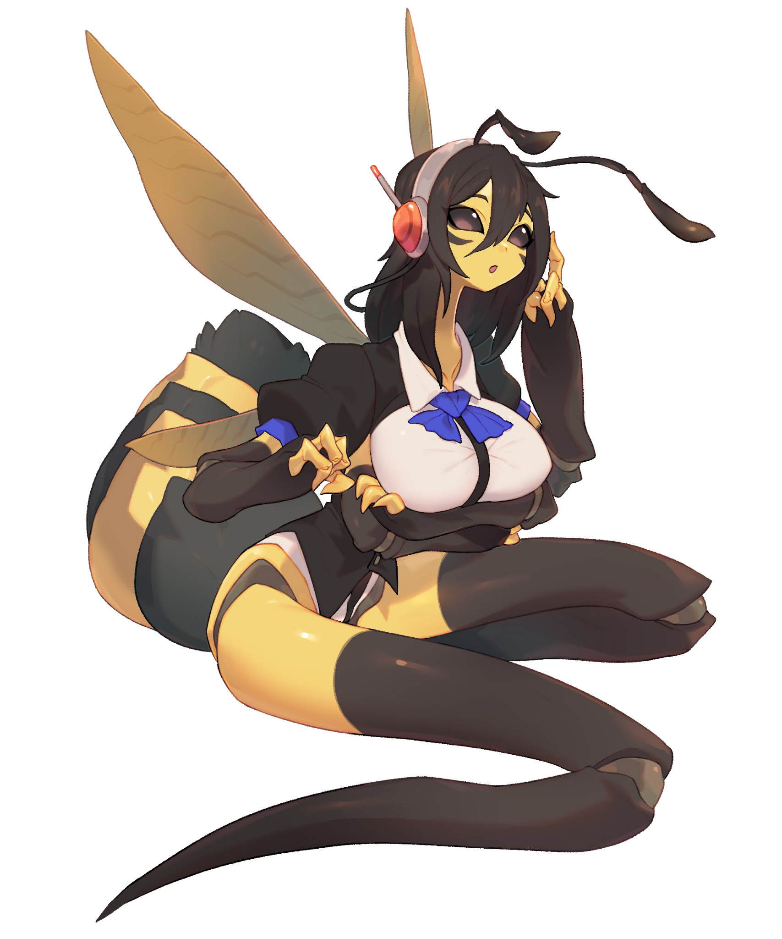

Letting Tina go, the Queen smiles as a matching leotard formed from the collective memories of Timothy and Jack forms over her attendants naked body, giving the young bee girl some measure of decency as hefty tits rivaling hers in size are covered in pale white cloth before the roiling wave of black and white threads crawl downward, concealing her muscled tummy before riding up between her dripping snatch and hearty ass, leaving a hole for her abdomen to peer through as it's spiked barb, her lifeline, emerges for a moment in her time of excitement with jiggly antenna bobbing to the beat of her heart.

By the time a blue bow tie asserts itself over her bosom, Tina's wings were buzzing back up to speed and control over her 4 arms was perfected with new nerves to link them to her messed up brain, not like she would ever realize what she had lost in exchange for this powerful yet graceful body. A body the Queen could only hope the rest of her brood would follow after once a suitable hive was established.

**"My lady! Oh this is wonderful!"**

**"No need for thanks dear. This is the least I can do for my dearest baby girl~"**

**"I won't ever let you down my lady! But…how will we escape? To build a home of our own?"**

**"Umfufu~ Why escape when we can simply start here Tina? Feel it…sense it…do you not hear the reverberating hearts of so many of your sisters just waiting to be hatched? To be made whole? This place will serve as a staging ground…we need more material before breeding can begin…but once our numbers are up to par…then we can start thinking of moving on up and out of our home~ Be a dear and get on the radio could you? We can start with the pesky guard who bothers your host mind every day…whether he’ll be your first mate or fellow sister, I leave it up to you."**

**"Mmhmm~ Of course my lady, I’ll be right on it~'**

Sighing as she prostrates herself on her back before letting loose a tidal wave of thick honey from her roiling abdomen, coating everything in dark oranges and yellows while the Queen clamps her mouth shut watching her daughter work, mimicking Timothy’s voice and behavioral patterns to ensure the human on the other end never caught on to the alien intruder that had taken the naive scientist’s place in the world.

Once she was done however, the salacious drone drops her headset into the thickening swamp her mother was making, rolling lazily around in it while spooning mouthfuls of the delectable treat into her mouth, processing it into the thick white paste that would be used to build the hive over the ugly human architecture their altered minds couldn't tolerate.

**“As delicious as ever my lady~ I think we’ll be fine with a worker to begin construction…maybe many more…if there are leftovers, perhaps we could keep them locked up for breeding purposes? Maybe we could even find one that suits your fancy!”**

**“Ahann~ As forward thinking as ever my dear….but in time…we shall see…for now? For now, we relax…and here comes the first meal~”**

*THE END?*