THE BROODMARE
COMMISSION STORY
BY CHALDEACHANGE
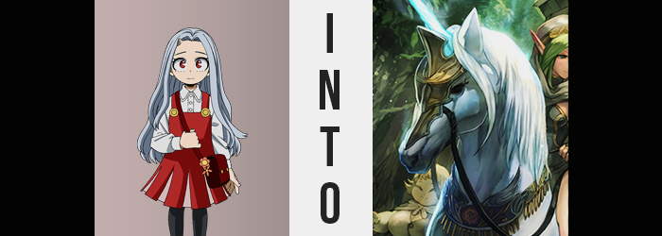

Day by day, Eri felt a little more comfortable with her circumstances. It had been several months since she had been saved from Overhaul and his accomplices, and for a child that knew so little of happiness, at first it had been very difficult for her to adjust to the idea of being worthy of kindness at all, much less did she have any idea how to properly reciprocate it.

It gradually became more apparent, and she learned. The love and attention she was given by Aizawa, Mirio, Deku, and everyone else involved both in saving her and in the days that followed – it all helped her develop to the point of comfort that she was at now. But even though she was young, that didn’t mean she was ignorant to the dangers her Quirk posed if something were to happen.

Fortunately that horn on the girl’s head hadn’t grown much since she was saved, but it was something she stared at intently in the mirror ever morning and every night, fearful of it growing even an inch. It had led to a great deal of nightmares on Eri’s part, and that night?

Was she actually having a very good dream for once? “Wow! Are those unicorns!?” The child couldn’t remember falling asleep, but she suddenly found herself standing in an open field of green, a bright blue sky with a rainbow shining above. There were what looked like horses of white running off in the distance, but they all had horns! Just like Eri herself.

Young as she was, it was simple enough for her to logically dismiss this as the dream she believed it to be. But it wasn’t. A vigilante had caught wind of her Quirk’s power and had deemed her a risk to society, and as a result had organized this plan to take the girl out of the picture altogether. It didn’t involve killing her though, that would be a little too cruel in the grand scheme of things.

Whether or not the solution they came up with was any better was something that could soon be debated.

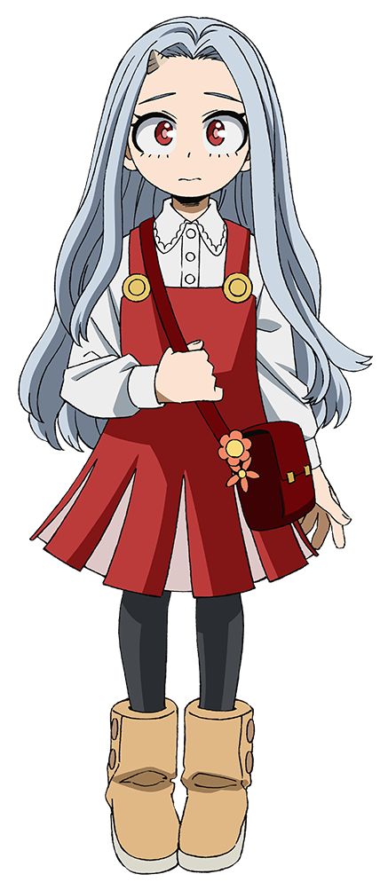
In awe of her surroundings, and still assuming this all to be but a dream, Eri was oblivious to the fact that her little horn had begun to glow a bright blue. She wanted to run over to see the unicorns, but something stopped her before she got too far. A tingling accompanied by a strange tightness. Her clothes felt almost suffocating?

“H-Huh?” Everything felt very tight, almost like she was about to burst out of the pajamas she had worn to bed that night. And this wasn’t actually too far off of an assumption, because the glowing horn atop her head had begun to grow. And her body? It did the same.

Like a sapling seeing its life cycle speed amped up by ten times, Eri’s body had begun to swell in every foreseeable way. Upward, outward; all with the apparent intention of taking her from child to adult in a way that sacrificed the integrity of her outfit. “A-Ah…! Nn…!” It was all difficult for the girl to process with the discomfort she felt, though.

The sleeves of her pajamas tore as shoulders became too wide, tatters raining down arms that were far too long to even wear those sleeves, while the waistband of the pants snapped thanks to the swinging of hips and the bloating of thighs and ass alike. Even Eri’s chest puffed up to sizable B-cups while her face matured, and her hair lengthened.

“Huh? Did I get bigger? No… Older?” She was hardly upset by the nudity that followed, and she was completely naked thanks to her explosive burst of growth. Rather, she was marveling at herself, cupping her chest and grabbing her butt with no shortage of curiosity. That curiosity was subdued by something else, though. The fact that the change had been more than physical.

She felt strangely adjusted to this body, and she knew things. Things she would have learned growing up. Things from school. General life lessons. Things about her body. And her personality had matured to match. “This is really strange. Is it all because of this dream?” That certainly made the most sense, but the woman had been so caught up in the rush and confusion of it all that she hadn’t noticed her horn. The fact that it was incredibly long now…

Nor the fact that it had moved into the center of her forehead.

Eri still believed that she was dreaming even after being transformed into the beautiful young adult that she had. Rationally there just wasn’t any other possibility, was there? This felt far too elaborate to be the work of someone’s Quirk. Yet she was dismissing the possibility that it could be the result of multiple Quirks working in conjunction with one another, which was exactly what was going on here.

The light of her horn was merely a side-effect of what she was enduring, and the woman herself hadn’t put two and two together that she was being manipulated in the first place. Still, the intentions of those who had aged her were not to simply make her older. In this state she was more dangerous than she had been as a child, for she now recognized how to use her Quirk properly. Aging her up was merely the first step, so that what came next wouldn’t be as awkward.

“I still want to go see the unicorns, though…” Her change in age hadn’t removed her interest at all, and seeing as she was entirely alone aside from those mythical horses, she was hardly bothered by her own nudity – even leaving behind the scraps of her clothes while she moved towards the animals across the fresh, green grass. Did she really want to see them, though? In some sense, she was almost being compelled to approach.

The woman became fixated on the herd in the distance as she moved forward – this fixation serving as an appropriate distraction for what was to come. Even now, her snow white hair was beginning to shimmer in a way it hadn’t before as it reflected the glowing blue of her horn, and that shimmer culminated in a different color entirely: a sparkling silver. It was only a few shades different from her natural color, and yet it wasn’t quite the same. Her locks also appeared to grow longer, and yet?

That wasn’t exactly the case. She was growing more of it, but not from her scalp. Instead strands to match the length of the hair atop her head had stretched out down the center of her neck and the peak of her back. There was something to be said about the quality of all of this hair, too. Whether it was the freshly grown batch or what had already existed upon Eri’s head, it all became coarser, losing even the softness afforded to her by her humanity.

With each step, the heft of Eri’s adult rear twitched behind her, rising up and down. This sight was gradually obscured by a new sighting of silver hair though, for a tuft of it appeared to sprout from above her tailbone before growing longer and longer still, ultimately dangling behind her thighs as it began to swish slightly from side to side. This was because a bone had protruded from just above her ass, thick at the base and very thin at the tip – granting a tail not unlike those of the unicorns in the distance that Eri was so focused on.

Despite the fact that she should have been able to feel this tail, and she in fact did, she was wholly incapable of registering it. “I need to get closer…” It was as if the woman was in a trance, entirely incapable of continuing to push forward no matter what, regardless of any anomalies that should have deterred her from the idea.

She may not have addressed it, but she did begin to feel strangely warm. Even though she was completely naked, it was almost like she was being swathed in a warm blanket. While she hadn’t suddenly been dressed, that didn’t mean she wasn’t developing some resistance to the elements, however. One needn’t look any farther than a series of small patches that had begun to develop across her skin.

These patches were notably whiter than her skin, to the point that they were, in fact, pure white. But it wasn’t exactly the color of her skin that was changing. Rather, fine hairs had emerged that were overall much softer than the coarseness of her hair. They were only a couple of inches long, yet the sheer number of them was so excessive that it left an overall softness that soon spread and merged together.

The end result was a coat of thin, comfortable fur that coated everything but her hands and feet. It obscured her navel and nipples, although in the latter case there was something much more at work there. Her now fuzzy breasts appeared to be diminishing in size, which was a shame because she had only just grown them. Her nipples disappeared into the void while her chest turned entirely flat, and yet? There was an exchange at work here.

Four nubs had appeared above her groin, roughly around where her bellybutton had been before her fur had grown in. They grew from the fur but also past it, growing longer and rounder at their tips into it was ever so obvious what they looked like. Teats. Not the nipples you’d find on a human, but something more akin to udders, albeit on a smaller scale. Once the teats reached full size, the skin beneath them swelled and sagged – fur retreating from the bright pink flesh that protruded only two or so inches. Were she an animal, this would indicate that she was not with child, nor had she recently had one.

Eri’s body had changed so much already, leaving her looking like a split between a human and some kind of beast, yet she continued to push forward. She had to be with the herd. She had to be. Her steps were becoming clumsier however, thanks to something that was happening to her hands and feet. Digits and toes slowly combined and hardened, the fleshy color and the accompanying nails blending into a blue hardness that glittered with an equivalence shared by the color of her horn.

The sparkling blue split her hands and feet right in two, better resembling hooves than their human equivalents at this point. This was more or less sold by the lengths of her feet shortening so that the hooves basically protruded right from the bases of her ankles, and from palms flattening vertically with a slight arch. There were no hands or feet now, only cloven hooves.

“Ah?” There were ramifications to having your feet suddenly become hooves, and it didn’t take long for Eri to soon fall onto all fours. Walking this way was initially awkward, and yet she didn’t stop her pursuit of the unicorn herd – even if it was already clear that she was destined to join it. The horn atop her head had grown larger than ever before, and had slid more towards her head’s peak.

Walking on all fours gradually became easier though. The human design of her body was slowly being chipped away at, and now? She was growing bigger. Height was certainly a factor thanks to legs – bones, muscles, and all – hardening to better accommodate a much greater weight while joints popped and swelled to properly meet a horse’s shape (such as her elbows inverting in the front). But weight was just as prevalent of a factor.

Eri was bloating. Already taller, she was also growing thicker and wider, but that wasn’t due to fat. It was muscle. Raw, undeniable strength that brought her body to thicken. Her stomach bulged forward but so did her chest, the two merely composing a singular torso that also included her now inconsequential shoulders. The sides of her body, running into all four legs, was completely smooth without any joins protruding.

Of course her chest thickened vertically too so that it could better accommodate her now large stomach and engorged heart – one big enough to properly pump blood through her hulking body. When it came to her ass? Her cheeks unfolded so that only her tail served to mask her genitals and butthole, her teats hiding beneath her underside.

Hooves clopped against the grass much more naturally now, and as a result Eri’s speed increased. Her point of view, on the other hand? It was rising. From the base of her neck down she already looked like a horse, and now the transformation had come for the neck up. Said neck grew taller and thickened to match her main body, muscles thick and firm beneath her pure white fur.

From that point on, she was rendered incapable of human speech. Not that she had felt compelled to use it for a little while now. But her face was being pulled forward not just a little bit, but an almost excessive amount. In the process her nose led the charge, widening as nostrils flared and deepened on the sides. In her mouth, teeth spread and flattened so that she had twelve incisors, all large and evenly distributed around a tongue that had grown just as massive as her new muzzle was. Completing it all, eyes found themselves more off to the sides and looked to be wholly black.

There seemed to be nothing left of her humanity physically, and her glowing horn stood at a whopping four feet in height.
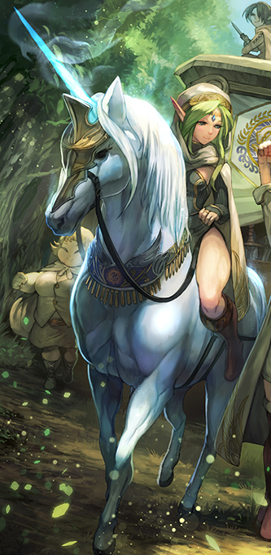
The broodmare unicorn’s cloven hooves touched upon the grass with no shortage of grace now, the mental state of the woman trapped within its equine form now wholly conformed to her newfound existence in every way imaginable. This field? It was her home. And the herd of unicorns off in the distance? As she made her way to them with one sparkling blue hoof after the next, she recognized them as her family.

Midst the herd, there wasn’t a single other unicorn with a horn as big and mystical as hers, nor was there a single unicorn with a coat of fur as pure white as her own. Eri was an outstanding specimen, the cream of the crop, and that was what made her the breeding queen of the herd. There were no shortage of stallions that would have desired to plunge into her, but she currently wasn’t in heat. The longest days of spring would soon be upon them though, and then this mare would be at her peak.

But for now she was hungry, and her herd was occupying the best grazing spot along the crystal clear lake’s edge. Guided by instincts more than anything, she snorted as she neared them. She would have her stomach’s fill, and the rest of the day would be spent resting. Because with her equine brain she couldn’t really process the specifics of it all, but…

She felt very out of sorts for some reason.

