Isn’t Life Strange

A Vignette

By Maryanne Peters

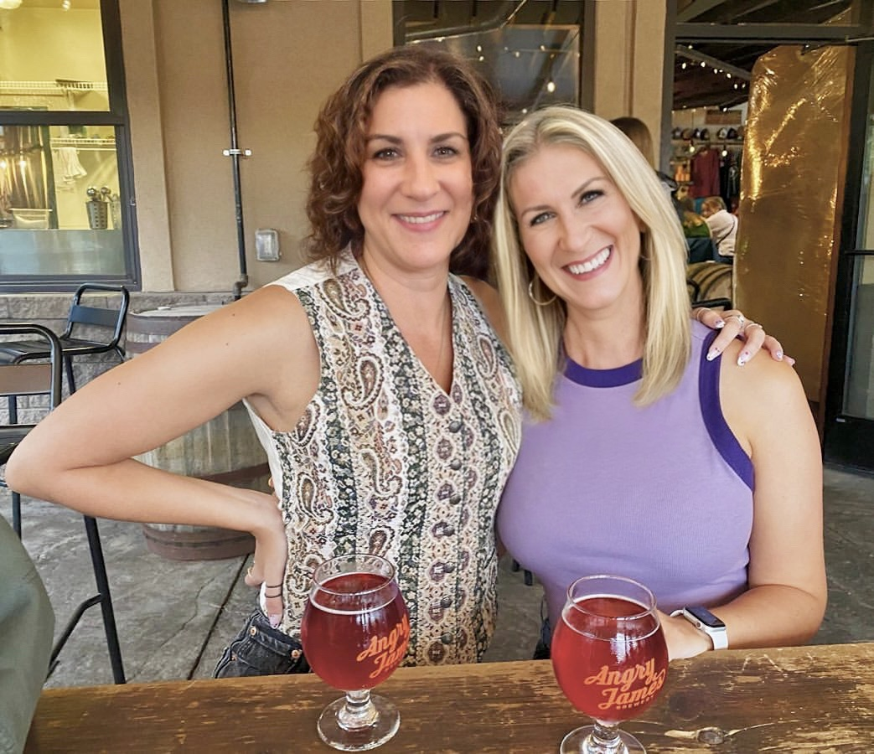

I was on holiday with my husband Mike and his two boys by his first marriage, and we were visiting a brewery in Colorado. They served what looked like a great lunch, so we sat down for a meal, to be washed down with one of their craft beers. I have to confess that I still prefer beer to wine, even after all these years post transition.

I need to go to the ladies room, and I was conscious that a large woman followed me in, but I thought nothing more of it until and sat in my cubicle and tinkled as ladies do. As I was washing up she came over to me.

“Excuse me, but I have to ask, did you go to John Bridges Hight School?” she asked.

“Yes I did,” I said. “Were we at school together. I am sorry, but I don’t remember you.”

“We did go to school together,” she said with a smile. “And we played high school football together too. I would have called us quite close in those days.”

There was no mistaking those eyes, and that smile, despite everything else about her.”

“Oh my God, Avery Thompson!” I suddenly realized that another cubicle was occupied so I dropped to a whisper – “Who would believe this!”

“It’s Abbie these days,” she said. “Abigail is such a feminine name, don’t you think? And I am guessing that you don’t go by Shane these days?”

“It’s Sharon, but people still call me Shay, the way you used to – remember? It is good to still have you own name to answer to sometimes.”

“You have a family I see, Shay,” she said. “I have t say that I saw you across the room and doubted that it could be you. I love your hair, by the way.”

“What about you, Abbie. Do you have a family?”

“I have a husband. He is hard to miss. Bigger than me. He was a pro-footballer so he just had to marry one. He is not that smart but he has a heart of gold and I love him to bits.”

“You haven’t thought about a family? I married into one, but adoption is an option”.

“My husband Rory has a big family. Nieces and nephews to give and receive love with no responsibility. We are happy.”

There was a flush and a woman stepped out of the cubicle and stared at us from the mirror over the basin before scuttling out.

“Let’s talk anywhere but here,” said with a smile. “Come and meet Rory.”

“Let’s do that,” I said. “And then let’s grab a drink and step outside to have a chat. I mean, so much has changed. I want to hear all about it.”

I waved at Mike while I crossed the floor to where Rory sat, a huge man with freckles and red hair cut in a flat-top.

“Honey, this is Shay. We went to High School. Come over and meet her family. Is that OK Shay?”

I took them over and made some introductions and then while Rory sat down to talk sports with Mike, we went to the bar and then took our beers outside where there were fewer people.

“Imagine if we had known back then that we were both trans,” I said.

“I wouldn’t have admitted it,” said Abbie. “I was fighting it like crazy. I never thought I could do this, until one day when I just had to. It was that or do myself in. Well, maybe not that, but I got married to a lovely woman and I ruined her life, so I was not going to let that happen again. But by the way you look I imagine you transitioned early?”

“Not really,” I said. “I pursued women too. We both did in high school, remember. I didn’t think of myself as gay. I never have. I have always been attracted to the other sex, so when I became the other sex my attractions changed.”

“I had a few crushes on guys in high school,” said Abbie with that cheeky smile again. “But I liked to crush guys on the gridiron so I buried those kinds of thoughts. I wanted marriage to fix me. It didn’t. It was awful, but I learned how to cry. I think that was what drove me to go ahead with in – knowing that I needed to cry like a woman. I do it all the time now … movies, bunches of flowers, morning kisses. I am easy to set off.

“You look great,” I said. “And your voice is so feminine too.”

“I still have my size to contend with, although I have lost all my muscle as you can see. But Rory helps me with that. Alongside him I could almost be called petite. People like to see that a big guy has found a big woman. Your husband Mike seems very nice, and it is clear those boys adore you.”

“They are into sports like you and me were,” I said. I can still throw a long pass and hit a baseball, you know. I am better than Mike at both, but I hide that from him.”

“Very wise,” said Abbie. “Men have fragile egos, right? Women like us in particular – we need to look after their self-esteem.”

“So true, Sister,” I said.

We chinked our beer glasses together and drank as deeply as we used to, just for old times’ sake.

The End

910

© Maryanne Peters 2023