MY DAILY SOLDIER LIFE AS A MONSTER GIRL
CHAPTER 3: JEANIOUS
BY CHALDEACHANGE
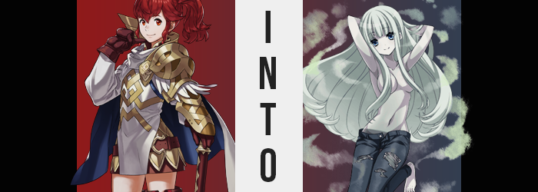

It was past midnight in Askr now, and Anna was doing her rounds on the city’s outskirts as one of her duties as a knight. She knew of Sharena’s disappearance earlier that day, and it was odd that the summoner had not contacted her as they usually did, but she was also bound to her route until her shift had ended. She was actually covering for one of the soldiers beneath her, them having come down with an illness several days prior. She trusted that Sharena wasn’t truly missing, and that the girl was just off doing some good somewhere in town.

“Hmm… I should go through the reports gathered today when I get back to the barracks. I wonder if any unusual phenomenon were noted in the kingdom today?” They had been enjoying a period of peace after their latest kerfuffle with another kingdom. Most would relax during a time like this, but it seemed that Askr’s luck was along the lines of ‘the moment we let our guards down is the moment that something weird happens’, and in this case that was more or less true as well.

She was scaling the top of the farthest wall of the city’s border, only the light of the moon and the torch in her hand to guide her, when something caught her attention standing a short way away. Their back was turned to Anna, but it looked like a young girl with her hair tied into twintails, fingers laced behind her back. “I knew you’d be here at this hour, Anna!”

The girl’s voice was cute, but those words were enough to put the soldier on edge and reach for her axe. The familiarity used, the claim of knowledge that most people did not have; it was inherently shady and worthy of caution. “Oh, did you? And what business might you have to go out of your way to see me here, alone?” Suspicious or not, she was still smiling. The chance that was just a little girl that knew of her wasn’t 0%, even though it was relatively low.

As the girl turned to reveal a single, glowing red eye though, she immediately realized she had made a mistake. Her body tensed up as it contacted the crimson, and weakness forced her to drop her axe to the ground. “My business? I’d just like you to eat a candy!”

“Bleh!? What the-!?” How long had she been standing there? A few minutes? Half an hour? From Anna’s perspective, it was as if she’d just come out of a trance with the taste of something putrid on the tip of her tongue. It almost tastes like spoiled meat, and that flavor traveled down the back of her throat and into her belly, where a dull pain seemed to be radiating. Radiation along with something else. “Magic!?”

Whether it was a spell or a curse, Anna did not have any means to distinguish between the two. All she knew that was, after one sharp release of its energy, all of her armor, cloth, and weaponry had completely eviscerated-

Wait, no. This time it was different. Rather than it all disappearing outright, Anna’s clothing and armor just seemed to fall from her body and hit the ground below her. Some of it falling even through her body. “Huh!? Whoa!?” Anna’s high energy led to a fitting reaction as she threw her bare arms up and to the side, looking down at a body that was completely naked.

Or was she looking through it? Her breasts were quite large, so she couldn’t typically see past them. But now? She could make out her legs and pelvis as if she were peering through her own breasts. Her body? It was completely translucent, a semi-solid in terms of appearance.

“Wait, is that right?” She could see as far as her feet, or where her feet should have been. But the clothing and armor was piled up there, and her feet were completely buried within them. Just by lifting a foot, though, she could free them without any resistance, and putting it back down again would have it phase back through. For some reason it wouldn’t pass through the ground, however.

Because her mind was subconsciously telling her body that there was ground there. It was a passive incorporeality guided by her perception of ‘things I can pass through, and things I cannot pass through’. As much as a part of her mind was questioning whether it was normal for her to be this way though, there was another voice telling her not to worry about it in the least, as if it were completely normal. It wasn’t, of course, but the candy within her belly’s perception dulling effects were just as strong as they had been with the Queen Bee and Mimic that were once the royal children. The captain wasn’t even bothered by her sudden nudity, not even an iota.

Naturally, Anna’s wavy, red hair had fallen down behind her with the tie that usually kept it in its ponytail now laying upon the wall’s stone floor. Her hair had not been impervious to its effects, and it appeared that an even greater influence was taking hold even as she looked around with confusion.

All of the waves of her crimson mane found an unwinding straightness, bringing the length to appear even longer by trick of perspective alone… at first. Before long, there was little question that her mane truly was lengthening, falling as low as her ass where it curved inwards toward her body.

Just as curious though was its color. A pale green began at Anna’s roots and swept like a wave straight down to the tips, all the while presenting a supernatural glow that saw its translucency all the more eerie by nature. Some might have called it ghoulish or ghastly in how it was alight, yet her pubes, dyed the same color, curled into a hefty bush, and took on the very same glow.

“Hmm… The light of the moon is… nice…” For some reason, the woman’s words were slowing. It wasn’t a difficulty of thought, her mouth was just conveying them with what felt like a subtle lag, eyes turned to the bright moon above. As the red of her hair had waned, so too did the red of her eyes. A blue possessed them, but the light of her irises faded at the same time. Somehow, they seemed lifeless, and yet there was a spark of mischief that danced around them at the same time.

It was the color of Anna’s skin that went next, but there was nothing even remotely natural about the color it took. At first it paled, but then as if she were a walking corpse, that translucent flesh took on a gray tone as well. Her nipples and pussy likewise took on these grayish-blue tones, but in their case the color was much darker. “Brr…” Cold suddenly, she held herself for warmth. But she quickly adjusted regardless.

Without even realizing it, the woman had begun to float. Not because she had intended on doing so, but instead because her body was collapsing inwards towards her belly as a focal point. This meant her arms and legs were pulled in towards her torso, which itself too became a little shorter from both sides. Had she any awareness, Anna undoubtedly would have felt dismay at this fact, because it also ate away at what she would refer to as her ‘voluptuous female figure’.

The weight of her breasts deteriorated immensely, for example. Likely pushing the realm of the D-cup (not that you’d know it with how her armor usually hid them), any excess weight that gave them their big and bouncy shapes was etched away as they throbbed. They grew a bit briefly, them when they regressed much of their original weight had been eaten. It continued like this for four or five times, until her bosom was a pair of large B-cups at best. To compensate for the loss of size on the other hand, they were impossibly perky and jiggled with every heave of her lungs.

Not that she even needed to breathe anymore. She wasn’t exactly alive, and a stilled hard supported that fact.

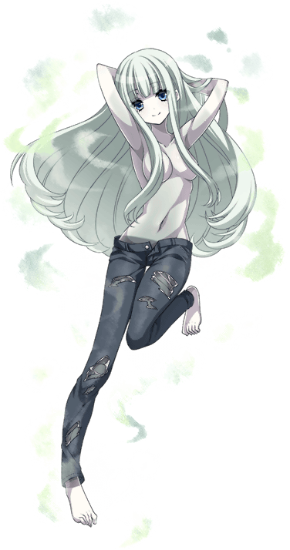
Much like her tits, Anna’s pear-shaped ass suffered these demerits as well. They weren’t as substantial as what had happened to her breasts, but the cheeks of her butt certainly diminished so that her hips could narrow. Yet, with her body short and thin, this ass stood out regardless. Paired with thighs that were still quite pleasantly plump, she’d clearly become an ass girl.

Not a woman, a girl. She appeared far too youthful to be an adult and was likely eighteen years old at best now. “Why am… I naked? At least…” With a voice that was much higher than normal, the Ghost glanced down at herself. Interestingly, she didn’t consider her exposed breasts a problem. Her hair was long enough that it covered them anyways! Rather, with a snap of her fingers, she summoned a pair of tight, torn jeans to her hips. No panties whatsoever beneath them, and they were so tight that they showed off her peach butt magnificently.

“Kukukuku… I see… I am… a… ghost…” The moon itself filtering through a body that was completely translucent short of the torn jeans covering her lower half, Rei the Ghost ran her fingers through her long hair slowly. She could not muster a means to speak properly, and so her words came out slowly and eerily as she just floated there. “I am… Rei…”

Perhaps her ability to speak had been impaired because she was a ghost? The undead could have problems communicating, after all. But as she looked down at her bare breasts below and gave them a little bounce by floating up and down, she remembered just how much she could influence the living. And how fun it was to play tricks on then. “With… my… body… Kukukuku…”

Stepping up the stairs leading onto the wall though, a certain Blackbeard sighed. “Are you really fixated on courting as well? What is it about our mistress’ spell that makes you all so kinky?”

It really was becoming an issue.

