DEMON STAYER
CH1: SUCCUBUST
BY CHALDEACHANGE
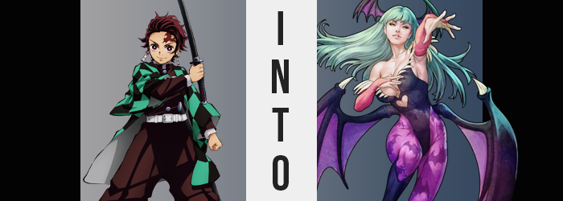

As of late things had been a little too quiet, but maybe that was for the best. After the incident with Daki and Gyutaro at the Red Like District, everyone in that incident had returned back to the small village that fundamentally functioned as the home base of the Demon Slayer Corps in order to rest and train alike. Weeks had passed since Tanjirou Kamado, his sister, and friends had all returned – yet there were no reports of any actions taken by Muzan Kibutsuji or his Upper Moons.

It was possible that even they were licking their wounds after losing another Upper Moon in the battle that had ensued weeks prior, but that didn’t match the actions of Muzan in the past. He was undoubtedly planning something, and without information about what, the Demon Slayer Corps were an unfortunate step behind. But they couldn’t have known that this plan of Muzan’s involved wreaking havoc on their own turf.

Tanjirou felt content, if not a touch restless. All of his wounds from the fight with Gyutaro had essentially healed up now, and it seemed that the treatments his friends were getting from the Butterfly Mansion had seen to it that they were almost all in ship shape. Which meant that it was only a matter of time before they were assigned their next mission and would be thrown into danger once again. That was what he was restless about. That, and the fact that Nezuko had been strangely quiet the past few days.

“Dark already… I guess I should hurry up!” Shaking off some of the fatigue from resting for so long, the young demon slayer had been out practicing his swordplay on the outskirts of the Slayer Corps’ territory. Returning to the Butterfly Mansion now that he was done, in order to check on his younger sister, was now his priority. Fortunately it wasn’t all that far away, and there weren’t exactly a plethora of dangers to deal with.

So at the sight of fog rolling in along the pathway home, Tanjirou didn’t even bat an eyelash at it. For all he assumed it might as well have just been completely normal fog. It wasn’t like it never got foggy in these parts of Japan or anything. “It’s pretty thick tonight.” At first this was all of the acknowledgment that he gave it. But his extremely sharp nose eventually picked up on something, and he stopped dead in his tracks.

“Wait, what’s this smell? It doesn’t smell right…” He couldn’t really place the smell, either. It was a little sweet, and a little like alcohol? The scent certainly suggested it wasn’t natural, but there was nothing like poison wafting amidst it. Was it harmful? “Maybe I should get back and tell someone about it…?” That plan of action made the most sense, and yet now that his feet had stopped? He couldn’t seem to get them to move any longer.

A shudder ran down his spine. Something was wrong. But was it dangerous? Well, he’d largely been paralyzed, so probably, but at the same time he couldn’t sense any menace behind it. There was no presence. Whatever was causing this, the culprit wasn’t here. “Damnit… I need to get back… to Nezuko…” He could still speak – barely – but it wasn’t enough to yell.

Since Tanjirou’s movements were limited and the fog was thick, it was difficult for him to observe his surroundings much less himself, which would very rapidly become a big issue for a number of reasons. And one of those reasons? Well, his skin was paling. Or perhaps it was better to say that it was taking a pale-pink tone? Not just that, but the skin evened out any blemishes, and that included beauty marks, scars, and callouses – and he had plenty of the latter two considering all of the combat he had been in. Not even the dark scar on his forehead was spared, for it faded just the same as the smaller knicks.

The change in color suggested something bizarre in actuality. The color that had been stolen from him? It was a piece of his identity as a Japanese youth, and the new color it had taken on was closer to something more common among Western people. But the skin didn’t need to insinuate this fact in silence, for there was a more damning confirmation taking shape. Or, well, reshaping.

Initially it was prominent in the shapes of Tanjirou’s eyes than anywhere, shapes widening and rounding so that the tighter arch of his lids had been undone – all while a green replaced the natural color of his irises otherwise. But it likewise saw his nose hook more sharply, and his lips thin… briefly. It was like he was becoming a Caucasian man at first, but the changes that saw his face changed began to lean in the wrong direction. That is to say they became more feminine.

His lips had thinned in shape, that much was true, but in turn they began to thicken in girth, with skin stretched to the point of a seemingly natural gloss that would surround their pink surfaces. These lips were pronounced, not like those of a girl but like those of a woman, and raised cheekbones and a narrowed chin helped with this impression. Lashes fluttered longer and brows thinned, ultimately leaving the shape and design of the boy’s face to look like…

Well, not like a boy at all. Like a woman that wasn’t even Japanese.

He wriggled his nose. “Something isn’t… Eh? What’s wrong with my voice? Why do I sound like this?” Tanjirou was still speaking in Japanese, but the sound of his voice was high and libidinous, almost sounding like a needy purr even though his words were panicked. He sounded like a woman, and that was making him uncomfortable. On the other hand… Is being a woman all that bad? Haven’t I always been one? A voice in the back of his head spoke to the contrary.

Adding to the impression that the demon slayer was in fact a woman was his hair. It was growing at an alarming rate, dancing against his shoulders and then eventually spilling to where the base of his spine roughly was. His bangs dangled forward to cover his forehead now, and they were swept evenly to either side. All of this came before a very stark change in color, with all of the strands lightening to a bright green that had a comparable vibrancy to that of Mitsuri Kanroji’s… just without the pink.

Of course this extended to all of the hair on his body.

Although… “Ngh!? Oh…” Both a shudder and a moan bellowed from swollen lips, legs mustering all of their energy to rub together through his hakama pants in response to a feeling that had been one part uncomfortable and one part pleasurable. “Did I just…?” No, she knew the answer. Her dick was gone, and a woman’s vagina had taken root beneath a bush that had inherited the same green as her hair.

And while her pants were big and baggy, perfectly concealing any change made within, that didn’t mean that there were no further changes taking place. In fact the contrary was true, with hips swinging significantly wider which in turn left her waistline to seem significantly narrower. This was to pave way for the bloating that was to come next. Hips had already stretched the gait of her posture so that her legs were farther apart and so there was a great deal of vacant space between each leg.

Space that was promptly eaten up by a surge of warmth that ‘attacked’ Tanjirou’s thighs. “Mmn…” She bit her lower lip, arousal building quickly. It was getting difficult to focus on the changes, and her mind was clouding over with a strange fog of acceptance. Why would she believe herself to be a human boy? That didn’t make much sense? Would a human boy have a pussy? What about thighs that were thicker than his waist? Because those were the thighs she now had – both soft and firm in all the right places, muscle and fat mended harmoniously.

And of course with great thighs came an equally great ass.

Cheeks had bulged almost gratuitously, pushing out the back of Tanjirou’s hakama so that their rounded shapes could be respected even with so much cloth overtop them. Shaped like a heart and flowing selflessly into her thighs, there was only one part of her body that could be deemed more remarkable upon a body that had stretched three inches taller. Well, two parts described with the same word, technically. Her tits.

And they grew fat. Beginning from nothing, her nipples, which were already erect, practically quadrupled in size as weight pooled beneath them, stretching the skin of her chest as they attempted to accommodate the heft beneath. They jiggled to attention, disheveling her haori from within and pulling it open in the front so that you could see the cleavage of her new E-cups. But were they knew? From her point of view, she had possessed those tits her whole life.

And if her sudden shift from boy to woman wasn’t shocking enough alone, a sprinkle of fantasy was soon tossed into the mix. For from a building pressure around the base of her spine? A pair of huge, bat-like wings of purple grew and expanded, tearing through the cloth of her clothes and leaving the rest to fall. She was effectively naked from the waist down, and with her ability to move returning, an immense strength pulled off everything above the waist.

There was also a second, much smaller pair of bat wings that emerged from the sides of her head.

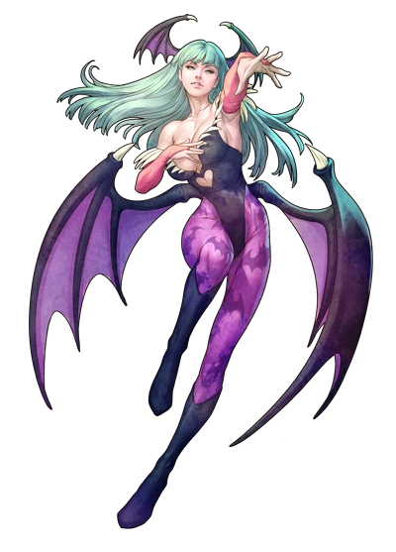
“Mmm?” Being a succubus, there was little reservation in the gesture of sensually smacking her lips as she moaned, hands freely exploring her new body with the demon slayer robes shed from her. There was little concern given towards her nudity from Morrigan Aensland’s perspective, which was certainly once again attributed to the type of demon that she had become. But while she certainly hadn’t been a succubus up until moments ago?

She found it hard to believe that she had ever been anything else.

The bat-like wings that stemmed from the base of her back stretched out, dislocating some of the thick fog that spurned her ability to see even now before it rethickened to replace what had been lost. “There’s something off about this fog…” Even now it was obvious to Morrigan, but she also sensed it would not do her any harm. It seemed it did not affect demons, only humans. “Although I do feel sorry for any humans that get caught up in it.” Of course she had been one of those humans. But that was how gone her old memories were.

Flapping her wings, the woman eventually rose up into the air with another lick of her lips. Her destination? “Somewhere clear. And somewhere where I can find some clothes.” Just because she was shameless didn’t mean she wasn’t cold!

