The Many Unexpected Dangers of Underage Drinking.

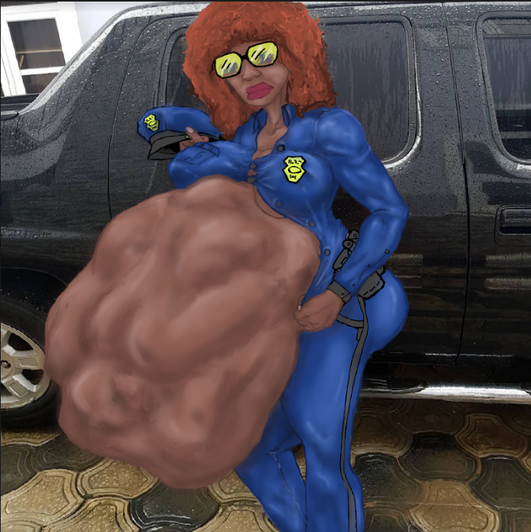

Monica was pacing her living room worried sick. Her daughter Keisha had said she was going to study at her friend Kim's house the night before and had stayed out way past her curfew. After calling Kim's mother and learning that Kim was asleep and that Keisha hadn't been there all night Monica began to freak out. At about midnight Monica decided to get the police involved and called to report her daughter was missing. Because she was 18 and although not a minor the police sent a local officer anyway named Simmons over to ask a few questions. Once Monica had given him a complete description on Keisha, he had her fill out some paperwork and sign a few documents before he put an APB out telling all police in the surrounding area to keep an eye out for her missing daughter.

Monica had laid down on the couch taking Officer Simmons’ advice to not panic, saying that Keisha will probably come home soon enough on her own. Despite her best efforts she snapped awake every time she dozed, listening for her phone or a knock at the door. It wasn't until the sun began to rise that her exhaustion got the best of her, allowing her to nod off on the couch. It five minutes into this shallow sleep Monica heard a car pull up into her driveway, and a car door slam.

Dashing to the her window Monica saw a large black and blue police truck parked in her driveway and a large large breasted Officer attempting to help her partner out of the passenger seat of the vehicle. Dismissing the other officer attempts to assist, a tall, ebony skinned Amazon of a police officer heaved herself out of the car. To Monica’s surprise the Amazonian police woman seemed to be immensely pregnant, with a massive trightly packed belly that protruded from her midsection, nearly dwarfing her large frame. The officer wore dark shade, although the sun was barely up and a grimace as she, now standing, tugged at her shirt that had no chance of buttoning past her large breasts, leaving her the gargantuan brown protuberance naked to the cool morning air. As they approached the doorway she saw them exchange a few words and the large bellied officer sneer. She then pounded her chest Belched loud enough to hear from inside before wholloping the side of her belly harder than monica would’ve ever expected a pregnant mother to. When the the officers knocked on the door Monica opened it with understandable reluctance.

“Good morning, Ma’am, Im Officer Dia Blackstone, and this is my Partner Officer Loretta Guerriera” the first officer greeted, “Are you Monica, mother of the missing teen the APB was issued about last night?”

“Y-Yes. I am. Is there new’s about my Keisha? Is she okay?” Monica said opening the door wider concern about her daughter wiping all apprehension away.

“Yes ma’am she is okay. But she’s quite lucky we got the APB when we did. But Ma’am, before we bring her out, could we come in. I’d like to ask you a few more questions and go over a few things you should know about.” Officer Dia sad, throwing a quick glance to her partner and then to her partner’s engorged belly, which churned loudly. Now that they were closer, Monica could see frequent movements beneath the surface Officer Loretta Guerriera’s exposed stretched stomach flesh. Officer Loretta sighed in response to her partner glance.

“May I use your restro-**oOORUP\*** ugh. Pardon. May I use your restroom Ma’am?” Officer Loretta asked upon entering the house behind the other two. After telling the big bellied officer where the restroom was located, right down the hall, Monica led Officer Dia to the living room where they sat.

**\*BUUURRROROORRAAAARP**…*Koff Koff* ...**HEeuurrrraaaakkk!**\* Echoed from the bathroom as Dia pulled up a chair sitting across from Monica unfazed.

“I-is your partner okay? I-I dont think its okay for a p-pregnant woman to be belching and all that” Monica said, looking down the hall concerned.

“Pregnant? Oh she’s not pregnant. The department wouldn't allow pregnant police officers to patrol. “ Officer Dia said nonchalant. “She just had a big dinner last night that’s not agreeing with her. Don’t worry, she’ll be fine. Now About your daughter….”

**\*BWOOORRRP…*haff haff* ...HUUURRRRRRRGGGLK\***

“...Loretta and I found her a few hours ago in the car with a drunk driver we pulled over. A guy, in his mid twenties. Rodney Delaney. Do you know him?” Officer Dia asked. Monica shook her head, clearly distracted with the ordeal going on in the bathroom.

**\*HIC-HHUUURGGGOOORP* *Wheeze*...*huff huff*...UURRRRRROOOUURRRKKGGG\***

“We didn’t think so. She was very drunk and when Loretta….secured…. the drunk driver for processing, your daughter attacked Loretta, and was also promptly restrained and secured with him for processing. Not long after that we heard of the APB and checking a wallet we found Keisha was the passenger. And so we brought her back here.” Dia said, grinning clearly proud of herself.

**\*HUUURRROK-URAAAK-GURRGLELRLGLEUgglkkglg…..**\* THUNK*

“Oh! She’s here!” Dia exclaimed as she looked up at what sounded like a heavy sack of potatoes being dropped on the bathroom floor as if it was the first and only sound that came from that direction. Monica stared down the hall, eyes wide with horrible realization as she saw Officer Loretta step out of the bathroom, her stomach still hugely oversized and swollen yet still visibly smaller than it was before. Although somewhat smaller, Loretta’s stomach contents were much more active now, as protrusions pushed out from all over, accompanied my muffled sounds.

“I hope that’s a lesson to ya kid...” Loretta said, into the bathroom as she walked out, wiping her mouth with a hand towel, beats sweat coating her face and neck. “...Next time you won’t be so **\*BuORP\***, lucky. Now apologize to your mother.”

At that Monica sprinted down the hall to the bathroom, almost pushing Loretta out of the way to get into the doorway. She shrieked with horror and relief as on the bathroom floor she found her daughter, curled into a fetal ball shivering and sobbing. Her body was coated with green and black bile, and coated with slimy mucous from her forceful trip back up and out of the esophageal shaft. Keisha’s clothes were torn and singed from her time in the unforgiving gastric cell and she only had one pink- half melted sneaker on..

“M-m-mommy…” Keisha said as her mother hugged her also sobbing on the floor, pulling globs of slime from her daughters shivering body.”...Wh-where’s Rodney? Did h-he come out t-too?”

We’ll ma’am, I see you and you’re daughter have some catching up to do.” Dia said popping her head into the bathroom, waving. “We’ve gotta get going. My partner here is anxious to get back to processing the drunk driving perp. No need to thank us. Have a good day.”

“No! Rodney!” Keisha suddenly blurted out.Though clearly still weak she tried to stand, but her mother held her back.. “Where’s Rodney? Give him back!”

“No, Rodney, is going to be processed. He broke the law and now he will serve his punishment.” Loretta said sternly, stepping back into the doorway, her swollen bouncing belly clearly visible to both mother and daughter as Rodney struggled inside. Keisha immediately scampered back pushing herself against the far wall, away from the man-eating Police-woman.

“If you’d like to file a complaint…” Dia started before being interrupted.

**\*BRRRAAAAAAARRRRURP\*** The missing pink sneaker flew from Loretta’s gullet, splattered against wall and fell into the bathtub sticky and smelly with stomach acid. With that Loretta walked away, heading back toward to the car. Better to leave now before she put that insolent thankless brat back in her now only half full belly.

“...Well I recommend you don't. Good day ladies.” Dia finished, leaving the two in their bathroom to contemplate the many unexpected dangers of underaged drinking.

The End.