HEART OF A KIJIN
COMMISSION STORY
BY CHALDEACHANGE
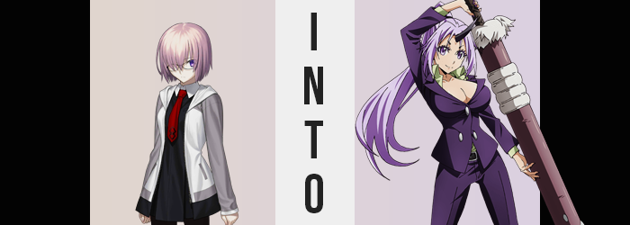

There had been a lot on the mind of Mashu Kyrielight as of late.

One of the topics had been the subject of her Master, Ritsuka Fujimaru. The sole Master of Chaldea… If you asked anyone in the organization, then nothing had changed about them at all, right? The orange haired woman was the same as she usually was. Working hard for everyone’s sake, nothing about her personality seemed to be amiss whatsoever. But it wasn’t the young woman’s personality that had struck Mashu as ‘odd’.

“Senpai was a man, wasn’t she?” It was a thought that the Demi-Servant couldn’t get out of her head. Her recollections of it were vague, but she could recall them being a dark haired male, not an orange haired female. Yet that was the Master Chaldea had, and no one she had expressed this question to seemed to agree. It didn’t matter if she tried discreetly lead them to questioning it, or if she asked them outright. The Ritsuka that they had was the Ritsuka everyone remembered.

And a part of Mashu wanted to believe it too. “Maybe this is taking too much of a toll on me…? My performance lately has been suffering as well.” That was the other issue that had been on the Shielder’s mind, but it was likely an unfortunate consequence of the first problem. She’d been so distracted not only by the perceived difference she saw in Ritsuka, but also the appearance of a katana wielding Servant she couldn’t find any record of. Whom, by the way, everyone seemed to think she had been summoned for a while despite it.

Being the only one who thought differently was slowly driving Mashu insane. It was weighing on her mental health, which in turn affected her results in battle. She was weaker simply because she’d been so distracted. And whether or not her senpai was supposed to be a man or not, it was still her responsibility to protect them, right? She was basically in between a rock and a hard place. “I wish I could be strong enough despite it all…” And she couldn’t exactly confide in Ritsuka about Ritsuka, sadly. Her Master would probably look at her like she was crazy.

And the worst possible person had overheard that wish.

The day had worn on as always even after murmuring those comments to herself, and before long? Mashu found herself returning to her room after having dinner in the cafeteria. She didn’t really have much planned for the evening aside from perhaps watching some television to distract herself. It would take her a bit of time to wind down before she could even do that though.

“I really wish this wasn’t bothering me so much! Am I the one who is crazy!?” There was another possibility that had crossed her mind, and it was one she was reminded of when she turned on the light to her room. The possibility that everyone had fallen under some sort of spell or curse, something that had rewritten history in their minds. It wasn’t impossible, right? Not after all the things that they had faced throughout their journey.

She was actually on the right track, but the issue was that she hadn’t really had any way to prove it. So long as no one believed her, she couldn’t get any allies, either. She was stuck between a rock and a hard place, and that had played into her despair. Looking around her room now that the light was on, though? She came face to face with an unexpected distraction. One that was unknowingly related to the problems she had been having in the first place.

Walking over to the object of fixation, Mashu held back from touching it at first. “A sword…?” Propped up against her wall, it was a big sword that was taller than even herself. Its hilt was smothered in white fur, and it wore a purple scabbard. “How did this get in here?” The doors to each person’s quarters in Chaldea were not only locked, but the walls were enchanted so a Servant couldn’t sneak in even in Spirit Form. The only ones with universal keys were da Vinci and her Master.

The sword gave her a strange feeling, though. The scabbard was radiating magical energy? No, perhaps it was better to say it was composed of it. A little curious and assuming it wasn’t harmful, the Demi-Servant eventually reached out to touch the scabbard. It should have been safe, right? And from Mashu’s perspective, at least at first. This really seemed to be the case. Yet by touching the weapon?

She’d created an invisible connection. A conduit that allowed magic from the blade to flow into her Saint Graph. And that certainly wouldn’t end well.

“Well, it doesn’t belong here… Should I take it to da Vinci-chan in the morning?” Mashu took off her glasses, which were purely for decoration anyways, and put them back on her nightside table after wandering over to her bedside. She could have taken the blade out now, but it had been a long day – and not to mention while she could carry it, the fact that it was taller than her meant that it would have been awkward for her to lug around. It would be better to just rest for the rest of the evening and move it in the morning!

Besides… “Ugh…” The Demi-Servant felt a splitting headache coming on. Demi-Servant status or not, she was still prone to the odd malady. Headaches weren’t very common, but they did happen. And so at first? As she sat down on her best with thoughts of resting before she got changed into her pajamas, there wasn’t really much of a reason to ponder why her head might have been throbbing. It wasn’t until the pain became more centered that she thought to question it, a hand reaching up to rub the tension point.

What was odd about it? The location. Rather than the sides of her head, or even the back, all of the pain ultimately ended up focused on the center of her forehead. This wasn’t exactly a normal headache spot, at least not for her. Not to mention there was this strange building of pressure that didn’t at all make any sense. She’d had plenty of migraines before, and never had she ever had anything quite like what she was feeling in that moment.

“…What?” And so her lips parted with surprise when she recognized just how abnormal it actually was. Her massaging of the pressure point had uncovered something. A lump? It didn’t feel like a bruise or even a cyst. It was too hard, almost like bone was rising beneath her forehead’s skin. “That’s… impossible.” At least it should have been, but tapping on it with a finger, it became clear that the tip was not only pointed, but it had pierced her skin. “U-Um!?”

Mashu stood up again and her second hand came up to her head. Yet no amount of contact from her fingers could prevent this protrusion from getting larger and sharper. Something growing out of her head like this? It could only be a horn. But why? “Am I becoming an oni!?” All of Chaldea’s oni had horns, so it was the first thing that came to mind. She ran over to her full length body mirror while struggling to cover the growth. And it was obvious as to why. The black bone now jutted out about six inches, curved up into a sharp point. “I… need to tell da Vinci-chan!”

In a case like this it made sense to run off to the Rider. She’d know what to do, and Mashu could already see things worsening beyond her new horn. Its appearance had parted her bangs in the center now, but she could see her hair getting thinner and longer alike, strands spiraling down past her ass. Perhaps just as noticeable was a change in the colors of her locks that extended to her brows and pubes. The general purple tone was retained, but it was like the vibrancy of her hair had been turned up to eleven.

The same could be said about the purple of the Demi-Servant’s eyes. Eyes that flickered around the room as she found herself struggling to piece together what her plan of action was supposed to be. “Wasn’t I just about… to go somewhere?” She was certain it’d had something to do with her transformation, but she couldn’t remember where. Why, even? Something deep down was telling her to just stay put. An instinct, maybe.

She wrinkled her brow, a brow that was in the process of changing itself along with the rest of her face. The purple of her eyes brighter now, their shapes were actually leaning more towards those of a Japanese woman with how they had narrowed. A similar trend saw fit to refit the rest of her facial features, with fuller cheeks and lips upon a lowered jaw. More than making her look Japanese though, she looked older. The swell of her lips and the look in her eyes were both certainly indicative of a woman that was physically in her late twenties.

“I was going to… dote on Master?” At the very least, the plan she expressed with a deepened voice sounded like a good thing to do, but it still didn’t sound right even if some large part of her believed she wanted to go do that instead of lounging around her room. That instinct from before kept her rooted, however. If she’d left mid-transformation, regardless of how aware of it she still was, it might have caused problems if someone noticed before the Chaldea-wide memory alteration had taken place.

A sharp exhale accompanied a strange stumbling of the woman’s feet. She struggled to maintain her balance for a moment, and as for the why, well, it was pretty blatant. “Huh? Was I always this tall?” Her limbs had certainly stretched, as had her torso. Three additional inches had been applied to her overall stature, making it so that she was 5’6” and so that her tights had been pulled down so that they were stuck on the center of her butt cheeks, skirt lifted a little higher. “Maybe I always have…?”

Was it all that important? It didn’t feel like it to her. Wouldn’t this energy be better spent on training or spending time with Ritsuka? While pondering this conundrum, her body continued to change into a form that was increasingly ‘monstrous’ in very different ways. In the more literal sense? Her fingernails had become sharp like claws, and her canine teeth were soon better described as ‘fangs’.

In a less literal sense? Well, there was nothing as monstrous as an excessively buxom woman, was there? And that was exactly the image that was taking shape upon Mashu’s frame. Her waistline pinched in even further than it already was, but as if to compensate her abs became much stronger and deeply defined than they already were. This trimmed gut not only left the impression that her hips were wider, but they legitimately stretched several inches wider as well.

“Mmn…” It was a strangely sensual moment, for not only these widened thighs, but extra meat applied to the shape of her rump fought against the smaller fit of her underwear and tights. Once compact cheeks swelled fuller, and each inch of ass forced her panties deeper into the crevice between them. But this also meant the cloth in the front was flossing her pussy and the purple bush above it. She bit her lower lip, tights slipping down yet getting caught again on hips that were fuller both with fat and muscle than they had been before.

And yet? The growth her cheeks and thighs succumbed to was mediocre when compared to what befell her bosom. Mashu already had a fairly abundant chest size for a woman of her age and build. To describe the breasts that swelled from these ample beginnings as ‘voluptuous’ might have almost been a disservice. Her dress struggled to maintain them as they ballooned, the front of her bra snapping long before any of the straps that supported it could. The muscles in her arms and back rippled to accommodate the G-cups that ultimately sat proudly upon her bosom. “Why is it… so hard to breathe…!?”

Was it not obvious? Perhaps not to the woman whose memories and personality had slowly been absorbed into those of a new being. As far as she was concerned? This was how her body had always been, and so it had to be her clothes that were crushing her lungs by pressing her huge tits into her ribs. Not that it took very long to resolve. Cloth scattered into particles of gold, leaving her sexy body naked and allowing her to breathe a moment.

Those particles found their way back to her body a moment later, their magical composition forming new duds. A purple suit with a neckline so low that it almost fell down to her nipples and showed off her tits, hiding a green, unbuttoned dress shirt and no bra. Matching boots on her feet made sure she kept her professional look, properly fitted panties hugged her loins, and her long, purple hair had been swept up into a ponytail.

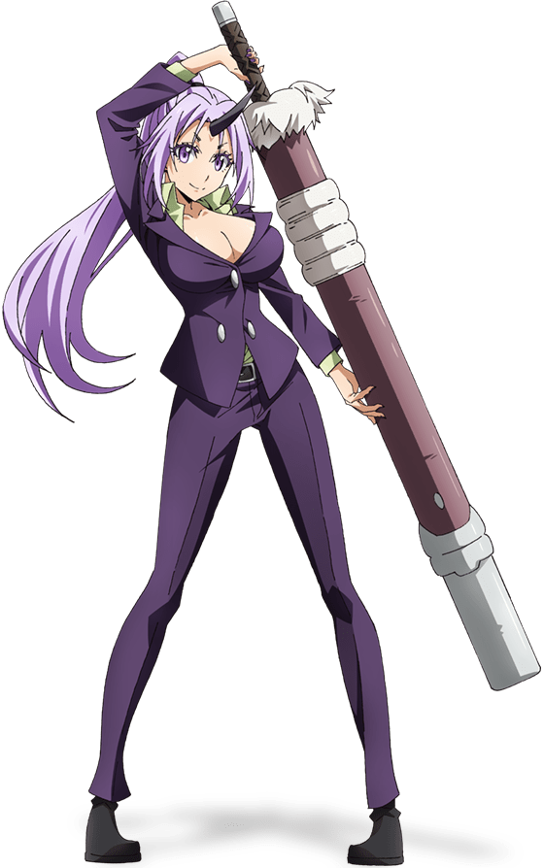
“I… This isn’t right, but…?” It appeared that the tall, buxom Kijin woman had yet to be fully assimilated by her new memories. At least thus far. Hands pressed against her own body through the fabric of her new suit, both shocked still and simultaneously savoring just how strong she felt and how sexy she looked. Her breasts were so big, and she was so tall! Most women wouldn’t have much to complain about in situations like these.

Deep down she understood. Her old Master? Kagura must have been him. He had been transformed like she had, but then who was the Ritsuka Fujimaru walking around Chaldea now? The thought should have made her upset, but just thinking about her Master stirred a different set of feelings. Pride, loyalty, the desire to protect without questioning it. How could she doubt Ritsuka? All she wanted to do was smother her with her affections like a good big sister!

Something that put her at odds with Raikou, as she could vaguely recall. The two were constantly fighting for their Master’s attention, and since they had similar builds it was a tireless fight. “N-No, these memories aren’t right, I can’t—” It was disorienting, but she stopped herself from falling too far down the recollective memory rabbit hole. If she fell too deep she’d forget, right? That there was a threat to Chaldea transforming it from within!

But fate had other plans. It didn’t want Mashu to remember, seemingly. The woman hadn’t thought much of it, but the memories that had already surfaced, along with her new personality, had ultimately guided her to grab the sword’s hilt since she was tall enough to carry it now. She hadn’t thought anything of it because she had the vague sense that she always carried it. And the moment she touched it? One final injection of magic from the blade targeted the remnants of her past self, leaving Shion a touch disoriented.

“Huh? What was I so worked up about?” Was it something important, maybe? The Kijin Berserker felt like it might have been, but since she couldn’t remember? She ultimately shrugged it off instead, fastening her blade to her back. “Oh well! I should go find Master! I bet she’s exhausted after a long day! I bet she needs a good pillow to help her relax!” Like her lap, for example?

“That was a close one! I can’t believe Mashu had almost caught on… But that should be dealt with now.” Occupying the bedroom of Chaldea’s Master, “Ritsuka” leaned back in her deck chair with heels kicked indecently up on her desk. This wasn’t the personality she presented publicly, but that was because that was all an act. She wasn’t actually Ritsuka. She was BB, having disguised herself as a Master after transforming the original.

“But this wish granting shtick isn’t so bad… I wonder if anyone else has any wishes for me?”

