BOTW: WITHOUT BLESSINGS
FINAL CHAPTER: BIG AND BEAUTIFUL
BY CHALDEACHANGE
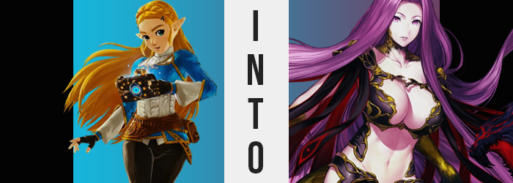

Confusion. Panic. Fear.

This was only a taste of the feelings that had been swirling around in the heart of Princess Zelda when the sky had turned red, indicating Calamity Ganon’s arrival. So much of her life had been dedicated to seeing to it that the entity’s plans to destroy their kingdom would not succeed, and yet time and time again she had been met with obstacles. It had been a great find when she had uncovered the Guardians, and she considered it to be among one of her proudest accomplishments, and yet…

She had been incapable of awakening the power that laid dormant within her. The very same power that had been passed down from her mother, and from her mother before her. For each Princess Zelda was meant to take hold of the light so that Ganon might be staved off. But she had failed. Time and time again, regardless of how many sacred locales she had visited, she had been unable to awaken her dormant powers.

And the end had come too soon. Almost like it had been waiting for her final failure. She had already felt defeated enough, and so to find herself teleported away from everyone else? Well, it might as well have been the final nail in the coffin.

“Is this beneath the castle?” While not entirely sure where she was, her dimly lit surroundings did strike some chords of familiarity. She was in a very big room, and the brickwork was very reminiscent of the castle she had grown up in. Yet this room was much, much too big to be on the surface, much less used for anything good. It was so empty and didn’t appear to have any exits that she could see. Almost like it had been designed to keep something in. There was also the question of what was lighting the space. Torches? No. it almost seemed as if the stones walls themselves with self-luminating.
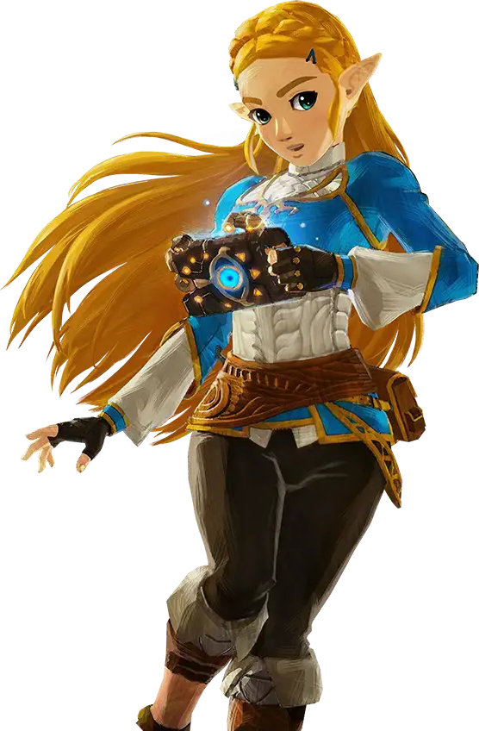
She knew not of what was transpiring outside. Had the others managed to get to their Divine Beasts? Was Link okay? These were questions that she didn’t have answers to, and while she felt defeated? She also knew that she couldn’t give up. For how hopeless it all felt, as the kingdom’s princess she had an obligation not to give up. And so she had to take a step forward and find an exit. Except the moment she tried to take that step?

She was met with resistance and the sound of a rattling chain.

“Huh!?” What? How? When? When had that long chain been clasped around her ankle? It seemingly fell into a small hole in the room’s center, and was evidently designed to keep her from escaping. But who had put it on her? It most certainly hadn’t been there when she’d first gained awareness of her teleportation! Try as she might, she couldn’t shake herself free or pull them loose. It was firmly mounted to her leg. “This is impossible!? When did that get there!?”

Crouched down, the girl gasped in surprise and recoiled after catching sight of the tips of the fingers upon the end doing the pulling. She had initially thought that there was dirt or worn rust upon them from all of the yanking, but after fingers slipped and she pulled them up to get a closer look? She realized that hadn’t been the case at all. The fingers exposed by her fingerless gloves had become covered in something black and scaly.

No, that was exactly what they were covered by. Scales. Like those on a reptile. A lizard? A snake? It didn’t matter if she got more specific about what, it was all in the same vein. They continued to spread up past her wrists, all the way to the bottom of her elbows. But not all of these scales were black, because the scales on her upper arms and fingertips shone a golden yellow – while fingers not only lengthened, but developed nails so long and sharp that another word better described them.

“Claws!?” Staggering while upright, Zelda raised both of these monstrous hands before her. Her mouth opened wide during this exclamation, and in doing so revealed that her canine teeth had likewise sharpened into a set of fangs. Her tongue had even lengthened slightly, but there was too much alarm when it came to her hands for the princess to really notice that.

What went just as unnoticed was that these scales had appeared elsewhere across her body as well. Some of them, at least golden ones, appeared on her neck and the sides of her face. Others? They saw her feet and lower legs transformed in a manner similar to her hands. Contrary to her arms though, the scales that emerged there were largely gold, and extended all of the way up to her thighs beneath her tight pants.

Zelda, on the other hand, was still alarmed by the sight of her hands. “This can’t be happening… They look like they belong to ssssome kind of monsssster!” Why had she begun to slur her Ss that way? Technically speaking, not even the demonic woman she was becoming was one to slur like that, but the crimson corruption from the sky was so intimately focused on Zelda with purpose. It didn’t want to give her a chance to hold onto any semblance of reason, and so her mind was quickly succumbing to primal urges. That meant becoming more like a monster in nature. And that her intellect was draining much faster than she realized.

All while the physical aspects of what she was enduring became more prominent. After all, had she always had that growth peeking out from between her pants and shirt? The one that appeared to be growing longer and longer as golden scales covered the top and black grooves lined the underside? It was most certainly a tail, but it resembled the body of a snake more than a typical reptilian extension.

“Graaah! I’m! SSSSSSO! WHY!?” The princess felt less and less like she was in control of her own body, and clawed hands reached up to grab her head as a strange feeling welled up from within. What was this? Why did she feel so strong? Why did she feel so powerful? For as unstoppable as she was quickly believing herself to be, she was indeed powerless to notice that the golden locks her claws ran through were not only growing long and thick, but a dark purple quickly weaved among it. Before long, this dark purple fell even to the ground, but much it?

It melded together at the tips, darkening as crimson sigils kept them all together. These merged strains ultimately let loos growls and hisses, as maws were formed complete with fangs of hair. Five beastly snake heads had been fashioned from what was once normal, purple hair – and that hair obscured her long, Hylian ears.

“GRAAAAA!” The girl’s eyes shone a supernatural purple, harkening in the next phase. The sound of cloth ripping and tearing became the only sound in the cavern aside from her ghastly screams, her flesh and bone expanding at a consistent, yet alarming rate. Zelda was growing, making great use of the ample space in the cave as tattered cloth was shed from a body that, well, didn’t look quite as consistent halfway into her becoming giant as it had near the beginning.

It was evident that her frame had become lankier, yet bare flesh also revealed that her figure was taking on curvature that was far more adult at the same time. For example? Beginning with an engorging of her once fair nipples, the pale skin of her bosom beneath was ultimately stretched as her breast filled with an enticing fat. Before long, they jiggled with no shortage of supple appeal, each tit comparable in size to her head. With her height continuing to grow though, each breast was likely larger than a house.

The same could be said of her ass, really. The princess’ hips were pushed apart as obscenity saw her cheeks swell. Any trace of purity in the girl’s appearance was overwritten by a maturity that was overwhelmingly sublime in its lewdness. Thigh swelled plump, cheeks took on perfect curves, and an unkempt bush protruded above her pelvis. But for all she looked the part of a beautiful, sexy woman, her mind was mostly that of a mindless beast now.

Her claws fell to her sides as instinct calmed her down somewhat. Yet she still snarled with a face that looked significantly unlike what it once had. Her features had matured more towards those of a woman in her thirties. One with plump lips and a naturally lustful gaze. Or at least it would come across that way if not for the lack of reason that shone in her violet gaze. A gaze that had become oh so dangerous to look into.

Unless you wanted to be turned to stone, that is.

While largely humanoid in appearance, the monstrous woman of over one-hundred meters in height let out some nasty snarls and growls as she lashed out against the pull of the chain binding her one leg in place. Ever so slightly there was the presence of Zelda’s will deep down, but all it amounted to was her desire to escape. Her soul had become completely distorted by the same phenomenon that had transformed all of her friends, yet the red light of the sky high above the prison she had been trapped within had saw it fit to rob her of her reason.
Because of the powers possessed by her bloodline, she was much too dangerous to allow freedom, much less any manner of will. Her personality, which had been corrupted over her transformation, nonetheless, was blatantly drowned out by almost demonic impulses to feed, destroy, and terrorize. Yet the Gorgon was incapable of doing any of these things. “RAAAAGH!”

The chain that bound her had lengthened and thickened as she’d grown, and it was much too durable for her to break. This left the snake giant to thrash about aimlessly, at least until she inevitably grew tired. This honestly felt a little extreme even for the will of Calamity Ganon, but there was a reason for it. The evil had sensed that some of its creations did not support its cause, and an interloper had even slipped in from the Twilight Realm.

If it found and freed Zelda, then there was a chance that memories could be returned to the serpentine princess, and then its hold could be undone. Calamity Ganon wanted to prevent that, and was willing to take every step short of death to prevent that. Because there was something it needed from the princess, too.

So far beneath the castle, it was nigh impossible for one to find the chained Gorgon – particularly now that corrupted Guardians had seized the castle perimeter. Even if she was found, who would assume she was Zelda, mindless as she was? There certainly wouldn’t be much desire to free a creature that yearned for such destruction.

But then again? Midna wasn’t a normal person.

There was a chance this realm could be saved. But that didn’t mean the damage done could be reversed. Including what had befallen the Champions.

