ADRESTIAN INTERN
COMMISSION STORY
BY CHALDEACHANGE
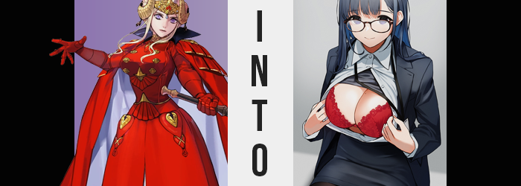

Edelgard von Hresvelg was the emperor of the Adrestian Empire, one that had thrown the entire continent of Fodlan into war by declaring open opposition to the Church that ruled it five years ago. Needless to say, the woman had earned herself no shortage of enemies as a result, even though this was an Edelgard who had the support of Byleth Eisner and certainly wasn’t as corrupt as she might have been otherwise.

All manners of attempts on her life had certainly been made over the years. Whether trying to fell her in battle, or assassinate her from the shadows, all of these attempts had ended in failure. And those that opposed her? With time they became more and more desperate. Some eventually resorted to black magics of the likes they could hardly wrap their minds around to varying degrees of failure,

And even though Edelgard had aligned herself with Those Who Slither in the Dark, there were still members of that group that did not trust her and would prefer to see her conquest thwarted. It was through the hands of one of this faction’s mages that Edelgard was eventually removed from Fodlan’s stage once and for all.

Despite being the leader of the rebel faction, Edelgard was still humble enough to reside in her old dorm room while using Garreg Mach as their base of operations. Some of her advisors saw this as problematic, for security was much weaker there than if she were to take Rhea’s old quarters in the main building, but the emperor was insistent. If she wished to understand her soldiers, she had to live as one of them.

In this case, it had truly been a mistake.

“What? Where am I?” Nothing but questions escaped the emperor’s lips as she looked around at her surroundings. She had returned to her dorm room, but the moment she had stepped in? She certainly wasn’t within that familiar space at all. The world around her held no color, but was likewise full of motionless people, likewise free of color. Like she had been placed into a monochrome prison. Had she fallen into an enemy trap?

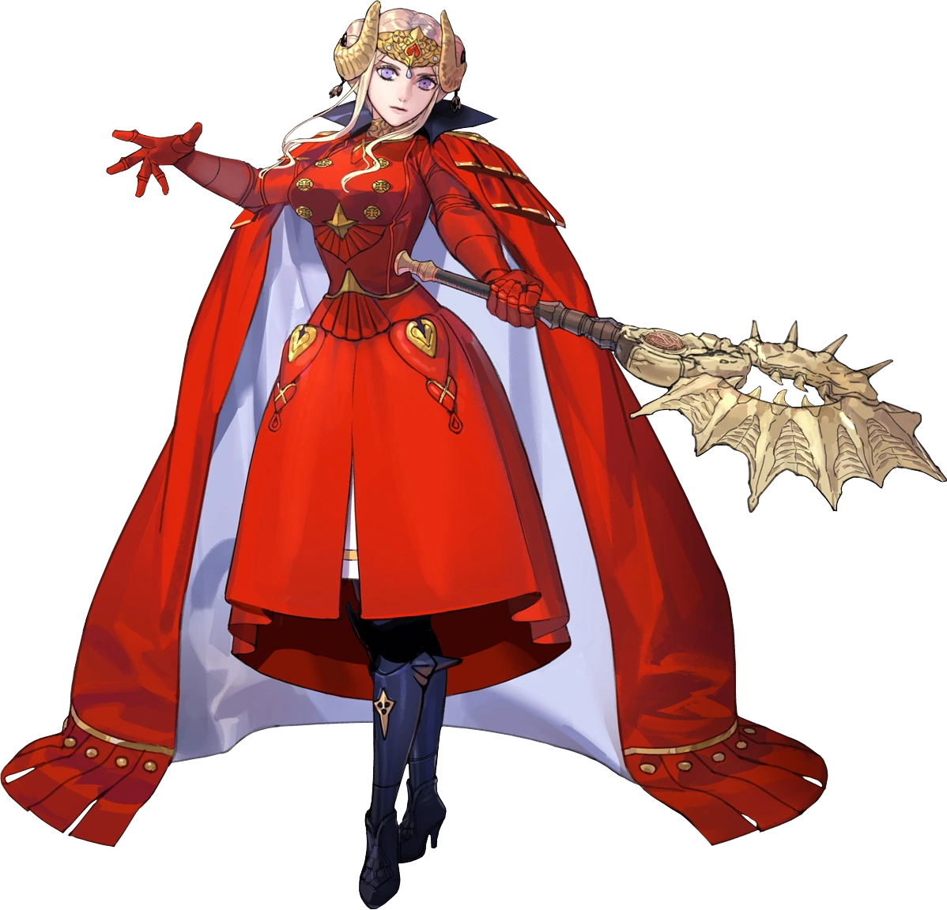
But Edelgard herself? She was still clad in crimson (although in less than normal, as she’d gone out without armor that day), and she had her full range of motion within this space. A space filled with people sitting down at desks within tiny, cube-shaped booths. Most of these people were dressed similarly and were staring at what she best assumed were mounted images covered in words and numbers she couldn’t comprehend for they weren’t scribed in a language she was familiar with.

She had actually appeared in one of these booths, and so she examined it closely while a bare finger traced the desk. There appeared to be a name plate of some sort there. One that, at first, she couldn’t make out. But the wording, suddenly, made sense to her. “Himawari Eiko? Wait, I can read that?” Violet eyes narrowed. This was all far too suspicious.

Time magic was clearly at work upon her surroundings, but how had she ended up in this location? Some sort of displacement spell? But even if that were so, this place didn’t at all resemble Fodlan in any capacity, nor did she believe that any kingdom across the sea might bear such an aesthetic. Had she had her axe at her side, Edelgard did not doubt that she would start smashing everything with the intent of unraveling whatever this was.

But unfortunately that axe was not at her side, and the emperor in question had begun to deal with a sudden impairment. “Hm?” In the beginning, she hadn’t been sure that what was happening actually was happening, but her near perfect eyesight had blurred a little. The black and white details of her surroundings all muddled together, for her vision quality grew worse and worse still, until she couldn’t make out much of anything. Yet she wasn’t dizzy, nor was she ill.

“What is wrong with my vision?” Still within the cubicle, she knew that if she stepped too far forward she would bump into the desk with the strange scroll upon it. But she found herself approaching nonetheless, and without thinking about what she was doing, Edelgard gently lifted something off its surface, unfolded it, and settled it upon the bridge of her nose. Her vision immediately clarified, but the woman was left dumbfounded. “What did I just…? Glasses? How did I know these were there? How is it they’re helping my vision?”

She stood shocked, for she hadn’t even noticed them sitting there when she had first looked around, so how could she have known to grab them? Not to mention she had never worn glasses before since her vision should have been fine, and lenses were something of a luxury item back home. Did this mean her vision had gone? So suddenly?

But the extent of the problem was not one she could properly see without a mirror or some sort of reflective surface, for her eyes themselves did not look right. The unique violet glow of her irises had faded along with her 20:20 vision, and instead a dark, almost silver tone had stolen away their light, so her gaze appeared dim. Her irises barely stood out as a result, giving these eyes an almost vacant look to them – suggestive of some sort of depravity perhaps?

Color alone wasn’t all that had been adversely affected, though. Whether she realized it or not (she didn’t), the shapes of her eyes deteriorated, losing some of their roundness in exchange for some additional width. The slant of these eyes spoke to a different racial background than the European equivalent she had in Fodlan, one that was common were she close enough to look at the faces of literally anyone else in this office.

Her nose wriggled, and with it the nose’s tip flattened to a degree, scrunching closer to her face while nostrils widened. Her lips? They became plumper and stood to headline her face, with a gloss sticking to them from nowhere. Eyeliner traced her eyes as well, with lashes growing extensions via mascara. All in all, she looked like she had dolled herself up for someone. Yet with her slightly heavier cheeks and the overall altered look of her complexion, she was not dolled up as Edelgard.

If not for the rest of her body remaining how it was thus far, she would have born absolutely no resemblance to the Adrestian emperor she was supposed to be.

Though she also looked a little younger. Around twenty?

These remaining visual cues were quite simply on borrowed time though, as her hair soon showed. How much suffering had she endured for her hair to lose its color entirely? How many siblings lost? How much pain had she been subjected to? Edelgard knew the answers to these questions because they had haunted her every single day since this hair had whitened.

Yet, even then, color returned. Beginning at the tips of her mane, the white darkened into a much healthier tone. Had she noticed, this might have been a point of joy for the young emperor who thought her humanity to be lost. But it would only be a passing moment of elation before she’d eventually realize the inevitable. That, while color returned, it was not the same brown she had possessed as a little girl. It was a much darker shade instead, almost black, with dark blue undertones. Not much time was needed to see its entire saturation shift, but with her hair tied up as it always was, there wasn’t much cause for her to notice.

“I… Why did I just freeze up? Something is… wrong with me? I-I’ll get in trouble if I’m caught doing nothing though! No, wait… I don’t belong here! I’m the emperor of Adrestia, not some subservient little…” Little what? What was this place? The words on the scroll – no, the computer – she could read them fluently now. And the people around her? Despite not knowing them, she could start putting names to their faces. Her ego was in shambles, and her confidence was dwindling.

All the while, her regal Adrestian garments showed signs of the mundane, bright crimsons paving way for dark blues as the material evened out and her layers changed by design. Her jacket loosened while losing the golden buttons that decorated its breast, ornate eccentricities lost until it was little more than a modern, blue suit jacket.

Beneath, her worn-down undershirt separated into several layers, extra fibers born from nothingness to create a white, button up dress shirt over a gray undershirt of a crimson bra that appeared to be several sizes too big. But that was a trend with all of Edelgard’s new upper wear, because it seemed to be crafted for a taller woman.

Edelgard could only watch in awe as the crimson skirt of her usual ensemble was dyed dark blue as well, its length receding until it hardly covered her thighs – not that it mattered, for boots below stretched up and thinned into black tights, while modern heels were made of the foot portions. The last wardrobe change involved her hair, which fell straight behind her without her horned crown to keep it bound. “These clothes aren’t… 私は何を着ていますか？” What am I wearing?

Immediate pause was given. “私の声はどうなりましたか？ 私は何語を話しているのですか？” What happened to my voice? What language am I speaking? Two switches had been flipped. The first took all of the power from her voice, leaving her to speak softly, while the second had robbed her of her native language. Instead, she was both speaking and thinking in what she now recognized to be Japanese.

So much was changing at once that it was difficult for Edelgard to keep her reality straight. Something that had struck her as odd just seconds ago would suddenly be seen as normal, and she would be left wondering what she had even found strange. She’d already forgotten that her language had shifted, and she could remember learning Japanese in school. She’d been such a shy student, but she always had good luck with boys because of her nice body even if she was both plain and a coward.

Almost like it was responding to the differentiated recollections her consciousness was putting forth, the Japanese woman’s physical form began to bend further. She grew several inches taller, lifting the suit jacket and her pencil skirt so they sat much more comfortably (and revealed more of her tights-covered thighs), while all of the iron muscle she’d forged for the sake of her war against the Church? It gave way, flesh left soft and supple. Which made sense, as she had never been particularly good at gym class. In fact, she’d always found it annoying because of how her big breasts flopped about.

“Nn!?” Right on cue, the sensitivity of her bosom was enhanced, almost as if it had become that way from being fondled every day for the past ten years. Whether it was her classmates at school, or her higher ups at works… Well, doing things like that often got her a free pass. The depravity in her eyes was beginning to make a lot of sense.

But Edelgard was only made aware of their sensitivity because the breasts themselves were heaving. Nipples were erect and rubbing up against the underside of a bra that just moments ago had been several sizes too big. Then and now were different periods of time, however, and the skin around these tits became taut as the flesh engorged itself, perky F-cups shaped through an additional weight that made her weakened muscles ache. Ah, they were just as big as she remembered them! Even a familiar mole had appeared on the inner portion of her left breast.

And there was also, of course, her ass. The back of the pencil skirt was stretched and lifted to the highest possible point it could stretch without being labeled indecent, while tights were stretched thin across her rump and thighs alike. Hips stretched just a little, forcing her posture to passively buckle while her rear flourished into the full, peachy shape it was destined to take. Big and perky, how often was her rear groped? Whether it was on the train to or from the office, or within the office itself… But she didn’t mind. Submissive as she was, she actually enjoyed it and often gave her big ass a little wiggle to entice strangers.

Until finally, the illusion shattered, and the woman remembered the conundrum she was facing… though not through the same point of view she’d had prior.


“Hawawa! Why is everyone frozen!? I was just working on entering data when all of a sudden…!?” The Japanese office intern was absolutely flustered looking around at her surroundings. This was the Tokyo office she had been traveling to via train from the countryside every day for months now, but why was it all black and white? Why were all of her coworkers frozen!?

What Eiko didn’t realize was that she was simply at the tail end of the effect of a spell. One that had essentially isekai’d her from Fodlan and transformed her into a demure and obedient intern, the bottom rung of her company that wasn’t even good at her job. But her internship? It paid very well, so much that she was willing to do whatever it took to hold onto that job.

Whatever it took.

Eiko’s life was of striking contrast to Edelgard’s – and could she remember this life any longer? She could, actually. There was a small part of her that retained awareness. Not strong enough to reject her new reality, but enough to stew in her powerless as she had become a weak and foolish woman of the likes she had never wished to lower herself to becoming. The proud and powerful emperor of the Adrestian Empire, diminished into nothing more than a coward of a woman that would lower herself to such disgusting lows to guarantee a nice paycheck. How low?

“Eep!?” Color and movement returned to the world in tandem with a firm hand gripping her shoulder. Hadn’t everything just been all colorless and quiet? Had it? Eiko felt like it had, but it felt like a such a surreal thing to believe that she’d tossed the thought aside as she turned to look at the one who had gripped her.

The hand belonged to a woman. Her supervisor, Shimamura-san. She was a beautiful woman in her mid-thirties, with a figure that outshone Eiko’s own. But she was also notoriously thirsty and exceptionally bisexual, so she had decided to keep Eiko in the company provided she play the role of one of her breaktime pets. It was a role that the intern had gladly accepted, making it mutual. It was great in Eiko’s eyes, but for the small part of her within that was still Edelgard? This could only be hell. “It’s time, Himawari-chan.”

Eiko merely squeaked in acknowledgement and followed along towards Shimamura’s vacant office, where the desk had already been cleared off in preparation for the two women that would soon be fucking on top of it. “R-Right, so please take care of me as always, Shimamura-san…” She heard her superior lock the door behind her, and on cue she began to unbutton her jacket and blouse before resting her plump bottom on the desk’s lip.

She pulled open her top to reveal her crimson red brassiere, the only colorful callback to her old life. For some reason Eiko had always been drawn to red clothes outside of work and had never really understood why. It was because she was Edelgard at the end of the day. Regardless, Shimamura didn’t wait for Eiko to strip any further, and pressed her down against the desk. “Remember to moan quietly.”

And moan quietly she did.

She had a lot of practice through the years, after all.

