DEERLY REVEALED
BIWEEKLY STORY #124
BY CHALDEACHANGE
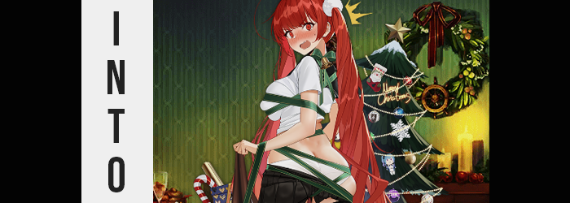

Christmas and New Year’s had finally come to a close.

For the first time since October there wasn’t any major holiday looming on the horizon. No Halloween, no Thanksgiving, no Christmas, and no New Year’s. You could argue that Valentine’s Day was coming up, but that wasn’t really a big holiday especially if you were perpetually single. The hardest holiday months had finally come to a close and now things could finally get back to normal without the same five seasonal songs playing on every radio station.

Now don’t get the wrong idea. I don’t hate the holidays. Quite the contrary, in fact. But it’s always a relief when they finally come to a close and things go back to how they were supposed to be. It was nice for things to not be so exceptional again. And it was doubly great to have normal television commercials once more! “But what isn’t great is having to clean up all the decorations after…”

That much was true. Looking at all the work I’d have to do to clean up? Taking the ornaments off the tree, putting the standalone decorations back in their boxes… Wreathes needed to come down, as did lights. It was going to take a lot of work. But it was work I had to, and would eventually get around to doing later that day.

How many hours had it taken me? Three? Four? All I knew in the end as I put the last of the boxes away under the stairs of my basement (where they would hide for 11 months once more) was that I was glad that all of that work was done. Out of sight, out of mind; I could now move on with the new year. “Let’s go 2024! I’m going to kick your ass!” I jokingly cheered as I stepped out from under the stairs. It was supposed to be a moment of triumph! And yet— “SHIT!?”

My feet clumsily tripped over something and I practically rolled out from under the stairs, my legs getting more and more tangled up in something in the meantime. Things wrapped around my arms and legs, and while I managed to land on my feet once more through some sort of miracle – I was tied up with some Christmas decorations I hadn’t even known I owned.

“What in the…? When did I buy a reindeer costume?” Somehow my feet and lower legs had gotten wrapped up in a human-sized reindeer costume, the full length of the costume laying on the floor in front of me. But the rest of my body was tied up in festive green ribbons. My chest and ass were tangled in them, and a bell jingled behind my neck. Were they part of the reindeer costume? I didn’t really understand! “Would that costume even fit me?”

I was trying to rationalize the costume’s appearance. My feet fit in it, but it was clearly much too short for my tall body. Like it was made for a younger person, or perhaps a small woman. Not a man that was almost six feet. And I didn’t live with any women. I lived alone. There was absolutely no reason for me to own it!

Of course, that could change. And it was about to.

If things weren’t bizarre enough already, the ribbons tightening without me moving a muscle certainly added a little spice to the situation. “What the hell!?” They were digging into my skin and rubbing against them. They pulled maybe a little too tight, because at first it seemed like they were applying more pressure than my plus-sized body could tolerate. At first, anyways. “Ngh! Too tight!” The way that the ribbons bound my arms and wrists made it impossible for me to try and struggle free.

But it didn’t seem like I had to, at least not for the sake of my comfort. It soon didn’t feel like the ribbons were digging too sharply into my flesh, and looking down I could easily see just why that was. “H-Huh!?” If my hands were free I absolutely would have used them to pat down by shirt because I could hardly believe my eyes. It looked like all of the extra weight on my body was dwindling away, allowing the ribbons to pull more snugly against my body without hurting me. Over just a matter of moments I was entirely thin. No man boobs, no gut, no fat thighs. But I also hadn’t become fitter, either.

“GRK!?” As shocking as that was, however, I wasn’t able to dwell on it for long without something just as unusual taking place. The bell on the back of the ribbons that had wrapped around my neck rung as my torso lurched forward. Those ribbons yanked by neck downward towards the floor a handful of inches, forcing my back to curl in the process. And yet while my point of view remained unchanged from this point on, my back soon corrected itself? I was standing up straight and the tension loosened? How was that— “HUUUH!?”

A shriller voice cried out this time as I managed to crane my neck to look down. My clothes were baggier than even after my weight loss now but those bindings kept them in place. Those were simply a side effect of what had happened. I was shorter. I had to be about 5’4” now, which was a very stark departure from my previous, almost 6’ tall height. I definitely would be able to fit in the reindeer costume that was caught around my ankles now.

Oddly, part of me now believed I had intended on trying it on in the first place.

I shook my head, the weight of my hair not distracting me like it probably should have. Because it was growing much, much longer. “This doesn’t make any sense! I’ve lost weight around my chest and butt, I’m shorter, my voice sounds…?” Had I just said something wrong? Hadn’t I lost weight in more places than my chest and butt? But my memories… Didn’t I normally have big tits and a big ass? It made trying on things like this reindeer costume so hard… “W-Wait, these memories aren’t…!?”

They weren’t mine? They belonged to a woman, didn’t they? Something that I was not, even though my hair had now spilled well down past my ass now while igniting in a bright red color that had been replicated in my eyes at the same time. Eyes that were larger, rounder, and cuter upon a face that looked about eight years younger. When I’d shrunk I had also seemingly slid back into my early twenties age wise.

“I… I…” It was difficult to even think, and as my Adam’s apple smoothed away my voice was left in the shriller, softer state that could have been heard intermittently earlier on. It undeniably sounded like a woman’s, and it really matched my face. Maidenly eyes aside, my lips had swollen upturned and pouty. My nose was smaller and button-shaped, and my cheeks were lean but soft. I had a cute and pretty face that certainly learned into the feminine. There was no assuming that I was male from face and hair alone.

But you didn’t really need to assume I was a girl anymore. “EEP!?” I shuddered at a sharp yet painless, almost sensual pull between my legs. My dick and balls had paid the ultimate price, folding into a new crevice in my pelvis – the walls and lips of a pussy now burrowing into a womb that cemented my biological change into a woman. “D-Did I just…? But I’ve always been a woman? NO! That’s… wrong… right?” I was holding onto my old self just barely. The act of doing so was becoming more and more difficult to pull off though.

It became harder and harder because reality was rapidly matching my (arguably incorrect) memories. My earlier thoughts about being too thin around my chest and butt? Well, that weight soon manifested just as I ‘remembered’ it. My ass cheeks exploded with weight, prompting boxers to wedgie between plump, heart-shaped cheeks that were so thick that they jiggled with the slightest movement. What couldn’t fit in my rump thickened my thighs, and the engorging of both regions pushed my hips wider.

Further up, ribbons once again dug into my chest uncomfortably – but not because the green ribbons themselves had tightened. It was clearly the opposite. I’d had a weightless chest for only a couple of minutes before fat returned with the vengeance, my shirt lifted up to show a slightly chubby tummy as thickened, erect nipples led the charge of the bouncing tits that erupted beneath. Ribbons gripped into bouncy flesh greedily, and some of that mass peeked through the ribbons along with my erect nips. They had to be at least G-cups, each breast nearly rivaling my head in size.

And that’s why buying bras is so hard…

And that was why I wasn’t wearing one, right? “Wait… What am I wearing? Th-These are a man’s clothes!” But wasn’t I supposed to be a man? I felt more and more uncertain about it. When it came to my clothing it didn’t really matter for much longer though. “EEK!?” The ribbons gave one finally yank and I fell to my knees. My huge tits cushioned my forward fall, but my face was buried into the head of the reindeer costume.

When I managed to eventually pull myself up onto my knees again, I didn’t even realize my clothes had changed. An unkempt girl’s uniform that was largely undone, my ass crack and panties fully exposed and my hair now tied into tails with white scrunchies. Tights were yanked down, my skirt was falling off, and the ribbons still hugged my tits like jello – revealing I was still braless even though my clothing had changed to reflect my new sex and identity.

What I did notice was that my surroundings had changed between my face hitting the floor and getting back up again.
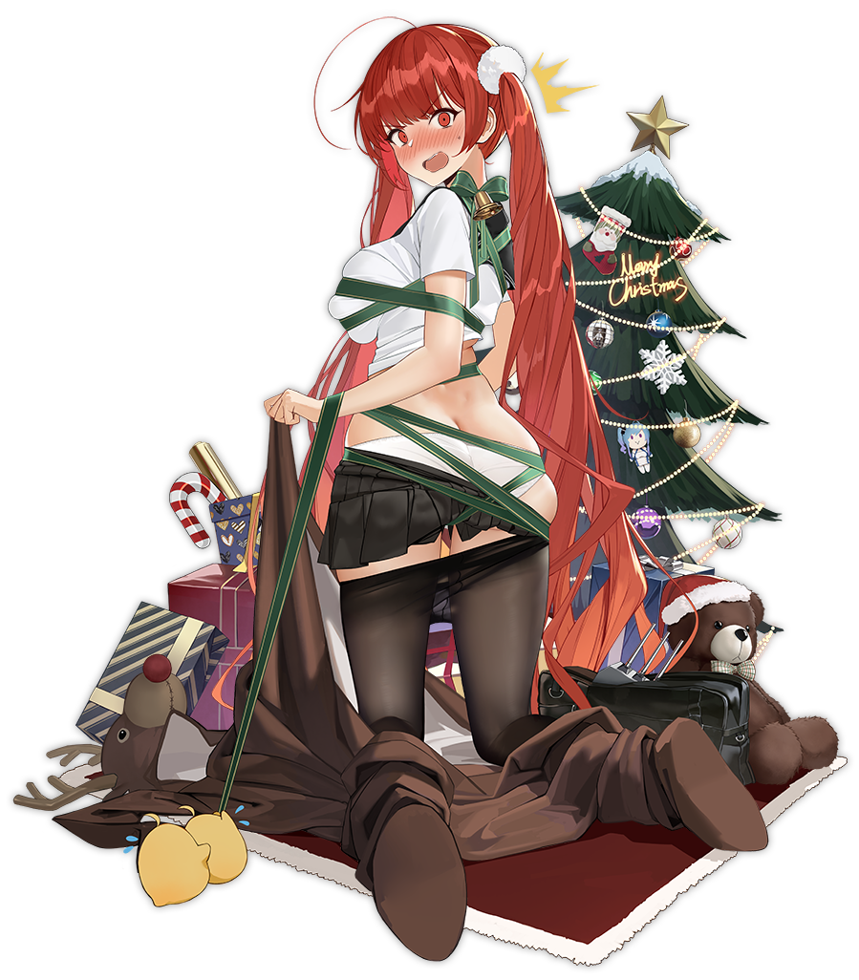
“H-How could this happen? This isn’t even my house anymore, is it? B-But I can’t even remember what my old house looked like…” I couldn’t help my cheeks from burning red. In the disheveled state my uniform was now in… with my breasts and ass in such lewd shapes because of the ribbons and reindeer costume… how could I, Honolulu, keep my cool!? I could recognize that I wasn’t even thinking of myself with my old name – no doubt a side effect of whatever had happened to my mind to make me act so unusual yet feminine. A personality to match my body.

But I wasn’t wrong. The calendar on the nearby wall implied it was Christmas Eve, and the living room I was in… was at base? Base? Was I some sort of soldier? A ship girl? “That… makes sense, but…” Did it? Hadn’t I gotten through the holidays? So what was with the date? Did any of that even really matter? It was getting increasingly difficult for me to care considering my state of dress. “I-I need to get this costume on before someone… walks… in…?”

Much to my dismay I could hear the door behind me slowly opening. Of course people would come into the living room! This was where the tree and presents were! But the only present they would be greeted by would be the peach-shape of my exposed rear end. “D-Don’t come i—HELENA!” A blue-haired ship girl had stepped in. I knew her name was Helena, and somehow her presence made me even more embarrassed. Was she someone important to me? She must have been!

…And now she had the full view of my ass, green ribbons wrapped around me like bondage.

I was going to die of embarrassment. I was seriously going to die!

