FATE / DOWNGRADE
FINAL CHAPTER: NINJA UP
BY CHALDEACHANGE
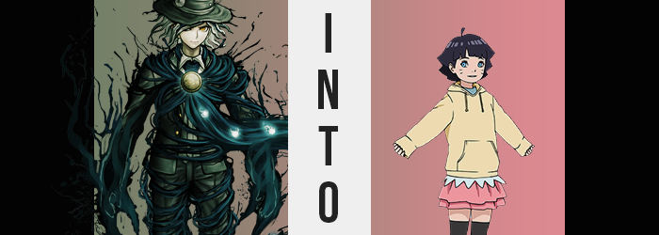

If there was any Servant within Chaldea that might have caught a whiff of the scheme being put into motion behind the scenes, it absolutely would have been Edmond Dantes. Not only was it probably, but it was factual to boot. The Count had realized early on that even midst the lack of good will from the Clock Tower’s lackies, there had been one of them acting in even worse faith.

And then there had been the disappearances of Servants that had been allowed their opportunities to remain within the facility. A number of stars had aligned that allowed the man to see the truth, and that truth wasn’t pretty. An invader using an already unwelcome party as a Trojan Horse, that once in had poisoned their well both with ill intentions… and literally.

They sought to remove Servants from the equation. For what purpose? Dantes had not learned that much. He just knew that Chaldea’s power would be needed for whatever was ahead for humanity. Anyone who thought that this would all end with Goetia’s defeat was ignorant – the Singularities that had popped up since spoke to that. Removing Chaldea’s firepower, its Servants, would only lead to humanity’s assured destruction.

That was why Dantes had prepared an ambush. He didn’t know who was behind these events exactly, but he knew they worked in the security room. Having control over all of the camera footage in the building would have been a necessity for the plan that had been put into action, lest someone catch on too soon. And there had been a new employee planted there with the Clock Tower’s invasion.

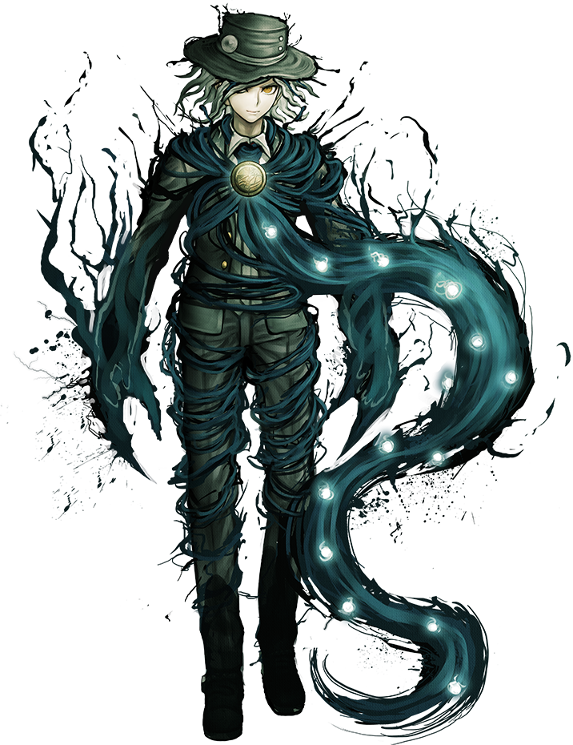
The plan was simple enough. Lay in wait in the hallway leading to the security office. It was a very isolated pathway, and as Servants could enter Spirit Form it would be simple enough for the Avenger to mask his presence. All it would take was waiting to see who it was and then pouncing when the opportunity was right. But the window was limited, largely because one of the Servants had already been transformed into a security bot. Fortunately she largely lingered inside the office itself.

And so Dantes had taken position. There wasn’t much that could go wrong, and he felt like he had accounted for every possibility. The issue was that… so had his opponent. No sooner than the man saw a shadowy figure loom down the hallway did the Servant disengage her Spirit Form, ready to get answers. But when he had? Something triggered Chaldea’s fire alarm, and sprinklers began to rain down on the hallway interior.

Sprinklers that used water from the same source as the drinking supply.

“What!?” His eyes had been cast skyward and then back down the hall. But his target was already gone, and some of the water droplets had been deposited into his mouth and nose. It was already too late, and he acknowledged that. But what he didn’t understand was how the culprit had foreseen his plan.

…The robot? Did she have some sort of functionality that allowed her to perceive Servants in Spirit Form? The possibility had crossed his mind, but he hadn’t really thought to believe it. It had felt too outlandish at the time. But it seemed that he had dramatically underestimated the enemy’s preparedness, and now he had no choice but to suffer the consequences.

Because the Avenger knew of the water’s power, he wasn’t oblivious to its effects right out of the gate like all of the other victims had seemed to be. He could feel it wriggling within, tampering with and depleting his Spirit Origin so that it could transform him into something that wasn’t a Servant at all.

There were external signs of this as well, and none so coy that Dantes wasn’t immediately able to recognize them. “Damnit…!” He bit his tongue, aware that he wasn’t able to do much more than that in the face of what was now transpiring. If only he’d discovered a way to prevent or reverse the water’s effects, then? But he hadn’t. He’d only been able to use the tools at his disposal. Did that mean Chaldea was doomed?

Avenger lamented this as the walls and ceiling of the security hallway quickly grew around him. The room itself wasn’t actually growing of course, and so the truth of the matter could only have been that he was the one who was being subjected to a change in size. Almost like he had been put under a shrink ray, his whole body had shrunk down to 4’6”, utterly swallowed whole by the characteristic, green suit that he wore. The drop was actually so sudden that even his hat fluttered off the man’s head, landing nearby.

The loss of mass hadn’t exactly been consistent, either. While he’d undeniably shrunken, it wasn’t equal either, and it wasn’t like he was just a smaller version of what he had looked like previously. His arms and legs were proportionately shorter, with the digits on his hands and the toes upon his tootsies smaller still. Throw in a torso that was almost irrationally petite, and a rejuvenated youthfulness that saw his face rounder and brighter than ever, and…

Well? “I’mma kid now!?” The manner in which the boy exclaimed this from within the void that was his dramatically oversized suit jacket was just as childish as he looked. Evidently his mental state had been reversed just as much as his body had been, and he was having difficulty thinking of anything that a child wouldn’t know. “This is bad!” He was also overreacting and flailing his arms around as much as one as well.

Things only worsened from there, but drowning in clothes as he was, it consisted of seemingly dramatic changes that were simple to overlook because of how the clothing was constantly flickering against his body. Well, the mental transformation taking root certainly didn’t help things either. Nor did his current age of around six or so.

But the long and short of it? His biological sex was inverted, quickly turning him into a young maiden. This meant robbing her of what dangled between her legs, while bestowing upon her deposits of soft yet subtle tissue in key area that would eventually flourish into eye-catching features when she one day grew older. But Dantes herself didn’t even realize she’d become a girl, nor could she even remember that she’d ever been a boy.

“Um… Why is it raining inside?” Her voice even bore a girlier sound now. It seemed like she didn’t understand the sprinklers, or why her clothing was so big. The fact that it was just as drenched as she was certainly didn’t help. There was no way she was going to be able to stand up unless her situation changed. And it would! Just… not yet. Before it reached that point, there were still some finer adjustments that needed to be made.

For the sake of repurposing her race.

Already flattened by the sprinkler water raining down from above, the girl’s shoulder-length, silver hair darkened to a raven black. While the length didn’t really appear to change, once that hair dried it would do so into a much neater, cleaner style that was layered in the back. Her eyes, fluttering about so chaotically, soon shone with an ocean blue – while the corners of those eyes? They narrowed to give her an undeniably Asian aesthetic that spread throughout the rest of her face. What was bizarre, though, was a set of whisker-like markings upon her face. They weren’t drawn on. They were a part of her.

Her mind was processing her thoughts in simplified Japanese by this juncture, which made sense because she absolutely looked Japanese. At the very least, the child was afforded some relief from her green jacket prison, for clothes dispelled into pretty golden sparkles that made her “Ooo” in awe, before they reformed as a pink skirt, blue tee, and yellow sweater with black leggings and pink shoes. All of which fit her perfectly, and all of which was just as soaked as the old outfit.

But hey! At least she could move!


“Huh? Why’m I all wet?” Still sitting on the floor of the hall, and playfully splashing about despite the fact that her clothes were still soaked through from the sprinklers that continued top rain down from above, the six year old child seemed weirdly flustered about her situation. She knew this place was like… Cat… de… a? Or something like that? She had been brought here, separated from her family due to an accident. But they were working to send her home, so the little girl wasn’t sad! She’d be a big girl!

Finally jump up onto her tiny feet, Himawari Uzumaki looked around. Why was it raining inside? Which hallways was this? The building was like a huge maze, so it was really easy for her to get lost in it. Before she could think more about it (not that she would come to any meaningful conclusions at her current educational level), a rumbling in her tummy grabbed her attention. “I wanna eat!”

Before she ran off with her arms trailing behind her.

When all was said and done, no one was able to stop what had happened. Reality adjusted for the unaware, and the one who spread the serum walked away Scott-free. There were no realizations, no investigations, no nothing.

But I suppose you could say they got their just deserts when Chaldea was frozen over at the turn of the new year.

