1001 DELIGHTS
COMMISSION STORY
BY CHALDEACHANGE
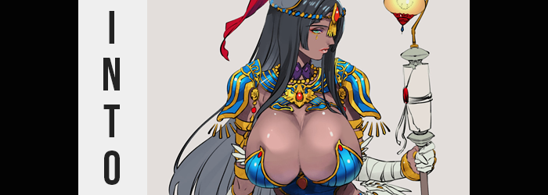

Getting your bachelor’s degree was the worst.

How many years had I been in school now? From childhood until the middle of my twenties? I really didn’t want to think about the exact number of years, come to think of it. Regardless of the exact number it had definitely just been a very long time. But every year I inched a little bit closer to the finish line and that was a good thing. And yet it was also difficult to not have my doubts about my future, nonetheless.

What awaited me at the end of this dark academic tunnel? Presumably I could find a job with my degree to make it all worth it, but how much debt had I accumulated over the years? That one was another question to add to the pile of ‘things I didn’t really want to think about the answer to at the moment’, but it was still something I’d have to think about eventually, much to my dismay.

“But what’s a pretty young woman in her twenties to do?” I laughed to myself as I pushed open the door to my college’s public library. The fact that I was being sarcastic in my humor wasn’t difficult at all to discern from my tone of voice. I didn’t really think I was all that pretty and never had believed that. I wouldn’t say I was ugly either, I just thought I was more or less average. And it showed in my relationship status.

That was more or less a roundabout way of admitting that I wasn’t in a relationship. But this was more a product of me not trying, or at least having time to try to find a partner. When was I going to go on dates when I constantly had papers to write and reports to submit? All of my free time went to furthering my studies instead of earning social points with other people.

…Okay, maybe I played too many video games too.

On that evening it had been more of the same, really. I had some people that I’d call ‘friends’ in my program and once in a while they’d ask me out for drinks. The kind of social experience that most women my age enjoyed. But not only was I not much of a drinker, but I also had a paper due the next day. “And so here I am, after dark, at the library…”

A library that was supposed to be closed, mind you, but I had a volunteered in the building whenever I had a free moment. As a result, the librarian had given me a key and allowed me to use it whenever I liked as long as I kept quiet about it. I couldn’t deny how helpful it was for me, especially as a literary major who loved to read. Most content was available digitally online these days, but nothing beat reading a book physically in my opinion.

Once I was inside and the front door was locked up again, I flicked on the few lights I’d need within the section of relevance to my paper. I had recently been studying Middle Eastern literature these past few months, and it had come to culminate in a paper I was writing on perhaps one of the most infamous collections of stories known far and wide in the west: One Thousand and One Nights.

They were tales told by the narrator Scheherazade within a main ‘frame story’ as she tells them to her husband, the ruler Shahryar and they covered a number of whimsical fictional topics for the reader to enjoy. “Now where was the material I saw last time I was here?” Knowing the topic of my paper well in advance, I had come to the library earlier in the week to make sure what I needed was available. It was, but I didn’t check it out at the time. It had been a little risky not to at the time of year when papers and finals were due in excess, but I had a pretty good feeling no one was covering the same topic as me.

“Aha!” And in the end, I was happy to discover that I had been correct in that assessment. I’d tucked a copy of One Thousand and One Nights as well as a written analysis about the narrator character, Scheherazade, on the far end of the shelf. Not out of the way enough where anyone looking couldn’t find them, but I wanted the two books in the same place so that I didn’t need to spend precious time looking for them again later.

In hindsight, maybe I shouldn’t have left them on the shelf that was above my head. I was only 5’4”, after all, so it was a bit of a struggle to pull them down. It certainly wasn’t impossible though, and I managed to get both of them down by standing on my tiptoes and tugging sharply. Both books were within my grasp, but… “Ow!?” I wasn’t expecting a third item to fall down with them. It landed on my head and then fell onto the floor behind me. Once I put the books on the table? I picked it up. “A scroll? Do libraries carry scrolls?”

This was a college, but probably not, right? But it was just a scroll in the end, and I was curious. So… I opened it! And yet what happened next took me entirely by surprise. “H-Hey!” The two ends of the scroll jumped out of my hands and flew around my body, wrapping me tightly within its paper aside from my hands, feet, and head. “Wh-What the heck!?”

I squirmed about in a panic, the scroll fortunately not so tight around my legs that I was in any immediate danger of falling but enough that my arms were bound to my sides, and I faced discomfort. I naturally could have cried for help, but a part of me stopped myself. I knew well enough that there was no one around to come to free me if I attempted to call for any sort of assistance. “What do I do?” And so instead, I made my best attempt to talk myself through the situation.

“A… magic scroll of some kind has wrapped itself around me. Not exactly a normal thing to deal with, huh? But weird as it is, I just need to keep calm…” At least that was what I was telling myself as I continued to wiggle a little, attempting to seek any means of loosening the scroll’s grasp on me. Because so much of me was covered, however? I was unable to see my own body; nor the effects the scroll’s actual magic was having on me.

This was something that could very much be seen in my head, just not at all by me personally. Take my short, shoulder length, dark hair for example. I hated wearing it too long because it interfered with my focus when it got in my way. Unfortunately, for whatever reason the scroll didn’t really seem to care much about my feelings on the subject if the sight of my hair growing longer was any indication. It wasn’t even like it just grew a few inches or anything either, but instead fell down to my ankles while both darkening to a raven black and becoming silkier to the touch.

And that was to saw nothing of how my bangs parted in the center.

I could feel my face twitching her and there, but ultimately chalked it up to a problem with my circulation what with how tightly the scroll had wrapped around my body. I couldn’t have possibly fathomed that it was because my face’s shape was changing, and certainly not to better suit a completely different racial profile. I was slowly looking more and more like a woman of Middle Eastern descent. The shape of my face overall had grown longer, while twitching in the corners of my eyes brought them to narrow. Lips puffed up not because of race but because this face also began to show a much greater maturity – perhaps because I was more mature. My face showed an advanced age of being in my mid-thirties, or perhaps even closer to forty.

Regardless of how much older I appeared, there was something to be said about how much more beautiful I had become as a direct result of those changes. This was further enhanced by something that had affected far more than just my face but could be seen in my face the most clearly while I was wrapped up. It was my skin. The level of melanin within rapidly increased, and the direct result of that increase could be observed in how my skin darkened to a brown comparable to the darkest of sands. Oddly, two yellow diamonds were painted under my eyes immediately after.

The strong scent of flowers and sandalwood now coating my body along with it.

A shimmering sky blue had replaced the original colors of my narrowed eyes as I looked down at myself still. I could feel it. Something was… different. “Is it my hair?” I had shaken my head to see. None of the strands entered my vision, but I could certainly feel how much more weight there was to it. Then there was my voice, and the unfamiliar way that my lips smacked against one another (because they were fuller now). “No, it’s more than that. But…” Why was I so calm about it all? That bothered me more than anything.

Something was happening to my body, and it didn’t alarm me at all. I felt at ease and, if anything, comforted? On some level I felt like I was becoming something, someone better than I’d ever have been. “I suppose I’ll need to see what happens from here on.” Or at least what I could observe despite the difficulties. I no longer saw the scroll binding me as something to be freed from; I now wished to embrace it. “Alright then, do what you must.”

But in the short few moments since my skin had changed, it had continued to do just that. My body’s shape had changed a fair amount vertically, with limbs stretching beneath the scroll along with my torso. In the end I had grown a full two inches to bring my height up to 5’6” from 5’4”. It was still in the realm of ‘average’ for a woman, but it also wasn’t enough for me to really bat an eyelash at, either.

What would make me react strongly at this point, now that I had been lulled into such a sense of security? Well, it would have to be something surprisingly excessive. Something that— “OH!?” My posture had remained unsullied by my transformation thus far, but I almost fell backwards from the suddenness of what happened at that very second. My hips had parted a staggering amount and my ass had thrust out behind me, parting the grip of the scroll around it so that full, chocolaty cheeks could be peeked between the layers of parchment.

My ass had swollen to maybe four times its original size and I could now see it even by simply craning my neck – while obscured slightly by my long, dark hair that is. “My behind is rather… abundant.” As were the thighs that had followed suit, parting the wrapping scroll around them in kind as each upper leg nearly doubled my waistline’s width. I had certainly become quite the bottom heavy Middle Eastern woman.

And my upper body had no intention of being left behind. If I’d been in danger of falling backwards before, I was soon in danger of falling forward now as flesh finally escaped the scroll’s grasp entirely. My average sized breasts had exploded into a pair of K-cup, dark-skinned tits that the parchment made no effort to contain, allowing them to escape with hearty bounces that showed off just how much lighter my nipples were comparatively. Lighter in color, but even larger than my eyes in size; fully erect from the stimulation I was feeling beneath a now shaved pussy.

“And it is done, is it not?” I knew, deep down. Memories that had not been my own now were, and the weight of my new form matched up with those new reminiscences. As if it was obedient to my words, the scroll loosened and unfurled before floating in the hair around me. I snapped my fingers as if it was second nature, somehow knowing what change that would trigger. It clothed me.

Skintight white wrapped around the upper halves of my breasts, hips, and even formed a pair of bridal gloves around my fingers and upper arms. But the lower halves of my tits were instead wrapped with royal blue cups that flowed into a narrow raiment that hugged my bellybutton. This blue matched new, ornate shoulder pads and numerous golden bangles and other jewelry pieces. Including a forehead gemstone and a transparent, lamp-shaped ornament on the top left side of my head.

“Now this an interesting change in perspective.” With the scroll once again wrapped up and held between my long, delicate fingers so that my new outfit, although revealing in its own right, was plain to see, I finally had a moment to savor just what it was that had happened to me. I was still myself… at least on some level. Or at least I hadn’t forgotten at all who I once was. But now? There was someone else. I was someone else. A woman whose identity and memories had melded with my own.

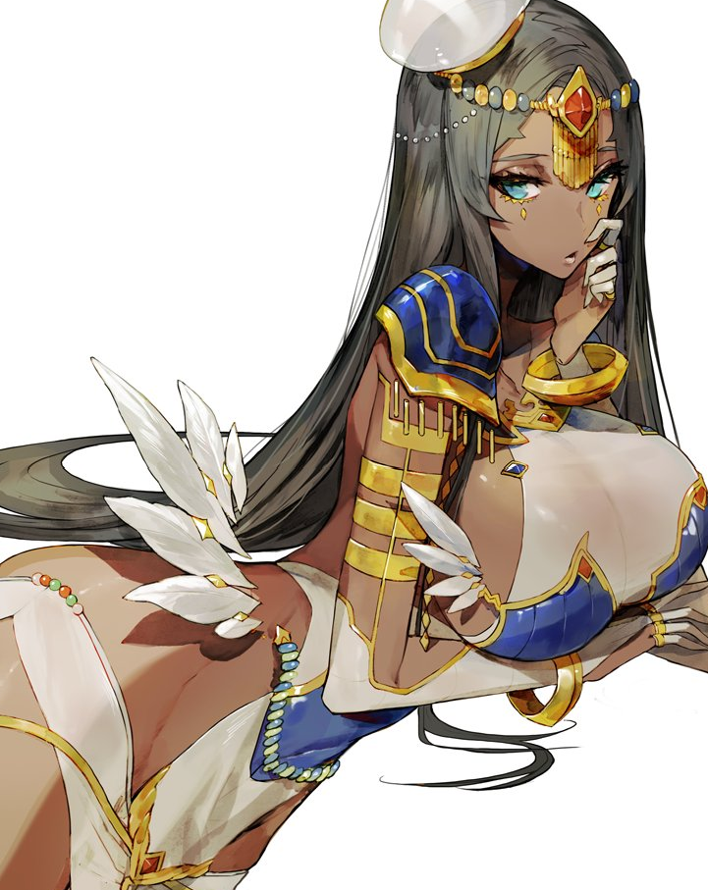
I was the narrator of One Thousand and One Nights. Scheherazade. A woman that by all accounts was merely a character in a story given flesh as a Servant of the Caster class. I had played Fate / Grand Order in the past, at least enough to know all about her – my – existence. “But to think I would be living her life in the flesh. Truly a magnificent tale.” All of the information I needed for my paper… I no longer needed to find it in a book by any means.

Ultimately, it was all in my own head. “But what do I do about this? I suppose lessons are offered only and I can turn in my work there as well.” As far as I knew, there was no way for me to return to normal. Did I even wish to return to normal? I could start a new life with this beautiful, sexier body of mine. Perhaps one day even finding a new partner to call my own. “No, wait… I needn’t be concerned.”

I realized after rooting around in the bag I had left beside the table I was using that my student card, my government identification – all of it had changed to match my new identity. I was a legal immigrant from the Middle East and, as such, there were no real hurdles to my presence. In fact, everyone’s memories had been modified to match the changes to my personage.

“That means that I have no choice but to make the best of it, I suppose.”

