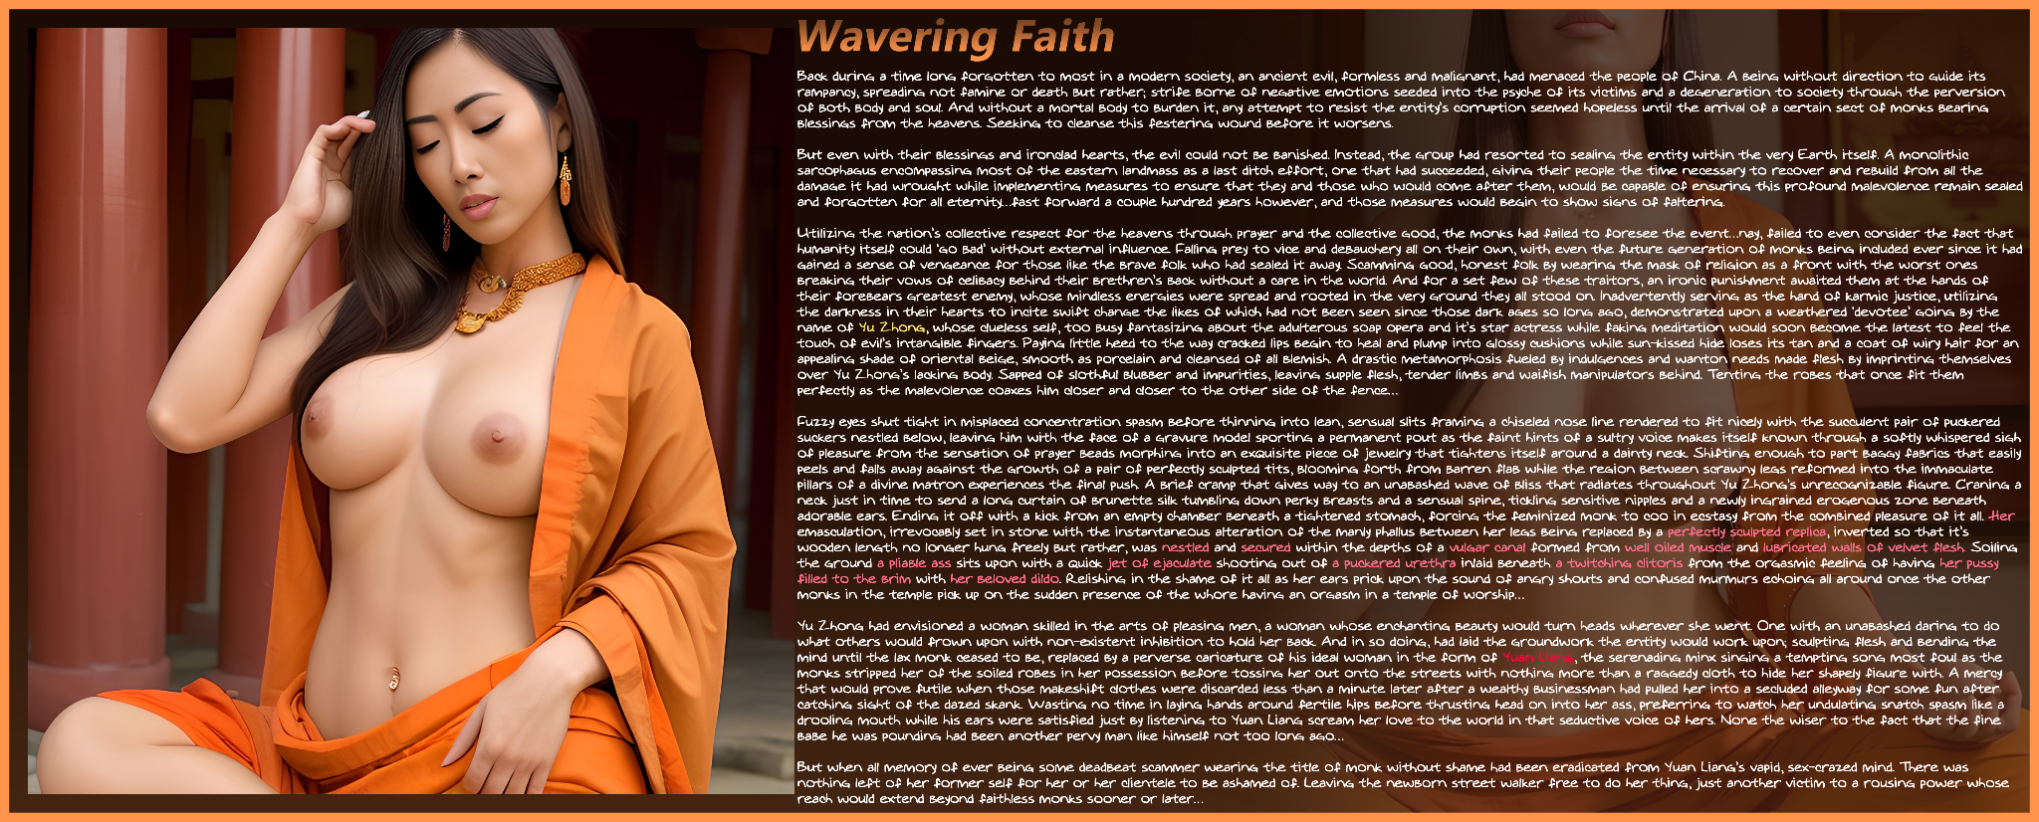

Back during a time long forgotten to most in a modern society, an ancient evil, formless and malignant, had menaced the people of China. A being without direction to guide its rampancy, spreading not famine or death but rather; strife borne of negative emotions seeded into the psyche of its victims and a degeneration to society through the perversion of both body and soul. And without a mortal body to burden it, any attempt to resist the entity’s corruption seemed hopeless until the arrival of a certain sect of monks bearing blessings from the heavens. Seeking to cleanse this festering wound before it worsens.

But even with their blessings and ironclad hearts, the evil could not be banished. Instead, the group had resorted to sealing the entity within the very Earth itself. A monolithic sarcophagus encompassing most of the eastern landmass as a last ditch effort, one that had succeeded, giving their people the time necessary to recover and rebuild from all the damage it had wrought while implementing measures to ensure that they and those who would come after them, would be capable of ensuring this profound malevolence remain sealed and forgotten for all eternity…fast forward a couple hundred years however, and those measures would begin to show signs of faltering.

Utilizing the nation’s collective respect for the heavens through prayer and the collective good, the monks had failed to foresee the event…nay, failed to even *consider* the fact that humanity itself could ‘go bad’ without external influence. Falling prey to vice and debauchery all on their own, with even the future generation of monks being included ever since it had gained a sense of vengeance for those like the brave folk who had sealed it away. Scamming good, honest folk by wearing the mask of religion as a front with the worst ones breaking their vows of celibacy behind their brethren’s back without a care in the world. And for a set few of these traitors, an ironic punishment awaited them at the hands of their forebears greatest enemy, whose mindless energies were spread and rooted in the very ground they all stood on. Inadvertently serving as the hand of karmic justice, utilizing the darkness in their hearts to incite swift change the likes of which had not been seen since those dark ages so long ago, demonstrated upon a weathered ‘devotee’ going by the name of *Yu Zhong*, whose clueless self, too busy fantasizing about the adulterous soap opera and it’s star actress while faking meditation would soon become the latest to feel the touch of evil’s intangible fingers. Paying little heed to the way cracked lips begin to heal and plump into glossy cushions while sun-kissed hide loses its tan and a coat of wiry hair for an appealing shade of oriental beige, smooth as porcelain and cleansed of all blemish. A drastic metamorphosis fueled by indulgences and wanton needs made flesh by imprinting themselves over Yu Zhong’s lacking body. Sapped of slothful blubber and impurities, leaving supple flesh, tender limbs and waifish manipulators behind. Tenting the robes that once fit them perfectly as the malevolence coaxes him closer and closer to the other side of the fence…

Fuzzy eyes shut tight in misplaced concentration spasm before thinning into lean, sensual slits framing a chiseled nose line rendered to fit nicely with the succulent pair of puckered suckers nestled below, leaving him with the face of a gravure model sporting a permanent pout as the faint hints of a sultry voice makes itself known through a softly whispered sigh of pleasure from the sensation of prayer beads morphing into an exquisite piece of jewelry that tightens itself around a dainty neck. Shifting enough to part baggy fabrics that easily peels and falls away against the growth of a pair of perfectly sculpted tits, blooming forth from barren flab while the region between scrawny legs reformed into the immaculate pillars of a divine matron experiences the final push. A brief cramp that gives way to an unabashed wave of bliss that radiates throughout Yu Zhong’s unrecognizable figure. Craning a neck just in time to send a long curtain of brunette silk tumbling down perky breasts and a sensual spine, tickling sensitive nipples and a newly ingrained erogenous zone beneath adorable ears. Ending it off with a kick from an empty chamber beneath a tightened stomach, forcing the feminized monk to coo in ecstasy from the combined pleasure of it all. *Her* emasculation, irrevocably set in stone with the instantaneous alteration of the manly phallus between her legs being replaced by a perfectly sculpted replica, inverted so that it’s wooden length no longer hung freely but rather, was nestled and secured within the depths of a vulgar canal formed from well oiled muscle and lubricated walls of velvet flesh. Soiling the ground a pliable ass sits upon with a quick jet of ejaculate shooting out of a puckered urethra inlaid beneath a twitching clitoris from the orgasmic feeling of having her pussy filled to the brim with her beloved dildo. Relishing in the shame of it all as her ears prick upon the sound of angry shouts and confused murmurs echoing all around once the other monks in the temple pick up on the sudden presence of the whore having an orgasm in a temple of worship…

Yu Zhong had envisioned a woman skilled in the arts of pleasing men, a woman whose enchanting beauty would turn heads wherever she went. One with an unabashed daring to do what others would frown upon with non-existent inhibition to hold her back. And in so doing, had laid the groundwork the entity would work upon; sculpting flesh and bending the mind until the lax monk ceased to be, replaced by a perverse caricature of his ideal woman in the form of *Yuan Liang*, the serenading minx singing a tempting song most foul as the monks stripped her of the soiled robes in her possession before tossing her out onto the streets with nothing more than a raggedy cloth to hide her shapely figure with. A mercy that would prove futile when those makeshift clothes were discarded less than a minute later after a wealthy businessman had pulled her into a secluded alleyway for some fun after catching sight of the dazed skank. Wasting no time in laying hands around fertile hips before thrusting head on into her ass, preferring to watch her undulating snatch spasm like a drooling mouth while his ears were satisfied just by listening to Yuan Liang scream her love to the world in that seductive voice of hers. None the wiser to the fact that the fine babe he was pounding had been another pervy man like himself not too long ago…

But when all memory of ever being some deadbeat scammer wearing the title of monk without shame had been eradicated from Yuan Liang’s vapid, sex-crazed mind. There was nothing left of her former self for her or her clientele to be ashamed of. Leaving the newborn street walker free to do her thing, just another victim to a rousing power whose reach would extend beyond faithless monks sooner or later…

THE END

Images generated by Pornpen : <https://pornpen.ai>