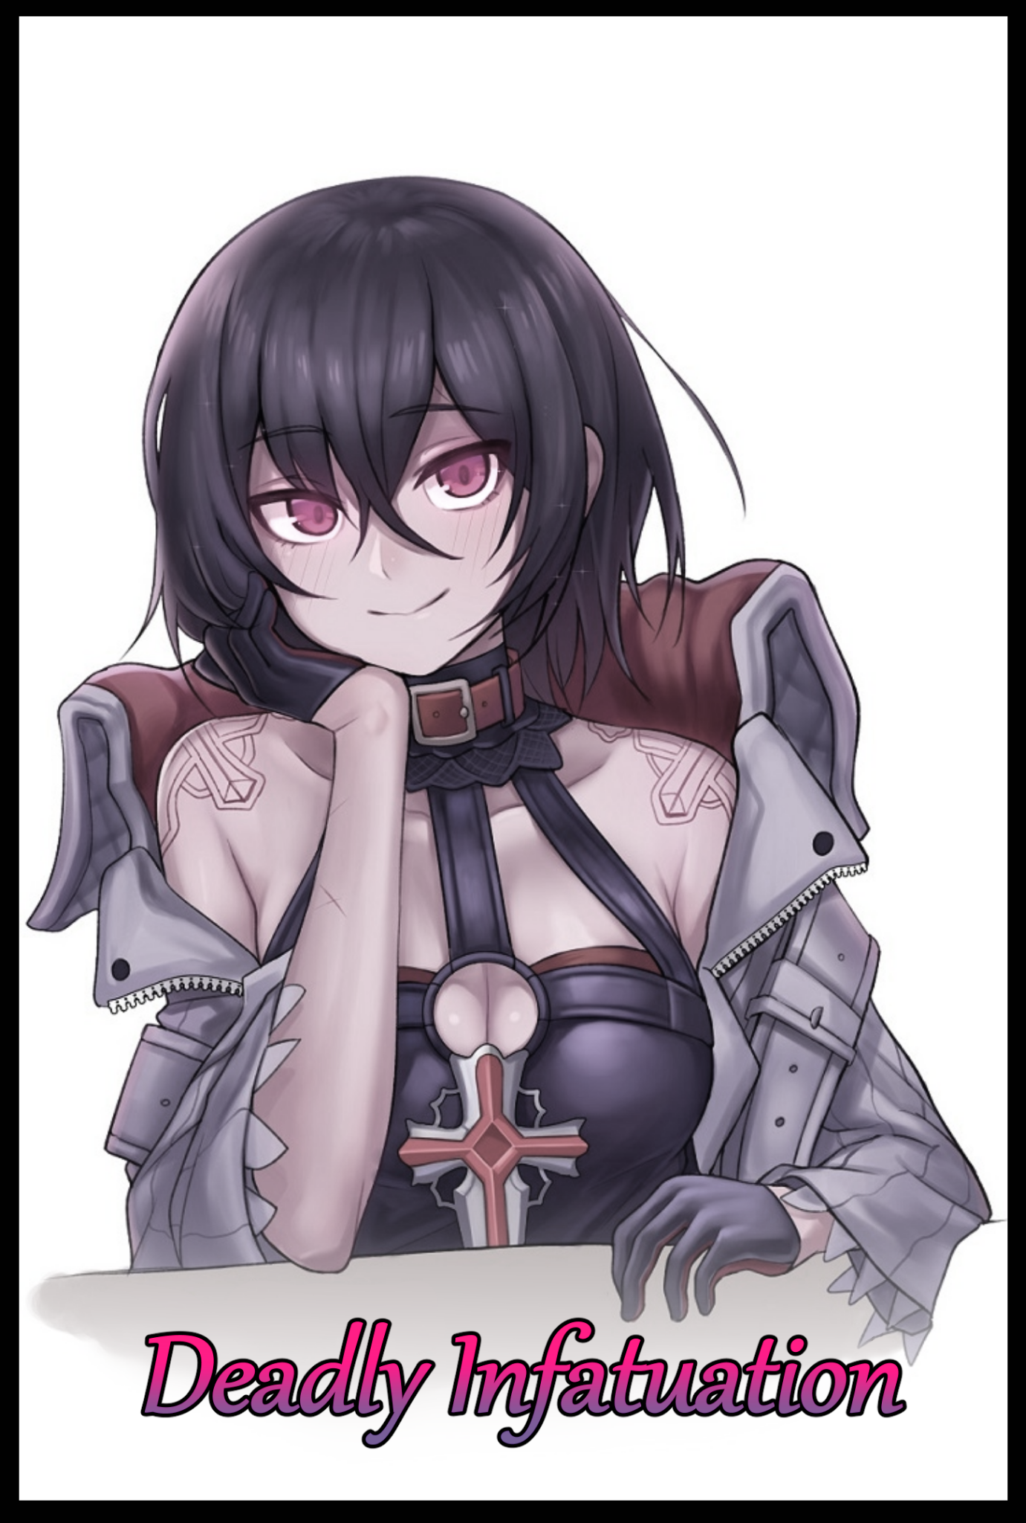

**"My Lord…always a pleasure to see you…has the Young Lady been treating you alright?"**

Setting down the herbology book I'd been reading heavily into upon noticing the arrival of a ragged young man in disheveled armor as his heavy footfalls echo throughout the hallowed halls of Dibellith's Temple , I move to assist him just when it looks like he's about to collapse, catching him under the shoulder wherein I realize my mistake, rectifying it on the very same moment with a powerful healing art that instantly soothes his suffering as I feel the gash in his armpit heal right back up.

**"Dear me, to suffer a wound so grievous…you let your guard down again didn't you My Lord?"**

Setting him down on a nearby table, I listen to him recount the tale behind the injury while cleaning my hands with a bowl of purified water, readying a fire for another of my soothing brews as he talks about a child he was helping out of a refugee's caravan, only to realize the danger too late, dodging out the way just in time through a risky maneuver that had left him with that bloody gash, caused by a weapon…no, a sickled claw…large enough that if he had dodged a millisecond later…

Slapping him lightly on the face midway through his delivery of how thankful he was for my aid, I take his bloodstained hands in mine, forcing him to keep quiet and look me in the eyes, all while battling the shivering chill of nervousness in my limbs as I murmur my plea to the reckless man.

**"My Lord…please…take better care of yourself in the future…my ability to heal isn't all-powerful…and as much as I trust in your abilities as the fabled Hero…you and I are still flesh and blood humans at the end of the day."**

I could sense a bit of hesitation in him, an unwillingness to admit to his…our fragility. But after a few silent seconds of contemplation, he lets out a sigh before nodding slowly in agreement, shrinking away in his seat like a child who just received a scolding after doing something naughty, chiding him for it as I hand him a freshly poured cup of the aromatic tea that had just finished brewing by the time I return to tend to the pot, taking a seat before the shaken man with a subtle smile on my delighted visage.

There was a time when I would've felt bad for telling a lie with such a straight face, a time when doing something bad would've left a dent in my heart. But now? I can hardly feel a thing…as long as it was for the sake of the Hero, I would do anything for him…

*'And if anyone's to blame, it's the utter fool who thought to make me submit with devotion…how ironic…'*

Thinking back to a few months ago as my gaze begins to drift around the main hall of the temple while I sip on my own cup of relaxing tea, the moment of my arrival in this strange world still seemed like it had happened only a few days ago when the people's deific figure; Dibellith, Goddess of Light had plucked my wayward soul from another dimension altogether shortly after my supposed death in a traffic accident involving a truck. I had been a naive little boy then, and after the annihilation of my 'first' vessel, I found little problem with the female one bestowed upon me by the goddess herself. Wholly believing in her ethereal message to me that I was to aid the people of Luthiria, thinking I'd be gallivanting across unknown lands saving villages and rescuing maidens from wicked beings, not knowing what she had meant until I finally met him not even an hour into my time in a new world where everything and everyone was as foreign to me as my new body, descending in a pillar of light, slender form draped in extravagant silks and enchanted cloth…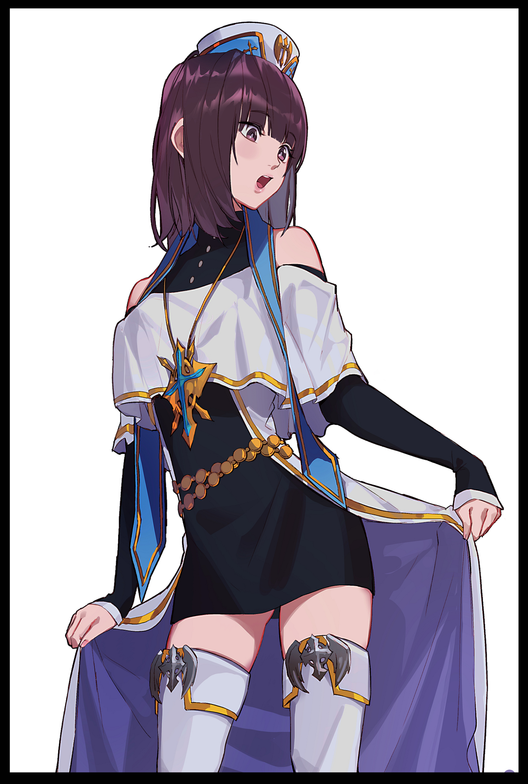

Getting used to the functions of the female form aside, my first few days in Luthiria aside from that *thrilling* first encounter with the Hero went by rather uneventfully. With my identity as the people's newly installed Priestess of Light in hand, I struggled to abandon my old identity while working to uphold a pointless charade. Even more so when I realized what my purpose was to be; nothing more than a damsel locked inside her stone castle, administering aid to the Hero whenever he had need of it after his return from beyond the walls of a daemon ravaged country…like a battery to be used in times of need.

A side character in an ongoing story whose sole purpose was to help the main character overcome the odds and save the day…

Overtime, I remembered growing bored, bitter, agitated…wondering what to do when the guards outside wouldn't let me step foot outside the temple, giving me no form of outside contact to speak with whatsoever…leaving just the Hero himself to talk to whenever he would return from his treacherous journeys for healing and empowering, a process not too dissimilar from that one of the games of old I used to immerse myself in. And seeing as how I was technically the man's guardian…only I possessed the ability to perform the rite. Innate skills linked to my 'class' so I wouldn't need to do any prior reading beforehand in order to activate them. Except I had to find out for myself that my 'class' of Priestess had a strong link tied to the Hero himself…probably a part of the goddess' machinations in ensuring I remain *loyal* to him.

Like I said before, my previous vessel was that of a young man much like the Hero, and as anyone would expect, a man's mind in a woman's body was already a bad enough combination…but to add an arbitrary addition that made me yearn and desire the Hero's attention the more time I spent with him…could anyone really blame me for doing what I did?

When I first realized what those strange, heart rending feelings of pain were whenever I tended to the man's wounds. I vehemently denied the urges while he seemed to get the wrong idea with my discomfort, teasing me just like any man would a floundering damsel whose face was as red as searing magma. But it would only grow worse from there, much more when I had already begun to…shall we say, *explore* my body's feminine appeal.

Spurred by sinful lust and dreadful love, my once peaceful nights in my bedroom above began to grow restless and heated. Affecting my habits when I eventually showed no qualms with fingering myself to sleep when I would've once retched over the idea of doing so despite the memory of having stroked a man's pecker to climax…and even though I knew…*know* I was once a man myself? Now I can't help but to salivate over the Hero's manly qualities, an unabated lust that would grow more and more severe until eventually…it would start to affect me…warp me…becoming more assertive, thinking beyond useless prayer and healing magic, looking into alternative ways I could help my dearest come home to me safe and sound even if said methods came at a cost…all while my love for him continued to skyrocket with each homecoming, each interaction, everytime he praised me, his words repeating in my head every night as I ravished myself while imagining him to be the one doing so…

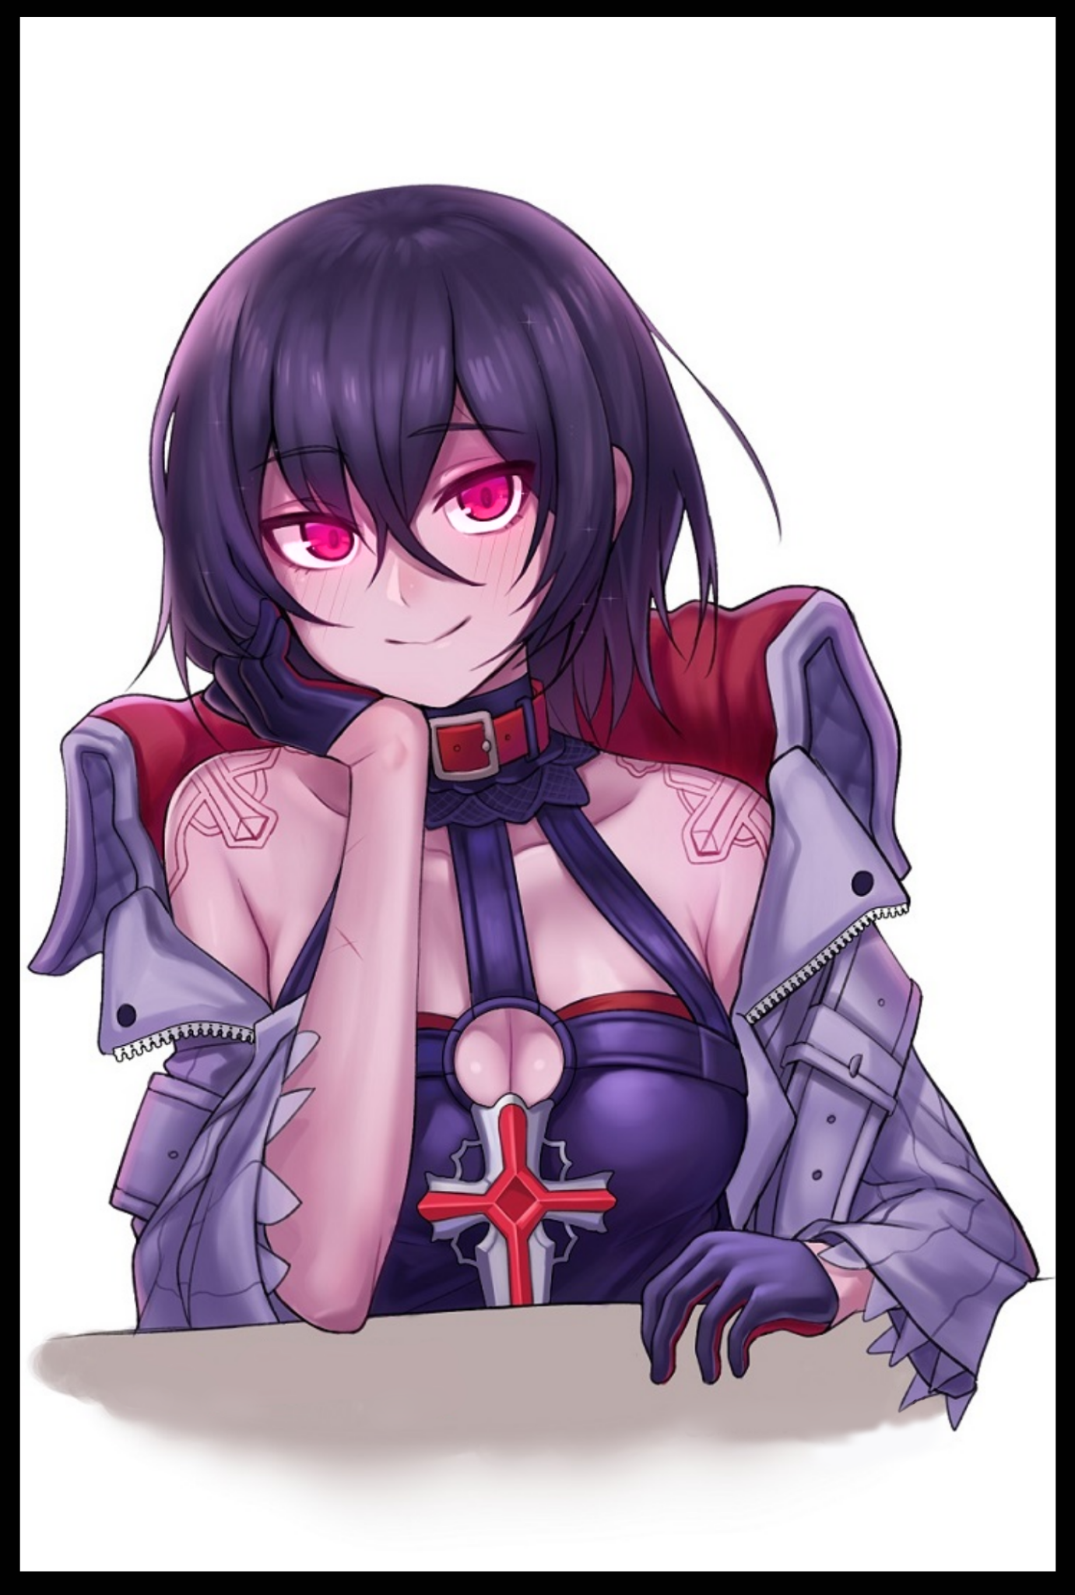

Over time, the meek, uncertain little man-girl I was had faded entirely. I can barely even remember the details of my old life anymore as I sit here right now, delighting in the sight of my darling Hero enjoying my tea like a clueless rabbit eating its way further and further into a Hunter's trap…he hadn't even noticed my change in attire…or rather, I think it'd be better to say he didn't even realize the significance behind such a change, ignoring my abandonment of the Luthirian royal coat, the goddess' enchanted equipment, praising me instead for how well the colors of my new dress code gelled with my new raven black hair, or how nicely my breasts have grown in being the pervert he is~

With a little bit more time and research into daemonic binding, I'm certain I can truly become someone worthy enough to stand by the Hero's side out there beyond the city walls, though I'm quite certain the knights who once tried to stop me stand little chance in doing so now, it's still not enough…just like my healing magic…but there was still the issue of the warrior princess being a potential thorn in my side…we'll see who's the one strong enough to protect the Hero once I've amassed enough strength to do so…although I can't guarantee no harm might befall the Young Lady~

For now however, I must do what I can, and as I see the cup slip from the Hero's trembling hands, I waste no time in scooping the limp man up into my arms, easily carrying him like an overgrown babe in my arms as I begin to make my way upstairs to my bedchambers. Cooing gently into his ears while I stroke his head gently like a mother would her child…

**"Close your eyes my Lord…you must be so tired after fighting so hard for our sake….come, let me help you…leave everything to me…"**

I know the depravity that consumes me, but I would **never** lay my hands on the Hero…for now at least…just a little more, then I'll show him what I can really do…and Luthiria will finally have the protection it *deserves*…

THE END