JK ACCLIMATION
BIWEEKLY STORY #84
BY CHALDEACHANGE
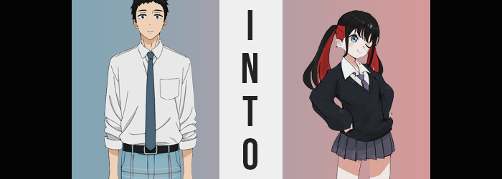

Life had been a whirlwind for Wakana Gojo lately.

He still hadn’t decided if it was a good thing or a bad thing, but his whole world had been opened up after becoming friends with Marin Kitagawa, one of, if not the most beautiful girl in his class. Wakana had been a social recluse for much of his life after enduring a great deal of mockery in his childhood for liking Hina dolls, and to have someone in his life that wanted him around? It was a refreshing change.

Of course it still had its awkward moments. She was relying on him to help her make her ideal cosplay costumes, and there had been that day when he’d had to take all of her measurements… it wasn’t exactly the safest for work moment of his virgin life. He’d think back on it fondly some day, but for now? His cheeks turned beet red whenever he even reminisced upon it a little bit.

Class had ended for the day, but something had been bothering Wakana however. Marin was always running over to him to talk to him on breaks, but it wasn’t like he was very well acquainted with her friend circle. There was a chance that her JK pals wouldn’t treat his hobby with the same respect that Marin did, and even if they harmlessly teased him, he wasn’t sure if he would be able to just brush it off.

But it was only natural for a friend to mingle with your other friends, right? It was something that he would inevitably have to do someday. “I wonder if there’s a way for me to better understand her friends…?” While his classmates had all shuffled out from the classroom by this point, Wakana was still resting with his head on the desk. He hadn’t expected anyone to hear him, yet…
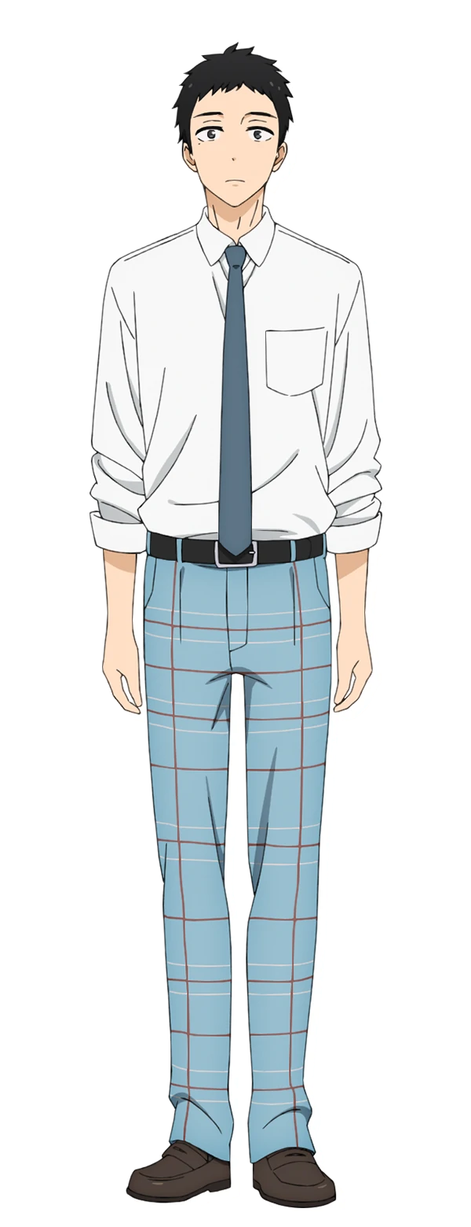
“Yo! You wanna get closer to Marin’s friend group!? Here you go!” The sound of a young and peppy voice startled the Japanese teen, who sat upright again the moment something was dropped on his desk. But when he looked around? No one was there. He was still alone, and where he had heard something drop? A bottle of nail polish? Black, it seemed. Didn’t one of Marin’s friends paint her nails black? The short one.

He rubbed at the back of his head. “Am I supposed to return this and start a conversation that way?” The whereabouts of the person who had run off aside, that was the only use he could imagine this bottle would help with. What else was he supposed to do with nail polish? Paint his own nails? He’d have more to worry about socially than his obsession with Hina dolls if he did that.

“…Eh?” Maybe it was the way the setting sun filtering through the window was hitting it, but did the bottle look like it was glowing? That couldn’t be the case, right? Bottles of nail polish didn’t just glow unless this was some sort of gag gift. Maybe it really was just the way the light was hitting it. But, on a (what he believed to be) unrelated note, he suddenly felt strangely warm. “That’s weird…”

The teen was so focused on the bottle of nail polish that he didn’t notice – or perhaps he had been coaxed into not noticing – that his posture in his desk chair had begun to diminish. Even though he was only fifteen, he was already six feet tall naturally, and so sitting through his classes wasn’t always the most comfortable of situations.

Yet now? That problem would ultimately be rectified, not that he would notice. His height had already slipped beneath 5’9” and continued to spiral downwards. Arms became shorter, and so naturally the hands that were attached became fairer to oblige. Those fingers became soft and gentle, with nails that protruded an inch past the tip of each digit. But there was also the matter of the paint that spread across them – the very same black that was in the bottle of nail polish that had been provided to him.

“Did I not put my uniform on properly this morning…?” Gojo truly was incapable of comprehending the strange situation he had fallen into, because his height was nearing five feet now, and the most he could wonder about was his school uniform. Though was it all that surprising? Considering he’d been wearing a uniform meant for a man one foot taller than he was now, his dress shirt was practically swallowing him whole. And his plaid pants were bunched up around his knees, held up only because he was sitting in the first place.

With his height adjusted, one could almost say that the boy looked much more youthful now. It was to be expected for a boy of that height, but there were aspects that contributed to it that weren’t actually signs of him getting younger – because he wasn’t. Even so, his eyes appeared to swell bigger, wider, and more expressive. Their volume seemed to be helped plenty by lashes growing longer as well. They would dance like butterflies whenever he blinked.

But there wasn’t any denying that those eyes elicited another impression. That they were far more feminine. They better matched the eyes of a young woman than the man he was meant to be, and that impression would ultimately escalate as his transformation intensified. For example? Gojo’s nose wrinkled, and he thought he had been on the verge of sneezing, but it had actually shrunk into a button shape – all while the lips below appeared ever so shinier and, causing this, plumper. Toss in cheeks that seemed to be impossibly fair and what looked to be a smaller face overall, and you would easily assume…

That the student sitting at that desk was a girl.

“Huh? Why’m I still in class? I’m totally not the kind of person to wait around.” His own confusion aside, the peppering of overly casual verbiage in his words was striking. Wakana was a fairly formal guy, and that was the way Marin talked more than anything. Maybe she was rubbing off on him? If only that had actually been the case.

The boy’s short yet messy cut of hair, once again without him noticing, began to grow longer. At first it was just an inch here and an inch there, but before long? Like a sea of snakes it began to slither, falling to his shoulders and beyond like a raven jungle. Once it grew past the center of her chair’s backrest though? Something was set aflame in its color. A crimson hair dye mingled with the lower half of his locks, a layering decision that would give his black hair red undertones. Were he paying attention, he might have realized who that resembled. He only knew one person with hair like that.

And they weren’t a guy.

But then again? Neither was Wakana Gojo. Not anymore. Her legs wriggled together, the flannel of her pants causing friction thanks to the rubbing. There had been a good reason for it though, because one didn’t lose your dick and have it replaced with a pussy so casually under normal circumstances. The red dye from her hair even made its way into her pubes.

With the foundation set, one that made it undeniable that she was a woman, the rest of a young woman’s assets were quickly applied to her visage. This included a thickness to her thighs that had them rub together much more gently upon the chair, with their flesh muffining over the cusp of the seat. Her point of view also rose just a little bit because of her ass. It swelled, and so too did the maiden rise to sit more comfortably upon cheeks that were sizable for her height.

Long lashes blinked as she looked around the room. Gojo seemed to be in something of a daze, the world around her confusing. Her mental condition was being adjusted to suit her new reality, and her mind? Rather than thoughts of Hina dolls, she was thinking about JK fashion, accessories, and all kinds of high school girl nonsense. As she did? Her chest erupted subtly into an A-cup bosom, with nipples that were so large that they appeared to betray the masses of her chest itself. With a dip in her waistline to present her with a much more effeminate gate, well…

“Yuck! I’m not really wearing this stuff, am… I? This has to be a bad dream!” She sounded downright offended after checking out the boys uniform she was wearing, but fortunately her concerns were immediately addressed as the material of the clothing she was wearing tightened around her body. Whether it was color, fit, or design, all of it changed to create something new.

Well, her white top remained, but it now fit her. It was just shrouded by a black cardigan and accessorized with a purple tie. As for her pants? They had become a gray, pleated skirt that left her short legs otherwise exposed, and her feet were left clad with socks and mary janes. This was all up to code, but the three black piercings per ear lobe she now sported would likely get her into trouble. As would how her hair, now styled into twin tails, showed off the layered coloring.

She sat there stunned for another moment longer, until it struck her.

“Huh? I’m gonna be late, and this ain’t even my desk!” Finally cluing back into reality, the short and spunky Nowa Suguya jumped up from the desk she had been so casually sitting at while fixing the distribution of black nail polish upon her nails. “Isn’t this the desk of that guy Marin has been totes obsessed with? Gojo-kun!” Saying that name somehow stirred something inside of her. Like she had just referred to herself in the third person, even though there was no way that could be true, right?

She took the bottle after standing and shoved it into one of the big pockets of her black sweater. In the same motion, Nowa also removed a pocket mirror and had a look at her hair, pulling on a few strands that looked dishevelled. The teen was planning on meeting her friends at karaoke in half an hour, but it was a whole train ride away! It was a shame Marin couldn’t come, but she worked so much it was pretty much expected at this point.

“Mm… Maybe I should take the time to get to know Gojo-kun soon? Marin really seems to like him, but how do ya break the ice with a guy like him?” Ironically, Wakana had been transformed into one of Marin’s JK friends so that he could ‘better understand them’, only for the opposite problem to arise from Nowa’s perspective. The two of them, actually, had swapped place. But there was one major issue with all of this.

No matter how many friend dates the new Nowa would go on, nor how many boys or girls she’d date in the coming months or years… It didn’t matter how well she understood the JK lifestyle.

Because she would never change back.

