BEING A SUCKER
COMMISSION STORY
BY CHALDEACHANGE
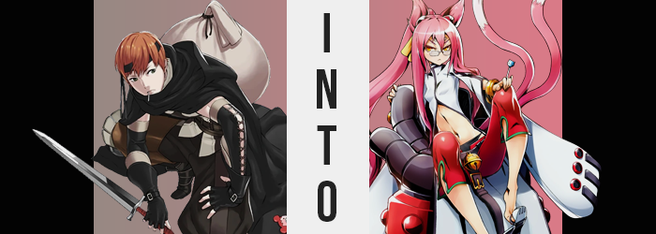

The sound of rain crashing down outside of the castle was all that filled the decrypt halls in terms of audio, yet for Gaius that was preferrable. It meant that no one else was up and about, and he certainly hoped that they hadn’t been seeing as he’d chosen this location exactly because it was abandoned. Such was the life of a thief. You needed to pick buildings and battlefields where your odds of survival were highest, because his dagger would do little against better prepared opponents.

Not that he wasn’t an honorable thief. Well, okay, he sort of wasn’t. But ever since joining up with the Shepherds of Ylisse he hadn’t been as much of a societal menace as he had been before. He largely had put his talents towards supporting his friends and family, and the nation had enough enemies littered about that he could still steal undeterred so long as it was from the right targets.

Take this castle, for example? It had long been abandoned and, at most, had been used by bandits as a fort here and there. So if anything was left laying around then it would have been completely ethical for him to take it. What if it had belonged to someone the bandits had stolen it from? Well he had no way of knowing that, now did he? So it was just best for them to cut their losses, because he was just going to keep it.

Carrying his sack over his shoulder as he always did, he wasn’t really in much of a rush considering the weather. He’d just get soaked if he went back out in the rain, and to be fair he’d only explored a small piece of the huge building thus far. Chrom was expecting him to bring back a fairly sizable load, and this was only one stop on a few that he had marked for the day.

“Hm? A pantry? Nothing’s likely all that good here anymore.” The thief’s wandering eventually brought him to what was clearly the location where those that had stayed there had kept there food. Emptied boxes that contained flakes of dried food and pasta were littered about among used pans and dishes. The bandits that had used this place as their base most recently clearly had no respect for cleanliness.

But maybe that was asking a little too much of bandits in the first place?
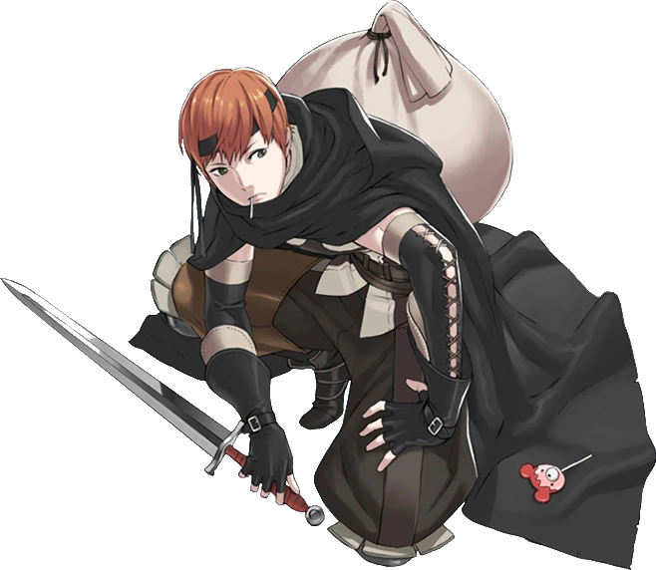
Still, Gaius responsibly looked through all of it. Dried foods had the potential to still be consumable, and there was never anything wrong with bringing more food back to the camp. It often felt like they had a new mouth to feed every day, after all. But it didn’t really seem like there was much of anything in that regard. Everything had been used up.

Just as the man was about to carry himself off to the next room, though? Something caught his attention in the corner of his eye. It stood out to him because against a bleak and dirty background, it was a thin line of white. One that was extremely familiar once he gave it the proper attention. “Well hello there!” And it was something that had excited the thief to boot.

Bending down and picking it up, a whistle escaped his lips next. And it was over something so small. A wrapped lollipop, not the sort of thing that most grown men would have an interest in. But Gaius? He was obsessed with the little stick-bound sweets. And it had just so happened that he had finished his previous one just moments before. It was wrapped still, right? So there was absolutely nothing wrong with it.

Using this potentially flawed logic he took the wrapping off and stood up, marveling at the bright blue of the candy. “Looks good to me.” No specks of dirty, no signs of any tampering. Instead it looked pretty darn delicious, so without delay? He shoved it in his mouth! It took a moment for the flavor to greet his tastebuds, and Gaius gave a little hum of delight. Blue raspberry flavored! One of his favorites!

“Alright, but I still can’t leave here empty handed.” A lollipop was all good and well for him, but that was it. He couldn’t bring a used candy stick back to camp and expect any praise, so he slid out of the pantry and into the hallway once more. “There’s gotta be a bedroom or something around here, right?” The castle was so big that there had to be something that had yet to be uncovered. Yet the more he pressed on? It was uncanny, but he began to feel a little off. In a way he couldn’t even describe.

Whether he was able to describe it or not, though, there were physical signs of what could perhaps initially be perceived as an illness. If you were rather open-minded to what an illness might cause. Because sicknesses that could change the color of one’s hair weren’t exactly all that common… probably? Gaius never claimed to be a medical expert. Just a thief.

Regardless? That was exactly what was happening. The tips of the man’s orange locks had passively lightened – and then brightened – to a cotton candy pink in the end. Gradually this color then slid all of the way into his roots, painting even his eyebrows and pubes in this off pink. Off only because it wasn’t his natural color. But Gaius didn’t really notice? How could he, when all he saw of his hair was the tips of his bangs, and only when he was squinting at them, at that.

“Maybe it’s nothing…” It would be best to just press on. He might have been feeling sick because of the rain? That was the easiest way to dismiss it all from his perspective. Though even as he was trying to pass it off as nothing there were clear signs to the contrary. For the thief’s eyes not only began to glow an unusual gold midst the dim light of the fort’s walls… but the shapes of those eyes changed as well.

And not even just a little bit, either. Narrow by design, optics stretched both vertical and horizontally so that the golds of his obvious were made even more obvious, the roundness that followed feminized by lashes that likewise fluttered longer. Ultimately? Those eyes were indistinguishable from a sharp-gazed woman – and so too did the rest of his face follow suit.

Gaius’ chin shrunk and his cheeks rounded, not to mention the collapse of his nose into a rounded shape. Brows, narrower, pointed downward passively to help demonstrate a resting face that was notably agitated even if he didn’t feel that way. Lips bloated a touch, but it was a more natural sheen to their texture that left them looking fuller and softer. With his expression blank, they were shaped into a dissatisfied pout that matched the look his eyes and brows gave.

“Or maybe it’s all just a pain in the ass.” While not a dialect he would ever use under normal circumstances, he groaned this quite natural. Why bother pressing on? It’s just a lousy castle. This line of thinking kept him from pressing down the hall and as such he remained in place. Why even bother why this place was so big? Bigger than it had been a moment ago too. Odd.

This was just a passing thought from his perspective, but there was a legitimate reason as to why the hallway appeared a touch bigger than it had before. Simply put? The man himself was in the process of shrinking. His arms and legs were regressing in overall length, while the hands and feet attached to them? Digits became slender and heels and palms grew soft. With his torso following after, before long he was about five inches shorter than he had been previously – and his pants, top, and cloak all rested much more loosely as a result.

He tugged on his pants, tightening them around his hips via his belt, but Gaius didn’t ask any critical questions about it. “Now what the hell do I do?” He sounded grumpier. Much grumpier. But he also undeniably sounded female. Like a young woman befitting of the face he now possessed. Or, well…

She possessed?

Yet the only physical and mental response to the removal of her genitalia was a sudden discomforted rubbing of her thighs. Cock and balls were out, and a pussy was in. All the way up into the new feminine organs that had taken form inside of her. With a womb rooted deeply, so to did the outward around them distort into something more suitable of containing it. Hips stretched wider by a few inches, forcing his knees to buckle inwards ever so slightly.

Although those hips were simply there to help support everything else in their direct proximity. Gaius’ ass swelled up like a full peach, pushing the backs of her pants out so that you could readily make out the swell of her rump and the indentation of the crack between either cheek. All the while? Scrawny thighs found a layer of cushion to them as well, bloating outward until pushing into them would see the fat take a few moments to properly rise back up. That said, neither her rear nor her thighs were excessive in their appeal. Rather they were just right for a woman of her apparent size.

“Mmn?” For a brief moment she almost wondered if something was wrong, but instead? The hand not holding her lollipop pushed up her glasses on her nose. Glasses that had not been there moments prior, but glasses that were now necessary for her to see. All the while? Her pink hair was rapidly extending around her, spilling far past her shoulders and past the bloat of her new rump. Slightly wavy by design, it almost looked like it might be better tied up?

Though Gaius’ little groan hadn’t been because of her hair. Rather, she was itching idly at her chest through her top. “Why is it so itchy?” Especially around her nipples? As she itched it probably should have been obvious to her, but the reason was that the chest in question was rising like a cake in an over. Weight was gathering beneath her nipples, shaping into a pair of A-cup breasts while nipples grew several coin sizes. By no means was her chest obvious nor notable, but boobs were boobs depending on who you asked, right?

Pressure mounted in two areas of the woman’s body next, with the first being at the base of her tailbone. It prompted her to lurch forward slightly at first, an agitated look on her face as she did so. But fortunately for the thief (?) this pressure soon found itself disposed of. Only because the cause of it came full circle and made itself known, though.

Not one lump, but two lumps emerged from where her tailbone was at the base of her back. Side by side, they were just small bumps initially. But after a few seconds they protruded with such length that they had forced their ways out between her top and pants, hidden only by her cloak. Only about as thick as a hose, they grew longer and longer, and became prehensile as they did. But more than that? Light pink fur to match her hair grew along them, with white tipping off what were undeniably the tails of a cat.

Which brought us to the other points of pressure. Two on the sides of her head’s top. What grew there wasn’t quite as dramatic as what had grown everywhere else, though. Triangles rose with pink fur upon them, and before long they had amounted in a pair of fluffy cat ears that twitched in response to the falling rain outside the nearest window. To maintain balance? Her human ears soon smoothed away, leaving long hair on the sides of her head to disguise their new absence.

It was clear that the woman’s entire mood was soured… because she was confused about a few things relative to memories that had twisted. She no longer perceived herself to be the man she had been. “Tch.” Rather, as she clicked her tongue and her costume transformed into a pair of short red pants over black panties, a white crop-top jacket with oversized sleeves resembling cat paws, cat paw sandals and a ribbon to tie her long hair into a ponytail, there was nothing left that inspired memories of Gaius the thief.

“Ooookay then, I’m in some sort of creepy ass castle with no memory of how I got here? …Well, maybe that’s not entirely true.” From the perception of Kokonoe Mercury, it was almost like she had just slowly woken up somewhere different entirely. Because she was the sort of lab rat that never left her laboratory back home. But upon thinking on it a little more seriously, she couldn’t deny that there was more to this than immediately met the eye.

She squinted, removing the blue raspberry lollipop from her mouth and instead licking the flavor from her lips. “This thing is the culprit, huh? Someone’s invention, no doubt.” But who and why? The recollections were vague, but had she just been… someone else? She could recall finding the lollipop in a nearby room, yet it hadn’t been done as herself. Her cat tail swished from side to side at the thought of it.

After all, didn’t it sound impossible? The idea that she had been another person, and a man at that, transformed into who she was now? Yet how did such a process manage to possess and transfer her memories even if the physical alterations had somehow been possible. As a scientist? Kokonoe was absolutely fascinated. But she still lacked information necessary to solve the puzzle - and wasn’t sure if there was a way for her to piece it together based on what she knew now.

“So what the hell are my options here? I’m in a strange world, barely myself, and with no clues as to how the hell I get home.” But if the lollipop had been found in this medieval castle, then there existed the chance that she could find another clue here, right? “Guess I’d better get to it…”

After hours of investigation, however? Kokonoe was no closer to comprehending her situation than she already had been, and it was now dark so there was no point in venturing out. The cat-eared woman could only groan and rub her head with frustration, collapsing down into a cross-legged position on the cold ground. “At least I found some beds so I can wait until morning.” But it had been raining all this time so it wasn’t like she could leave.

“I don’t like it, but I guess I’ll need to rely on these stupid memories that aren’t mine and find the Shepherds or whatever the hell they are.” And wouldn’t that been an awkward conversation?

