MOMMY MAYHEM
COMMISSION STORY
BY CHALDEACHANGE
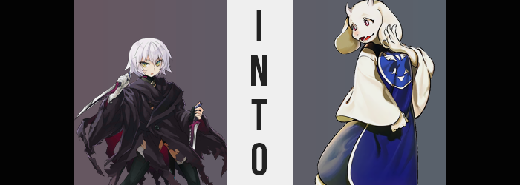

“Mother!? Mother, where are you!?”

The Assassin class Servant wandering midst the darkness was on the verge of tears, for she had been separated from the Master that acted as her de facto ‘mother figure’. Jack the Ripper didn’t have the foggiest idea how she had ended up where she was. While dark, the space she now occupied wasn’t without any light whatsoever. She could make out what seemed to be walls, traps, and pillars. It was like some sort of underground ruins? A maze.

But what had happened that had rendered her alone in this space? Well, it wasn’t actually all that complicated. As she often did, Jack had been following Ritsuka around like a chick following its mother about. Whether the woman went to the cafeteria, the bath, or to do some sort of job? Jack had been shadowing her. It didn’t bother Ritsuka personally, but she knew that some of the other Servants were wary of this relationship.

Jack was an Assassin, a murderer. She may have physically been a child, but that made her all the more volatile. There was no denying that the possibility she might one day attack Ritsuka without a good reason existed, and so she was often closely watched by others. It went without saying that Jack followed her ‘mother’ even into the recreation room, where Ritsuka had planned on playing some games from her backlog since she had some free time.

Details about the game didn’t matter to Jack. She wasn’t watching the television, she was observing her ‘mother’. So she didn’t know what the game was called, nor what it was about. And yet something had gone wrong. Was it the game? The console? The television? Jack didn’t know anything about technology, so she didn’t really know. All she realized was that there had been a flash of light and she had suddenly found herself in this dark place with Ritsuka nowhere to be seen.

“Huh? Maybe mother is here!?” Jack had wandered in the dark for what had felt like hours, easily dodging traps thanks to her expertise as an Assassin. But she had finally come across something that didn’t really fit in with the rest of her surroundings. It was, of all things, a house. One that was lit up like someone lived inside. There was no need to explain why this seemed out of place compared to everything she had seen thus far.

With her sense of morality not particularly developed, the child Servant didn’t even hesitate to break and enter. Not that it was all that hard to do since the door was unlocked. But so unabashed in her methods, she had even gone as far as to announce her presence. “Mother!? MOOOOTHER!? Are you here? We want to go home!” Being a collective of souls, Jack always referred to herself like she was multiple.

Her call received no answer, however. Was no one home? If that was the case, then there were no risks if she decided to explore further, was there? Not that the opposite being true would have stopped her from doing so at all. And as such, Jack’s sightseeing tour of someone else’s home began!

Having gone left upon entering, nothing had really struck the child as odd. The home was clearly lived in. The fridge in the kitchen was stocked, and the living room was clean. This more or less made up the entirety of the left side of the house, while the right side? There seemed to be bedrooms. Not one, but two. One looked like it hadn’t been used in a long time. It looked like it had been designed for a child. And the other? Someone had been using it. Had it been Ritsuka? Had her Master actually come through here?

After checking out the two bedrooms, Jack noticed that the right hallway seemed to go somewhere darker. But she didn’t depart down it, because something else had caught her eye before she could. She was so short that she could only see over its bottom border, but there had been a mirror hung up in this hall. “Wah!?” In it? Her reflection had startled her. It was like there had been some kind of soft, fluffy monster in it! But looking now, it was just her usual reflection, wasn’t it?

But despite everything, it isn’t you.

Jack blinked. She had been surprised by it, but had she been seeing things? Not only that, she felt weird. Warm… Fuzzy… Almost like how she felt when she was around her mother! Did that mean Ritsuka was nearby!? The prospect had certainly excited her, but that wasn’t quite what she was feeling. But the warmth only grew and spread, from her breast to her head, all of the way down to her fingertips and the ends of her toes.

While nothing too dramatic came of it initially, that didn’t mean that nothing was happening at all. Rather, the initial ‘complications were simply things that Jack herself didn’t really comprehend because they were so discreet. Such as? Well, the most obvious ones (to everyone but her, anyways) could be seen one her face. It was more about what would soon no longer be there, though.

The scars etched in the Assassin’s face were dressed away, damaged tissue and skin healing, leaving her body without any scarring, whatsoever. This included whatever laid beneath the bandages that she used to hide her right arm and hand. Never had this Servant’s been so clean and clear, with even her calloused fingers and toes refreshed into something softer.

“Our hands…?” That said, it wasn’t the lack of callouses that prompted the tiny murderer to hold out both of her hands and turn up her palms. They had been throbbing like they were swelling? But that couldn’t have been what was happening, right? Her mind was childish, she wasn’t really thinking all that critically about it. “Huh!?” But she did gasp at the sight of her hands getting bigger. Each throb saw them grow in size, the thickness of each finger doubling. Yet her pinkies? They merged into the fingers beside them so that she only had four per hand.

The girl squinted, uncertain. She didn’t know if she was seeing things, and she certainly didn’t know how to feel. Especially not with the wrapping around her right hand unraveling to show unwounded skin below. She squinted at the bandaged hand further. It almost looked like something was sticking out from between the bandages. Something soft. Something white. It wasn’t on her left hand yet, so she poked at the right with those swollen fingers. “Do we have fur!?”

That definitely appeared to be what it was! She pulled on it and winced with pain since it was attached to her skin, and it seemed to be spreading to the second hand as well! Before long both of these four-fingered hands were almost entirely covered with fur. Except for beads of skin on the tips that had risen with a pink color. Jack blinked several more times as short, hooked claws sought to replace her fingernails. It was a lot to process!

She found her attention quickly shifting down to her feet though. The swelling throb that had affected her hands could now be felt within her boots, but there was a big difference between them and her hands – that her feet were wrapped in footwear. Toes and soles alike swelled within their confines, and pinky toes were robbed just as her pink fingers were. Unlike her hands, though? Her toes seemed to grow forward too, until four furry, clawed digits had torn through the fronts of her boots and the new widths of these paws split the sides.

“A-Are we turning into a dog!?” It was understandable that this might have been her first assumption. After all, she was so young and inexperienced that she didn’t really know a lot of animals? A dog was just the first thing that came to her mind. At the same time, though, the fur that had covered her hands and feet had begun to sprout up all over her body. It peeked through the bandages of her arms, shrouded her loins and small chest, and just overall made her outfit feel too small with this white fur adding extra inches to be swathed by their fit.

The girl idly itched here and there, mostly through her clothes after she found herself forced to discard her cloak. You couldn’t make out her bellybutton on her bare tummy now, and it was sprouting out around her neck, the fur travelling up to her face with time. The second it hit her chin, though? Her face changed very dramatically structurally.

Jack made a weird noise that wasn’t wholly intentional. For a brief moment it had felt like her jaw had unhinged? Only for her to feel a forward tugging on it, as well as the sight of her nose being pulled farther and farther away from her eyes. She couldn’t really vocalize much during this, as the bone of her face contorted and lengthened into the shape of a rounded muzzle that her nose flattened into as a pair of wet nostrils. Her canine teeth remained sharp as teeth were moved around to fill her maw’s new, goat-like shape, but many of the teeth became flatter and better suited for chewing greens.

“O-Ow!?” It hadn’t really hurt, but she felt like it should have. What’s more, a longer tongue had hung from this mouth a moment before she finally managed to pull it back in. Was she not becoming a doggie? No, deep down she felt like she was beginning to understand. A goat. She was becoming something like a goat now that her eyes glossed over with red and her hairline receded into a head that was only covered with white fur. But how did she know that? How did she know that the short horns that popped out of her forehead, and the round, floppy ears she gained belonged to a goat?

By this point, she very clearly looked like an anthropomorphic goat girl. Proportionally she was still a child, but she was certainly some kind of monster with an appearance like that. “But of course I’m a monster…?” Evidently she wasn’t referring to herself in multiples anymore. The voices in Jack’s head had faded. She was a singular individual now. “Oh dear!” And one who spoke much more properly at that.

Her ladylike expression of shock actually wasn’t random. The girl had almost fallen forward, and it took her a moment to understand just why that was the case. But the fit of her clothes and her eye level promptly gave it away. “Now I’m getting bigger?” Was she supposed to be bigger? Not only did she get the impression she was, but her voice deepened as if to confirm as much.

It wasn’t just a little but of height that was gained, though. Her furry body shot up like a beanpole, an increasing maturity somehow coming across through her goat-like facial features while hips and shoulders likewise widened to suit her new stature, shorted eventually ripping completely in half vertically, and her top basically exploding as she came into her new form.

She was effectively naked now, with remaining clothing scraps falling from her body. Yet she was in no danger of revealing herself, either. The soft fur that clad her form concealed her chest, loins, and rear. Which was convenient since to better suit her almost seven foot tall body perceived age range of an older woman, her figure began to blossom in kind.

Even though Jack was technically covered though, she still seemed a little bashful. This was especially true once the once meager mounds that the fur of her chest concealed began to swell. Little by little orbs took shape, and those orbs soon became baseballs, then soccer balls, and basketballs. Each breast was perky and sensitive, but they weren’t even the only things on her torso to swell. Her tummy, too, bulged a little. An enticing bit of chub that seemed to suit her new age. Something to hold onto or play with if that was what you were into.

“I really should get back into shape… Less pie would help…” She remarked while pinching her own gut, only to let go when she remembered this wasn’t right. “My memories feel so jumbled. Is this right or wrong?” She sought clarity, but it didn’t come very quickly. Her body just continued to become more abundant instead.

Hips had already widened as she’d grown older, but they parted several inches further so that her body shape was the spitting image of idealize maternity. It offered plenty of space between her legs to her thighs, which tripled in furry girth and would jiggle a touch when she walked. The lower halves of her legs thickened too, but this was more in terms of bone to better flow into her now huge feet. And her ass couldn’t exactly go unmentioned here either, not with how fluffy cheeks took on a fullness to rival her big breasts. The rise and fall of those buns with each step would likely be the stuff of legends.

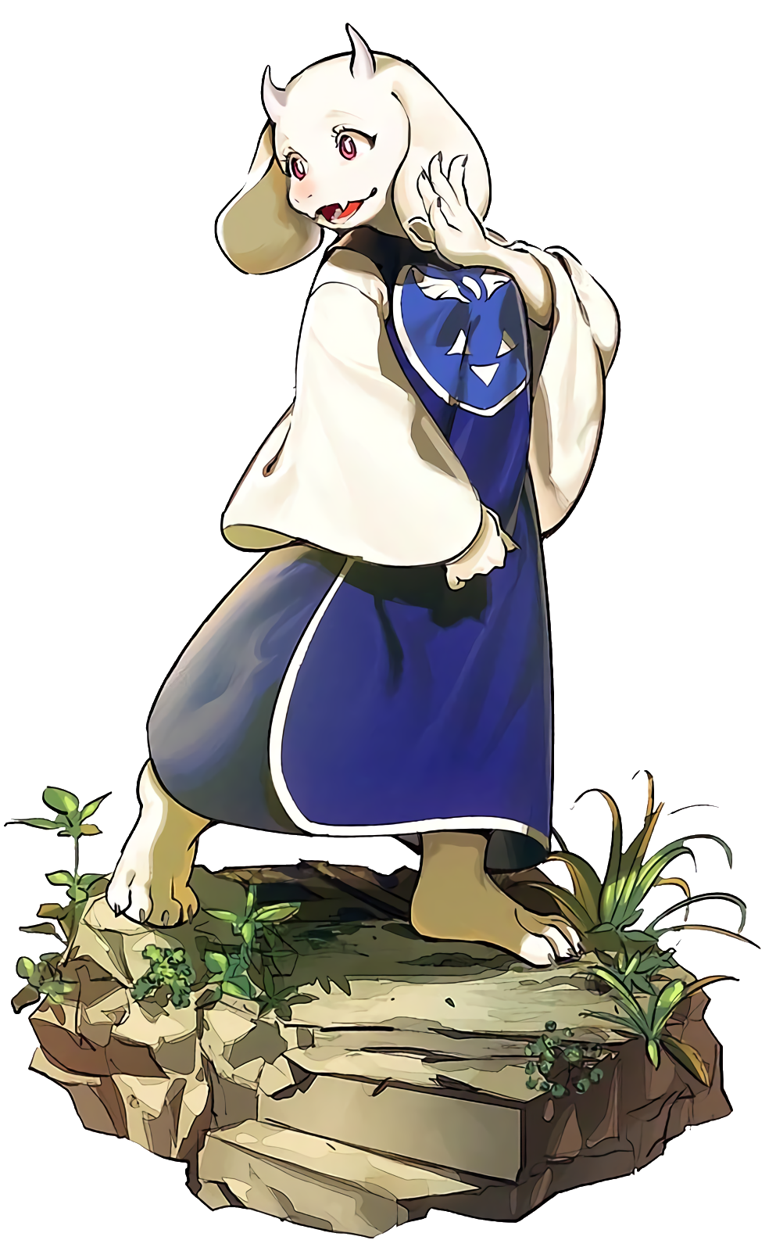
“I’m… a goat? No, I suppose that isn’t quite right. I’m a monster that resembles a goat.” The woman’s words were just as calm and collected as their were gentle, a maturity unbefitting of Jack’s previous life giving her a very measured perspective about her current predicament. It seemed that memories of her past existence stayed with her, but otherwise? She was still Toriel. A monster that lived in the underground world where all monsters resided. Memories of this life coexisted with memories of her old one, but obviously the new ones better suited her appearance and personality as they were now.

Toriel smoothed out her robe. So this house was her home. She had good reason for not venturing outside as she could recall. She was a mother who had been left to mourn, an ex-wife that did not agree with the actions of her ex-husband in the wake of their loss. It was simply easier to remain hidden away so that no human child that fell into this realm would suffer a similar fate. So that she could protect them.

She exhaled. “But that includes her too, doesn’t it?” It would have been easy enough to just accept her new life as the only thing that mattered. But Jack’s love for her mother was strong, even though she was now technically in the shoes of a mother herself. Ritsuka had been in the recreation room when she had been brought to this world, and so it stood to reason that she was somewhere in the underground herself. “And yet that means…”

It would mean venturing out of the ruins and into the rest of the world to find Ritsuka. That girl was probably in danger. So both as a woman that had once been her Servant, and as a woman that now deemed herself as the protector of any humans that fell into this land? The answer seemed obvious. She would have to leave. She knew how dangerous this world was for the uninitiated, and how her ex-husband would use any human at his disposal to see his goals to fruition.

“I need to leave, and quickly.” With her big, soft body she would protect the things important to her – people and morals alike. This was what Toriel had decided for herself, and so she couldn’t waver now. Ritsuka Fujimaru would be found, and she would be protected. She had a duty. The issue, of course, would be finding her. “I suppose I can use some old connections, but this world is vast…”

Not to mention Toriel was overlooking a possibility. One that she really should have noted, seeing as it had happened to her. Because after all? She had been transformed into a denizen of this world after interacting with the right object. Ritsuka could have very much been at risk of the same thing happening, wherever she had ended up. And even as Toriel steeled herself to leave?

Ritsuka was navigating a spider’s nest.

“Wait, I should probably throw on a robe first…”

