Colligative Properties Formula Sheet:
Useful Notes:  $$∆T=T_{solution}-T_{solvent}$$  $$T_{solution}→FP or BP of solution$$  $$T_{solvent}→FP or BP of solvent$$  Adding Salt to Water:  $$Salt↑ → BP↑ π↑ VP↓ FP↓$$ | Boiling Point (BP) Elevation:  $$∆T=K_{b}∙m∙i$$  Freezing Point (FP) Depression:  $$∆T=K_{f}∙m∙i$$  For H₂O: ${ K}_{b}=0.51 ℃/m K_{f}=-1.86 ℃/m$
Molarity:  $$M=\frac{moles of solute}{Liters of Solution} M=\frac{n}{V}$$  Molality:  $$m=\frac{moles of solute}{Kg of Solvent}$$ | Osmotic Pressure:  $$π=MRTi$$  $$R=0.08206 \frac{L*atm}{mol*K}$$  $$T_{K}=T_{C}+273.15$$
Substance: Van’t Hoff Factor:  $$C_{6}H_{12}O_{6}$$ $$i=1$$  $$NaCl$$ $$i=2$$  $${MgBr}_{2}$$ $$i=3$$  $${AlCl}_{3}$$ $$i=4$$  $${Al}_{2}{\left({SO}_{4}\right)}_{3}$$ $$i=5$$ | Van’t Hoff Factor:  $$i=\frac{moles of particles in solution}{moles of solute dissolved}$$  Ion Pairing: $i_{observed}<i_{ideal}$  Note: $m↑ ion pairing ↑$
Mole Fraction for Solutions:  $$X_{A}=\frac{n_{A}}{n_{T}} n_{T}=n_{A}+n_{B}+n_{C}+...$$ | Vapor Pressure of a Solution:  $$P_{soln}=X_{solvent}∙P_{solvent}$$
Mole Fraction of Gases in the Vapor Phase:  $$X_{A}=\frac{P_{A}}{P_{T}} P_{T}=P_{A}+P_{B}+P_{C}+...$$ | Solution Vapor Pressure: (2 Volatile Components)  $$P_{soln}=P_{A}+P_{B}$$  $$P_{soln}=X_{A}{P_{A}}^{o}+X_{A}{P_{B}}^{o}$$
$$P_{A}→Partial Pressure of Gas A$$  $${P_{A}}^{o}→Vapor Pressure of Gas A$$  $$P_{soln}→Vapor Pressure of Solution$$  $$P_{solvent}→Vapor Pressure of Solvent$$ | Partial Pressure:  $$P_{A}=X_{A}{P_{A}}^{o} P_{B}=X_{B}{P_{B}}^{o}$$

Vapor Pressure:  $$P_{2}=P_{1}e^{- \frac{∆H_{Vap}}{R}\left[\frac{1}{T_{2}} - \frac{1}{T_{1}}\right]}$$  Note:  $$P_{H2O}=23.76 torr at 25 ℃$$  $$P_{H2O}=17.5 tor at 20 ℃$$ | Clausius -Clapeyron Equation:  $$\ln\left(\frac{P_{2}}{P_{1}}\right)=-\frac{∆H_{Vap}}{R}\left[\frac{1}{T_{2}}-\frac{1}{T_{1}}\right]$$  Note:  $$∆H_{Vap}=43.9 {kJ}/{mol} at 25 ℃$$  $$∆H_{Vap}=40.7 {kJ}/{mol} at 100 ℃$$  $$R=8.3145 J/{mol*K}$$
Temperature:  $$T_{2}={\left[\frac{1}{T_{1}}-\frac{R\ln\left(\frac{P_{2}}{P_{1}}\right)}{∆H_{Vap}}\right]}^{-1}$$ | Enthalpy of Vaporization:  $$∆H_{vap}=\frac{-R\ln\left(\frac{P_{2}}{P_{1}}\right) }{\left[\frac{1}{T_{2}}-\frac{1}{T_{1}}\right]}$$
Graph: $\ln{(P_{Vap})} vs \left(\frac{1}{T}\right)$  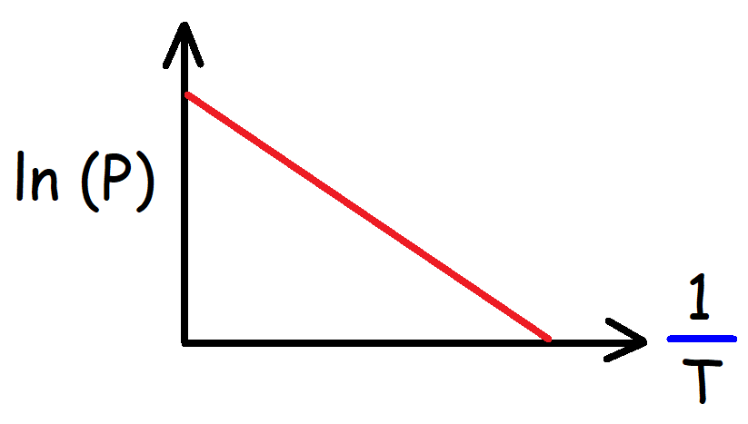 | Slope-Intercept Form:  $$\ln\left(P_{Vap}\right)=-\frac{∆H_{Vap}}{R}\left(\frac{1}{T}\right)+C$$  $$y=mx+b$$  Slope of Straight-Line Plot: $\ln{(P_{Vap})} vs \left(\frac{1}{T}\right)$  $$m= -\frac{∆H_{Vap}}{R}$$

