SPIRAL ARROW
COMMISSION STORY
BY CHALDEACHANGE
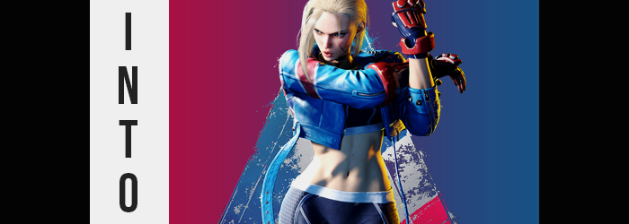

Capcom had wasted no effort in making sure the potential purchasing audience of Street Fighter 6 knew exactly what they were getting.

In the eyes of many? It was one hundred percent the right move. There were likely few long term Street Fighter fans that didn’t remember the launch of the fifth entry in the popular franchise. A limited roster, missing game modes… it had been a PR disaster for the company, honestly, and they spent the game’s entire life cycle trying to earn the good will of the consumer back. Fortunately for them they managed to do just that, but it certainly had not come easily nor quickly.

So it went without saying that the same audience would be skeptical about the release of the sixth entry in the game. And early impressions very much factored in this sentiment, yet these were only the early impressions. A closed beta came, and then another, and through word of mouth and streaming viewership, the game’s reputation became better and better. Then came the demo, allowing everyone to try out the World Tour mode, and it was nothing but sunshine and rainbows in the FGC for the most part.

You just know Manon is going to be the best character.

No way! Cammy has always been the best!

But for some, the discussions were a little more childish. Despite being adults ourselves, my friend Joseph and I had found ourselves in a heated Discord debate! …Okay, it wasn’t that heated, it was more like a pretty normal discussion that had derailed from our conversation about how the game appeared to be shaping up. I was in team Cammy, with her having been a longtime favorite of mine – probably ever since the days of Street Fighter 4, at least. And it wasn’t just because of her design! Although her design did help. I wouldn’t deny that at all. My friend, on the other hand, was excited about the new character Manon.

“It’s too bad she isn’t in the new beta though…” I mumbled to myself after sending my most recent text response. An online open beta was coming out in just a few days, and while most of the cast had been announced for it? Cammy, unfortunately, had not been. It was beyond tragic, but it was what it was. The full game was coming out in a few weeks anyways, and then it would be my time.

Why not experience Cammy now?

A new DM had popped up on my Discord, but this one hadn’t been sent by Joseph. Actually, who had sent it? I didn’t recognize the address, and with Discord rolling out its new unique name system I couldn’t be certain if it was someone I had added in the past. I didn’t have any existing chat history with them… but that wasn’t even the weirdest part. I hadn’t told anyone what I had been talking to my friend about, and what that DM spoke of… was something I had simply uttered to myself. My microphone wasn’t secretly on, was it? Well, it didn’t seem to be.

I went to type a confused response back, likely a chain of question marks, but the moment my fingers so much as grazed the keyboard? From my perception I had fallen out of my computer chair and onto my hands and knees, but that would mean my desk was gone. “Huh!?” Technically my desk hadn’t disappeared so much as it was a matter of me disappearing. And reappearing in a completely different location.

“Where…?” I managed to pull myself up, naturally confused about my circumstances. I was standing in a vacant city alleyway. It had to be early evening with the orange glow of the sun bearing down on me and my surroundings, graffiti painting the walls. One of these works of arts read METRO CITY in stylized font. “Wait, like in the game!?” That was the primary location for Street Fighter 6, wasn’t it!?

I almost wondered if I’d hit my head. Or maybe I’d been consuming too much weird fiction lately?

Thinking back to the DM I’d been sent in the moments prior, it had almost sounded like the person sending it to me a way of trying out the beta as Cammy White, and early at that. Had the thought simply slipped into my dreams? It wasn’t impossible I supposed, but flexing my fingers together? It didn’t exactly feel like a dream. I’d had quite a few lucid dreams over the course of my existence, and I was pretty good at telling the difference between them and reality. “Is this actually real?”

If it was, what was the purpose for bringing me here? If the intention was to just try Cammy out before the game release, it didn’t make sense to bring me to what was… was this just an elaborate set? Maybe there were some machines nearby with the game installed? Evidently I was desperate to try to make any sense of the situation, because this still didn’t make any sense. There was no logical way to explain the fact that I had basically been teleported without assuming I had been drugged or something like that. And it really didn’t feel like this was the case.

Or was it? The longer I lingered in this unusual location, the more off I began to feel. Maybe it wasn’t right to say that my body felt sluggish, but… No, it was the opposite? Wasn’t it? I felt more energetic. Almost… stronger? Although at first it was only slightly so. And I didn’t exactly notice the reason why in the earliest moments – though it was certain that no drug could do what was actually happening to me.

I wasn’t exactly a thin person, or at least I hadn’t been. A notable gut decorated my body, and I wouldn’t have called myself fit or even the slightest bit muscular. I didn’t have the time to work out, or at least that was what I had told myself. And yet the bolstering of energy I had felt coming on was a direct result of that build that I knew was changing.

Gradually? I was becoming a trimmer person overall. It was largely noticeable in my stomach, because even while wearing an overly large tee, my tummy could usually be observed pushing forward against it. Little by little, though, its protrusive nature waned. It flattened until there was no bump at all, while excess weight in my chest and limbs thinned in kind. Of course, this meant that the clothes I was wearing had become incredibly loose – and this was most certainly something that I noticed.

“What the— I’m thin!?” Hands pressed through my shirt, which felt more like a blanket with how loosely it was dangling now. Fingers ran across my entire body out of disbelief, and in the process it escaped my notice that they were becoming smaller and increasingly calloused. Like I had been using my hands in a more physical sense for a very long time. Pressing against my stomach, though? I noticed something else. I wasn’t only thin now. I was getting muscular! “No way!”

Immensely curious about what was transpiring, I lifted up my shirt and tossed it aside. This was something I had to see, and even this simple observation had rendered me awestruck. When was the last time I was truly thin? My teens, maybe? And even then I had never in my life had much muscle to my body. Yet there was a clearly defined eight pack upon my torso, arms and legs rippling with a great deal of strength and muscle as well. No wonder I felt so much stronger, it was because I was!

Still, why was my waistline so narrow? It almost made me look like…

“Wait, so putting this together… I was teleported into what looks like a scene out of Street Fighter 6, and now I look fit enough to be a fighter in the game. Bollucks…” Bollucks? That had been an odd thing for me to say, and I’d even said it with a very British accent. Saying it had stunned me momentarily, but as I tried to work through what I had just said and why, well that didn’t stop my body from continuing to undergo change. Making me fit and buff had not been the only thing in store for me.

Take my hair, for example. Usually dark in color, it had begun to lighten shade after shade, until it found itself dyed in a platinum blonde coloration – that wasn’t technically a dye at all. What’s more, it lengthened to my shoulders, each strand silky in texture yet displaying something unexpected. It was a little coarse and worn, as if it belonged to someone in the middle of their life rather than just their late twenties. My bangs were left slightly slicked back, but a long bunch of it fell over my right eye. It was a hairstyle that should have been obvious to me, but without a mirror I was just left confused.

“This has to be a dream, right?” Each words sounded higher in pitch, but also? That British accent that had surfaced earlier was becoming stronger and more constant. “Why can’t I even speak right?” Even if I spoke carefully and deliberately, I couldn’t shake the changes my voice brought. And beyond my notice, my face was changing so that this voice actually suited me better.

It began with my lips, which inherited a natural pout as they became fuller. Still talking to myself in an attempt to sort out why I was speaking with an accent, these lips smacked against each other awkwardly for a time as this occurred. It certainly didn’t help that my jaw was narrowing or my cheeks slimming, giving that face a more diagonal shape. Lashes around my eyes became longer, highlighting that my eyes had actually become smaller. Perhaps most notable in the sense of how iconic it was, a scar etched itself across the left side of my face – from the left of my chin to just shy of my nose.

This face didn’t look all that young though, it made me look like I was in my late thirties.

Idly, I had begun to itch at my chest. I was still shirtless, and my pants were only being held up by the whims of my hips. And were those hips wider? I hadn’t really thought to consider that. Because I was shirtless though? It was easy for me to see that something was awry once that itchy led to me thinking my chest felt a little softer than it had just moments ago. “Huh?” Looking down, my chest seemed strangely puffy.

Swollen, almost. Was I having an allergic reaction? But that wouldn’t lead to my nipples looking so full and erect, would it? It took a moment for it all to click. The sound of my voice, the shape of my body, my hair… “Am I becoming a woman?” Was there any other plausible explanation? After all, my calloused fingers were sinking into the mounds that had built upon my chest now. They were definitely breasts, and while they weren’t larger than C-cups? It looked like they wanted to sag a touch, reinforced only by my fit pecs.

What followed after might have been a touch predictable. A similar feeling filled my pants next, the shape of my ass pushing out and rounding behind me. Muscles that had been built in my rear when I had grown muscular were concealed somewhat by the softer weight that built those cheeks, and my boxers were chewed up by the depth of the ass crack that followed. This ass forced my hips to widen even further, and before long my pants were much too tight around them.

It didn’t help that I was shrinking. “Woah!” I was almost six feet under normal circumstances, but now that my body had begun to take on traits more biologically sound for a woman, it seemed that this height was not meant to be preserved. I shrunk vertically, and this only made my breasts and ass look bigger against a frame that was ultimately rendered just over 5’1” in height. This compacted my thighs as well, which bloated gratuitously until either thigh greatly surpassed my narrowed waistline in width. They were both muscular and soft, and they were crushing what rested below my pelvis.

My dick. I looked like a middle aged woman now, and I’d pieced together who I looked like. Yet my biological sex was still mismatched and being crushed between my now thunderous thighs. Much to my relief and concern, the discomfort went away as my cock and balls went away, the uncanny sensation of it all folding up inside of me beneath coarse, blonde pubes prompting me to shudder. “This can’t be… I’m Cammy?”

Not just in body and personality, either. My clothing wriggled, and while it tickled? I did not laugh as my shirt crawled back onto my body, changing shape along with my pants to give me a new outfit. Tight, blue pants with red boots concealed everything below my hips. My tight and toned tummy was completely bare, but I was wearing a black crop top and sports bra around my chest. Paired with a red and blue leather jacket that represented the British flag, calloused fingers were likewise concealed by red and black fighting gloves.
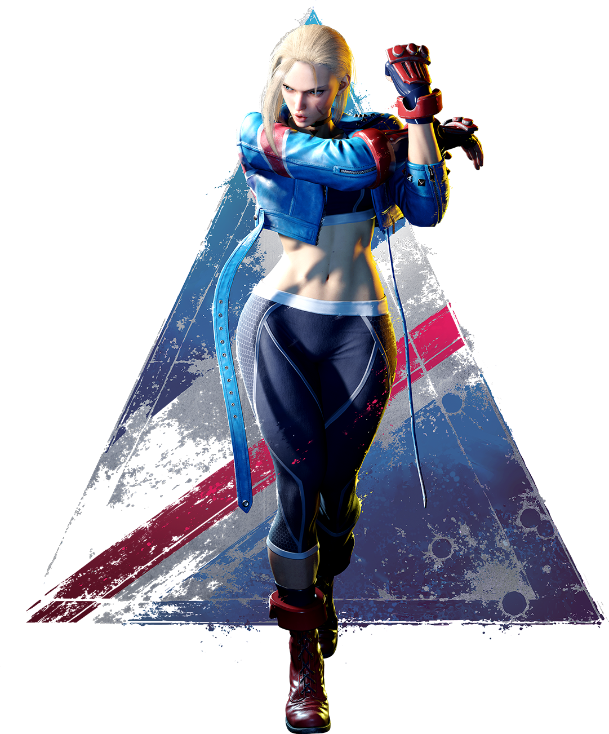
“I still do not believe this is real.” It was a sensible take from me despite that fact that my body was that of a fit, buff, middle aged woman – and despite the strong British accent that clung to a voice that was suspiciously similar to the voicework of Caitlin Glass. How was I supposed to believe that my life had just been turned upside down? That I was in the world of Street Fighter, or perhaps literally the game itself, as Cammy White?

As unfamiliar as this athletic form should have been, I found myself breathing, moving, and stretching as if I knew it all too well. Something deep down wanted me to keep my muscles loose, and despite my previous aversion to any bouts of athleticism? I couldn’t help but think that after this I should go hit the nearby gym. My entire personality, including my priorities had changed. But in terms of memories? I was still limited to what I knew about the character as a player. I couldn’t recall anything from her – now my – point of view.

“But even if I were to accept this, why am I out on a Metro City street alone?” No, I felt like I knew why, didn’t I? It was an itch deep down, an instinct. I was there to fight? And I instinctually knew how to contort my body to make use of its strength and speed, allowing me to use moves like Spiral Arrow and Cannon Strike. “Who am I fighting?”

“The pleasure is mine!” The voice of another woman prompted me to look down the alleyway, and a beautiful, French woman dressed both to fight and dance strut forth with delicate movements before her posture slouched. “Non! I did not mean to say that! I am not actually Manon, and yet…!” Huh? I was certainly confused. This was Manon, another character that wasn’t on the beta roster and Joseph’s favorite. But…

It couldn’t be, could it? “Wait, are you also not— Beginning operation!” Before I could ask my question, I struck a pose with my ass to the side and spouted out what was undeniably one of Cammy intro quotes, and my posture tightened into a battle stance. As did Manon’s. Wait, were we actually about to fight here? I had personally never taken a punch in my life, but I felt as if I’d taken worse now. I was unable to resist the desire, the urge, the instinct. The need to fight now that an opponent faced me.

Almost like I had been programmed to do so. Almost like I was being controlled like the video game character I was.

And such was the reality for both me and Joseph, for being brought into the world of a video game meant playing by its rules. When the rounds came to an end, provided the player decided to turn off the game, we would be able to communicate as normal. But as long as those rounds continued we would be stuck in a cycle of punches and kicks, of pain and triumph.

Such was the life of a Street Fighter.

