Tricia route patch 2.1

* After starting the game and doing the first events of the game where you get bullied by tricia you go to summer.(Find her using the app you got from the Devil) 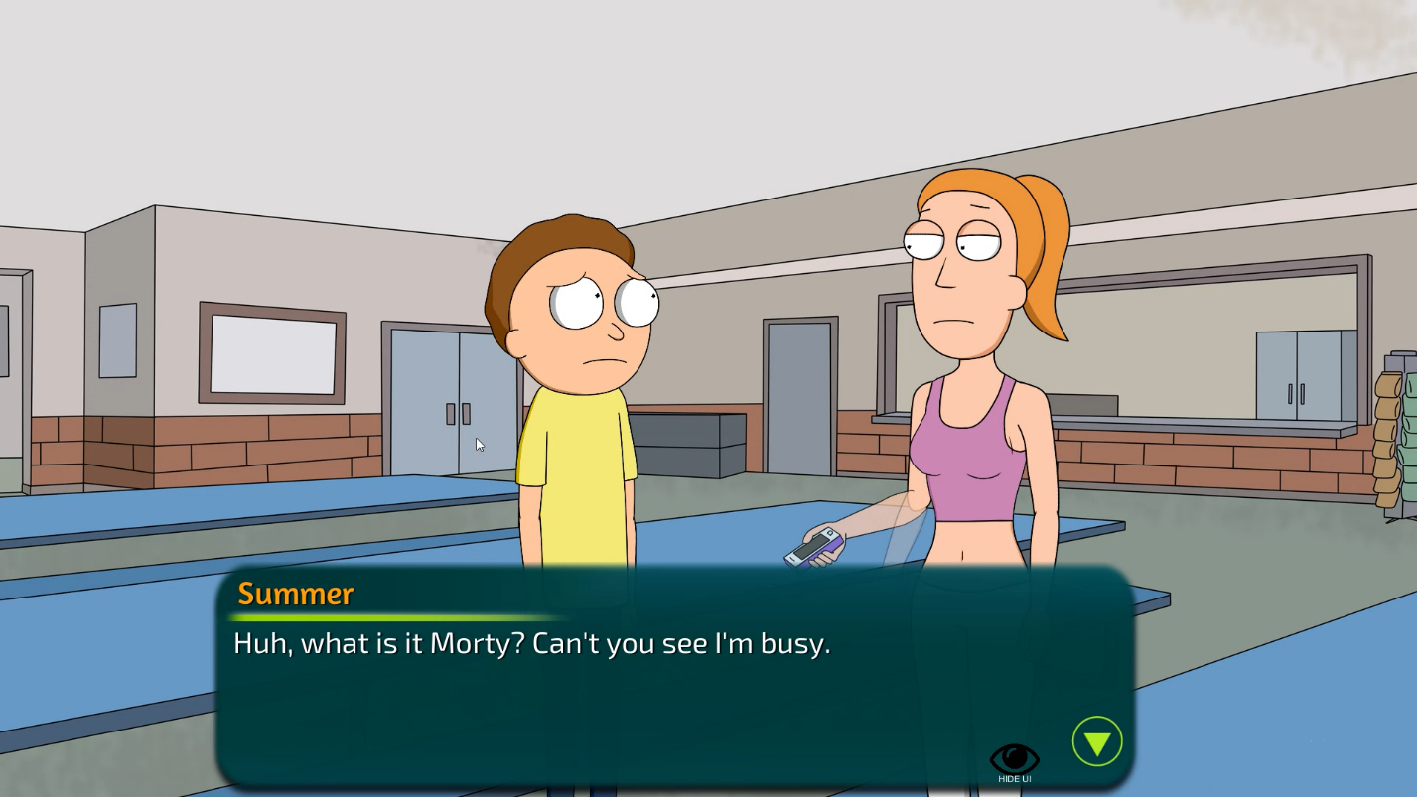
* For the next event you have to continue the missions with Tricia.
  + Talk to Tricia in the school bathroom.
  + Then you will have to go home and drink water. After that go back to the school bathroom
  + After the bathroom scene Summer will talk to you.
* After Summer shows you the video of Tricia you have to ask her about Jessica. This will activate the mission to sneak into her room and search her phone
* At midnight you have to go to summer’s room. She is sleeping you have to click on her. Then click on her phone – Its locked. Click her diary on the shelf to get the password. After that click on her phone again. 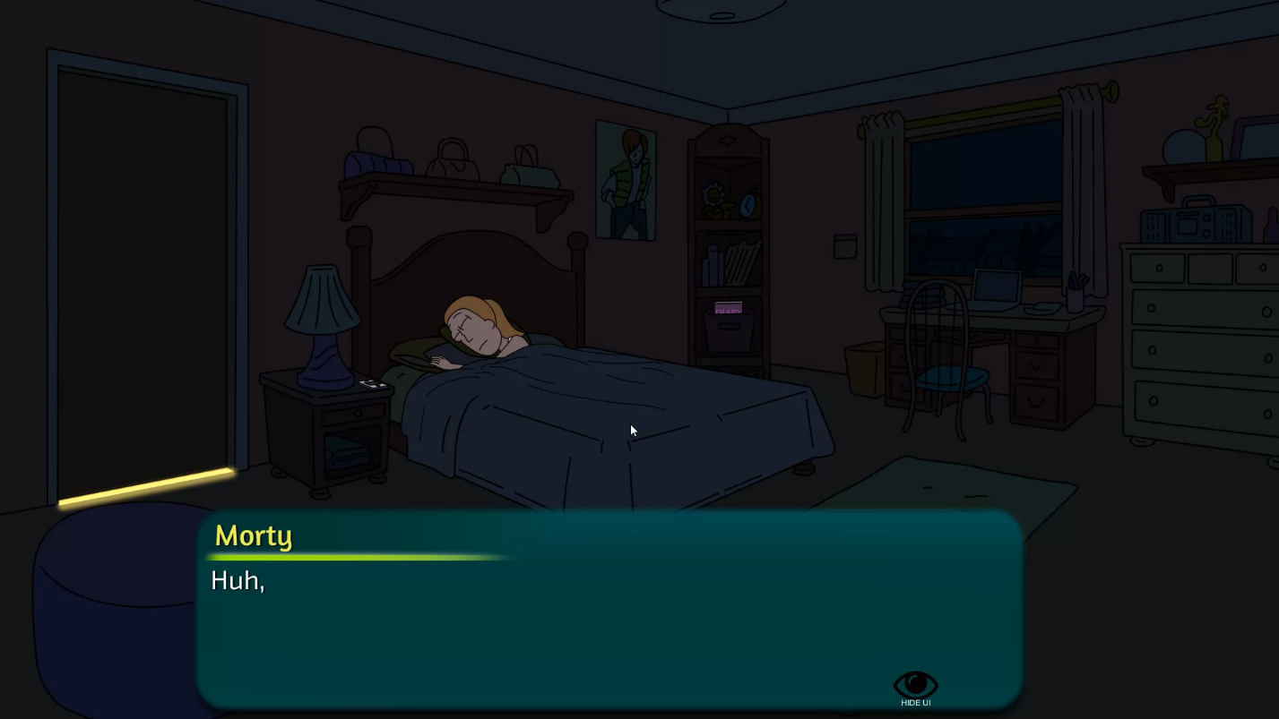
* On the next day go to school and talk to Tricia and black mail her to show her boobs.
* Talk to Jessica and Tricia in school.
* After finding crying Summer she will ask you to make Tricia give you a blowjob.
* You need to find her in the Church.
* After the event wait for her to be at the church again and meet her there.

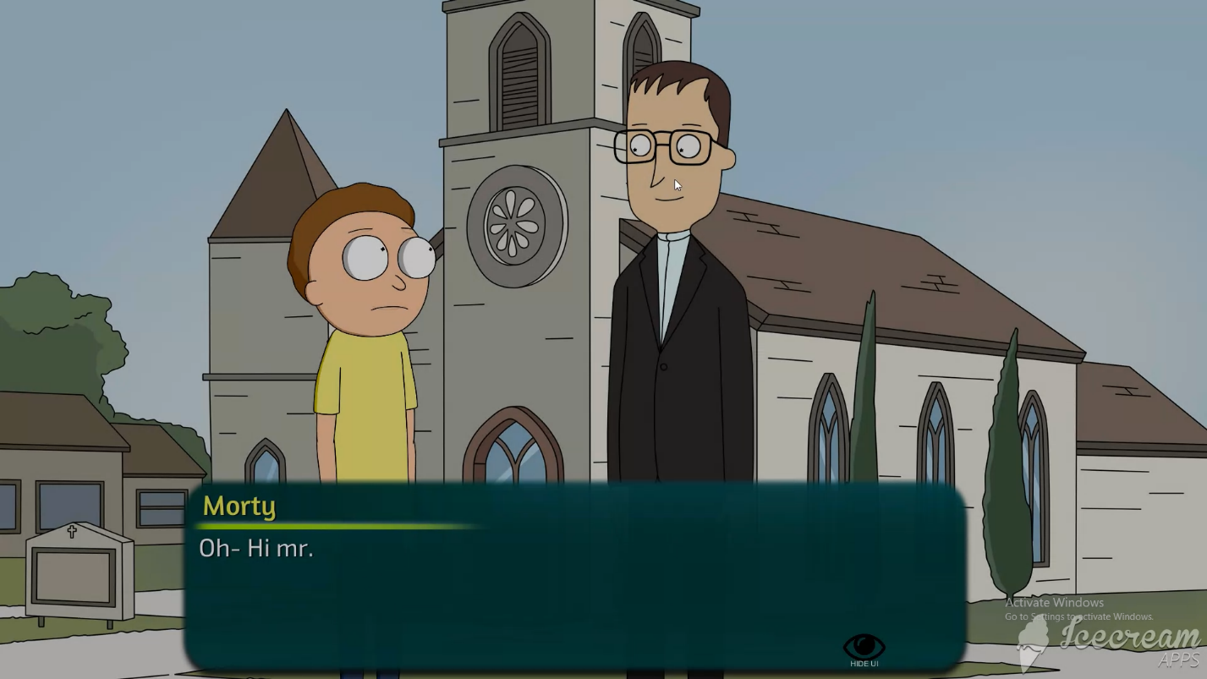

* After the scene you will visit Morticia and will trigger the next event and let you message Tricia.
* You have to message Tricia and ask her for nudes. To get them you have to buy her a pack of emojis.
* Then message her again to get Jessica nudes
* And a third time to trigger the rape event.
* After messaging her, go to Jessica’s house. It will trigger the pickle Morty event.
* 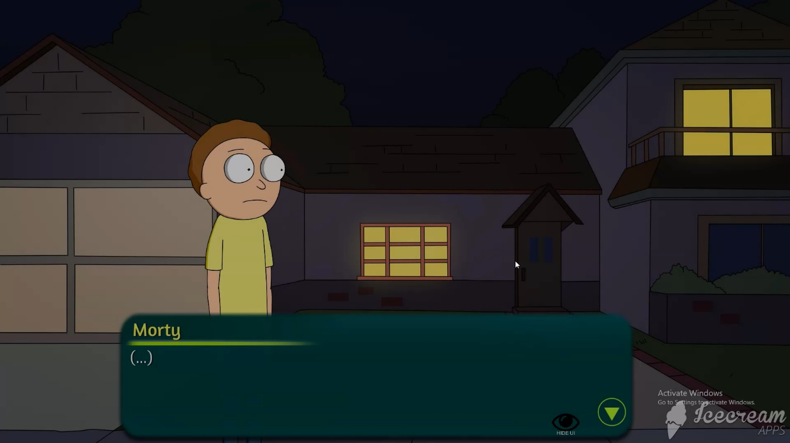
* On the next day find Tricia and ask her to help you to get closer to Jessica and do what ever it takes! Then you can sneak on her to see what is she doing.
* Then talk to Rick to help you build confidence. Then after the scene drink the purple potion in the garage to trigger the Rape scene.
* After that message Tricia.

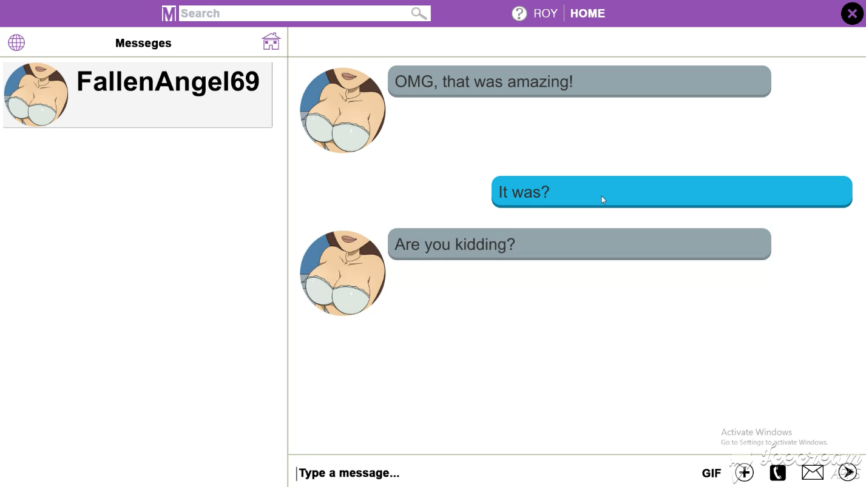

* For the next mission you will have to go to the Mall and buy a Buttplug
* After buying it, go to school and give it to Tricia and this will trigger the next scene.