**Ino, sakura & Hinata’s beach MISSION**

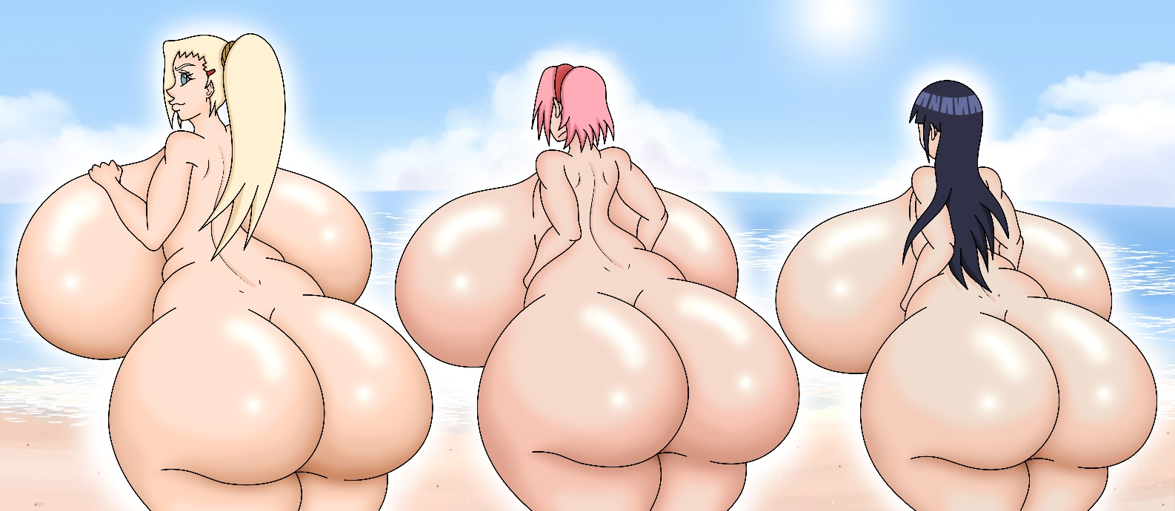

**Part 1**

It’d been two and a half years since Naruto and Jiraiya begun their training far away from Konoha, and even longer since Sasuke left the village. Their absence was definitely felt by their Genin friends at first, however they quickly moved on with their lives. The same could not be said for Sakura and Hinata…

***“Good morning, Lady Hokage! What can I help you with?”*** Ino greeted, getting into Tsunade's office. Last night she received a letter from the Hokage, in which her presence was required early in the morning.

***“Hi, Ino. I have a mission for you today, not a dangerous one, but not particularly easy either…”*** She explained to Ino, who had brought a bouquet of roses as a present.

***“Oh? Sure, but shouldn’t I call my teammates then?”*** She asked

***“Oh, no no… this is a mission for girls only”*** The Senju descendant began explaining… ***“See, Sakura and Hinata are both underperforming in their missions and trainings ever since… you know…”***

***“Yeah… I noticed. Neither of them are the same anymore. I got really sad when Sasuke left too but I guess I’m over It now.”*** Ino replied, not really knowing how She could solve her friends’ sadness.

***“Indeed. And that’s why I’m counting on you for this one. See, You’re gonna…”*** Tsunade explained the whole plan to Ino, nothing too complex, but taking Sakura and specially Hinata out of their comfort zone could prove a tough challenge.

After the meeting with Tsunade, Ino approached the two girls under the excuse that… ***“The Hokage has a mission for us”***, and afterwards she explained the whole deal. The girls simply couldn’t say no to an order from the Hokage, so in the blink of an eye the trio was on their way to this new “mission”.

***“So We have to approach these 3 men and… spend the day with them?”*** Sakura asked as they walked towards their destination.

***“Yeah. apparently Lady Tsunade wants to put them as Jonin or something like that, she said they are really strong…”*** Ino lied, in reality those 3 were already Jonin in the village and the plan was for them and the girls to have sex.

***“Uhm… But why are we meeting them… in a Beach? I wouldn’t feel comfortable in a swimsuit… around 3 strangers…”*** Hinata claimed, not really sure about this being a good idea.

***“Well… You gotta endure It because… we’re already here!”*** Ino yelled, smiling. Luckily for Hinata specially, the beach was almost empty, aside from a couple people swimming around.

***“Hm… I thought there was only one beach nearby the village, never heard of this one. How Is It called?”*** Hinata asked.

***“Well does It really matter How It’s c…”*** Sakura was saying until she saw a sign that probably had the Beach’s name or something. It was shocking for the trio When they walked there and... ***“NUDIST BEACH?!!!”*** Sakura yelled furious, immediately looking at Ino afterwards.

***“What?! The Hokage sent us to a nudist Beach? Oh I can’t believe this…”*** Ino actually didn’t know about that part.

***“W-wait… Nudist means We… We have to…”*** Hinata blushed and covered her face in shame.

***“Why would Lady Tsunade do this to me?... Sorry, us. But I mean, I’m her favorite apprentice so I get to be the most offended one here…”*** Said Sakura.

***“Ugh, will you stop being such an arrogant bitch? Mrs. Flat as a b…”*** Ino was replying to the pink-haired, but then looked at her head to toe… ***“Damn It, why did you have to grow SO MUCH these last couple years?”***

***“What? You jealous, Ino-Pig? That you needed countless sit-ups and I just naturally got a huge butt?”*** She mockingly replied.

***“Uhm… Excuse me… I think We have a mission… to fulfill…”*** Hinata interrupted… and she was fully naked already! Everybody in the village knew It, but her massive tiddies were even bigger than they seemed!

***“W-WHUT?! Hinata…”*** Sakura couldn’t believe what she was seeing! It was really strange for that timid girl to be the first one stripping out of the three, but she certainly did.

***“Haha… No need to undress, Sakura. Hinata and I can handle this ~”*** Ino claimed, grabbing Hinata by her waist as she finished removing her clothes.

***“Guh… Shut up…”*** Sakura claimed trying to keep her cool, right before tearing her clothes appart. Incredibly, Sakura’s tits and ass were pretty much as big as Hinata’s, her growth was outstanding, to say the least.

***“S-Sakura… you look so good… and you too, Ino…”*** Hinata complimented them with a cute smile in her face, blushing.

***“Thank u, Hinata! Guess there really isn’t a reason to compete anymore… I mean, we are all just as thick, aren’t we?”*** She commented, looking at her partners’ breasts and thighs.

***“Hm… Yeah, I guess so. Although those guys in the water staring at us… doesn’t feel so nice…”*** Ino said a bit annoyed, and more people began showing up too, which just made things worse…

***“Y-Yes… and the people coming are also looking here… oh my…”*** Said Hinata, looking to the ground in embarrassment.

***“Well, well… We just got to get used to It! To be honest… It feels nice to me ~”*** Sakura was saying, and before Ino commented how much of a bitch that made her sound, she explained herself… ***“See, I was always the flat girl with a big forehead… and now look at all those guys and girls staring at my ass!”***

***“Huh… Well if you say It like that you do sound less slutty. We’re also older now, so It isn’t just kids looking at us, but the adults too...”*** Ino stated.

***“Uhm… and their wives as well… although they look… angry…”*** Hinata added, though at this point the naked girls kinda had forgotten about their mission; It was time to actually fulfill It…

***“Okay girls, how about we separate and look for those guys Lady Tsunade told us? It´ll be faster that way”*** Sakura suggested.

Ino was already looking around the place, and just as Sakura said that, she saw one of the guys staring at them from behind… though He had something that awakened her libido immediately… ***“Oh yes! That’s a great idea, Sakura! Let me know if you find them!”***

And like that, the trio began their search. Sakura went to the east, Hinata to the west, and Ino run to the south, towards the guy she had seen.

***“Oh, hi sir ~ How you doing today?”*** Ino greeted with a naughty look in her face, trying not to look to that BIG thing that caught her eye earlier.

***“Ehm, yeah, doing pretty good… Sorry for starring at you and your friends, I just… oof… you are honestly out of this world…”*** The stranger said, trying to avoid making eye contact with the blonde’s gigantic tits!

***“Oh really? Well yeah I mean… We are a bit bigger than average…”*** She jokingly said, squeezing her breasts and moving her up and down in a carefree way.

***“Goddamn… I mean… Not gonna lie, you were my favorite of the 3…”*** The male admitted, and that comparison only made Ino’s ego sky rocket, along with her sex drive.

***“Hehe… Yeah that’s pretty common… It’s hard to pass me by ~”*** She commented in such a cocky way, but immediately after she shifted the focus to the guy in front of her… ***“The same could be said about you of course… to say you’re just a bit bigger than average would be an understatement…”*** She seduced the male, now looking shamelessly at his enormous cock.

***“And you’re humble too, huh? I mean, I am bigger than average yeah, but you are tens of times above the average ~“*** Turns out the dude was a total flirt! After that comment Ino simply laughed a little, and a dense silence took place… For two seconds, because afterwards, the cow breasted blonde jumped at him and began kissing him, pushing the guy all the way back to the forest where she fell on top of him.

***“Ha… ha… Not too heavy for you… right? ~“*** She said, breathing more heavily than usual.

***“Too heavy, actually. I Love It!!”*** The guy yelled before spanking Ino’s fat ass with all his force, leaving her hand printed on the flesh.

***“Mmmmh~ I won’t waste any more time…”*** The female said as she turned around, showing off her huge ass for the male, and rubbing his cock’s tip against her anus… ***“Ready or not… Here I go!”*** Ino yelled squatting over that veiny monster, and right afterwards she pushed It all the way inside her, making her cheeks wobble as they hit the base.

***“NGH! D-damn It Ino… SO FAT! ~”*** He yelled like a total pervert, squeezing her giant buttocks as if He wanted to rip them off.

***“AHN!! F-FUCK…”*** She loudly said, holding her breasts as her hips moved in circular motion, with her asshole widened as much as possible… ***“You looked huge already b-but… THIS IS FUCKING GIGANTIC!!! <3”*** Ino yelled in extreme pleasure to the feel of her inner sides being so full~

***“Yes yes Mommy Ino… NGH! You love giant cock don’t you?!!”*** The guy began saying, beginning to appear more loud and childish the more Ino delighted him.

***“Yes… YES!! I LOVE BIG GIANT COCKKKK!!! MMMMH~”*** The Yamanaka bitch moaned, grabbing her own huge tits and now shaking her booty up and down real fast, clapping them cheeks against the base of the monster cock so loudly that folks in the beach were starting to notice It…

***“Your booty… so fat… Making so much noise!!”*** The stranger was saying, but his voice for some reason was becoming more pitchy…

***“OH YEAH BABY YOU LIKE THAT DON’T YA?! WANT MORE?! HOW ABOUT I GIVE YOU MOARR!! <3”*** She howled like the nympho slut she had always been, putting her hands on the ground as a support and absolutely smacking the dude with her monster ass, pushing that dick so deep that her stomach was beginning to bulge~

***“OOOOOH INO!!! NGGGGGH!!”*** utterly in bliss, the stud begun thrusting into the blonde whore, meeting her rear mid-air which only made him bounce back to the ground, lifting a cloud of dust around them.

***“AWWWWWWWEEEE!!! SOH GOOOOOODDDDD!!! KEEP DOING THAT BABE, KEEP DOING DAT!! <3”*** She moaned rolling her eyes, tongue out, and with her tiddies bouncing nonstop~

***“OOOOOHMMMMH! ~ HOW AWEHSOMEH CAWK!! SHO BEEG… SHO HUGGGEEEH!! AEM GONNA…”*** As her pussy began itching by arousal alone, Ino closed her eyes and completely exploded in juices, and in unison… ***“AEM GUMMINGGGG!!! MAH GAWD AEM GUMMIIIIN!! ~”***

***“Goddamn It INOOOO!! Such a juicy BITCH!! <3”*** The guy screamed while tons of Pre-cum were leaking inside the blonde’s stomach, and in that exact moment… ***Boom***, a dust cloud appeared, as that hung individual’s body transformation Jutsu disappeared…

***“K-Konohamaru??!!!”*** Ino’s eyes went wide open as soon as She saw who had been fucking her all along!

***“A-ah… D-damn It… I…”*** The kid was beginning to explain, but then…

***“S-SHUT UP AND FUCK MEEEEEE!!! DAT CAWK IS… AMASHING!! <3”*** For the Shota’s complete surprise, Ino didn’t care one bit about his true Identity, all she wanted was to keep having sex with such powerful dick of his~

***“Hehehehe… You’re such a slut I-In…”*** Konohamaru was saying, but once again Ino didn’t let him speak; this time, by pummeling his entire mini body with her hyper booty!

***“MMMMPGH!! ~ LESS TALKING MOAR… FUGGINGGGGGG!!!”*** The Kunoichi was in such a state of insane pleasure already, but the fact that her ass was so enormous to spank the kid’s whole body made her feel the nastiest prostitute in the whole world!

***“AAAHN!!! YOUR SOH SMALL AND YET SHOOO HUUUUUUUNGGG!! <3”*** The pony tail bitch was in utter love with the idea of a monster-cocked shota destroying her asshole, and when It began throbbing nonstop her excitement skyrocketed too!

***“I-ino… mommy Ino… I´m… I am…”*** Konohamaru closed his eyes and just stayed there, enjoying the delicious Yamanaka pleasing his cock, as the explosion began.

***“MMMMMMH YEEEEEEEEEESSSSSS!!! MAH GAWD… SHO MUSH… SHO MUSH GUUUUUUUUUUUMMMMMM!!!”*** Ino howled, louder than ever before, taking that anal creampie with all the pleasure in the world! Her stomach was filled to Its limits by the ridiculous amount of semen invading her hot body, but even after 10 minutes He was still shooting more!

***“AWWWWWW AYEM IN LOVEH WID YEH KONOHAMARUUUUUUUUU!!! IEM IN LOVEEEEEEEEEEEEH!!! <3”*** The Yamanaka prostitute moaned, utterly loving how warm and thick that sperm was. The pleasure was so insane, so out of this world, that she simply fell back, crushing the shota against the ground with her massive body, but he didn’t give a damn, his goal was fulfilled, Ino was turned into his whore~

***“Ha… ha… I can barely breathe but… your sweaty naked body on top of me… best day ever!!”*** Konohamaru yelled, just enjoying the female’s soft skin.

***“You… damn pervert… ahn~ You’re lucky you’ve got that monster… It… pretty… humongous... <3”*** She concluded, closing her eyes in bliss, as her body leaked the semen inside through every available hole, specially her ruined anus.

**…**