MARINADE
COMMISSION STORY
BY CHALDEACHANGE
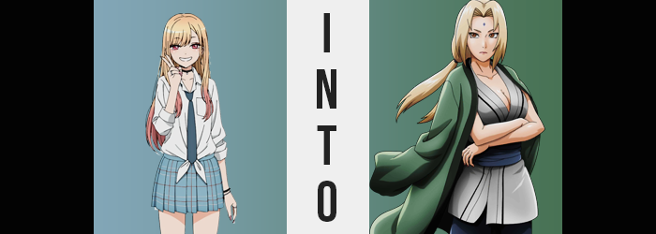

You might have assumed that cosplaying was easy.

That was a simple, albeit normie assumption to make. Marin Kitagawa would have been the first person to lambast you over the inaccuracy of that statement – being such an avid enjoyer of the craft. Sure, it was easy enough to just purchase a premade cosplay online and slap it on. In a lot of case you’d look fine. There was nothing inherently wrong with those premade ones you could buy online or in stores; Marin would certainly never judge anyone for using them.

But if you wanted that premium look? You either had to make them yourself or ask someone else to make them for you. That way you could get the costumes to look exactly the way you wanted. It would be easy to make adjustments so that it looked even more authentic, and didn’t it feel good to wear something you’d made yourself? Even though that was only half true for this rising cosplay star.

Marin had a friend (maybe more than that?) helping her, and she had been for a while now. Wakana Gojo was a real professional when it came to crafting the perfect cosplays for her. So when she paired his painstaking efforts and crafting with her ability to get into character while in cosplay, you more or less had the perfect combination. It really was no surprise that she had become such a rising star over the course of the past few months!

“Naruto? Mm… and the show is in three days? I guess I’ll have to settle with this…” Unfortunately? She wasn’t able to use Gojo for every cosplay now that she was so popular. She was receiving invites to themed shows roughly once a month and she knew full well she couldn’t burden him that much. Besides! He was presently working on a cosplay for her that she personally wanted to do. This show? It was just some work that Sajuna had offered to her. Needless to say? It was optional. But Marin didn’t mind so long as there was a character that stood out to her.

And there was! The teen wasn’t exactly familiar with the source material of Naruto, but she’d seen the anime on television here and there as a child. Shounen wasn’t really her genre, but those shounen series had some of the best character designs out there depending on where you looked. “Tsunade… Well, I guess I should see if it fits. I’m sure worst case I can still ask Gojo-kun to make adjustments!”

The girl had been lingering within her bedroom with a box resting on top of her bed. The second she had heard the theme of the cosplay get together she had known that she had wanted to go with Tsunade as her character. The wise and sexy Fifth Hokage of the Hidden Leaf Village. Marin knew this much about her and knew the gist of her personality. She was confident that she could pull off getting in-character if she binge-watched any scenes she was in on YouTube before the event.

Seeing as it was after school, she had to slide out of the school uniform she was wearing first. It was a series of actions that didn’t really take too long and before she knew it she had stripped down into only her pure white underwear. If it was only trying the cosplay on, she wouldn’t worry about an authentic undergarment experience (yet).

And so on went the blue pants, the sandals, a grey kimono-style blouse, and a green haori. There was a diamond-shaped marking on the woman’s forehead in canon materials, but Marin had intended on applying that with makeup later. So, dressed completely in the cosplay she’d put on… “Hm. How do I put this? It feels comfortable and the quality seems to be top shelf, but the fit of it…” The costume had been labeled as ‘one size fits all’. That had been a little suspicious at the time, but against her better judgment she had purchased it anyways.

The problems were quite clear. She was too short and nowhere near as curvy to properly fill the cloth out. “Should I have Gojo-kun take the waistline in and help make the top show more cleavage? It’s not like I can stuff it or wear pads since she shows so much cleavage. Mm…” Was there a way to make her breasts look larger naturally? Without resorting to implants that permanently increased their size, naturally.

Marin was taking mental notes before the full length mirror in her room. “The face shouldn’t be too bad. I’m sure I can make myself look a little older. And I won’t need to do much with my hair… But maybe a wig would be better?” The more she thought about it, the less certain she was that she could pull things off. Well, at least not to her own high standards anyways. If she was going to put on a cosplay then she wanted it to look the best she could possibly make it!

She departed the front of the mirror and instead moved to open her bedroom window. “Whew! Is it hot in here or is it just me?” The cosplay did feel unusually warm, didn’t it? The cloth was thin and airy though? Maybe it was just because she wasn’t used to wearing it? The cool, late afternoon air certainly helped her cool down though! And she eventually pushed the thought into the back of her mind since it was no longer relevant.

But it was much more relevant than she truly understood.

Her temporarily increased body temperature was part of the warning signs. She was heating up because an energy was being burned inside of her, triggered by an unusual force within the cosplay itself. Marin had never seen this brand on the shelves before, so she had assumed the company making the cosplay was an up and coming cosplay-making seller. But the truth might have been that these cosplays were being circulated by someone with special powers. Someone who got a kick of bringing fiction onto the forefront of reality.

“Ow!? What the heck was that!?” The second warning sign was one that had the teen running back to her mirror. It felt almost like something had bitten the center of her forehead? Was it a mosquito or something? With her hands she could tell that the skin had risen a little at the point of ‘impact’, but she was worried it was going to be really red – so she had to see for herself. “Uh…?”

But she didn’t find a bump in the center of her forehead; at least not a red one. There was instead a vertical, violet diamond in the dead center. It was slightly raised, but this was certainly no bug bite. Where had she seen it before? “…Ah!? The Strength of a Hundred Seal!? But I didn’t…? Wait, since when did I know what that thing was called?”

Marin did raise a good point. Her familiarity with the series and the character was barebones. She didn’t really know what Tsunade’s mark was, nor what it did. But that knowledge had left her lips so freely, and there was also the problem that she hadn’t applied it with makeup in the first place? Just where had it come from!? Realistically, however, this was the least of her worries.

One of those things she might have worried about was so subtle that it didn’t even occur to her, however. Namely that a sole centimeter had been shed from her height. It was a negligible amount that didn’t really affect her outfit, especially when it was already way too big on her where it counted. But for better or for worse? If given a bit of time she wouldn’t need to worry about that costume sliding off any longer. Nor would she need to have any adjustments made on the part of… Erm…

What was that boy’s name again?

“E-Eh? His name is, like… Um…?” He was really important to her, wasn’t he? So why couldn’t she remember his name!? She took her eyes away from the mirror just in time to avoid the sight of something unusual happening with her hair. The pink of her strawberry pink tips was fading away, and in fact the blonde that was prevalent throughout her hair otherwise was taking both a sandier tone and a slightly coarser, straighter texture. It was like someone had dyed and aged her hair alone, but the style shifted with bangs raising and parting so that the Strength of a Hundred Seal was completely visible in its center. In terms of color and thickness, similar changes affected the hair within her panties too.

Marin might have caught all of this, because her gaze slowly traveled back to the mirror. And if she had managed to get that far? She surely would have noticed the colors of her eyes were robbed of their pinkish hues so that a plain brown existed instead. But something stopped her gaze just inches away and redirect her attention down at the paltry cleavage line that the kimono-style blouse afforded her. Namely because, well, it wasn’t as paltry as she remembered. “H-Huh!?”

She couldn’t help herself, and hands came up to grope the heft of her own bosom through the fabric. Her breasts weren’t merely a little larger, they were growing more within her grasp. She could feel erect nipples pushing against her palms through the kimono, she could see her cleavage line growing longer, she could feel their weight pulling her forward while lifting up the kimono so that it fit better. Until that weight gain finally halted after snapping her bra strap, leaving her with J-cups that would have been utterly unbelievable except for the fact that…

The novelty had worn off? “Mm? Wait, what was so shocking about this?” Speaking with a sultrier tone, she lifted and allowed those tits to drop. Her previous confusion had all but melted, and she now felt certain that her tits had always been so large. She had to preserve their shapes with the same jutsu she was using to make herself look younger overall, but…

And so that was why there didn’t seem to be much of a reaction when it came to the rest of her figure filling out. Such as? Well, her knees buckled a little under the added weight of her tits at first, but once her back muscles had strengthened and adjusted they weren’t that hard to deal with. Instead? Her knees were prompted to buckle again because her hips swung about five inches wider.

This might have seemed like an arbitrary change initially, but it served a necessary purpose. Marin’s tits had become huge, but they weren’t the only part of her body that was undergoing a sexier growth. The loose, blue pants that were part of the cosplay had so much room in them for a reason. And that room was quick to dissipate in part because her thighs were bloating. They jiggled with both fat and muscle, for even her tummy had developed abs and her arms light, muscular padding that hadn’t existed before. Her thighs filled the upper legs of the pants keenly and even lifted them up to show her ankles.

That said, they had a little help with the lifting. Or, well, a lot of help. Marin’s thighs may have doubled in girth, but her ass might as well have tripled. The pounds were packed on, stretching the skin that contained them as her teenager-sized panties found themselves unfortunately pulled into the crevice of her enormous rump – the front of those panties slightly cameltoeing in the front. It wasn’t comfortable, but it wasn’t so uncomfortable that she seemed especially bothered either.

The woman shook her head. “What’s… wrong with me?” Not only did she feel off physically but her mentalscape had become a real mess as well. She couldn’t recall where she was or why she’d gotten there. Was there a reason that her clothing fit… aside from her underwear? She had the build of a mature woman, and yet her undergarments felt like they were made for a youth.

While Marin tried to pick at her snapped bra by reaching a hand, now with longer, painted fingernails, into her cleavage, the final wave of changes beset her face. She had already experienced a change in eye color, but those eyes sharpened and wore down in their shapes. For but a brief moment you could see Crow’s feet and wrinkles upon her complexion, but a jutsu smoothed them away just as quickly so she looked like a woman who was in her early thirties instead of what might have been the visage of a woman in her fifties instead.

“Aha.” She managed to find the bra and pull it out, leaving her tits to retain their shapes without the cloth in the way. She smirked a touch upon their removal, and this readily highlighted that the woman’s lips were much plumper than they had been – almost beestung in shape comparatively. They were housed beneath a nose that was longer because her face had stretched longer vertically, ultimately raising her cheekbones and cementing the idea that this was not Marin Kitagawa. Not any longer.

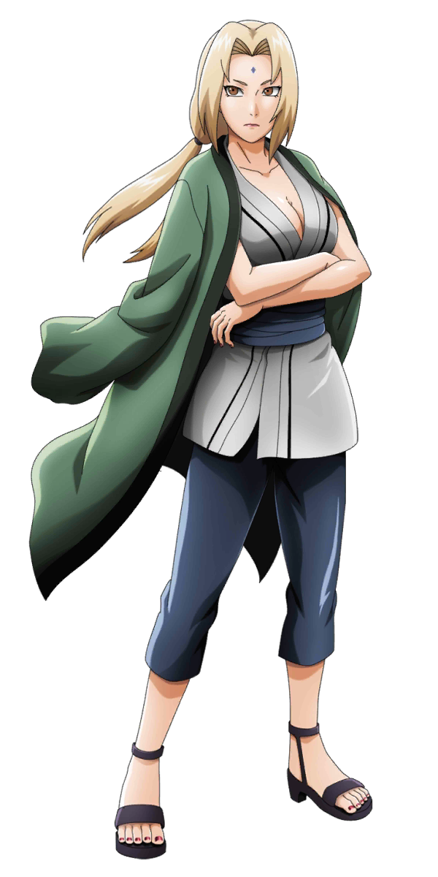
“…I think I need a drink.” Looking around at her surroundings now, Tsunade was beyond confused. Her memories didn’t align with anything she could see. This certainly wasn’t the Hidden Leaf Village, and the 54 year old woman couldn’t even remember how she had ended up here. But Tsunade, being Tsunade? Any worries hat she had about this unusual situation could definitely be washed away with a glass of sake. Or ten.

She looked down at her hand and opened and closed it. “I don’t seem to be injured, and there’s no damage to my clothing. Though a change in underwear seems to be in order. So there wasn’t a struggle. I wasn’t abducted then?” That was probably for the best. As the Fifth Hokage she would never hear the end of things if it turned out she had been preyed upon and dragged away to… wherever this was. Looking out the window she couldn’t fathom at all where her location might be.

This was obviously someone’s bedroom. A girl’s? It almost felt nostalgic. Tsunade might have written off the feeling as being reminded of when she had been a teen, but that nostalgia was because Marin’s identity still existed very deep within her. Far too deep to provide understanding, but not so deep that it no longer existed. It would subconsciously guide the older women through this new, unknown world. “An unknown world? Hm? Why do I know that?” This was a different planet than she was accustomed to? “Now I really need that drink.”

But she would need to sneak out of this home first though, right? Or, no, perhaps that wouldn’t be necessary? “I don’t know how I know this, but I suppose I could take the form of the girl whose room this is with jutsu.” Tsunade was a ninja after all. She could wield the same jutsu she was using to appear younger than she actually was to appear as this Marin Kitagawa person? …Even though Tsunade herself didn’t understand how she could picture Marin’s appearance so clearly.

“Oh well…” She needed to fit into this space somehow.

At least until she could figure out how to return home.

