Saquisha- Better use for a bad Wing-Woman

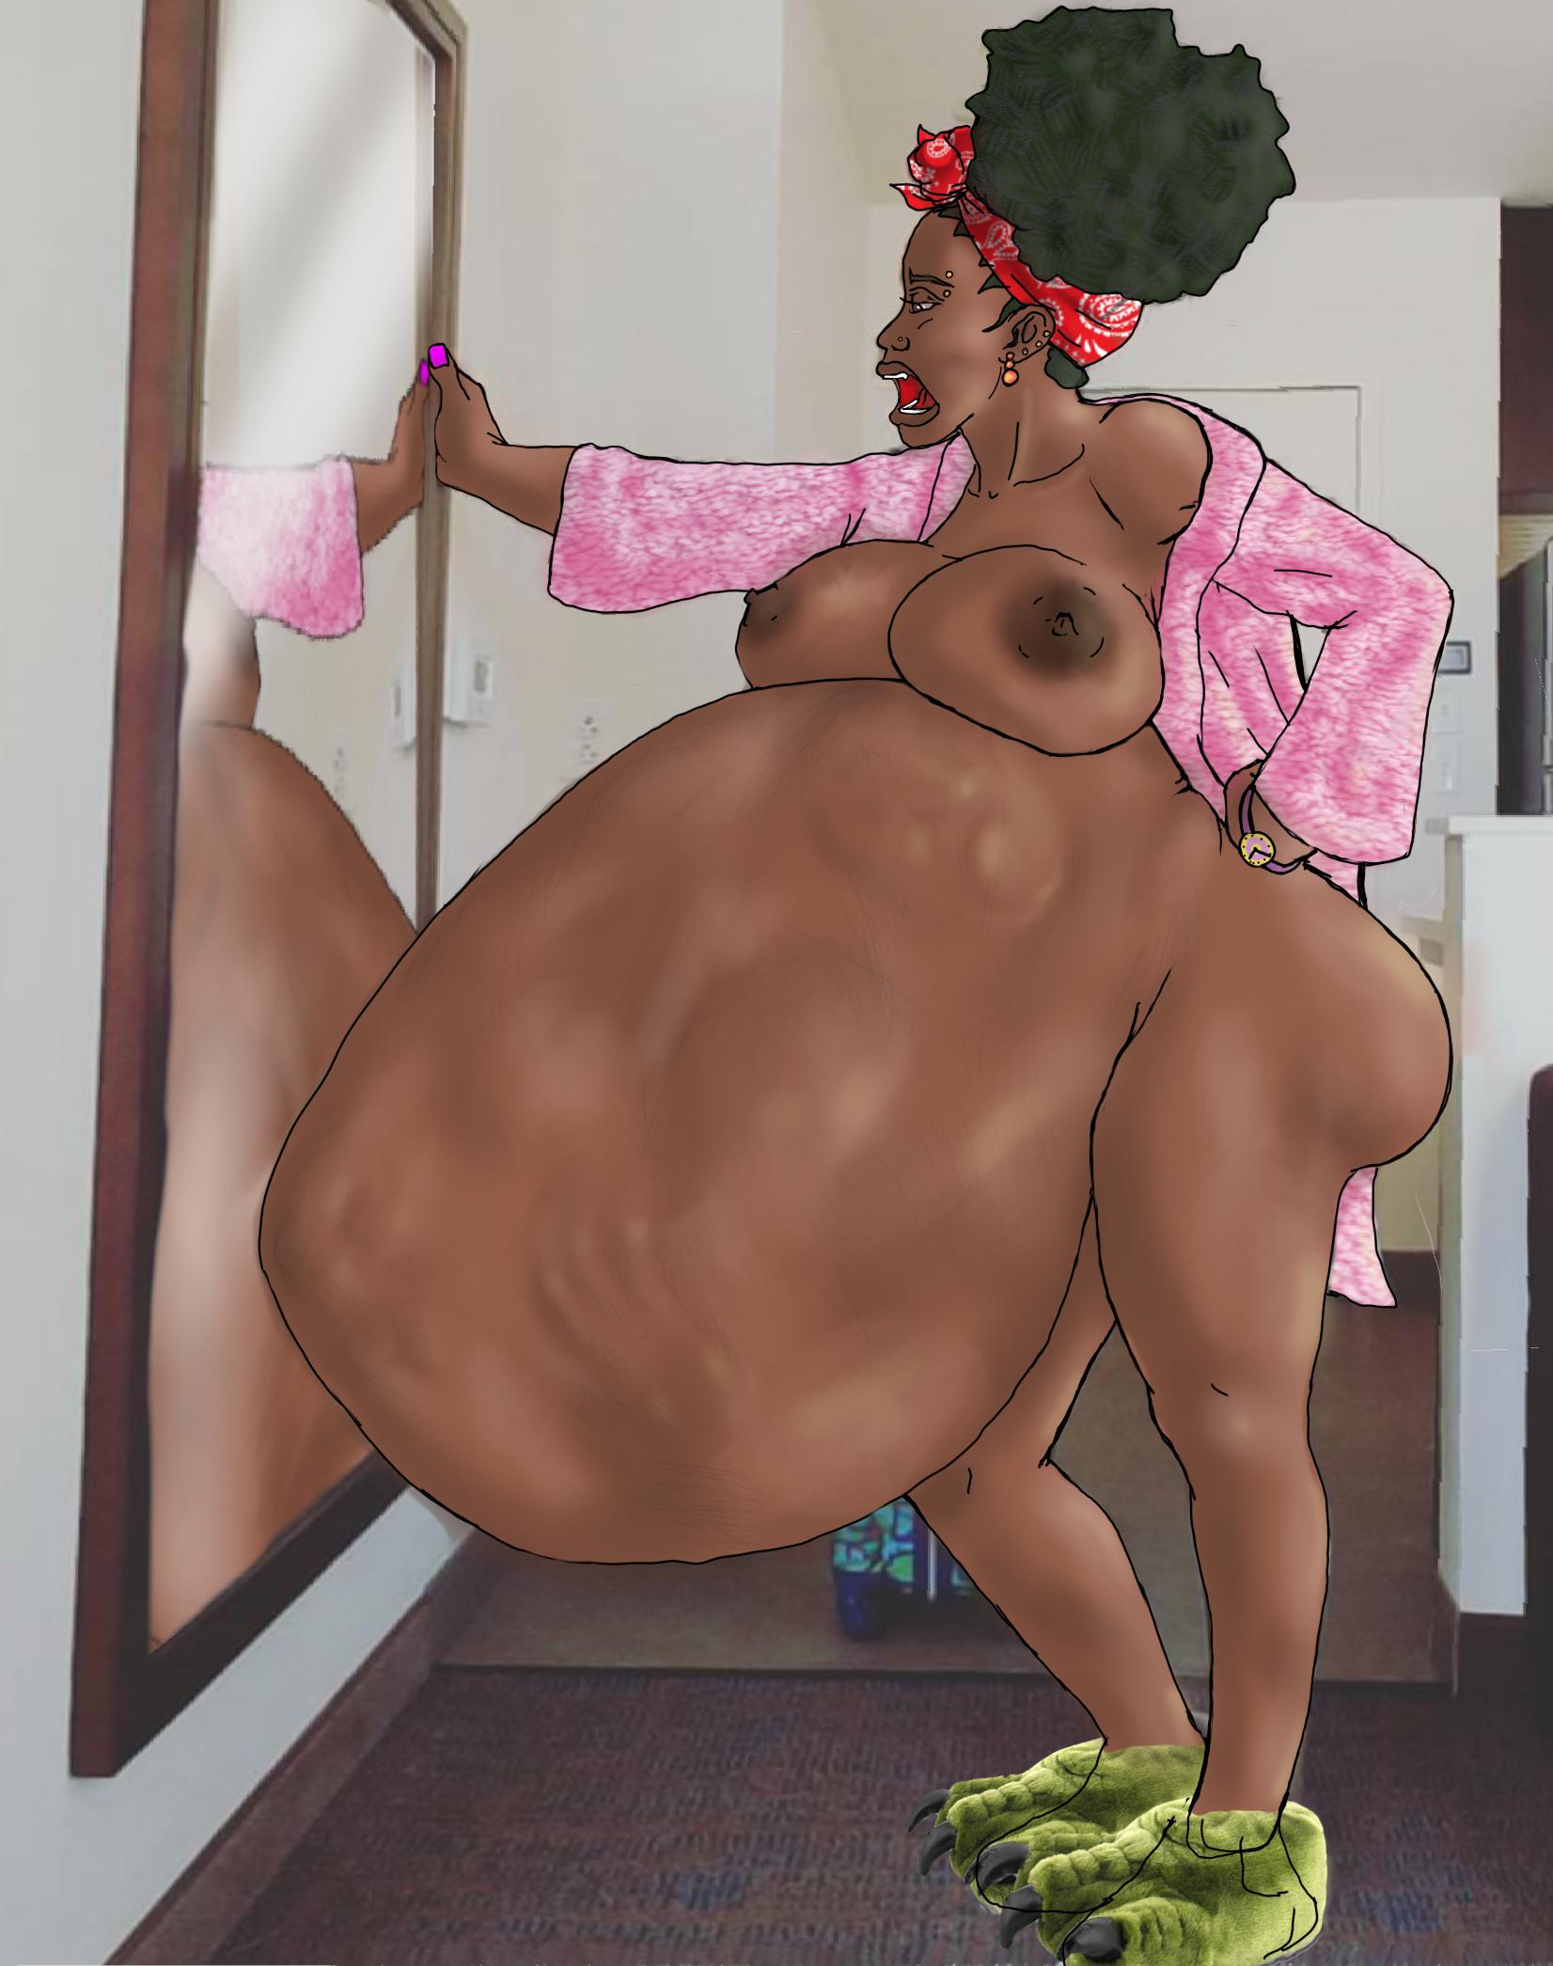

Saquisha stared at the pathetic drunken spectacle unfold across the dancefloor. A week's worth of planning for a night at her favorite club with her friend and coworker Shayla, was now utterly trashed. As Trashed as Shalya was as she made a slutty fool of herself with the two handsy sleazeballs on either side of her.

Initially the Friday plans had actually started off well. The two women had pregamed a bit after work prior to driving to the hottest party spot in Serval city; TasteyKakes Night Club. They danced and drank and at some point had gotten separated. Saquisha ended up having a nice time flirting with a guy she was quite certain would provide her some good dick for the night followed by a nice filling meal for the morning.

Sometime later, as she was making plans to meet up with the the yummy guy for a latenight sexy snack later she recognized her wing woman, obviously wasted and floundering about between 2 sleazy guys who were brazenly feeling her up and guiding her out of the venue. Saquisha watched getting angrier by the second as one guy reached under Shalya’s dress and the other guy reached his hand under her shirt and fondled her breast.

With an exasperated groan and a gut wrenching growl from her unfilled stomach, Saquisha excused herself to rescue her coworker from these obvious sexual predators. Storming up she snatched Shayla’s arm and wordlessly drug her away. One of the men tried to protest, but a viscous verbal rampage from the dick and food deprived Saquisha shut that down quickly and he sulked back into the crowd with his companion.

Saquisha angrily yet silently drug shayla to her car and all but tossed the inebriated flailing woman into the passenger seat. Her stomach growled angrily also as she slammed the door. Driving home utterly annoyed Saquisha had to pull over twice for shayla to lean over and hurl out of the window. Saquisha’s empty stomach knotted in disgust at the waste. Reaching Saquisha’s apartment, because Shayla had left her own house keys there, Saquisha was forced to haul Shayla’s snoring passed out body up the stairs and into the living room.

Shaking her head and panting from the effort, she glowered down at the peacefully unconscious woman. Saquisha’s stomach roared loudly protesting the injustice of this situation. Every Time they went for a good time a similar situation to this played out, ending with Saquisha babysitting Shayla, protecting her from creepy lecherous men, and going home with an empty stomach, a headache and a lush snoring on her couch.

**“Not anymore…”** Saquisha mumbles to herself before sliding her salivating tongue over her lips. **“... You owe me. Time to pay up. ”** She then began undressing Shayla as her stomach growled again...this time in anticipation.

---------------------------------------------------------------------------------

Happily humming to herself in the shower as the warm water cascaded over her sudsy naked body, Saquisha realized that shayla had finally woken up. A pair of slow moving lumps moving across the surface of Saquisha’s now prodigiously engorged belly indicated the occupant’s groggy awakening. Moments later restless protrusions of probing hands and and limbs coupled with a muffled confused voice indicated shayla was not where she expected to wake up and was not enjoying the surprise. Aside from a bout of light belches Saquisha remained silent for a few moments as she allowed the feeling of the soap and warm water pouring over her engorged form to soothe her building indigestion. Finally enjoying the movement of a previously disappointingly inert meal she hoped her poor wingwoman could keep her entertained for a little while as she digested.

**“Damn Shayla, you been sleep forever girl. I thought you were going to sleep all the way through the day. ”** Saquisha said speaking over the constant patterning of the water atop her bulging stomach. She hoped shayla could hear her well enough despite the noise.

**“Wherethefuckami!?”** Shayla shrieked disoriented. **“S-Saquisha? I-Is that you? Help me! Please!”**

Bending with a grunt and turning the water off Saquisha stepped out of the shower. Tugging off her shower cap she grabbed her towel and began the labor of drying off her magnificently engorged body. As she slid the soft towels across her damp curvaceous body, the fluffy towel absorbing the water covering her massive belly, breasts and ass, Saquisha felt a familiar pressure building in her bloated abdomen that coalesced into an epic belch that rocked Shayla’s gastric chamber like and earthquake.

**BWOOOOOOOUUUUUURRRRARP!**

**“Ah Excuse me.”** Saquisha said as she began to explain. **“Ya’ See that's the problem, Hon. I've helped you too much. I can't even count the number of times over the last few months I've saved ya ass from getting drugged and probably date-raped by the creeps you always end up flirting with. After so many close calls, so many nights scrubbing up your puke and of course so many scrapped late night dinner plans I decided to make a change. I figured we'd… “**

**“Ohmahgawd! Saquisha please don't tell me me I'm in your stomach! No no nononono!! ”** Shayla yelled interrupting Saquisha as she punched against the strong elastic stomach walls.

**“*\*Oouf-OURP\** Dammit chill out Shayla! Ugh... Look girl, I figured we'd both be better off with you in my belly. This way there’s no more creepy dudes, no more barfing hangover mornings, no more embarrassing one night stands. *\*BURP\** So long story short, yes I ate you shayla. But it's better this way.”** Saquisha said pulling her robe over her still relatively damp, still naked body not bothering to attempt to cover her massive swell as it shifted with Shayla’s pathetic movements within.

**“What!? No!! How is this better!? What the hell are you talking about!? Let me out you crazy bitch.”**

**“ugh, I'm trying to be nice here so quit with the name calling. Geez. “** Saquisha snapped. **“ Here I am trying to help you maintain a degree of dignity by allowing you to be apa-*ourrap!\** ...apart of something bigger, and you are being totally ungrateful. Otherwise you’d just end up some cheating asshole’s side piece of ass. It’s clearly better to use your body for something more important, like my nourishment.”**

**“NO! Fuck that! Let me out!! I don't want to be your fucking nourishment!“** Shalya cursed and kicked and struggled as Saquisha waddled across her living room to admire herself in the mirror. She imaging how much bigger her bustline or waist size would grow once Shayla was digested and added to their already sizeable girth.

**“Well too bad sweetheart. You’ve made a too many bad decisions so far and I’m not gonna let you make another. While my gut may not be good for your complexion believe me it’s for the best. Now you get comfortable and let my belly do all the work...or keep kicking. Either way just be done digesting by tomorrow afternoon, M’kay. I’ve got a hot date tomorrow night and I’m probably gonna need the room.”** Saquisha patted her squirming belly ending the conversation, on her end at least. Shayla apparently choosing the latter option of cursing and thrashing about within the gurgling churning stomach prision of her former wingwoman.

**The end**