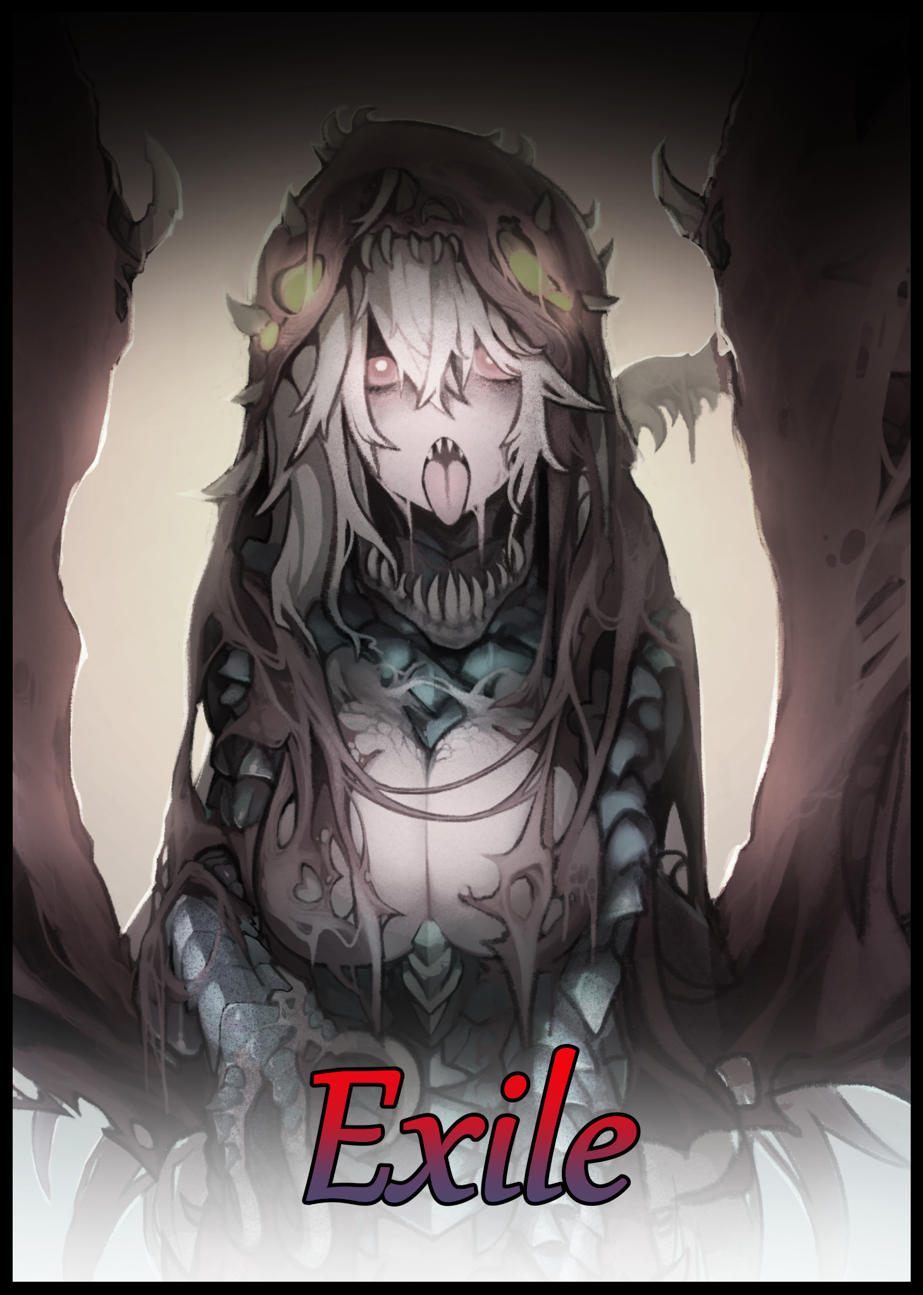

“H-Hey! You can’t do this to me! Let me go! This is nuts!”

A man's rabid cries could be heard reverberating all around an immense cavern, bouncing off the walls in overlapping waves as he struggles to break loose from the stiff rope keeping him tied up and on his bum before a group of four other people staring down at him with looks ranging from disgust to outright fury as evident on the man standing directly in front of him, hands balled into trembling fists. Whoever he was, it was clear they either wanted nothing to do with him or saw him in such a bad light that he was worse than scum in their eyes.

"Nuts huh? You wanna know what's nuts? Us actually believing you weren't the one robbing us blind this whole time! If we just had a few more of those med shots you've been getting high on, that family….their girl! We wouldn't've have had to-"

"C'mon Zack, no point wasting your breath on him…we're better off leaving him right here where he belongs…he's not worth it."

Hesitating before clicking his tongue in an overt show of his frustration, the man who seems to be the leader of the group listens to reason as he pulls away from the restrained man, turning to walk away followed by the rest of the small group dispersing as they silently follow after him, filing into the ramshackle buggy parked nearby while heartless pleas fall on death ears as the hum of the engines signal their intent to leave him for dead in the caves.

"W-Wait! At least untie me! You guys can't be serious! What happened to all that friendship stuff huh?!"

The only response he would earn with his incessant whining would be a deathly glare from those in the back as the vehicle soon speeds off into the distance, curving around the side of a sunken building before vanishing out of sight. Leaving the man bound and alone with only the dimming light of a nearby campfire to keep him warm and somewhat level headed as his pleas for help turn into bitter curses and vitriolic statements now that his former companions had left him behind, purposefully letting loose a loud series of honks once they were far enough away.

And rightfully so, for there was no remorse to be seen in the man's eyes as he continues to kick and trash against the weathered restraints keeping him down, accelerating his efforts when the fading sound of the vehicle's engines are steadily replaced by the growing sound of rumbling earth, accompanied by jittering pebbles and falling debris as the subterranean environment begins to shudder in the wake of something big headed his way.

"Goddamn it! Those self righteous bastards!"

Thinking fast, the imperiled man looks around in a panic, thinking to use whatever he can get his tied hands on to free himself from his bonds, unable to pick up on anything that could aim in his escape after quickly scanning through piles of refuse and wayward rocks. But at the far back of the chamber, there laid an outcrop of boulders perfect enough for a grown man to hide behind.

And seeing as how he couldn't fully stand, edging his way towards the hiding spot was the only way he could save himself, wiggling and jumping with the power of his lower abdominals, grunting like mad against the stabbing pain of the uneven cave floor biting through the thin material of patchwork leggings, barely managing to throw his bulk behind cover just before the ground where the buggy had been parked comes apart, caving in for a moment before an immense mass sends soil, rock and debris flying through the air upon its emergence out of the ground, towering over the surroundings in all its mottled glory, pointed featureless head covered with an array of red spherical sensory organs scanning the dusty air for fresh food to consume.

Its hide was rigid and bumpy, colored a muted brown to blend into its rocky surroundings with near perfect mimicry. A stealthy adaptation hindered by its gargantuan size and the fact that any appearance it made would be heralded by earth shaking tremors that could be felt for miles around as its worm-like body effortlessly plows through stone and soil without losing speed. Negatives that mattered little to a creature as successful in its own ecosystem as the Sandworm, and the fearsome specimen before the terrified human was impressive indeed; sporting a segmented body colored a faded beige and riddled with faint scars with the visible portions dwarfing the man made hunk of metal that had drawn it here in the first place, looking around the underground chamber in confusion before swooping low, sending the dust cloud it had kicked up flying absolutely everywhere, stunning the man as he watches the flexible beast begin to scan the environment, slowly stretching and undulating as previously unseen seams along its length begin to twitch and spasm like an irritated nostril, disturbing the nearby rocks as they tumble away from the billowing wind released from the widening tumors in the Sandworm's carapace.

'Shit…can that thing smell?!'

But as the holes begin to interconnect and form into slits that reach all the way to the tip of the worm's 'beak', the man begins to realize his mistake just in time for the creature's maw to split open with a crunchy sound, immediately releasing a tidal wave of thick saliva that pools around the open mouth, unable to surge forward and consume the human that laid in its midst thanks to its viscosity.

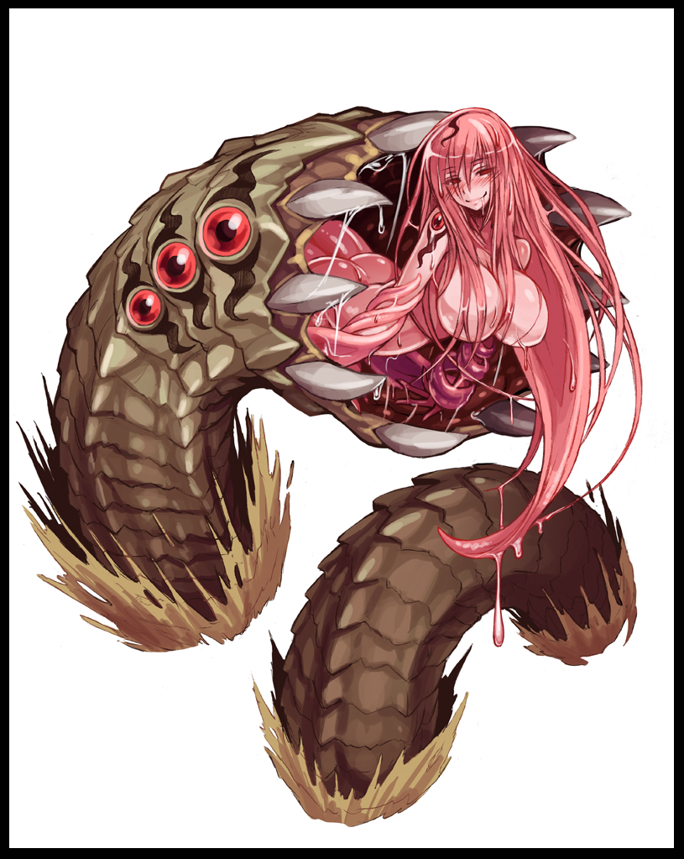
And there, nestled where there should've been nothing but inky darkness leading into the belly of the beast, was a pale, pink humanoid shape, wriggling in a cocoon of slime and flesh like an egg about to hatch. Curious, the bound man's vision zooms in on visible strands of voluminous hair pressed up against the organic outer layer, followed by the unmistakable curvature of a woman's torso, undulating as if whatever was inside was shimmying its way out of there in a strangely arousing dance, as slender arms manage to come loose, pulling free of slippery tendrils before the rest of the body does in an explosion of vanilla pink and saturated strawberry, sending giblets of the humanoid being's cocoon flying a good distance away while the sonorous voice of an enticing maiden's voice fills the air.

'Holy shit….no way…this thing can't be for real!'

No matter how much he thought he was hallucinating, the undeniable sight before him was very much real as he observes the voluptuous upper body of a human female slip free of the Sandworm's still open mouth, bumping her comparatively soft and smooth frame against solid teeth, long damp threads of luxurious hair acting like a teasing curtain as it falls down around her body, giving him only the briefest of glimpses, making the awestruck man almost forget he was supposed to be hiding as sultry eyes begin to scour her gloomy surroundings, instantly taking note of the dying cinders with glee as her beautiful face twists into a vapid smile, letting loose a rumbling giggle that almost sounded like it was coming from inside the minds of those in earshot.

But the Sandworm's reverberant laughter manages to dislodge the surrounding stone, sending a particularly large chunk falling from the ceiling above and onto the head of the the bewitched man still lying behind his hiding spot, serving the dual purpose of knocking him out of his stupor and alerting the behemoth, cursing for a brief moment before falling silent once more as he presses his back up against the stone, dreading the oncoming sounds of grinding stone and seductive musing as he holds his eyes shut in fear of looking back at the approaching Sandworm.

'Fuck me…how the hell did things even get this way to begin with…it was just one crate…'

Familiar to the danger but oblivious to his wrongdoing, the bound man's mind regresses to a point in the distant past when he had still been a normal villager eking out a simple living, helping out on the farm, collecting water from a nearby reservoir, menial labor…it was a simple life to be sure, but one that guaranteed his safety behind sturdy walls and armed guards who took shifts patrolling the perimeter of their commune.

Vic was his name, plain and simple. And even though he was a bit of a known prankster, he got along well with the other village children. None the wiser to the broader world around him, never questioning but always thinking about why they couldn't step outside the village's walls come nightfall or whenever the perimeter guards sounded the alarm.

But Vic's simplistic life would change after he came of age, becoming an adult where responsibility he never intended to bear would be placed on his shoulders in the form of needing to join up with the scavenging parties the village would often send out to look for supplies with the aid of well maintained wagon buggies, a remnant of a time long ago when mankind used to live in sprawling buildings that reached high into the sky, traversing the world in behemoth frames shaped like birds according to the tales Vic remembered from his childhood, passed down from old knowledge gleaned by wandering travelers who would often come by to trade and rest before continuing on their way.

And everytime they did, the hooded figures would always pique the interest of Vic, who envied the mysterious wanderers for their profession and seemingly fearless attitude against what lay beyond the village's walls. And now he would get his chance to do just that as a part of one of the village's salvage crews, led by a veteran he was familiar with as a sort of big brother figure while the others consisted of some of his childhood friends that, just like him, had been considered fit for the job.

At first, things seemed to be going well for the newly formed group as they spent each week long excursion listening to their trainer, taking in the vivid sights of what laid beyond their village while riding in the back of an all terrain vehicle that speeds them through lands of unspoilt greenery and rampant nature collapsing over the ruins of an ancient people, swallowing it all up as if trying to stamp out an old memory, rousing questions in Vic's mind whenever they went scouring through such remnant's in the hopes of finding what little scrap there was in comparison to the abundant fruits and vegetables that littered the wilderness, there were even animals to be hunted for their meat and hide.

But that same questioning would lead to Vic's first encounter with the reason behind why the scavengers stuck to their less fruitful gains after he had decided to take the initiative and pick from an especially bountiful tree, earning the ire of those that lived just out of sight in the overgrown thicket.

No one knew what they were called or where they came from, but the best description Vic had for the creature whose feeding grounds he had disturbed was like a human being fused with a bee, sporting oversized mandibles and four carapace clad manipulators tipped with hooked claws. If it wasn't for the overly aggressive buzzing and inhuman chittering noises she made with the rabid clacking of her mouthparts while attempting to spear him through with a barb tipped abdomen pulsing furiously with powerful muscles, Vic would've thought it was all just some big prank.

And just when it looked like he couldn't overpower his aggressor's attempt at his life, a sudden blur from beyond his blurry vision catches the monstergirl right in her featureless eyes, allowing for Vic to scramble away before she could regain his focus, barely able to hear a word after having suffered a concussion from the stone he had hit head on during the monstrous bee woman's surprise attack.
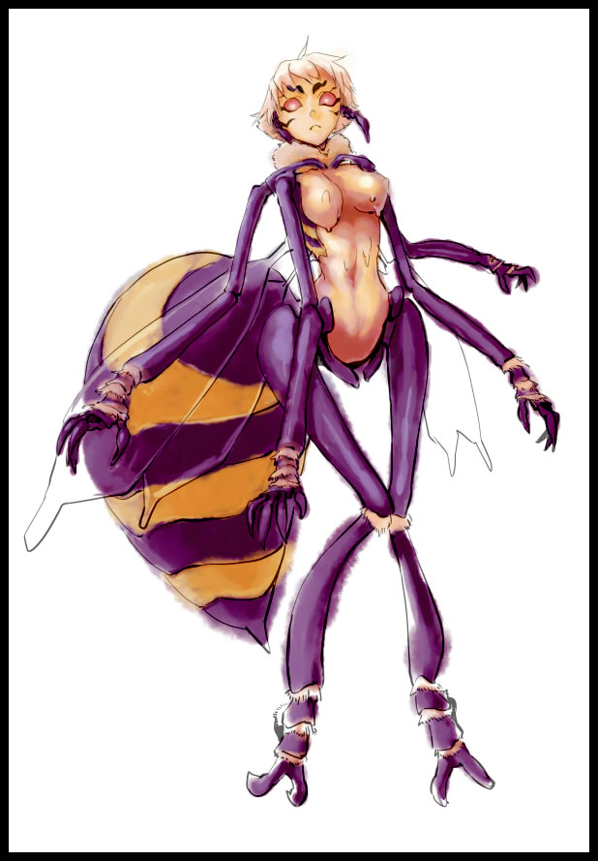
The proceeding events were a blur, but what Vic could recall was that his recklessness had cost the team their veteran. Which made the return trip all the more heart wrenching for them all once they had to explain their missing leader, who had stayed behind to distract the monstergirl while the others had their hands full with Vic…even if they had the numbers, they could do nothing against rending claws and unbreakable, organic armor. Neither could they risk the buggy and its resources in a daring extraction. So without a way to fight back and an irate beast out for blood, there was no other choice.

A downward spiral would begin to consume Vic from then on as the added weight of a death began to eat away at conscience, clashing with denial in the form of vehement claims that he'd only stepped off the beaten path in the hopes of securing more for his people, placing the blame on the creature that had lashed out in defense of its territory. Territory the former team leader had warned them all about many times over not to enter. All while he was expected to continue serving his duty in the salvage crew, relegated to a side job in the team while the next seasoned individual amongst them stood up to take over leadership. Leading to a gradual breakdown in Vic's morals as bitterness and a holier-than-thou attitude begins to take root in the wayward man's soul, harkening back to the moment he'd been injected with a stim syringe to treat his concussion to fuel his escape from reality…

But with such rampant abuse of easily accessible medicinal aid reserved for the needy and those on the salvage teams, it was only a matter of time till the hand of karma came to collect. And in Vic's case, he'd been caught red handed overdosing the previous night before on an entire crate of the team's hard won discovery all the way out here in an as of yet explored locale that was supposedly an abandoned hospital rendered unrecognizable after years of geographical changes had laid waste to the main building, turning what should've been a simple mess of corridors into a massive network of subterranean systems and unstable flooring that had left massive chasms scattered all over, obstacles only the buggy could navigate safely through and around.

And now that both his team and the buggy in question had left him, Vic was completely at the mercy of the sunken bospital's monstrous inhabitants much like the oversized arthropod that had almost impaled him all those months ago, barely managing to hide his shivering from the hot gust of air running by his cheeks from the encroaching monstergirl, tickling his skin as silky locks of hair hanging down from the well endowed female passes him by, failing to earn a response for a few seconds, daring the frightened human to turn and look, realizing why he hadn't been discovered yet despite being so close to the creature;

Her eyes were empty and slightly dull, so too were the sensory organs that dotted her shoulders and the cranial portions of the Sandworm's monstrous form, fighting the urge to move as pillars of thick, congealed saliva began to drip and pool all around the unmoving man. Despite how sweet the fluid smelled, Vic wasn't too eager to test if the saliva of a giant worm was safe to touch, much less consume. Especially after realizing the creature before him was far older than he had expected…either that, or something else had caused it to lose its eyesight, probably sensing through vibrations rather than sight like he'd previously thought.

'So it…she's…blind…and it doesn't look like she can smell either…now just…go away…shit…'

After a few more minutes of hovering over Vic, the aromatic driblets of saliva finally reach him, trailing over his boots like syrup before an additional fount lands on his face, screaming internally from the hot goop sliding off his face he desperately wanted to wipe off, unable to do so until the menacing worm left him alone.

And thankfully for Vic, the Sandworm seemed to give up its search as a saddened look seemed to cross the face of bodacious female serving as its 'tongue', retreating back inside of the main body with a faint sigh before its extended maw snaps shut with a loud crunch, slowly sliding back inside the nearby pit it had made for itself as the ground begins to shake once more, fading away with the creature's increasing proximity from the abandoned campsite, ending Vic's tense encounter and allowing him to move freely once more, grunting as his efforts to free himself take center stage once again, accompanied by additional insults directed toward the blind monster that had missed an early morning snack.

"Friggin' disgusting worm…goddamn drooling bitch…"

It would take a few minutes for Vic to get the ropes off after resorting to worming himself along an outcrop of sharp rocks, managing to catch the ropes that bound him along a nook before wear and tear did the rest, coming apart and allowing him to clean up the rest of the slop that hadn't dried and crusted to his face. Even though it smelt really good, the fact that it came from the inside of a giant worm was nauseating, picking off translucent flaps of dried saliva with disdain, even having to pick and peel bits of it off the skin of his cheeks in some instances while he stalks away down the vast underground tunnel with a torch in his other hand to light the way forward and a sack filled with whatever he could scrounge up from the campsite.

Returning to the village wasn't an option even if he could, so going at it alone was the only course of action open to him. Though it seemed daunting, Vic was more than confident in his own ability to sustain himself, almost to an absurd degree when the only experience he had to 'survive in the wild' was his limited experience on the field as a scavenger and the crops he had picked in his youth. If anything, he would probably eat something he shouldn't by the time night fell.

But still Vic would assure himself of his continued survival, intent on spiteing the people who had left him behind, no doubt already telling the others about how twisted of an individual he was. So what if he had taken vital medicine that could've been used to help others? Wasn't he suffering too? What moral right did they have to kick him out without even waiting for council?

"Assholes…all of them…if I ever see their faces again…I'm gonna…gonna kill em…get back at them…assholes…"

With his furious murmurs bouncing around the cave wall and the darkness of the underground obscuring his vision, Vic would remain oblivious to the way the skin of his face was beginning to pale and soften, gurgling with activity beneath irritated skin the oblivious man scratches at idly on occasion with his one free hand, waving the flaming torch with the other to light the way forward, confuddled ears pricking up at the sound of something else besides his own voice, a familiar sound he'd heard many times before, spurring his unsteady gait towards the source of the strange noise in obvious excitement, surrounded by the ruined shadows of abandoned buildings jutting out of the ceiling with bits of asphalt and even a road sign half fused into the surroundings.

Wherever he was, it was clear that his efforts to seek a way out of the underground hospital had instead taken him into a deeper portion of the impossible network, a place composed entirely of ruined structures that could just come apart at any moment. Entombing him within…just like the many glimpses of pale yellowish white of skeletal remains gleaned by waning torchlight, and they were everywhere, including some that bore semblances to the Sandworm from before, complete with the partially intact remains of its cocoon, containing the huddled skeleton of a human torso, curled up as if it had died in its sleep in the shadow of far larger ones that dwarfed their already immense stature.

A tomb disturbed by an ignorant, drug abuser who wasn't even aware of where he was going, nor did he know how long he'd been walking, nor the amount of time that had passed since coming to with the irate faces of his former comrades glancing down at him. Simply following along to a sound that had grown to become a thunderous roar by the time he steps out into an open chamber, lit by an unnatural glow of cyan green and warm orange originating from somewhere beneath the endless pool of underground water, fed by a torrential rush at the far end where darkness would keep the true size of the aquifer concealed. But it's beauty would be lost upon the ignorant Vic as he rushes for the lake's edge, eager to both cleanse himself and quench his thirst with a mighty swig of that deliciously cool looking water, oblivious to the signs that the supposed cave wasn't as natural as it looked to be at first glance…for instance, the overt, blue coloration the ‘water’ sported…

"Hot damn…water…so much water…I could probably set up camp here…make a home…my own home…where I can do what I want!"

Discarding the dim torch as it sputters and dies upon hitting the water, the ragged man immediately helps himself to the cool lake, scooping up handfuls of cool water before shoving them greedily against his face, sucking down on the enriching drink with delighted guffaws while washing up at the same time, cleansing his chin and neck of Sandworm grime, unable to believe just how good it felt to be basking in such soothing water. Scooping up more handfuls to drink, eager to experience more of the cooling torrents surging down through his irritatingly dried throat before spreading out to rejuvenate his weary body.

Vic had never tasted water this enriched in flavor before, tingling with some sort of…spice…as if roils in his mouth before falling into his belly where it's cleansing power would not rest, pooling into a bubbling mass that made him feel great, empowering his repeated motions of lapping up a mouthful before lathering himself with it. Stopping only when his almost rabid actions bring him into viewing distance of the torch he had discarded earlier…or rather; what remained of it.

The leather straps soaked in flammable liquid had come undone with the major loss of most of the wooden equipment's mass, breaking apart into foaming fragments as the surrounding lake seems to eat away at it, forming bubbles around the disintegrating torch until it eventually vanishes with nothing left behind to mark its existence in the world. Barely able to notice the same thing happening to his clothes as his collar begins to flake and melt away out of the corner of his eyes, exposing diseased skin beginning to lose its healthy beige coloration for a sickly green with a texture that would remind one of a rotting fish, complete with flesh that wasn't even connected to the skin anymore…

Before Vic could act on the rising terror in his heart, a sudden pain in his molars stuns him, followed shortly afterward by a sudden tightness in his chest, tearing easily away at what should've been a lightly armored tabbard to reveal a revolting sight in the form of a fleshy tumour growing right in the middle of his pectorals, covered in blue black veins running across its length all the way to his throat. Pulsating with each haggard breath that comes out through a mangled maw like a monstrous frog, becoming completely useless as his lower jaw falls off in horrific fashion, sticking to the bubbling mass that was once an Adam's Apple…

"Hallp! Sommuan…halllp..haarehhgg!!!"

All across the man's body, deformations and physical mutations were beginning to show as more and more of Vic's scav uniform falls apart at the seams, dissolving into an indistinguishable mess that slides off of slippery hide that no longer looked anything like skin, sporting more holes than a weathered rag as the highly acidic lake of alien fluid begins to eat away at Vic's flesh and blood body…although that wasn't all it was doing when the trashing man starts to bulk, gaining more mass than he was shedding as his freakish sounds swell in tandem, sending waves of the pale blue liquid splashing against the shoreline, melting rock as boulders crack and fall apart in the wake of the metamorphosing human.

By now, Vic barely resembled a normal human man in his late twenties, looking alot like a bloated sac of wild, incoherent biomass. Growing without direction as fingers fused while joints hardened, forming stubby protrusions that were once arms while vulnerable extremities and organs exposed to the fluid just…melt…becoming a slurry that caves into or slides off the growing form of Vic, now over thrice the size he once was before sampling the cursed water, letting out bellowing groans and gurgles as his pained movement slowly comes to a halt after the last of his bones atrophy into one combined structure of steaming pustules and quivering boils, covered in mottled hide and shaped much like a caterpillar…if it grew legs, contained a hybrid of fish and human genes and was midway through decomposing after realizing it was an affront to all creation that is…one couldn't even make out a face in that mess if they tried!

But while all seemed to be over on the outside, even more rapid fire changes were happening beneath the surface as evidenced by the incredible heat being given off by the massive structure one measly human being had been turned into. Most notably centered around the still intact brain of Vic himself, frozen stiff and trapped in complete darkness with the loss of his sensory organs and the ability to move, screaming without a mouth in complete isolation, still oblivious to the true state of his body while unknowable forces begin to work on his vulnerable mind, extending tendrils that mercilessly insert themselves into his brain before tweaking around, absorbing information, soaking up memories like a dry sponge all while Vic's psyche flounders helplessly in their wake.

'W-what's wrong with me?! Why can't just...move! That damned water…am I…dead? No! That's not possible…not…possible…head…still feeling so can't be gone…why am talking all funny?!'

Clueless to the end, Vic would never realize the how his intelligence levels were rapidly dropping alongside his memories, beginning with his birth in a happy family long vanished all the way up to that fateful encounter with the anthropoidal monstergirl under the tree, almost unnerved by the fact that he couldn't remember why he wasn't feeling panicked and anxious as he usually was now that his trauma had been removed from his mind alongside the supporting memory of it. And the more he forgot, the calmer he would get as memories blip into non-existence like a flame being extinguished. Leaving residual fragments that linger for a few seconds before burning out entirely, no longer having the benefit of knowledge and thinking capacity to vocalize his confusion when animalistic simplicity was all that remained…

A slate wiped clean, redeemed from past sins yet doomed still to carry out the remainder of a sentence it would never know the reasoning behind.

With their work done, the tendrils remove themselves from the well wiped organ, causing a series of final changes as the surface of the immobilized pile of flesh begins to ripple with activity, filling the air with grotesque sounds as bloated pustules pop while dead skin slides off, revealing indigo green scales mixed in with patches of soft tender skin colored a creamy vanilla, concealed by a rubbery layer of shredded but still living muscle slung over them like a tattered cloak. It reminded one of a butterfly emerging from its chrysalis, a changed being. Revealing stark traces of beauty to be found amidst the appalling sight as polished scales refract the glow of bioluminescent mounds of flesh burning with biochemical processes running down along the length of what was obviously a spinal crest, throbbing like a heart until, with a sudden bang, comes the emergence of two wing like flaps that sends chunks of inert cocoon material flying all across the azure lake, splashing as they break the surface, tumbling down to the measureless depths to join many other similar chunks preserved and hidden away by the acidic nature of their dark, aquatic environ.

Like the saturated red cloak covering the now visible figure of a gigantic humanoid, the broken wings extending from below a tight waistline looked deceptively weak; held together by webbed strands of crimson sinew with bone being visible through the gaps, casting a fragile appearance that masks obscene strength shown only when their emerging owner stumbles out of the crumbling remains of its former self, letting loose a low sounding howl mixed in with the undeniable vocals of a young human female despite the monstrous nature of its visage; looking like the shattered skull of an undead merman, complete with a skull sporting glowing embers within empty eye sockets and a detached lower jaw lined with razors oozing an organic bile that runs down a shapely left breast before falling past hooked talons connected to vaguely waifish hands, hanging down in front of lusciously thick thighs…

And as a long, skeletal tail rips free of their calcified outer shell, revealing plump buttocks whose only measure of decency laid in the hem of a makeshift dress formed out of repurposed tissue, the face of a haggard young woman emerges from the darkness within the gaping skeletal maw, struggling to breathe as sunken eyes snap open with maddened panic, letting out an ear piercing scream in a pretty sing-song voice while flexing her inhuman limbs to appear larger, causing the surrounding cave walls to tremble while the shores sizzle with corrosive fire wrought by the wrath of the draconic titaness in all her halfbreed glory, showing off a body with distinctly human proportions mixed in with reptilian elements, topped off with a diseased finish in the form of the pockmarked hide resting over her voluptuous body like a hooded cloak, concealing the glowing pustules that made up her spine and an unkempt head of ashen gray hair. Panting profusely while thin trails of blue saliva drips down her shapely chin, coalescing into the enormous pool she stood knee deep in.
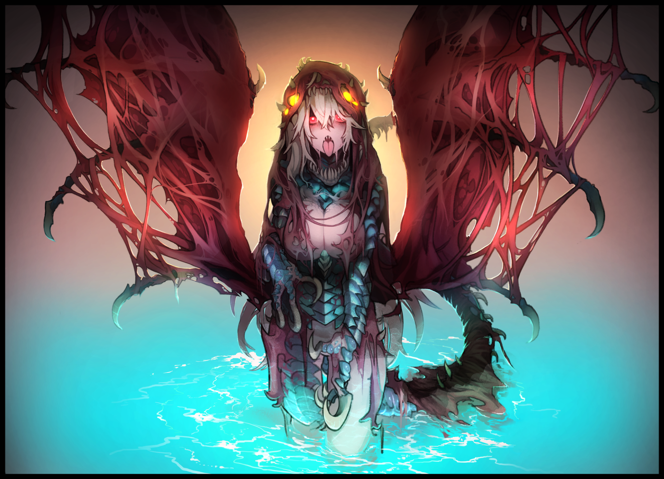
Gone was the apathetic man who had unwittingly given rise to her after drenching himself in the mysterious lake. And in his place was a newborn monstergirl, calling out in a mix of fear and anger against the darkness she had weakened to and the isolation associated with it, screeching and roaring incessantly, sending out pheromones and cries that would go ignored in the depths of a lifeless tomb far underground, surrounded by the bones of the fallen, kindred or otherwise.

An acid spewing Revenant, none the wiser to the circumstances that had led to its imprisonment now that her body was far too large to escape back the way where its diminutive past self had come from.

As for the human scavenging party that would safely make their way back home in one piece, their word of Vic's sentencing would be met with a resounding applause by the many inhabitants who had found his presence tiresome. With only the morally adherent protesting such a harsh sentence without the counsel of others, but after word of his recklessness involving the village's medical supplies were brought up alongside those who were no longer there because of it, all the naysayers soon fell silent.

In the following weeks, word would begin to spread from scav parties who frequented the caves where Vic had last been seen bound and left for dead. With reports of strange behavior displayed by the local Sandworm population, almost as if they were constantly on edge, sensing something or someone the humans couldn't. But that wasn't the wildest occurrence, for those who managed to brave the treacherous terrain deeper within the subterranean maze would be greeted with strange, ethereal cries originating from somewhere deeper inside the cave system far too deep and tight for their buggies to navigate. Causing any future expeditions there to be canceled after the scavengers had decided to forbid any visits to the region lest they poke a potential hornet's nest.

But in all the hubbub about the cave and rumors of Vic's exile being the cause, a certain scribe's interest would be piqued so soon after investigating a curious incident near the sequestered village whose inhabitants still had no clue about the true nature behind the monstergirls yet knew enough about them to stay clear. He still remembered the look on the village chief's face after having to explain the ins and outs behind the virus that governed them all alongside how they were basically no different from humans, just a bit more carefree in their behavior thanks to their vastly different physiology.

And in this instance, the scribe was brimming with trepidation after hearing about the disturbances in the arid cave system. If what the scavengers said about panicking Sandworms was true, a behavior only displayed by the resilient creatures when faced with another individual far stronger than them, then it could only mean that another apex species had recently arrived…or in his suspicions after being informed of the exile that had taken place there; inadvertently found herself stuck in a place she didn't want to be in after having been transformed by whatever viral agent lurked beneath the ground…this whole region was an anomaly in and of itself, as if an external force of significant power had warped the land, sinking entire portions of the dead human city old maps told him was supposed to be here.

He had seen many things in his long lived life on the road; from Royal Harpies in truly immense jungles of weathered concrete forgotten to time to the unbelievable gathering of a myriad Lamia in the remnants of a bombed out building known in the old world as manors. And as he puts his notebook away in favor of a gas mask and torchlight, the scribe had a feeling that whatever awaited at the bottom would easily be another experience worth cataloging in his tireless pursuit of knowledge in a vast, alien world…

THE END

Image Sources

Image 1 by Kenkou Cross (Monster Girl Encyclopedia) : https://monstergirlencyclopedia.miraheze.org/wiki/Sandworm

Image 2 by Kanemaki Thomas : https://www.pixiv.net/en/users/2130

Image 3 by Nyong Nyong : https://www.pixiv.net/en/users/14120806

