Charley’s Cousin
A Short Story
By Maryanne Peters

“I am already putting my life at risk, and now you tell me this!” Jubba was not happy. “Explain to me exactly why your cousin has to be a girl.”

“Look man, I just told them that my cousin from Colombia was bringing the stuff into the country,” Charley explained. “A cousin means a guy, right? I meant you were a guy.”

“So just tell them.”

“Well, their people supplied the stuff, and well, the real mule was a girl, so …”.

“Just hold on a minute,” interrupted Jubba, with a look of worry spreading across his face. “Do you even have a cousin from Colombia?”

“Of course, I have. And he is putting the shipment together for me,” Charley said. “But I was running out of time. I had to tell them that the stuff was on the way. I had to tell them that my cousin was arriving on Friday, so that they just wait for her to shit out the goods by Sunday night, and by then, I will have it.”

“So, what am I supposed to do?”

“You can do it Jubb,” said Charley with a pleading look on his face. “With that hair of yours you can pass. You have to, Pal. If you don’t, I’m dead.”

Jubba was not tall, but he was not small either. He had been chubby all his life, and had been teased for being fat, soft skinned and beardless. He did have some sparse facial hair, with a thin moustache being the best he could muster. His hair had been short, but that had resulted in him earning the nickname “Bubba” – with short hair he looked even more like a giant baby. He had grown his hair and wore it in a long queue down his back, like a Chinese coolie. But somehow instead of “Chubba”, “Bubba” became “Jubba” and he was happy to answer to that name.

Jubba knew that physical appearance was less important than reputation in the tougher parts of Long Beach, and he had worked to try to build one. The problem was that he was short of a violent streak. The best he could do was to develop a reputation for loyalty, to the right kind of people; people like Charley – Carlos Hernandez. Charley seemed to be on top of things, and he kept Jubba safe.

“I would do it, Charley, but nobody would believe I was female, even with long hair.”

“My sister Bea will fix it,” said Charley. “She has been to beauty school. That’s her pulling up outside.”

“You will owe me for this,” said Jubba, realizing that his agreement had been assumed.

Beatriz Hernandez had come equipped. But she was pleasantly surprised.

“What great hair you have,” she said. “It needs a wash with the right shampoo and to be blow dried for volume, but It is so long and fine.”

“Thanks, I guess,” said Jubba.

“You voice is not so bad either,” she said. “We just need to lift it a little, starting straight away. But first, lets get you waxed from head to toe.”

“You are kidding?” Jubba protested, even while she was pulling the shirt off his back.

“Charley says that we don’t have much time,” said Bea. “You have to appear on Friday. That is only three days away. You have to be 100% acceptable as a woman by then – appearance and behaviour. The buyers will have someone stay with you until you are supposed to pass the capsules though your gut. That would be no more than 3 days, but you will need to convince them for as long as it takes.”

Jubba turned to Charley watching Bea unpack with a smile: “Promise me that these drugs will arrive on time,” he said with a worried look.

“My cousin will be here on Saturday,” Charley reassured him. “We are allowing a full extra day. Sunday night at the latest. Just stall. I will give you some Loperamide. You cannot afford to have a shit until Sunday night.”

“You need to go and buy some breast forms,” Bea told Charley. “A bra full of socks will not work. I will measure up and give you the bra size to fill. I want something with a bit of weight and a bit of wobble.”

“I’m leaving,” said Charley. “Just make sure he will be ready.”

“No, no,” said Bea. “We can’t call her ‘he” and ‘him’ anymore. From now on it’s ‘she’ and her’, Ok?”

“Sure,” said Charley, before closing the door behind him.

Bea spread a plastic sheet over the table for Jubba to lie on. She said: “I won’t be comfortable, but you wont be up here for long. You have a lot of body to wax.”

Jubba gritted “her” teeth as the hair came off.

Across town Charley was finding his “tit hunt” more difficult than he could imagine. He finally managed to secure what he was looking for at a costume store. The pair was cheaper than he imagined so he felt able to spend a little more on the bra – a nude color as directed but with some detail – lace and bows.

But it was late when he got back. Jubba was already in bed and Bea was packing up. She said: “I’ll be back tomorrow early. Lucia has done a lot and she is exhausted. But I will need to be back here early tomorrow.”

“Lucia?” asked Charley.

“That is her name from now on,” she said, on her way out.

She did not even look at Charley’s purchases until the following morning, but when she did, she was less than happy.

“You have to be joking,” she said. “These breasts are bright pink!”

“Nobody will see them,” said Charley. “She won’t be going topless.”

“We’ll have to work with them,” she said. “And today she will be putting her own makeup on under my direction. She needs to know how.” She called out into the back yard: “Come on Lucy, you need to put your breasts on, and then we will do your makeup.”

Charley looked over his sister’s shoulder at the person standing in the yard. All he could see was a large figure in jeans and not wearing a shirt, with long beautiful hair hanging almost to her waist. When the figure turned he could see the smooth face and the arched eyebrow.

“Lucy,” he said.  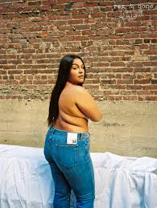  “Come on, You need to put your breasts on.” | 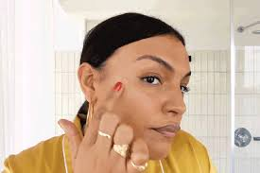  “Highlighter on the cheekbone”  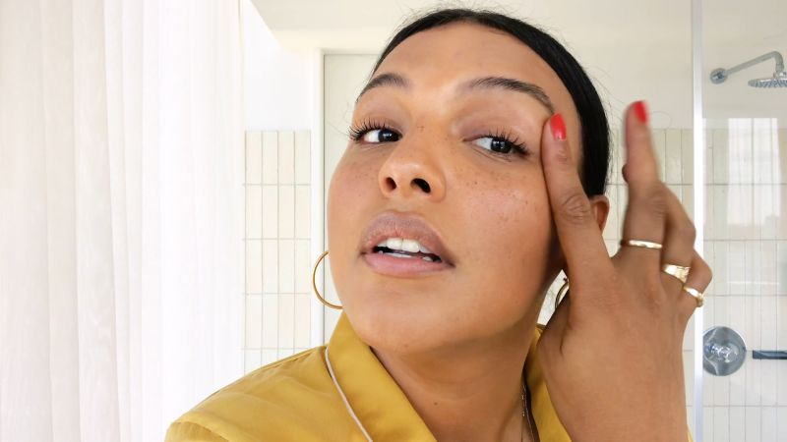  “And below the eyebrow” | 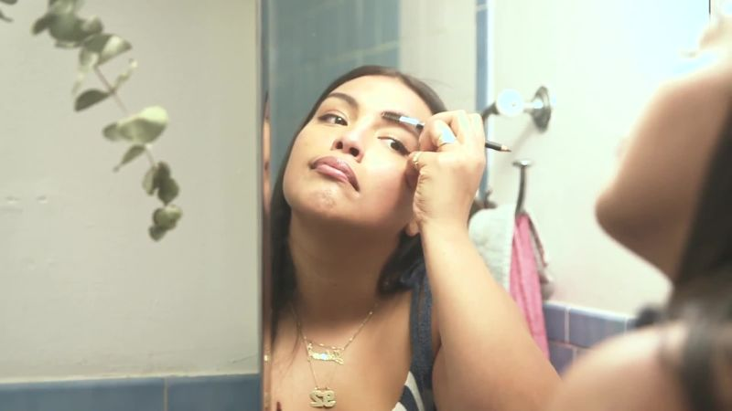  “Eyebrows”  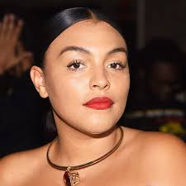  “Lipstick on. All done.”

She turned and walked to the back door, her chest, flabby but male, totally incongruous with the face. Even without makeup it was fundamentally feminine. As she walked past him “Lucy” puckered an air kiss but said nothing. She sat down at the dressing table to commence applying her own makeup.

Her fingernails were painted red and she wore some rings on her fingers. Her hands seemed to move with grace, but seemed splayed deliberately as if they were responding to some coaching the previous day. Still they moved across her face effortlessly. Bea only prompted four or five times.

Lucy was ready.

“Open your wallet,” said Bea. “We are going shopping.”

Charley produced a roll of banknotes and put it on the kitchen bench.

“Just enough for three days,” he instructed. “Tomorrow, Saturday and Sunday.”

“And tonight,” said Bea. “Tonight, we are going out, Lucy and me. I intend introducing her to the joys of womanhood. I think that she is ready for that, or will be by tomorrow.”

“Just make sure you are ready by noon tomorrow,” he said. “And dress down for that. You are a mule from Columbia.”

“But a high-class lady,” purred Lucy. “Your cousin, remember.”

“High-class is the look we are going for,” said Bea, as they hit the shops.

And from the moment that Lucy on her first dress, it was as if she was completely changed. The light fabric seemed to make her feel lighter. Jubba had seemed so heavy, so close to the ground, so weighed down with everything. The dress and the way it moved and rose and fell, made her feel as if there was air beneath her feet, even when she was standing still.

Bea saw it too. She said: “You’re enjoying this, aren’t you, Lucy?”

“Don’t tell anybody,” said Lucy. “But yes, yes I am.” She was grinning. With the high thinned eyebrows and the red lips, it made for a very attractive look. Certainly, many of the men at the club they visited that night thought so. Despite her large size, she attracted plenty of attention.

Bea suggested that she put her hair up and wear earrings and some more dramatic makeup for the evening and the look certainly worked for her.  Lucy could not help but notice the difference in going out to the club as a man and being there as a woman. As a man it seemed that he was doomed to fail. Women barely looked at him. Without attention he drank. With drink in him he got less attention, or attention of the wrong kind.  Even being not a real woman, but with a woman’s smooth limbs, her buxom (artificial) shape and her bright, open, well made-up face, she was fighting attention off. She had free drinks lined up, but no time to drink them. Men were asking for her name, her phone number, or just a moment of her time, even just a nod in their direction. It was empowering. | 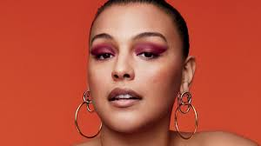

Bea and Lucy arrived home exhausted. Charley was unimpressed.

“Tomorrow is Friday,” he reminded them. “The shit you will have in the morning needs to be the last one you have until Sunday. I have some loperamide for you to take. After lunch Hector will come to stay with you, Jubb. To wait for that shit.”

“It’s Lucy,” she said. “Lucy or Lucia.” Her voice sounded completely feminine, slightly bitchy and quite sexy. It was a tone she had worked on all the night before. It suited her.

“Anyway, the shit will not happen. I will get the stuff and pass it to you through the bathroom window. They will be none the wiser.”

“And you will owe me,” said Lucy. It should have been Jubba speaking, but it was Lucy.

“Let’s rag your hair tonight,” said Bea. That will put a wave in your hair for tomorrow.”

I worked well. Bea was there to take out the ties she had used and to brush out the waves that they had left in Lucy’s hair, but she had no time to put on any makeup before Hector arrived. Only time to visit the bathroom and swallow the Loperamide.

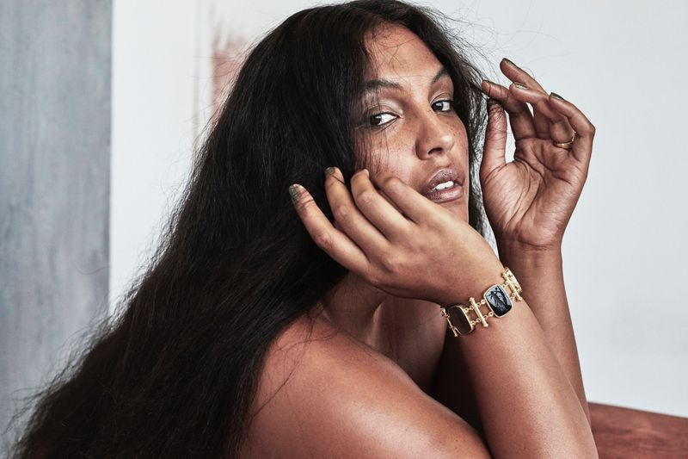 | “This is Lucy, my cousin from Colombia,” said Charley.  She looked over at Hector with pretended disinterest, but she had some difficulty in doing that. Hector was a large man. Larger than her but strong and powerful. His head was shaved and it had a scar across it that looked like the mark of a past battle, but instead of being threatening his face was warm and friendly, with a winning smile

“Lucy,” he repeated the name. He said in Spanish: “It would be my pleasure to stay with you, to protect you, and the goods you are carrying, if you will permit me to stay with you.

“That’s the deal,” she replied in English.

“You make yourself at home, Hector,” said Charley, adding in Spanish: “My house is your house.”

“I know,” said Hector. “It is.”

“My sister Bea will stay, as well,” said Charley. “I have to go. I have work to do.”

Bea made coffee, and (with Lucy’s help) she had made torta negra – the black cake so popular in Colombia. Hector enjoyed it as he enjoyed talking to the two women. But clearly it was Lucy he was most interested in. After, she was carrying the merchandise. But that was not on his mind.

“Can we go out tonight,” Lucy asked. She expected a negative reply, but she could help thinking about the night before. The idea of another night as a woman was appealing. There could only be a few days in which he could enjoy that experience. Why not make the most of it.

“We have to collect your stools,” he said. “We cannot afford to flush them down the toilet in a bar somewhere. So, if that is not going to happen, maybe? Somewhere close by? A possibility.

“There is a small restaurant on this block,” said Bea. “But maybe a bit expensive”.

“I have money,” said Hector. “It would be my pleasure to take to ladies to dinner, but at the first rumble of Lucy’s tummy, we must be back here.”
“Great,” said Bea. “We’ll go out. Let’s get ready, Lucy. Proper Curls I think.”  Hector was captivated. He only had eyes for Lucy. Bea felt as if she did not exist. It was as if she had created a monster who was consuming all of the air in the room. There was nothing left for her. The beautiful long hair, the dark eyes, the pout. Hector could not see the solidity of her body or the masculinity or her plucked chin.  Bea seemed to be doing a lot of talking but nobody was listening. It seemed to her that if she had simply thrown in the words: “Oh by the way, Lucy is a man”, neither of them would have noticed.  “Do you have a boyfriend in Colombia?” Hector asked.  “I would like to move to the United States,” said Lucy, although immediately seemed a stupid thing to say. | 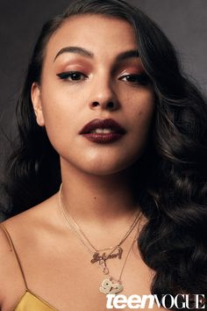

“I hope that you can stay,” said Hector. “I am born here. A US citizen. Wives of Us citizens have a right to stay.” That immediately seemed to him to be a stupid thing to say. But he did say it.

Lucy smiled. She did not think: “Is this man suggesting marriage – well is he in for a shock”. She was thinking that he would make a good husband, but maybe he is in the wrong business.

On the way back to the house Hector took a woman on each arm. But it was Lucy who clung tightly. Somehow it made her feel good.

Lucy tied her hair up to protect the curls as she slept. She dreamed of a life of domestic bliss. A husband and wife, and a beautiful home. But was she the husband, or the wife?

“No going out today,” said Hector in the morning over coffee. “I am sure that my Lucy will give birth to our little one today”

He had teased her over dinner about being the expectant father. But somehow today it seemed like such a nice idea.

“I think that we should continue the wait around at my house,” said Hector. “If you will trust e with your cousin, Beatriz, you do no need to come.”

Bea was worried, but after last night the thought of spending the rest of the day with these two was not looked forward to. She looked to Lucy for guidance.

‘It’s OK Bea. I’ll go with Hector. I thrust him.” Whether it was right or wrong to do so, she did.

She was surprised to find that Hector had a house in a nice part of town, but the beach. Not what she expected at all. It was comfortable, even luxurious. There was a terrace with sea views and soft furniture. She made herself comfortable. There was a magazine “Luxury Boats” which she thumbed through.

He left her alone for most of the morning. She read and watched some TV. He seemed to be working in the room off the living room at served as a study, making and answering calls, and his fingers clattering over a computer keyboard with remarkable speed.

Later in the day, he put a salad out for lunch. And after lunch when the sea breeze had picked up, he joined her on the sofa with two glasses of wine.

“You are not really an expectant mother,” he teased, handing her a glass.

“This does not look like the home of a Sicario,” she said.

“I am not a gangster,” he said. “I owe a favour, and that is all. Once it is repaid, I will never be part of this.” I want a life with a good woman. Somebody like you, perhaps?”

“I am not the kind of girl you would want to be with,” she said.

“You are exactly the kind of girl I would want to be with,” he replied.

“No,” she said. There were tears welling up. It could have been that the fact that the words that would follow would crush him, or result in her immediate death, or both. Not even she knew. Those words she had not chosen deliberately. They were said in sorrow. She said what she felt: “Because I don’t a womb. I don’t even have a vagina.”

The smile that had been on his face, even while he saw the tears begin, seemed to last a strangely long time before she saw realization, and then shock, and then what looked like a growing anger.

But he said softly: “Show me”

Almost mechanically following this direction, Lucy pulled up her dress, right up to her belly. Only days ago, there were just a few dark hairs around the navel, but as part of Bea’s enforced change, they had been waxed off, leaving her round tummy smooth and soft, and remarkably feminine.

She pulled down her underpants. There, nestled below he small bush of pubic hair that Bea had spared, was his singularly unimpressive penis, even more withdrawn by the fear of the moment. Barely a nubbin, a small shy bunny hiding in a black hedge.

“Hmmm,” he said. He seemed to be looking at as if he were a zoologist looking at a dead animal.

The tears were now rolling down her face. “I am so sorry,” she said.

“And breasts? Do you have breasts?”

“Fake,” she said. “Just like me. I don’t have breasts.”

“Not yet, anyway,” he said.

She was confused. When would he kill her? Was he still waiting for her to crap out the pellets? After that she would die.

“Stand up and turn around,” he said. She was completely in his control. “No. Keep those panties down. There’s no pellets up there, is there?”

The game was up. Make it quick. How could he lie anyway? What could he gain by it? He whimpered: “No. There’s nothing inside me.”

“Not yet anyway, but there soon will be.”

He could see her trembling. He added: “Don’t tell me that you are still a virgin? An ass as pretty as that and you are still a virgin? That’s a real crime. I think we need to fix that. Would you like me to make you a true woman, honeybun? Tell me you would. Would you like that?”

Lucy whispered in terror: “Yes.” If she agreed to whatever he was going to do to her, perhaps she might survive.

But less than an hour later she would be using that word again and again, screaming it in the highest voice she could muster: “Yes. Yes. Yes. Yes. Yes. Yes. Yes.”

They lay together in silence. She had kept her bra on. The massive cheap but effective inserts, were somehow comforting to them both. Her arm was draped across his hairy chest, fingering the course curls, something that she knew now she would never have, if she even survived.

“What now?” she asked.

“Now we wait for Charley and his cousin,” he said.

“But I am Charley’s cousin. Or supposed to be.”

“Charley called just before your big reveal. His cousin arrived with the drugs. We don’t have to wait until tomorrow. It’s over. I think they are coming to collect you. To take you away. Do you want to go?”

“What do you mean?” she asked. She propped herself up and looked him in the face. He was smiling at her. His dark eyes seemed to be full of life. Maybe her life.

“You could stay here with me,” he said. His desire was visible. Without words he was pleading for her to say it again. She felt her asshole quiver, and perhaps release a little more of what he had left inside her after their third lovemaking.

A lock of her hair dropped and he pushed it away from her face. They just looked at one another. Her lips trembled. What would she say? Would her life change forever?

“Yes.”

The End

© Maryanne Peters 2019
  New Breasts | 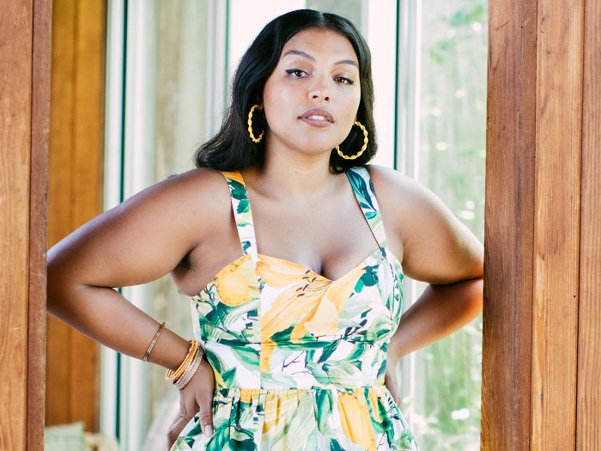  Growing into them    Using them to advantage
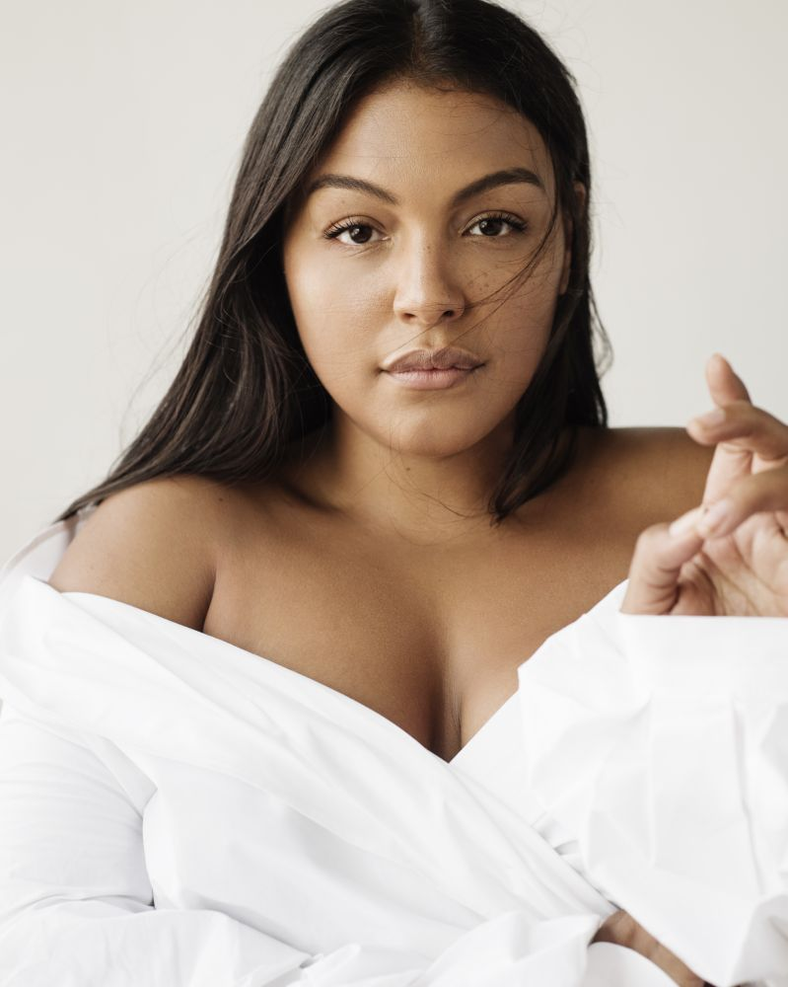  Back to bed? | 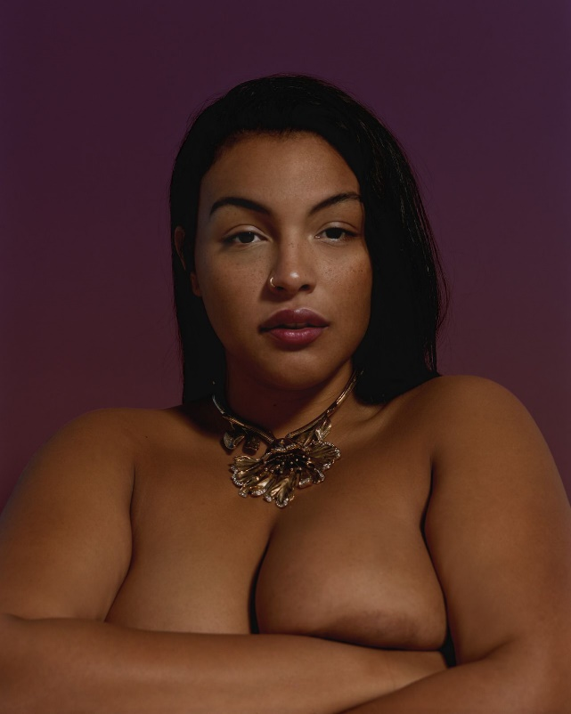  Just for her man
  You know what I really want? | 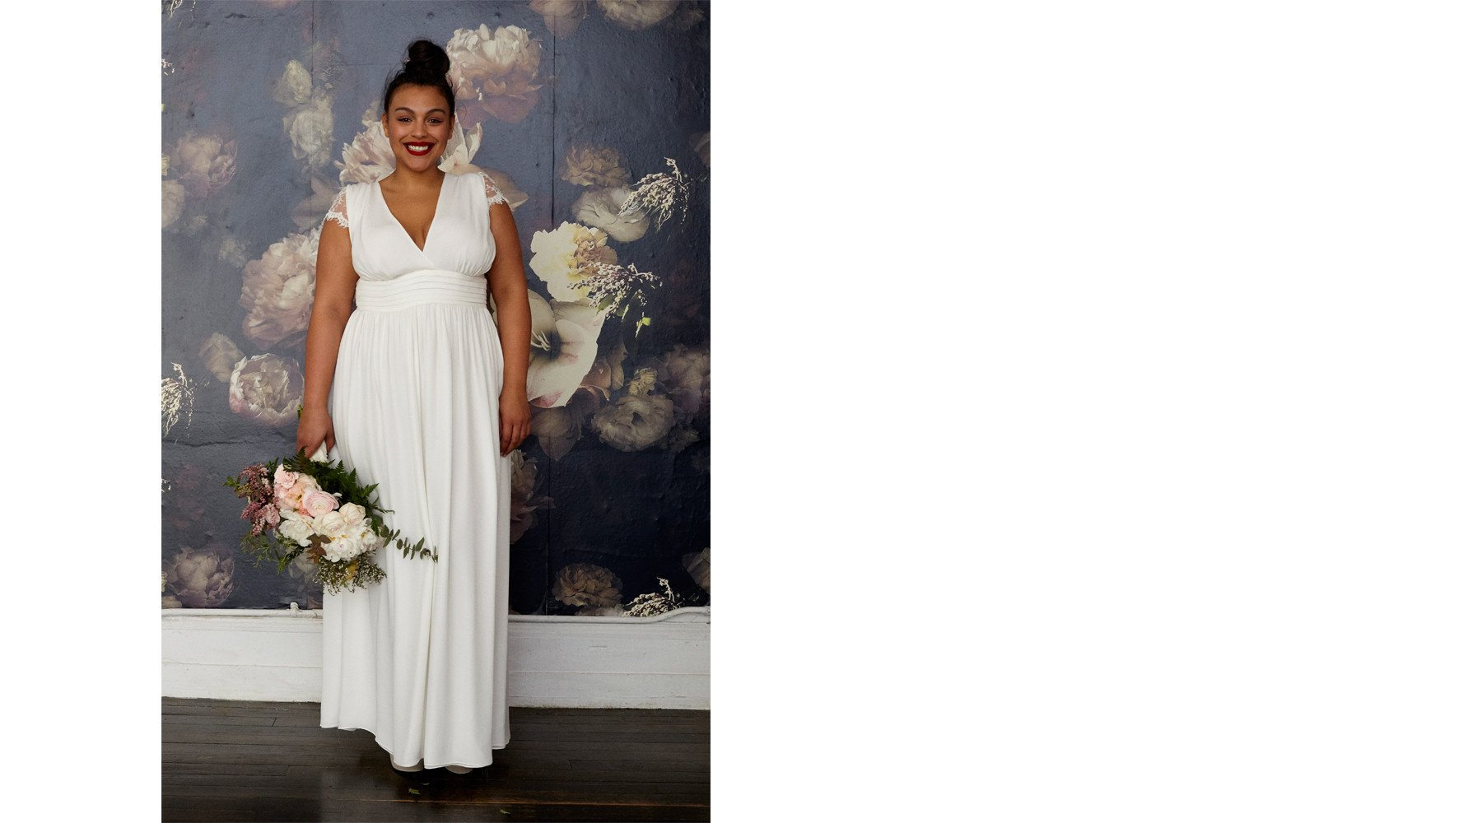  Do you take this man?  Yes. Yes. Yes.

