UMA FANTASY
COMMISSION STORY
BY CHALDEACHANGE
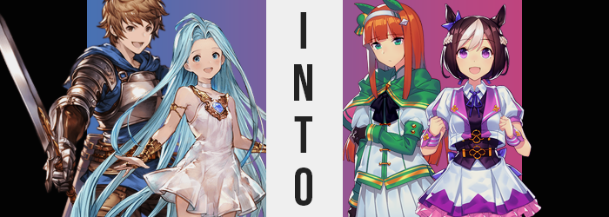

“This island is… strange?”

Considering the sheer number of islands that the Grandcypher had visited over the course of its journey, it must have truly been an unusual sight to elicit such a comment from Lyria. From what she could tell from socializing with the locals, the island itself appeared to be named ‘Uma’. Not only was it not on any maps of the Skydom, but they had stumbled upon it completely by chance.

What immediately stood out upon arrival was the floating isle’s architecture. The buildings sported unfamiliar tall and blocky designs that were so very unlike anything else they had seen across the sky. It also appeared to all be built around a race track of sorts at the city’s center, and had what was supposedly a very prestigious academy whose name Lyria had not yet caught.

By our standards the island would have been modern, but from the point of view of a girl that grew up in this world, it almost seemed to be fantastical somehow. Nonetheless, there was no sign of any danger upon arrival, and the people seemed to be amicable and more than receptive towards their arrival. Other airships had been visiting the port too, so it was easy to think that any potential paranoia might have been unfounded.

“I don’t dislike it, though!” With Gran staying back on the ship for the time being to help take stock of the airship’s supplies, Lyria had opted to go into the city all by herself. She had means of contacting the others if anything went wrong, but really? The city itself seemed to be far too harmless to warrant any concerns that something might happen to her. Besides, Lyria had been much more insistent as of late that she was capable of taking care of herself. Everyone wanted to give her the space necessary to prove just that.
After fetching lunch at a small restaurant in the city’s core, Lyria had chosen to check out the race track that was at the city’s center. It must have been important if it was positioned there, right? While she had not asked anyone about it, she had continuously heard people speaking of when the next race would be, or wondering aloud which horse would come out victorious this time.

“So it must be a horse track of some kind? But hm… I don’t seen any stables?” The Girl in Blue had arrived midst a break between races, and so there wasn’t really anyone in the stands along with her. Rather, it was almost suspiciously vacant, all things considered. Too caught up in everything though, Lyria didn’t really think too critically of it.

Even if she had, though, it was already too late. “Wait…” She felt it now. The energy of a Primal? There was a Primal here? But its influence felt strong. Very strong. So much so that she could feel its pressure pushing down on her. “Wha- AH!?” The next thing she knew there was the sensation of falling until, finally? She landed with a little bounce on a bed in an unfamiliar room.

“Where am I?” She was quick to crawl off the bed, and she couldn’t feel the Primal’s presence anymore. But she didn’t know where she was. It looked like a dorm room? Though it sported some unfamiliar, modern amenities. She couldn’t have known because she hadn’t been there, but Lyria had ended up in one of the dorms at the academy on Uma, Tracen.

Lyria could recognize it. She felt… strange. She just couldn’t bring herself to sit still for some reason? She was bouncing from unfamiliar object to unfamiliar object within the room, also noting that there were two beds instead of just one. But as unfamiliar as it all seemed, why was there a pang of nostalgia when it came to being there as well?

Bounding back and forth, the girl really was much more focused on her surroundings than herself, which she most likely should have been. From the perspective of a witness, she was handily losing the traits that made her the infamous Girl in Blue in the first place. The color of her eyes were among these altered traits, with irises taking on a very striking magenta that didn’t really suit her at all. She’d been known of her moniker of blue for so long that any color just didn’t quite look right.

Of course it wasn’t solely a matter of her eyes. Her hair was also blue, or at least… it had been. Her incredulously long locks all darkened with consistency, almost like someone was changing them with a color customization slider that affected it all at once. The end result robbed the maiden of her characteristic blue in favor of a dark, chocolatey brown that was darker than even Gran’s. There was one exception to this color though, for the front of her bangs ended up a silvery white.

“There’s so much neat stuff in here!” A voice crack went unnoticed as she examined a strange, silver rectangle on one of the two desks in the room. It was a laptop, but she didn’t know what that meant just yet. So curious about the surrounding gizmos and gadgets, no notice was paid even when her hair style changed.

Most prominently, as if an invisible razor had been taken to it, everything past the peak of her neck was severed off while the excess tumbled towards the floor. The hair that was left atop her head softened, taking on an unrivaled fluffiness while white bangs fell to dangle across her forehead and more of this white was laced within the rest of her hair. It have her head a rounder shape, or perhaps… Her head had actually become rounder?

It had! And not just her head, but her face! Lyria had always had a narrow, boney face, but no longer. Cheeks grew plump and round, but not in a way that really made her appear chubby or anything like it. Rather, she almost looked a little older? Lips rose to be plumper, and eyes grew far bigger and more expressive.

Until, from the neck up, she didn’t look a single lick like herself.

As for the hair that had fallen from the girl’s neck when it had been severed? It didn’t quite reach the floor. As it had fluttered downwards, it all collected into a thin stripe as the hair itself became coarser than normal, human hair. In turn it almost resembled a tail, and well… “EEP!?” With a voice that was absolutely unfamiliar, Lyria let out a squeak at the feeling of it suddenly clipping to the base of her spine, creating a hole in the back of her white dress. Her ears perked up in the meantime, because they had slid up her head’s sides and turned into triangles atop it, lined with fur in the same color as her hair and tail.

“What just…? Maybe it was nothing?” Even looking over her shoulder, the maiden just couldn’t seem to register it. The fact that she now had a dark brown horse tail flickering out from behind her. In her mind it was registered as ‘normal’, and so why would it take her by surprise? She must have just gotten it stuck on something in her room, that’s all! But… was this her room? At what point did she start seeing it that way?

Nonetheless, the influence that had seized her very being and sought to reconstruct it trucked on. The basics were dealt with, and so now it was only a matter of making the appropriate adjustments so that she could fulfill the role that had been intended for her. And that begin with a subtle increase in height. Lyria was typically beneath the five-foot mark, but steadily rose to five-foot-three, her white dress resting higher on her hips as a direct result.

Thus began a series of alterations that dismiss the childish physique that had plagued her for so long. She had already grown taller, and now? Broadness settled in as well. Hips stretched several inches, and as a direct result her stomach grew just a little thicker as well. Now lined with strong muscles, they spoke to a fitness that the girl didn’t normally possess. “That’s weird! What’s up with my clothes? Huh…” It definitely felt tighter, but again? The girl herself couldn’t pin down the problem. More than the fit… “Isn’t this style a little boring?” Some bright colors would do wonders!

Aspects of Lyria’s body continued to swell, which ultimately influenced her dress’ fit even more. A chest that was once essentially flat flourished, growing into a set of B-cups that pushed the dress’ front out, while down below her butt became more abundant so that her panties almost got wedged between her cheeks.

But nowhere was the weight put on more than her legs. Much like her stomach (and hidden within her buttocks), muscles swelled to perfection and made them naturally thicker before a subtle layer of fat took away the bulging edges that were normally so typical of legs that were so muscular. This left both legs, in their full lengths, looking much denser than legs did normally. Almost inhumanly so, in fact.

Because she was demonstrably no longer a human! Or whatever she was supposed to be.

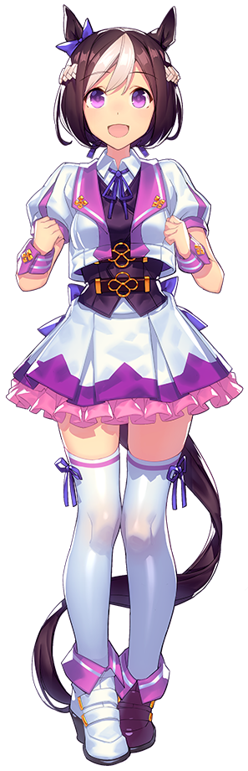
Any problems her dress provided faded away, for the dress grew to fit. In fact, while opening her laptop on the desk, the fact that her outfit was redone as an elaborate, Western-style uniform gown with a vest, golden buckles, matching white thigh highs, and pristine running shoes took shape. Even her hair was decorated thanks to a blue ribbon over her left ears. The white locks that were not bound to her bangs were, likewise, bound into braids that wrapped around her head like a crown of some sort.

“Huh!? Where’s Suzuka-chan!? We have a show soon!” The horse girl, Special Week, didn’t think anything of her transformation any longer. In fact, she couldn’t recall anything having changed at all. Well, maybe her memories had been repurposed so that she thought she had just gotten ready to go down to the track to perform and possibly race if requested, but she hadn’t changed in the transformation sense as far as she could recall.

Bouncing on her heels impatiently, Special Week was a real go-getter. Energetic and optimistic, if not a little bit clumsy at times, her extroverted personality was fairly contradictory to the more reserved Lyria, even if Lyria hadn’t exactly been anti-social. Magenta eyes, big and bright, kept flickering back between the clock on the wall of their shared dorm and the door. “Guess I need to go find her before we’re late!”

Special Week was truly a good girl.

Back on the Grandcypher, the ship’s captain, Gran had finally finished with the stock situation in the ship’s warehouse and had been planning to go out to meet Lyria in the city so that they could go exploring together. There was always something to be said about exploring a new location, and it could certainly be fun to take in all of the new sights.

What Gran hadn’t been expecting was to receive a sudden, one way ticket into the city proper. Or at least a locker room within one of the city establishments. “Huh!?” It had happened instantaneously, and the young man wasn’t as keen as Lyria was when it came to Primals to be able to immediately sense this one’s influence. He’d just suddenly found himself standing in a sleek, modern changing room.

It was lined with lockers and posters. The posters featured girls with brightly colored costumes and what he assumed to be Erune features that resembled… horses? While the lockers that were open? They revealed clothing that belonged to young women. “Crap!” All it took was the sight of a single bra for him to realize this was most certainly a place a young man shouldn’t be.
At least it would only be an issue temporarily?

“I need to get out of here.” It was the obvious reaction, seeing as this was a girls’ changing room. But even rationalizing that gave him pause. Why would he have any issue being there? Because he was a man? Was he a man? Now, it might have been confusing to try and understand without a little context. Because no sooner than Gran had appeared in this room, his body had already begun to change.

Or perhaps it would make more sense if it were stater that her body had already begun to change? Gran’s body had been shrinking in stature, leaving her pants and hooded sweatshirt resting upon her frame in a way that didn’t look very comfortable for anything other than sleeping in. The size of her body wasn’t what was most important in this case, mind you. It was the loss of what was supposed to exist between her legs. It had disappeared with such immediacy and efficiency that she hadn’t even noticed, and with a pussy now in place it felt more than natural to see herself as a woman. Or a girl?

Because Gran’s loss of height had revealed something else. She undeniably looked younger after recently beginning to push her 20s. Instead, her face held a youthful glow that made her better resemble a maiden in her mid-teens, something that only worsened as chiseled facial features smoothed and softened so that her face, while long, was still round and unrecognizable. Lips pouty, nose petite – she undeniably was beginning to resemble a young lady more and more.

Naturally, this meant earning the figure of one. “Um… What was I doing..?” Gran herself felt confused, speaking with a soft and girlish voice that much better suited her new sex – although it did not at all suit her traditional personality. Because it was being overwritten much like Lyria’s had been. The end result? Gran was growing more uncertain, less confident socially, and uninteresting in speaking more than absolutely necessary. More than that, why had she felt like something should have been concerning her?

There was certainly plenty she should have addressed. Like how her waistline had thinned beneath her hoodie, or how a pair of somethings had begun to poke up from her chest where strong muscles had once been. That was part of it too – overall, her upper body had become much weaker than it was normally. That meant that while breast grew, even though they only amounted to A-cups her chest was so flat that they still stood out.

Underperforming when it came to a woman’s figure was clearly a common trait here. Her hips hardly grew, and her butt? It only became perky enough to make it readily simple to differentiate it from the butt of a boy her age. Even her legs, while muscles persisted (and strengthened), did not reach the same heft as Special Week’s. But she was still a very powerful… horse girl? “I’m… Am I?” What kind of term was ‘horse girl’? But it sounded equal parts unbelievable and familiar.

Whether she believed it or not, it was becoming a reality. Her ears slowly crept up the sides of her head until they reached the tippy tops. Once there, they pulled up into equine points before an orange fur dusted them… an orange that then seeped into her spiky mane and saw brown spikes flatten. Her hair, now in this same orange, spilled past her shoulders until it reached just above her rear end in the straightest style imaginable.

While brown eyes lit up green, a short bone stretched out from her tailbone… which opened the floodgates for long, coarse hair to grow from it between her sweater and pants that hardly remained fastened. The end result was a long, orange tail that was just as horse-like as her ears – and felt just as natural to her.

The finishing touch saw her outfit, the sweaty outfit of a young man, replaced with something pretty, daintier, and cleaned. An outfit not unlike the one that Special Week wore, but individuality had been applied in its decals. Black tights hugged her legs, and the colors were more green, yellow, and white than anything. A throw clasped over her shoulders, and covers over her ears above a white headband added to its accents. All in all, both of the girls’ outfits seemed designed to draw attention not on the racetrack, but on a stage. They weren’t actually racing today, they were singing.

“SUZUKA-CHAN! THERE YOU ARE!”

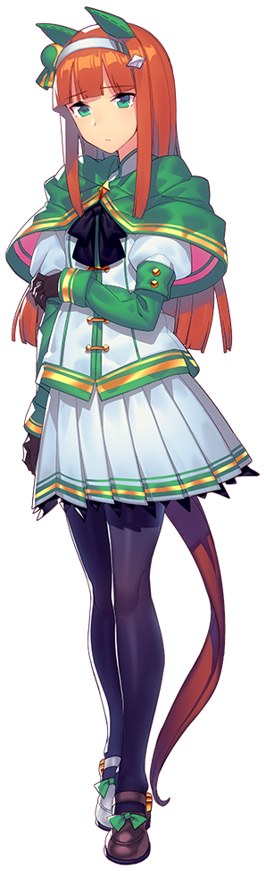
The door into the locker room blew open, and Special Week flew in at what seemed like Mach speeds before stopping just short of the ginger-haired horse girl, Silence Suzuka. The latter girl’s lips rested agape from the shock of it all, and in the end that shock helped her to forget about everything that had just happened. Had she been worried about something? She couldn’t really remember…

But the two of them had been caught up in the Primal’s spell. It had been attracting guests to this artificial island, hoping to bring in suitable subjects with which to repurpose to its goals. The city, the race track, it was all part of this plan. The plan to ignite horse girls as the next big thing in the Skydom, and all it needed was, well, the horse girls themselves. Individuals with strong bonds made the strongest horses, and Gran and Lyria had most certainly fit that description.

“S-Special Week? You were sleeping and wouldn’t wake up, so I just went ahead…” It was a completely valid explanation, seeing as her roommate and closest friend was extremely difficult to wake at times. And that realization immediately pinkened Silent Suzuka’s cheeks. “…Did you think that I abandoned you?” Suzuka would never miss a race. She was a professional, after all.

But even with this problem solved, it did not change that the Primal would undoubtedly prey upon others like these two had been preyed upon.

