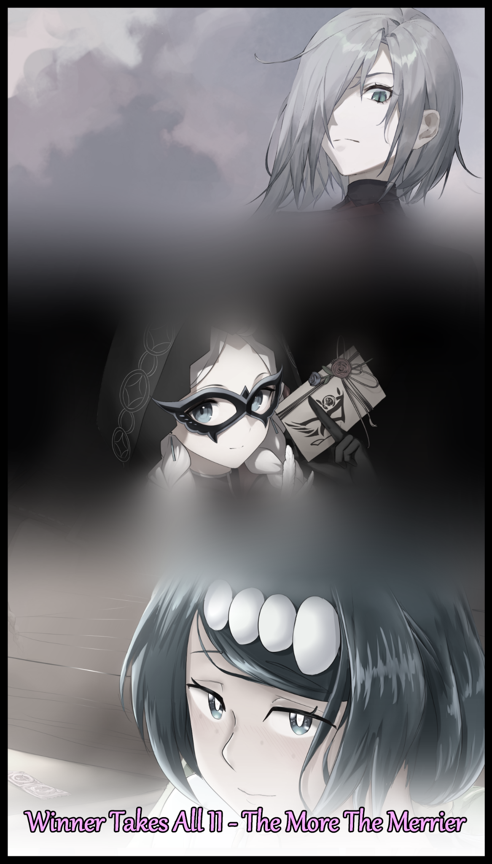

"So? Are we good to go? It's taken three hours for the safety inspection alone…and we're literally on the other side of town, is this really necessary?"

Hanging over the shoulder of a man dressed in scientist's garb was a black shadow. With a midnight blue business suit strapped tightly to a tall, skeletal frame, it would've been easy to mistake him for a phantom, lurking in the darkness of a small bedroom with only the light emanating from the monitor before him and his associate to illuminate the front of his suit, leaving the rest of his figure sheathed in darkness, the whites of his unfeeling eyes glimmering with unnerving excitement.

The shorter man however, wasn't panicked at all despite the heavy air of foreboding hanging over the room. Sighing while his hands flew over a keyboard, triggering hidden machinery behind the walls and floors as evidenced by the faint whirring of engines and the clack of joints being set in place.

"There's a reason it's called a safety inspection sir…the tech we're dealing with here could be unpredictable…and it ain't like usual radiation or all that other basic stuff, can't hurt to be shielded right?"

"Please, we've tested the product in public space already…in an apartment building. No casualties, no unintended side effects…in fact, our tester had the initiative to include his own tweaks in the code, and from that, we've learned plenty, especially when it comes to the usage of it…like today's mass public trial…"

From the mocking in his voice and the snide look on his superior's face, the scientist knew better than to question the efficacy of their undisclosed testing on this twisted device of theirs the eggheads over at research and development had birthed into the world, shaking his head in mild disappointment at the seedy company he willingly served under.

Better to be the one seated behind the table than the ones unfortunate enough to find themselves on the other side without knowing. Plus, he did need that hefty paycheck so he couldn't really complain. The man wasn't a moralist, and to be the good guy in such an environment was like being a sheep among wolves. Whatever he was here to do, he'd unfortunately have to go ahead with it whether he liked it or not…

"Well…I guess that does it…is there anything else you need me for sir?"

"That remains to be seen…ah, there's the feed!"

Growing visibly excited at the sight of the wide screen monitors flickering on before displaying separate camera views in what looked like different portions of an amusement park, the scientist follows his tingling superior's gaze toward two of the main screens, showing two men entering different attractions at the convention being held downtown. Something about anime? He wasn't sure, all he heard was that it catered to Japanese animation and everything else associated with it.

But what he did know was that the carnival game style booths they were stepping into were rigged. After all, he was the one who installed the devices that were going to be tested right then and there, inside an inescapable Hall of Mirrors and the other, nestled comfortably in the heart of a faux village where the goal was to find a nonexistent Golden Apple, all while hiding from a Hunter played by one of their own fitted with a shielding device that would render him immune to the effects of the device.

What this effect was however, remained a mystery to him, even now.

"Say, what're those things even going to do?"

"Hmm…I'd prefer to show you rather than explaining it all and ruining the surprise, but you've heard of the double disappearance recently, yes? Two boys gone like the wind? Well…guess who our tester decided to go for?"

"Damn…isn't that pretty harsh? Going after kids like that?"

"Hah! They were barely kids…young adults at best…as for the decision, that was entirely up to the tester's own will. Were we to have done it, a couple of homeless bums off the street and no one would be batting an eye…though I think the time for discretion is long past…"

Turning his attention back to the screens, the scientist could no longer see the men that had vanished into the depths of the attractions, finding himself sighing once again, loud enough for the sinister presence behind him to hear.

"What's wrong? You're not wimping out on me now are you?"

"Oh no…it's just…feeling a little out of breath is all, anticipation and all that stuff y'know?"

Rubbing his chin thoughtfully in an almost over exaggerated manner, the man brings his free arm up to rub the scientist's shoulder in an assurance, an act that only served to make the man feel more on edge than before. The oppressive atmosphere was palpable, heavier than ever before now that the scientist could feel it for real after that minor mistake…or at least what felt like one.

But before he could think about what punishment he was about to receive, his superior's heavy hand lifted away from his shoulder without ceremony. Leaving him alone once more.

"How about a wager? To lighten up the mood a bit hm?"

"A…wager?"

"Yes…I'd say the blonde one has a good chance of making it out the other side…how about you hm? What's your opinion on our lucky contestants here tonight?"

Giving it some thought, the scientist wasn't concerned about deciding their chances when he knew they had none in the first place, they weren't making it out of there…unharmed at least. He was more concerned with telling the truth or playing along and betting on the other contestant…as well as what he stood to gain or lose from this wager.

"C'mon, I won't bite…if I lose, you get to ask me anything you want…if you lose…well, I get to do the same…take that bet?"

Running his hands over his face before exhaling for the third time, the scientist slowly turns to face the stout man, giving his honest opinion on the matter.

"Truth be told sir…I don't think either of em are making it out of there in one piece…"

"Ahahah! So pessimistic…well? What're you waiting for? Start the experiment…"

Reaching around his back with his scientist lackey too busy fiddling with switches and entering commands into the laptop in front of him, the man thumbs a switch on the remote slipping out of his sleeves, triggering a hidden mechanism in the room that would go unnoticed to his crony…at least, not until it was too late of course…But for now, he had a show to pass the time with, keen eyes zeroing in on the man currently about to take his first steps through the unsuspecting Hall of Mirrors and the other, busy meandering about a stage picking out a mask in the style of those worn when attending masquerade balls, wondering what the on-site agents had cooked up for them…

-House of Glass-

Markus was first to be put on the chopping block, a man of average size and build. The only defining physical features he could boast about was the exceptionally fine crop of blonde hair he liked to keep slick back in a low sweeping wave. A thrill seeker and one who couldn't say no to a challenge, the attractions, as surprising as they were, hadn't impressed him one bit. So far they were all pretty tame 'point A to point B' type games, nothing that really made him use his mind to think of a solution. So to see something as epileptic as a bona fide House of Mirrors with a confusing layout that seemed impossible to navigate without bumping into something was refreshing. Even more so when the door behind him slides shut with the beep of an electronic lock going off, causing Markus to turn just in time to catch a drop down monitor with a simple message on it…no, a mission;

'Welcome to the House of Glass contestant! You have 90 seconds to make it out the other side! Do so, and prizes await! Fail, and a team of experts will make their way towards you if you just can't find your way! But be warned, for every 30 seconds that pass, a penalty will be placed upon you so make sure you waste as little time as possible! Good luck and have fun!'

Wasting no time upon seeing the timer next to the terminal counting down, Markus takes off running into the befuddling corridor of glass, holding his arms out in front of him to gauge the distance between his face and any potential mirrors he couldn't quite make out in front of him, dashing down in invisible corridors toward his objective which he assumed was probably at the end, a mistake he would soon realize when Markus' eyes widen at the sight of an entire living room complete with furnishing and decor after turning a corner, spying branching paths that led elsewhere into the mirror complex instead of entrances to the toilet and where the kitchen presumably should be.

For a moment there, relief seemed to cross Markus' face as he strides into the center of the room, choosing to continue his sprint down the pathway to the left. A challenge, this was it, not some simple puzzle room. Although it still relied heavily on choice and chance over skill and intellect, the man was more than fine with it if it meant he was going to finally face some form of opposition by the organizers of this little side show.

But before he could relish in the moment any further, a shrill alarm bell rings out from a hidden implement, bouncing down the glass halls in an ear piercing shriek that had Markus wincing in mild discomfort, continuing his trek through the halls while wondering what that was about, unable to recall the bit he'd read in the message about a penalty being applied after every thirty seconds had passed thanks to the dull ringing in his ears, the symptoms of something more than just a microphone malfunction giving his eardrums a good jolt. Something ominous that begins to eat away at Markus' mind, inducing several minutes changes to his physical form that go unnoticed to the oblivious man as he continues his attempt to reach the exit, beginning with a notable decrease in muscle mass and height in the span of a second or so, an instant drop that made running easier and harder at the same time. On one hand, Markus was taking advantage of the lighter than air sensation he was experiencing to hasten his advance. But in exchange for that, his chest was suddenly beginning to feel extremely heavy and strained, making movement hard when his joints were starting to feel sore.

Eventually though, he would make it to another room, one far removed from the apartment flat aesthetic he had assumed the place was going for. Because this wasn't a room anymore…it was a library…

"How in the heck did they manage to fit all this in here?! Shit, I don't have time for this!"

Part of him was contemplating on going back to try out that other passageway but Markus had decided against it. The trip back would mean another thirty seconds or so wasted, and for all he knew, the size and scope of this room might serve to intimidate contestants from advancing toward the exit that was most likely hidden somewhere inside this labyrinthian recreation, at least there was air conditioning in here to cool himself down with. A strange occurrence for Markus, seeing as how he shouldn't have been feeling this exhausted after a simple jog through a few hallways. He had run marathons after all, this was chump change in comparison.

If his mind wasn't so addled by stress and that initial ear piercing blast disguised as the thirty second alarm, then maybe Markus would've been able to tell how short he now was, or how his limbs seemed incredibly lean and slender when compared to the bulky pillars they once were. Hell, any man would've been able to tell something was very wrong with themselves if they found breasts growing on their chests like the ones forming a hefty tent in Markus' clothes as they gradually recede in mass and make, revealing smooth, sweat slick skin stripped of hair follicles and other blemishes, leaving them with a toned quality once the roiling mass beneath coalesces into supple flesh and solid muscle. Arrayed in such a way and with the perfect balance to form eye catching curves across every inch of his feminizing body, ignoring the invisible tongue of the wind licking the slender arch of his exposed back once the black t-shirt gives way to a revealing gym bra hugging Markus' new assets tightly as they continued to grow, straining the elastic material once they cross the B cup range. Earning him a hefty bounce with every step as the clueless contestant continued to explore the library. Jogging by the endless shelves with narrow, slant eyes on the lookout for an exit.

By the time Markus found the exit, the rest of his attire had finished morphing into form fitting leggings that clung tightly to his skin, making it clear that no part of his body had been left untouched by the silent metamorphosis creeping over him, sapping him of everything that made him a man, leaving Markus with long, curvy legs composed of a thickened thighs that retained only a modicum of their gaunt manliness alongside well trained calves that taper off into waifish feet tipped with well cared for toes. All of it wrapped up tight in women's sportswear despite the bulge still present in the middle of those juicy thighs, doing everything in its power to resist the mysterious influence tugging what little remained of Markus' pecker back inside a slightly damp slit formed from the smoothened out remnants of his empty testicles, organs that had long since been eaten away to be repurposed as egg factories flanking the empty incubator lying dormant beneath the man's soft tummy…not like he knew enough to be bothered as he sprints through the exit corridor after what felt like minutes of searching.

"Almost there now…just a little more to go…"

So he would say in a voice dripping with feminine wile, sex appeal and a slight hint of an accent, parted from its former gruff baritone and formed by a flexible tongue hidden away within pink fattened lips that were a far cry from the lean, cracked walls framed by a stubble. It had been washed clean and changed, just like the rest of his body, removing the final vestiges of what once was an energetic American youth, replaced by the visage of a feisty Slavic mistress with cool slits for eyes and a dyed head of platinum silver hair to replacing boring blonde, draping down across her left eye like a silken veil.

That was when the second pulse would hit her, this time sounding somewhere right above her, forcing Markus to slouch over in pain. Pain that brings focus with it once the confuddling spell over her mind snaps, enough for her to freeze in shock at the reflection staring back at her in the reflective flooring.

Gone was the man she knew herself to be, instead, she saw a banging young lady of foreign descent, dressed in a perverse rendition of a woman's sports bra that did little to contain a jiggly bust while the rest of her hourglass figure shows clean through the woefully tight leggings she could now feel biting into her handlebar hips as they struggled to contain the immensity of her gorgeous bubble butt. Trembling hands tipped with manicured nails, throbbing muscles prominent in her abdominals that served to emphasize beauty rather than strength, and most alarming of all; the sight of a puckered cameltoe squeezed tight by the fabric, beneath which she could not feel underwear to soak up the juices leaving a stain on her front, pudgy labia lips visibly squeezing and relaxing between her legs with each haggard breath that came out of her mouth.

Normally the sight of someone else staring back at him instead of his own reflection should've invoked feelings of dread or shock, but Markus soon finds herself enthralled by her drastically altered new and improved self, tracing the smooth contours of her chin, about ready to break into a warm smile…

Before the image of a sexed up Russian woman staring back at her vanishes just as quickly as she glimpsed it once the mental conditioning returns, snapping him out of his stupor and leaving Markus confused and afraid at what was happening to him. Was he just seeing things? Or was this place doing something to him?

"F-Fuck this…I've gotta get out of here…screw the prize!"

Ignoring the screaming pain in his joints, the bewildered man enters into a sprint, failing to remember the tactic that had enabled him to avoid unnecessary bumps and falls as he becomes a human pinball, bouncing down the glass halls, huffing and puffing like mad in his bid to escape, unaware of the mirrors around him reflecting the snow haired Russian woman mimicking his mad dash. A damsel in distress running alongside a panicking man.

Unlike the other corridors, this one seemed to go on forever, sporting new split paths that were traps to waste time in, either leading to dead ends or looping back around to a point further behind where he'd come from, hastening Markus' panic while infuriating him to no end, leading to mistakes that could've been avoided if he had simply remembered where he was going, oftentimes falling down the same rabbit hole thanks to adrenaline, rage and fear clouding his judgment…that, and everything looked like the same nauseating mess of dazzling mirrors no matter where he turned.

Seconds would fly by, and just when it looked like all hope was lost, Markus would eventually stumbled upon a final stretch of slippery glass leading to a brightly lit doorway, above which hangs a digital monitor with the words 'END ROOM' dancing across its screen in full capitalization, revitalizing him with a renewed burst of energy enough for one final spring as he scrabbles for the exit like a madman. He'd made it! Now all he had to do was run across it, and then he'd be safe to leave, safe to find out who was in charge of organizing this thing and give them a piece of his mind for scaring him like that really good shot of her sweaty bod while she waited for them to end shift and have fun with her…

‘Wait a sec…that didn’t sound-KZKRTT!!!’

The alert rings for one final time, blacking Markus' vision out for a moment just before he crosses the threshold into the exit room, suspending the confused man mid sprint as his mind fills up with white noise that instantly drowns his mental imprint in a deluge of new memories, personality traits and habits the Markus of old would never indulge in. Painting his metaphorical soul in new colors, tainted colors the likes of which belonged to that of a young woman from a land far across the American border, one who had been raised by uncaring parents before being passed like a toy between equally corrupt hands until eventually arriving where she now stood as a professional cosplayer working for a certain company sponsoring the convention, drawing in the masses with her cool beauty and reputation as an ice queen.

But that was just her day job, for beneath her calm, silent exterior laid a far more lecherous side of her she only showed to those who could afford her services. And with a banging body blessed with perfect genetics, there was no shortage to the amount of horndogs out there who wouldn't hesitate to throw thousands her way if it meant a chance to have her tight, curvy form all to themselves for one night…

Her old name was lost to her and nothing else from a past long forgotten rang a bell to her thoroughly fried brain. Not even the faces of those she once knew as friends and family struck a chord with the newborn Slavic babe as they slowly flitted by in her head before being dropped into the abyssal depths of her subconscious. She didn't need the veil over her eyes to mask her buxom form anymore. Because to her, this was who she was now; her new normal. It was like looking in a mirror everyday.

He had crossed the barrier into the room as Markus the thrill seeker, and in the time during the next step where his other foot would land ahead of him, all of that had been erased, ending with Mila putting her foot down before coming to a stop. She was now more than aware of her role as one of the organization's hottest girls they put to work in a variety of fields ranging from conventions to modeling. And in exchange for her services, they kept her status as an illegal immigrant a secret, paying for her expenses in addition to providing room and board in the form of a lavish studio apartment she rarely used in light of her extracurricular activities that fed chump change back into the wallets of the big daddies who kept her safe and well fed, rubbing her heated cranium in mild discomfort once the nausea subsides, leaving the scantily clad lady alone at the entrance of what looked like a gym, the open door to the mirror hallway behind her now sealed shut.
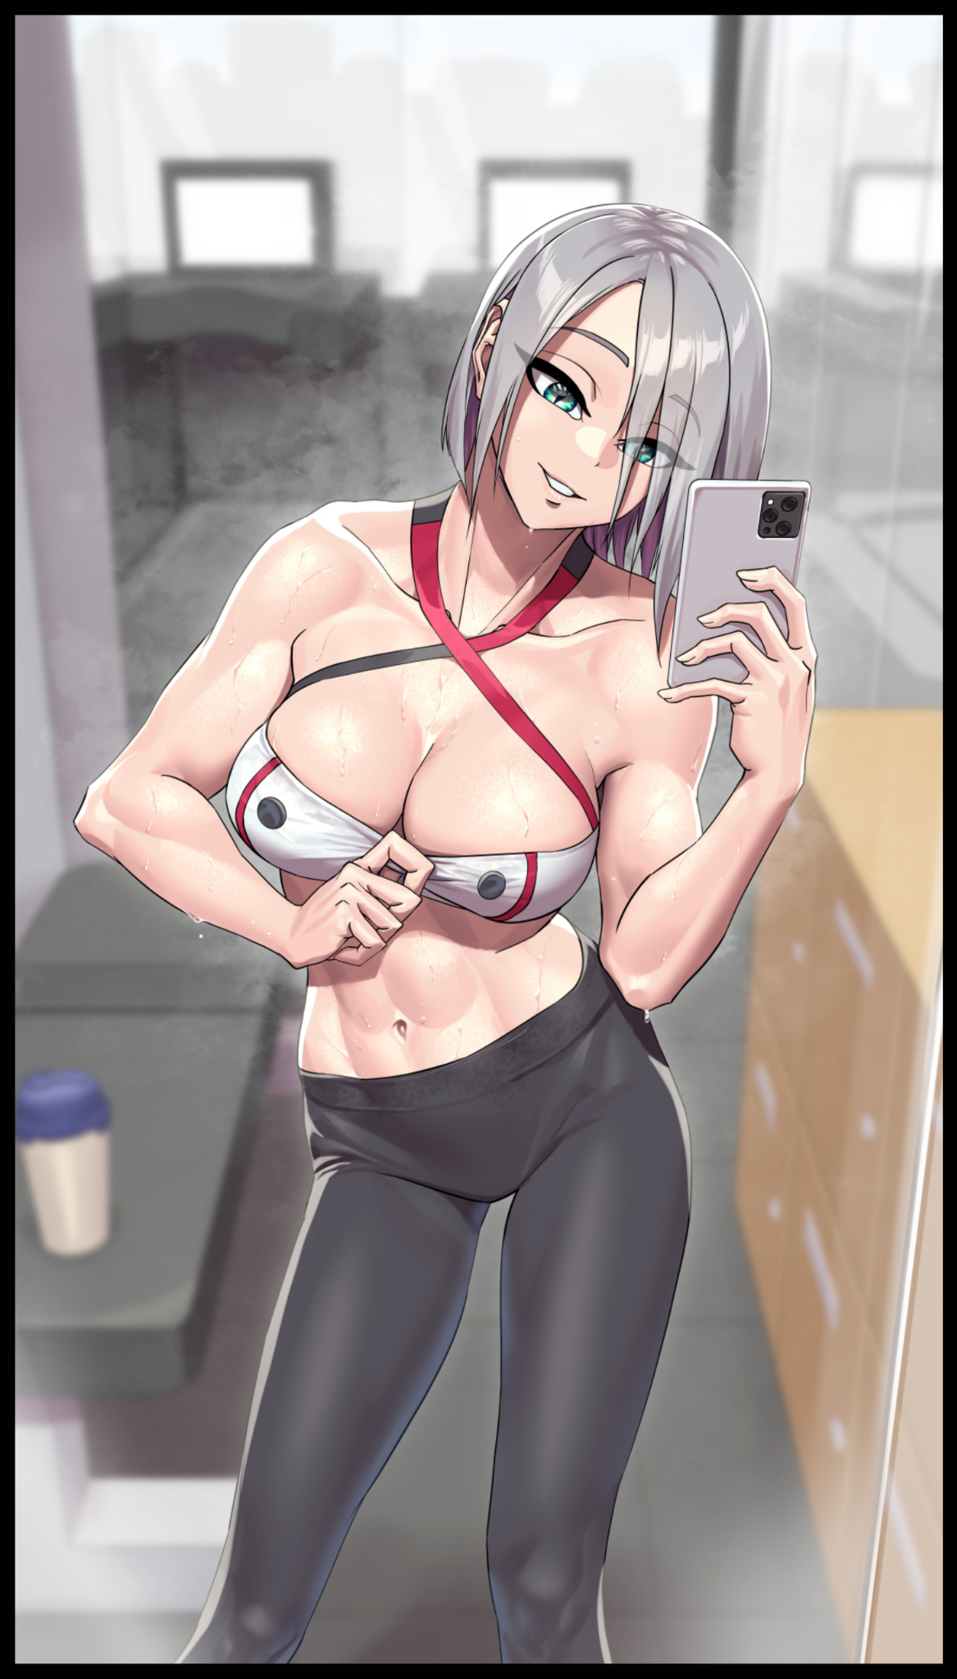
Looking around the room slowly, Mila unknowingly takes her first steps into the world as she saunters around the gym, broad hips swinging like a pendulum with each leg moving forward while inspecting dumbbells and machinery in search of something that seemed just out of mind to the groggy woman. Lazy eyes painted over in soothing lapis darting to and fro, on the lookout for nothing in particular.

'Blyad'…could swear I left it somewhere here…but what is 'it'...why thinking so hard so sudden?'

As if in answer to her thoughts, a loud synthetic bird song catches Mila's attention, turning toward the source of the commotion over at the receptionist counter where a row of computers and desks were arrayed, and on top of the one closest to the door, there laid a familiar smartphone, buzzing from an incoming call.

She'd left it there by accident, so eager to begin working up a sweat she'd forgotten to take it with her after fumbling with the light switches. Her friends must've gotten tired of waiting for her.

"Impatient monkeys…even more impatient than native dog…"

Swiping her phone off the table, before answering the video call from the boys over at the security booth, Mila didn't say a word, leering loose a flirtatious giggle instead as she maneuvers the camera over toward her bosom, tugging on the flimsy fabric soaked clean through with her sweat to the point where her right breast flops free of its prison, bouncing madly with a painfully erect nipple at its tip dripping nectar down onto the floor.

She loved the looks on their faces as the man on the other side lost his stoic calmness, calling his buddies over, shouting about how 'she was ready'. She snorted at that, Mila was always ready for anything. If the boss told her to get her ass out on the convention hall all dressed in her public friendly persona, she'd do so in a heartbeat. Just like how she'd readily give herself to her buddies…that is, if they would actually show up to play just like she promised instead of trying to get a better look at her tits over a digital screen.

"Бог…you all are like children fighting for mama's teats…if you want more of Mila, you know where to go yes?"

Hanging up the phone without bothering to listen to the men, the slutty Slav simply lays herself out over a bench, unabashedly spreading her legs before running dexterous hands over her inner thighs, finding a good grip to shred the fabric over her dripping snatch with the loud sound of tortured pants ringing out amidst the silence. Smiling in satisfaction as she discards the sopping wet rags in favor of plunging her index finger into the tight folds of her well used cunt, Mila's body bucks and spasms in the throes of erotic bliss, gasping and squealing all while she got herself amped up and ready for the gangbang her needy body so desperately craved as rapid footfalls made their way closer and closer toward the door…none the wiser to the life she had left behind…

-The Room-

"I don't want to be the bearer of bad news sir…but I think you just lost the bet…"

Back in the cramped room, the scientist and his supervisor were still keeping a close eye on the monitors providing them with real time footage of what was happening in the rigged booths at the convention, including the slow methodical annihilation of the blonde haired jock as he was slowly replaced by an admittedly beautiful woman…the same woman currently taking meaty sausages in every hole she could plug as the security team in charge of the hall of mirrors had their way with her. A sight that had the dastardly man behind him grinning like mad.

"Jesus…how are we even gonna explain this sir?"

"Explain? Ah…you mean credentials…it's all been settled. Markus Strafford has vanished off the face of the Earth true. But Mila Vasily will be more than happy to take his place, practically born to be a prostitute, raised somewhere in the slums of Russia before somehow making it here to America…where we found her…and now she's a locally renowned model, actress and cosplayer recognized and adored by the masses. They don't know the former of course…"

"Mila…Vasily…you mean the Mila? But isn't she-"

"A mere fabrication, until this very moment that is. We've prepared hundreds of potential identities, more because of circumstance rather than for this project. Artificial women made flesh…the marvels of modern science…but enough about that, has the second subject entered the booth yet?"

"Ah, right…let's see…yeah, looks like it, think he went with the third mask…took him long enough."

"Excellent~"

Shivering in mild discomfort before turning his gaze away from the supervisor, the scientist shifts a little in his seat with a noticeable jiggle to his silhouette, brushing aside bluish strands of curly hair amidst the strangely suffocating vibes he'd been getting from the way the older man was looking at him for a while now, adjusting his lab coat so the flab of his tummy wasn't showing. Proper presentation mattered after all, even if he wanted nothing more than to get out of there once the job was over.

'The heck am I being so self conscious for…he's just my boss…'

And with a small affirmation of hope and an even smaller flutter of a miniskirt in the wake of voluminous thighs folding over each other, the scientist shifts his gaze back toward the monitor, toward the final participant yet to be touched by the device's insidious influence as he shoulders his way through a curtained doorway.

He could only hope he had enough stamina left to keep him awake through the remainder of the test however, because that pleasant ringing he could almost hear at the back of his head was starting to look like an inviting hand lulling him to sleep…

-The Theater-

"Shiet…what sorta future techno babble is this?"

Stepping out into the snow laden streets that awaited him beyond the ordinary briefing room he was just in, it was tonal whiplash on a level he'd never experienced before. From a modern waiting room with high definition monitors and sound systems to what looked like a medieval village set against a winter backdrop, of snow capped peaks and an exaggerated aurora shimmering in the star speckled skies high above…all from a single step that took him from the tail end of 2022 to…maybe the early 15th century?

And as he turned around, he half expected to find the hidden doorway sticking out like a sore thumb, but lo and behold, that too had vanished. Leaving him standing alone on cobblestone pavement set between rows of huts and two story tall buildings.

"Seriously, with tech like this? You guys could be out there healing cancer or some shit…instead…"

Sighing in mild disappointment while exploring his immediate surroundings, a handful of facts were immediately discernible from his initial inspection. First and foremost being the supposedly simulated village environment was solid and a hundred percent interactable. The doorway he had used to enter the sim hall being gone was the second. And last but not least; it was cold…actual frigid temperatures that corresponded nicely to the faux snowfall that kept the sleepy village painted a perpetual white. If he didn't find a suitable source of warmth soon, his life could very well be put in jeopardy.

And he hadn't signed up to be dumped into a life threatening scenario, not in a carnival game where fun and prizes were to be had at a convention for weebs of all people. As depressed as he was, he wasn't interested in having a one way ticket to the afterlife forged with his name on it.

Not one to socialize, Kevin had become a recluse of sorts, refusing to step outside of the house unless absolutely necessary. Left a bitter narcissist after a devastating break up had left him single and alone, the man wanted nothing more than to vanish from society, never to be seen again.

But after catching a glimpse of an advertisement promoting this particular convention, one that held memories both sweet and vile in his heart, Kevin had found himself leaving home without a word, making his way to the con, paying for the tickets and then wandering the massive interior space with no particular goal in mind, just there to soak in the sights and sounds, reminiscing that one moment when he'd met the love of his life in far better times. It was still the same convention he remembered even after all these years, except this time, people gave him snarky looks and sidelong glances as if they weren't quite sure why someone like him would be attending an anime themed con.

Insensitive sure, but could they really be blamed for wondering why someone who looked like he got run over by a truck was there? Kevin stuck out like a sore thumb whether he knew it or not, and at this point, he couldn't be bothered to care about his disheveled appearance.

What he could be bothered to care about however, was the quaint series of booths set up near the edge of the convention where the bulk of the festivities were taking place. Almost as if they didn't want people coming to visit, and although there were people manning the lonesome stations, they too, didn't look the type to be attending a light hearted event for younger audiences. And so, deciding to see what they had on offer, Kevin had signed his name on the smallest station that looked like it wouldn't take too much time to clear…but as he stood in the middle of another world altogether, he could see the mistake he'd made; the classic that was 'judging a book by its cover'.

In his paper thin t-shirt poked with holes and knee high trousers, the few seconds Kevin had spent out in the open was already making him feel worse than being stuck in an air conditioned lecture hall for hours…and that was when he had a jacket on!

"I swear if these jackasses pull a Jigsaw on my ass I'll haunt them to hell and back…"

With the urgency to find a measure of warmth instilled within him, Kevin sets to work walking down the left side of the village road, gun metal mask strapped tightly to his face. According to the brief he had barely listened to on the way inside, his goal was to find a nondescript Golden Apple, all while a Hunter would stalk him throughout the village, blending in with the villagers, the first of which manifests themselves in front of Kevin while he was making his way toward what looked like the market district. Surprised as he was, the digital people were just that; intangible representations of people who lived in the medieval period of human history.

Except Kevin was beginning to feel a level of anxiety wash over him once he realized how many of these digital clones were appearing all around him. They didn't give a description for the Hunter, but it was easy to surmise that he'd be dressed in similar garb the villagers were wearing. And in an environment like this, Kevin was beginning to feel like a fish out of water. Sure, his clothes were dull and lifeless in color, but almost everyone around him was wearing apparel that covered their entire bodies, leaving him as the odd one out and easy pickings for the Hunter, who only needed to tag him a total of five times before the game was over and he walked away with nothing.

'Either that…or I freeze to-SHIT!'

It was brief, but there was no mistaking it as Kevin jumped in panic with a loud curse ring out amidst the busy road, flailing like mad from the warm touch of a stranger's hand patting down his thigh like a security officer doing a check. But as fast as it struck, the Hunter was gone, slinking back into the crowd of mimics before its prey could catch a glimpse of it.

Five minutes hadn't even passed and now the Hunter was on to Kevin, notching one point out of five while the clueless man remained stuck at square one, nowhere closer to finding warmth or the Golden Apple. Cursing in frustration at the fact while he lashes out at no one in particular, hoping to bait the Hunter out, watching for awkward movement among the crowd…but there was nothing, the Hunter would not be baited so easily, intent on playing the long game with Kevin.

In his rage and panic however, the man remained oblivious to the region of his body that had been marked by his unseen adversary. Clueless to the skin slowly bubbling like magma while the flesh beneath ripples in a manner not too dissimilar to semisolid putty, spreading like a virus over to his other thigh before traveling downward in morbid fashion.

Except no harm was being done. Instead, Kevin's once bony legs were beginning to plump up with thick layers of pudge and flesh. Reinforcing the lean limbs with mass and musculature until they were thick and round, clean shaven and washed to perfection, leaving an impossibly smooth hide colored a warm, rosy beige tapering off into dainty feet that made the underlying flesh they coated look like a fat, plush drumstick just begging to be slapped and squeezed like the cheeks of a cute mascot.

"Goddamnit…ever heard of a grace period jackass?! Next time you lay your hands on me I'll get your ass!"

Again, nothing but silence as the unfeeling crowd ignores him, leaving Kevin no other choice but to resume his search for the Golden Apple before the Hunter makes his next move, revising his method of approach by keeping to the sides where traffic wasn't so congested and he had one side less to worry about while he kept his head on a swivel, turning to and fro like a malfunctioning radar in a bid to catch the Hunter in the act.

Except the unimaginative man hadn't quite considered all of the possible windows his unseen foe might use to launch an attack from. Like say, the open windows a head or two above Kevin, who was more concerned with reassuring himself through idle chatter than covering all angles of attack…

"See how you're gonna grab me now when GAAH! L-LET GO!!! THAT HURTS!!?"

An impossibly strong grip from above grabs ahold of Kevin's dusty mop of hair, pulling hard enough to leave the fully grown man kicking and screaming a good foot above the ground, marking the Hunter's second victory over Kevin.

Except this time he didn't seem interested in leaving the man with a gentle tap on the leg, ignoring Kevin's pained protests as he kept him hanging in the air through the power of one strong arm alone, inducing changes focused solely on his head, spreading just like before from the roots of his hair down to the scalp and even his face, putting on an eerie display once the skin begins to grow taut as if the Hunter's grip was doing more than just pulling out his hair once the indentations of cheekbones and the daunt indents of eye sockets begin to show on Kevin's ghastly visage warped into an expression of pain as he continues to try and break loose.

Alongside the physical deformations, mental disturbances were beginning to afflict Kevin's mind, almost as if the Hunter was yanking on his very soul, dislodging memories, disrupting thought processes and permanently altering traits with each yank, causing the synapses to flash and burn, further tormenting the unwitting participant in this twisted game he'd found himself participating in purely out of curiosity. Blinded to the luscious mane of ashen gray his messy mop had been pulled out into, lengthened far beyond their original length and straightened out…instead of being torn free and ensuring a nasty hairline in the future.

With its work done, the Hunter releases Kevin, dropping him back down to the ground accompanied by a subtle popping sound and a shower of silver as his hair falls down around his crumpled form, rising up off the floor to reveal…

"Ughh…seriously…that asshole could've ruined my hair!"

The face of a naive young lady sits atop the still manly figure that was Kevin's body. Sheathed in skin as pristine as the hide of his legs. It was a complete one eighty from the moody mask of a depressed man that had been instantly obliterated the moment the Hunter had dropped in. Like an untied balloon let loose, Kevin's former visage had left him like trapped air being freed, leaving behind a face…no, a head that didn't fit the rest of his unchanged form.

But with his legs and now the entirety of his head rendered effeminate and unrecognizable, the fate that awaited Kevin was clear for all to see if the Hunter was given the chance to check the last three boxes on the scoreboard. Worse yet, his speech patterns were beginning to sound…bratty, like a perfect imitation of what he would've sounded like if he were a girl in the midst of a depressing breakup. Even his actions hadn't been spared from the brunt of the mental changes; doing up his hair into perfect twin braids with the aid of spare strips of cloth left by the Hunter, meticulously doing them up one link at a time until he was done…

"Stupid jerk undid my braids with that stunt…I swear when I get my hands on him I'll cut his dick off!"

Nevermind the fact that Kevin had begun addressing the Hunter with masculine pronouns despite not getting a good look, but there was no denying it anymore, not after the very girly way he tucks away a stray lock of hair behind his ears.

If he didn't find the Golden Apple soon, Kevin as he was a few minutes ago, would be a lost cause forever…but like any arduous task, finding the item he needed to get out was easier said than done. Especially after the mental shakeup had left him confused on what to do next as he rose to his feet, shivering from the unrelenting cold bearing down upon him in earnest. The search for the Apple was becoming muddied, warped by Kevin's tingling brain into a mission for warmth, turning him away from the marketplace he was about to search minutes ago in favor of the nearby alleyways. Hoping to find something, anything with which he could use to drape himself in like a blanket. Even though this was a simulation, trying wouldn't do him much harm now would it?

And as luck would have it, a nearby drain outlet seemed to be releasing a steady spout of steam into the air, and like it had been so far, the hyper realistic simulation would not fail to disappoint in that department as well, granting Kevin reprieve from the dreadful cold as he rushes over to bask in the warmth rising up from below him. With both sides covered and no windows above him, it looked like he'd be safe from the Hunter here.

Thank god for the designers leaving out the simulation of smell though, it would've been unbearable standing there if he had to endure the smell of the village's collective sewage…after recent events and the stress of what he had to endure, the billowing air beneath him was beginning to take its toll on Kevin’s worn out mental state, lulling him to near sleep as he leans his back up against the cobbled wall behind him for support.

"For a sim…it's actually pretty…relaxing…and really-mnf!? Good~"

In a strange turn of events, the Hunter had struck again. This time coming from an impossible place altogether; the barred hole from which Kevin was using to warm his body up. Unaware of how his legs were beginning to spread further apart alongside his hips gradually expanding to the sides as an effect of the Hunter's gloved hands fondling his balls through the gradually lengthening trousers. Squeezing, pinching and caressing with a seasoned degree that left Kevin unable to resist, breathing heavily in the throes of heavenly bliss, choosing to remain ignorant to the androgynous hand administering more of that intoxicating pleasure to his very being with each practiced move dealt by the fingers that held his privates prisoner, even as they begin to warble and shift in the Hunter’s grip, losing definition and solidity as the physical transformation begins again, this time centered around a place most men treasured but one Kevin was more than happy to lose if it meant basking in this alien sensation he…or rather she, had never felt before, bucking her newly expanded hips with vigor after an adventurous finger slips into the glistening folds of a vagina through the elastic material of a skin tight navy blue leotard formed from her shirt and pants coming together as one, pressing down on the fleshy walls just below her urethra to force a girly moan out of her mouth, struggling to remain standing amidst the overwhelming pleasure of having her third layer of protection stripped from her. Leaving Kevin dangerously close to losing her sense of self, something a smidge of her former identity seemed to recognize as a trembling hand slaps itself over her face, groaning in futile resistance as her other desperately tries to dislodge the hand currently fingering her stupid through her scandalous leotard, choking back moan after wanton moan in her bid to free herself of this perversion. Each flick adding layer after layer of womanly attributes, overwriting an overgrown beer belly with a hairless cushion lined with toned muscle, filling the empty space beneath with a fully functional womb connected to the sputtering gash between her alluring legs. All while the hand that held the Hunter’s vigorous digits begins to slim down, connecting nicely to the skinny, lean torso she not sported, ending off with small round shoulders that came together to make her look like an erotic mannequin, twitching and jittering in place while she made soft, naughty noises with her soft spoken mouth.

“G-Get…your h-hahn! O-Out of me!”

Almost as if in answer to her less than convincing demand to be free of him, the Hunter ceases his assault on Kevin's throbbing snatch, pulling away so fast the bulk of her juices soak through the stained fabric of her new, very revealing attire, pooling on the pavement beneath her feet and dribbling down her thighs in a mess that left her ashamed and embarrassed. Seemingly unable to recall the fact that the Hunter had massaged her dick out of existence, a worrying sign that her mental state had slipped off the point of no return if she couldn't remember her life as a man.

For indeed, her mind was beginning to fill with new thoughts and worries, no longer losing sleep over a failed relationship but rather, wondering why her faceless partner had decided to cut away at such an inopportune time…even though she was technically the one who had told him to stop. A memory both near and distant to her at the same time for she could remember voicing the words but not the context behind them. Left confused and desperate for release as manicured hands roam over her delicate chest and heated loin, failing to replicate the Hunter's touch.

"Why'd you have to go and leave so suddenly…I wasn't…wasn’t..no! Can’t forget…forget…what?"

The game was null and void at this point, for no one besides the Hunter knew what was going on, what he had done to the lost soul who had wandered in here on a whim. But just two more strikes, and he would be able to enlighten Kevin to the new calling greater forces beyond her imagination had planned for her. Watching the frustrated, half formed maiden sigh in frustration before limping out of the alleyway, presumably driven by the residual figments of splintered memory telling her to seek out the Golden Apple mixing with the growing desire to seek out the Hunter she was supposed to be avoiding taking root in a thoroughly twisted mind two personalities now occupied.

Although that bit of inner turmoil would soon be quelled as Kevin limps toward the market, spying the refraction of light bouncing off of something too metallic to belong in a fruit stall. Whatever it was had her full attention now, telling her that if she could just get ahold of it, then everything would be alright.

But in a world where almost everything had been rigged in favor of the monopoly, there would be no good ending waiting for Kevin as the Hunter strikes once again, pulling her through an open door into one of the many houses that lined the streets, instantly wiping her mind of any resistance as not one but two hands grab ahold of her flat chest, tweaking erect nipples in such a way that instantly opens the floodgate down below, soiling herself with a helpless cry in the arms of the one who had reduced her from sorrowful man to buxom wench, experiencing yet another growth spurt as her body begins to bloat and change for one final time in the arms of the suave looking man she could now get a good, long look at as he returns her stare with an unwavering gaze, instilling a strange weight in her heart removed from the twin breasts that had since grown forth, squished like rice cakes in the Hunter's hands as she continued to fondle her through the leotard that had become a perfect fit for her completely feminized body, developing pronounced curves despite her rather petite build.

Now wasn't the time for talk however, not yet. The girl in his hands hadn't yet matured, and he still needed to mark off his fifth strike to seal the deal, smirking as he watches the amber glow in Kevin's eyes dull and fade behind the mask that had remained stuck on her face this entire time, doing away with whatever was left of her original psyche in an effort to make space for something new, admiring the hypnotic blue glow burning deep within as he hoists her into a bridal carry, facing no resistance at all while he carries her up to the bedroom, planting her ass on the bed before adorning the unresponsive young woman in more accessories like leather belts, frilly boots, a hooded cloak and other miscellaneous add-ons that only served to bring emphasis to certain spots on her body like the key ring dangling not too far away from the cameltoe jutting out from below or the obvious cleavage window produced by the cups of her leotard converging with the triangular split down the front of her cloak.

By the time he was done, she looked like a cross between Little Red Riding Hood and the Catwoman from His old childhood comic books. Sitting perfectly still like a toy…giving him a perfect idea for the final blow that would satisfy his employers greatly with yet another girl who wouldn't mind doing the dirty if it meant earning a quick buck.

For now however, the Hunter would be her theoretical first in an imaginary list of many as he plants his lips against her pouty cushions, rousing her from sleep like a princess being freed of her curse just in time for her eyes to shine a pale tint of subdued blue just like Mila before her.

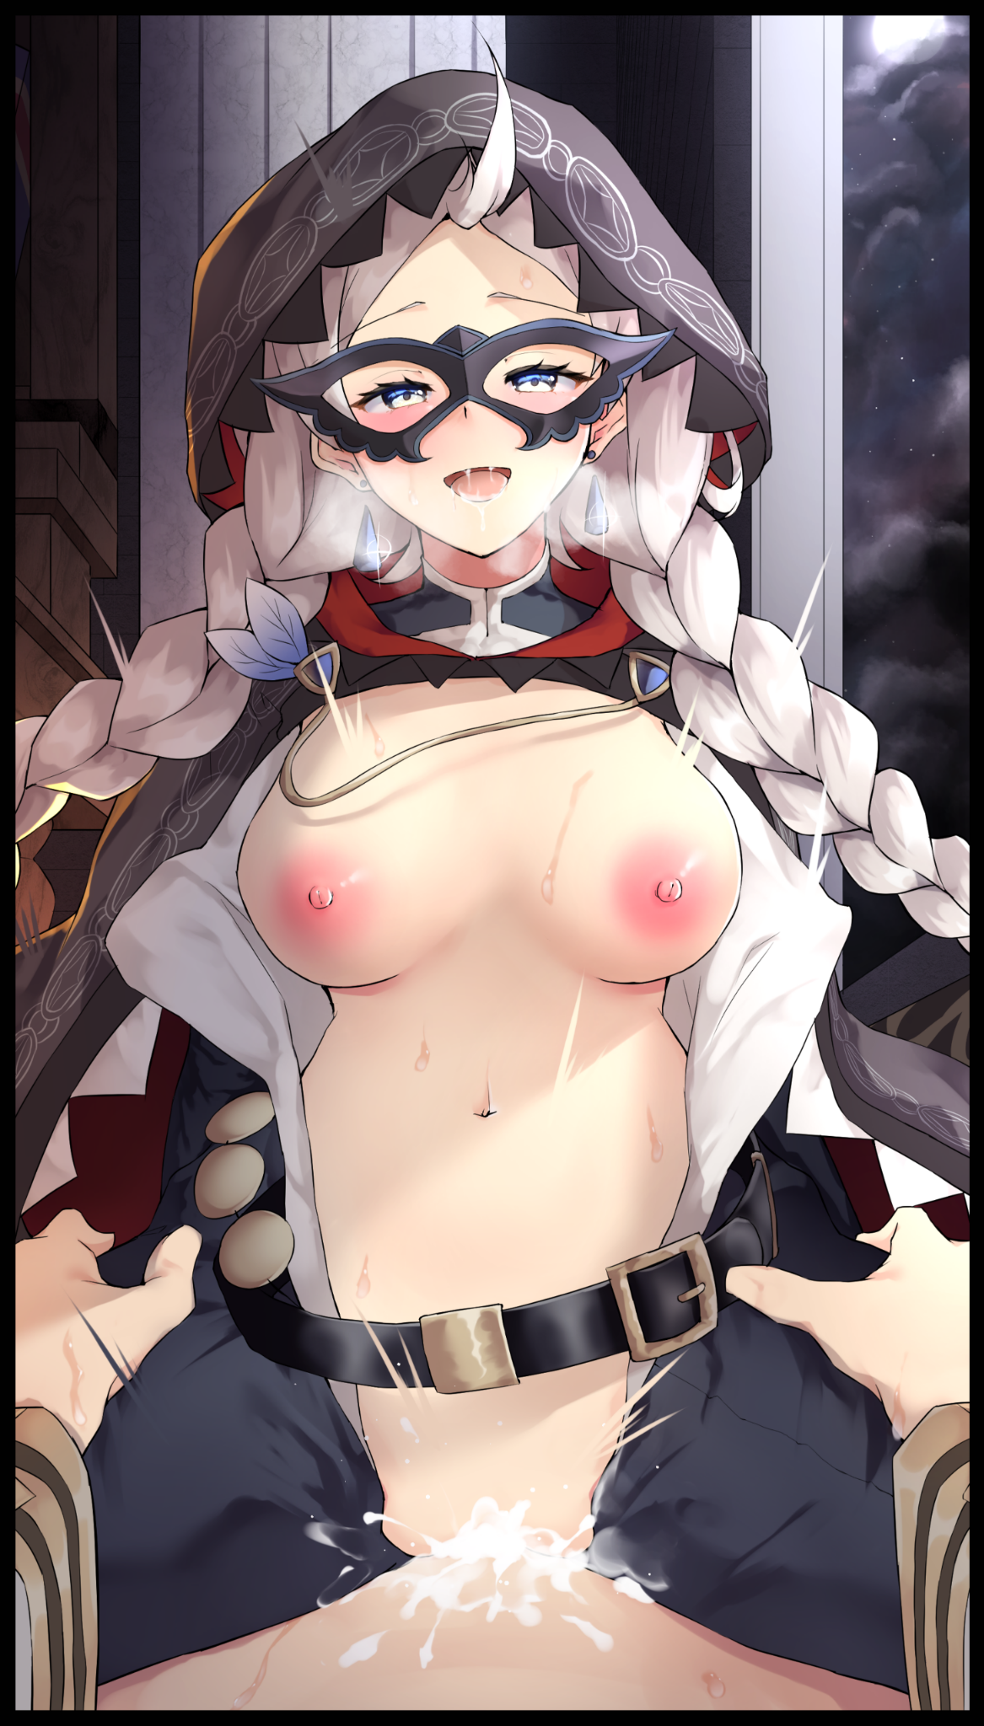
Except in this fairy tale, the main couple were not really in love with each other. Rather, the romance they were familiar with leaned more on the material side of things as demonstrated by the Hunter, a man the newborn girl now remembered as Chris, disrobing himself after pulling away from her, leaving him stark naked before his 'princess', who was already eyeing his meaty member with cross eyed cocklust, unable to stop her needy body from reacting to the sight of it as she hurriedly rips a hole through the front of her leotard, letting her pert breasts flop freely on her chest, pressing her groin into the sheets in an effort to staunch the flood leaking out from her hungry second mouth that still remembered the touch of Chris’ fingers from earlier. Earning an amused scoff from Chris as he joins her on the bed, sliding into a reclined position before she leaps on top of him, straddling him in a pale blur before he could even plant his hands on her warm thighs, the cold a distant memory now that the two were about to be joined as one in the sheets.

“Hot damn Krystal...you’re fucking wet…hope the guys out back have got spare outfits cuz you’re gonna end up burning through them right quick…”

“I told you already didn’t I Kiran? My name’s Nina…not Krystal…play along!”

“Ahh right…roleplay sex…forgot about that for a moment…maybe we should roleplay a Master-Slave dynamic? Lovey dovey stuff ain’t my thing.”

“Next time…now hurry up and let's fuck already! We’re supposed to be on shift in 10!”

The technical loss of her first time to Chris would go unnoticed to Krystal. A depraved soul who remembered so many men using her to the point where she had lost count over the years. She loved it, even more so than Mila, a common face she had shared a man or two with. Coupled with the orgasmic voice of that Slavic gal and the euphoric bliss of having a pecker lodged deep enough inside her to give her baby room a knock, and it was a guaranteed recipe to send her rocketing up to cloud nine…not to say solo sex wasn't amazing, just having Chris treat her like a cocksleeve was a good time in and of itself even if he was doing a terrible job at engaging her in roleplaying, something she usually did to get herself in the mood depending on the character she was asked to mimic by her employers for whenever they had to do big stuff like conventions.

And while Mila was kind enough to entertain her requests, the men unfortunately, weren't as eager…Laser focused on their need to satisfy themselves and nothing else…

Kevin's pain and worries had been tossed aside, traded in for the spunk and vigor of a loose woman who went by the name of Krystal, a flippant soul who couldn't care less about such things, capitalizing off of such topics as inspiration for what she could use next time she got frisky in bed with another man that definitely would be Chris, masking her personal disappointment with a giggle and a moan as he unloads inside of her…

-The Room-

“Marianne? Do you hear me?”

“I-I’m sorry sir…what did you say again?”

"The test is over…a stunning success I might add…see for yourself."

Rubbing her eyes while ridding herself of that suffocating labcoat of hers, the scientist turns her attention toward the screen without a shred of concern for the way her superior eyed her motherly bosom, inspecting the separate displays showcasing Mila currently posing for a photo out in the middle of the convention hall while Krystal Ashforth was still busy donning a new set of the expensive outfit that had been tailor made to fit her perfectly.

'How brash…if only I could be that brazen…'

He was right, the two showed no signs of relapsing into the men they once were. Taking their new identities with gusto right down to the enthusiasm they displayed towards sexual activity…something that reminded her of something she had been thinking about before dozing off earlier. Being a woman in her early forties was starting to take its toll on her endurance, and in front of her love…that was a weakness she could not afford to show.

"Looks like you really did win that bet…and I am a man of my word after all so; ask away…"

"Any question, hm? Let me think…sorry sir but…could I trouble you to come over here for a second?"

"Sure…what're you got in mind?'

Heaving a heavy sigh before bunching her hands together, Marianne turns to face her boss in earnest, fidgeting once again as hesitation claws at her chest, preventing her from delivering the one question she had always wanted to ask him, stemming from the tiny portion of her soul that had somehow made it out unscathed from the clutches of the secret device installed without her knowledge that had been powered down not too long ago. A fragment too small to remember but large enough to know her boss could not be trusted, doing all it could to stop Marianne from confessing to the falsely instilled feelings of love.

"What's wrong? You're looking stiff there Marianne…if you need some time off you can have it, I don't bite…"

"N-No! It's just…I…well…I was wondering…d-do…do you…have anyone you like?"

She had botched the question, wincing in embarrassment and mild annoyance at the minor mishap. Because even though the words were muddled, the answer might just determine whether continuing on her current pursuit of love was a worthwhile endeavor or not.

"S-Sir? What're you-eep!"

To her surprise however, her supervisor pulls her out of the chair without another word, cradling her so her fall wouldn't hurt her as he lays her out on top of him, tearing her skirt off before pulling up her suffocatingly tight shirt to give Marianne's swollen teats some much needed breathing room. Leaving her stunned to silence at the swiftness her unsuspecting boss had moved, leaving her kneeling just inches away from his own exposed privates poking at her clean shaven lips down below.

Her sky blue eyes were vapid and glassy and her brain had fallen silent from the adrenaline of being manhandled so quickly to the point where she hadn't even realized she'd been stripped of her lower garments, reducing her from a scientist in casual wear to a half naked woman who looked like she was about to sleep with her boss. And from the calm look on his face…it looked like he actually had a motive behind this stunt rather than simple lust.

"I like you Marianne…"

"Hahaha…you're…you're joking…right sir?"

"If I was, would I actually risk a sexual harassment claim by doing this to you? Don't play coy with me Marianne…you were never a good liar."

"You knew I…liked you?"

"Anyone could figure you out with a simple glance…your feelings were literally written on your face for me to see…and I'd gladly accept…"

"B-But….oh gosh this is moving forward faster than I’d anticipated!”

Watching his former lackey get all flustered at the prospect of dating the man she once felt creeped out by filled the man's blackened heart with joy. Taking the opportunity to text the person in charge of the eggheads over in his trusted Research and Development team a congratulatory message alongside a stealthily taken picture of Marianne floundering with her privates in full display, making sure to include the updated data log wired to his phone about the results of the rest, telling them to make refinements before going ahead with mass production…

And once that was sent, the victorious man tossed aside the sturdy device, planting his arms around the pudding that were Marriane's amazing thighs. Everything about her was tailor made to his specifications, making sure that nonchalant prick who he knew could become a problem sooner or later was utterly reformed from the ground up into the MILF of his dreams, aging the young man up into a bodacious single woman with a body ripe for motherhood. But there was just one thing missing about her, and he was more than happy to help his future wife through the process of making a child together.

Who knew, maybe this artificial want could one day blossom into an actual romance capable of tickling his cold, dead heart…

"Marianne…is it fine if I let you take the lead for once?"

"Sir…I…I'd be happy to!"
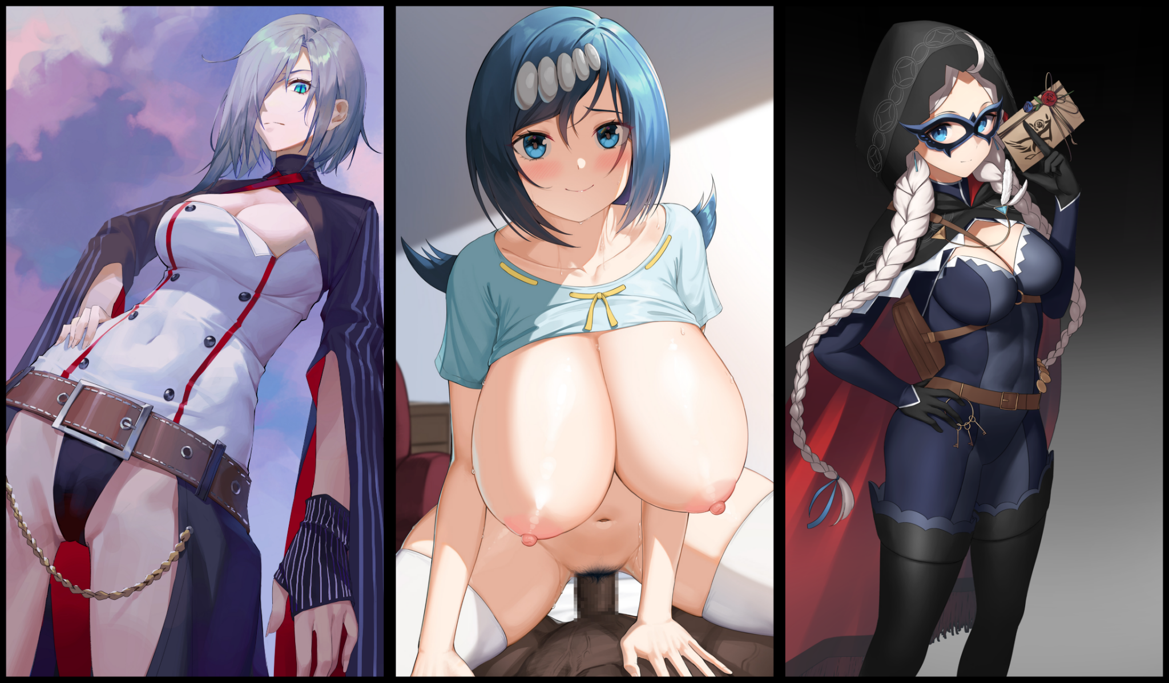
With the head of his member now well on it’s way inside the tight folds of the scientist-turned-housewife, the mysterious man’s agenda was complete; he now had with him a device capable of subverting the body and mind of anyone who would go against him and his company, just like he had done to Markus and Kevin whose only wrongdoing was being the unwitting lab rats unfortunate enough to end up in an inescapable situation where the only outcome…was change. A total reformation that left them as nothing more than loyal drones working for him, earning a pretty buck now thanks to the perversion of his other expendable lackeys. An invention equivalent to the landmark discovery of the steam engine or the first ever iteration of the conical bullet that revolutionized the firearms industry…

There were the finer things in life to enjoy however, and as he melts under the gentle embrace of his new wife, world domination could take a temporary backseat…at least, for the time being of course.

THE END

