STUCK IN SUMERU
COMMISSION STORY
BY CHALDEACHANGE
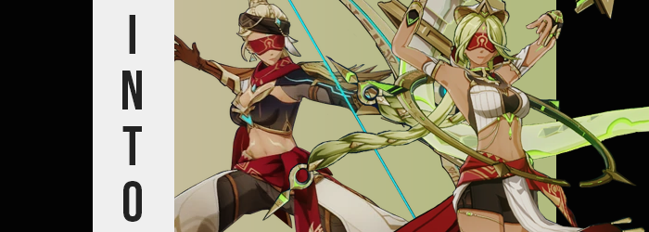

Why did video game updates take so long?

It felt like a valid question. In the modern gaming area where if a game wasn’t live service it at least received updates that required downloads in the earliest stages of its lifetime. There was plenty of debate to be had about whether or not this was healthy for the consumer – it wasn’t, but it was the way things had become – but that wasn’t what the two men chatting on Discord were discussing at that moment. Rather they were anticipating the downloads to finish.

Well, that and for the Genshin servers to open again after their lengthy maintenance. It was finally time for the next region, Fontaine, to go live. And while there would surely be plenty of ‘honhonhon baguette’ jokes to be had at this France-inspired region’s expense, Joseph and Axel were more excited for the story and world exploration. For better or for worse the world traversal, the discovery, and all of the battle that could be experienced in between were just as much of a draw as the main story.

Still, Sumeru was pretty amazing. Axel had remarked via Discord midst their conversation about what was to come. Sumeru had been a vibrant region composes of jungles, desert, and caverns that all held intriguing secrets. Not to mention the enemy designs being top notch, especially the Eremites. Neither Axel nor Joseph realized in the moment that their conversation was being watched by a certain nekomata with a penchant for mischief.

She was just waiting for the right moment. A moment that was provided courtesy of Joseph. I almost wish I could just stay in Sumeru though. I still have a lot to do… Wait why was that text underlined? He hadn’t hit a shortcut to do so. Unfortunately it wasn’t a question that neither of the two were able to answer, because the next they knew?

Well, to quote a famous movie. They certainly weren’t in Kansas anymore.

The change in temperature was immediately noticeable to Joseph but it wasn’t what he had initially fixed his attention on. Having been sitting at his desk just seconds prior, it was a shock to then find himself sitting on a fallen tree surrounding predominantly by sand. It would have all been sand if not for the small oasis that rested about ten feet away from him. “Uh… What just…?” He was understandably speechless and he certainly wasn’t dressed for the desert – which this location was clearly in the dead center of.

“Wait, no way this is Sumeru, is it?” Considering it was just an expanse of desert it was hard to say. Or at least it had been initially up until he saw a certain crocodile-like creature in the oasis nearby. A beast he had only ever seen in Genshin Impact. He wanted to make a bigger stink about this situation but it was way too hot standing up in the sun. The heat was fatiguing. “If only I had some relief… I wonder how far the nearest settlement is?” Or at least a cave. He’d worry about his situation once he was no longer in any danger health wise.

Little did he know there were plans to alleviate that issue, however.

As for how, there were subtle signs even just moments after he had arrived in the desert. They just weren’t in places that Joseph would have taken a particular notice of. The already olive pigmentation of his skin was one of them, for the subtle greenish tone that made the ‘olive’ part of it, well, olive eventually waned entirely. His skin remained dark, but it was a much more orangey-brown tan that was fuller in places. Even the brownness of his nipples was more apparent.

Similarly it seemed that most of the earliest changes dealt with coloration, ultimately almost turning him into a player 2 variation of himself when all was said and done. The man’s hair and eyes alike lit up with a pale and yellowish green that was similar to how plants appeared as they were drying out. As his hair didn’t grow or anything right out of the gate, it was impossible for him to notice.

“At least it seems like it’s cooling down…”, he remarked, unaware that things felt cooler because his complexion had adjusted to this heat. A lighter hair color certainly helped too, but the natural tan of skin that was now also softer to the touch was what was alleviating things more efficiently. It was still extremely hot beneath the desert sun, but it wasn’t really bothering him as much as it had been. “Should I get a drink from the oasis before I set out? Probably…”

All Joseph had to work with was a vague memory of the Sumeru desert map if this really was Sumeru. He’d caught sight of monsters that he wouldn’t be able to deal with in his current state, but oddly? That thought hadn’t really crossed his mind. On some fundamental level it was like his mind had already accepted he would be able to deal with them.

In fact his body was in the process of conforming to the confidence he unknowingly felt. Any excess weight upon his body practically melted away so that the vague muscle mass he already had stood out more keenly. But the impression they left grew because those muscles themselves grew. Arms and legs became more toned, an eight pack was engraved in his tummy, and yet? He didn’t grow bulkier. His body was still left lean, and his waistline seemed even narrower than it had been prior.

On some level? Joseph did notice. Each step he took upon the sand felt easier and more comfortable. This was helped a little because he stepped out of his shoes unintentionally, if only because his feet were now smaller with tinier toes. Yet he didn’t step onto the bare sand barefoot. Sandals covered his soles and while toes (now painted with a light green paint on the nails) were exposed, the sandals wrapped up the front and back of his shins.

“Hmm… How am I doing for time?” Time? Since when had time been an issue here? Yet the man felt like he might be late for something if he didn’t set out soon? This remark was made as his steps forward became increasingly pronounced. Hips swayed in a more accentuated manner because there was more of his hips to accentuate. They had parted several inches wider than they’d been before.

More than that, the rise and fall of his ass cheeks became rhythmically seductive. Each rise and fall saw them inflate with more mass, but not enough that their new muscular shapes were completely lost. The excess bled into inflating thighs, and between his rear and legs? It almost seemed as if he might burst out of his pants. Fortunately he didn’t, but only because those pants seemed to unravel all their own, revealing brown short-shorts above golden chains that hugged his right thigh.

There was a notable bulge in his shorts, but… not for long. “Mmn…” A hot and sensual moan escaped her lips with her next step, the bulge in her shorts flattening in the meantime. It wasn’t difficult to understand why. Her sex had changed, green pubes becoming a wild and unkept mess above the woman’s new pink pussy. This allowed her thighs to rub against each other without any discomfort and her tight shorts now fit perfectly. Even crimson cloth had tied itself around her narrowed waist, bound to a belt while a cream colored banned fell down the front.

“Yes, I must fill my canteen.” Joseph’s voice better matched her new sex now. It was deep and almost maternal sounding in its femininity, yet there was a thick accent communicated with a deadpan that wasn’t typical of her usual personality. She almost sounded, and looked, unnaturally calm. Though her head was changing to match her altered sex as well.

The words she cooed met some unusual natural resistance – her lips, which had swollen substantially so they were thick, albeit cracked and dry from the desert heat. The shape of her head shrunk smaller and rounder, and her green eyes seemed fuller yet narrower simultaneously as lashes doubled in length beneath thinned green brows. There was no denying she appeared racially different, though that race went by a different name in the world of Teyvat.

Her vision was obscured, prompting her to blink several times as lashes danced against a new, crimson visor wrapped around her eyes. But as quickly as she’d been blinded her vision was restored despite her gaze being obscured physically. If anything, the temporary absence of sight allowed her green locks to spill out dramatically both behind her and in front, with lengthened bangs parted to the sides as the hair in the back weaved itself into a pair of braids. A pair of braids decorated with a gold and green dagger at the end while a matching headdress settled on her head.

She wasn’t even thinking about her circumstances now. That much was obvious by how she dipped a canteen in the oasis – a canteen that had only just appeared in hands now wrapped in fingerless gloves. So it went without saying that she hardly noticed how her shirt was lifting, forced to wrap around a swelling, bouncing softness atop her pecs. E-cup tits stood proud before long, and her top shifting into a cream top with a low neckline that was designed to push her tits up certainly helped.

While her green eyes were now masked by the standard Eremite blindfold, Nayla the Floral Ring-Dancer did not technically have her vision obscured at all. She could see perfectly through the crimson cloth thanks to an enchantment placed upon it. “Mm… I suppose it is about time move back to camp. Surely she will berate me if I’m late.” Tossing the weapon ring that had spawned in her hands into the air, it disappeared into a pocket space from which she could summon it when needed and turned her attention to the path leading away from the oasis.

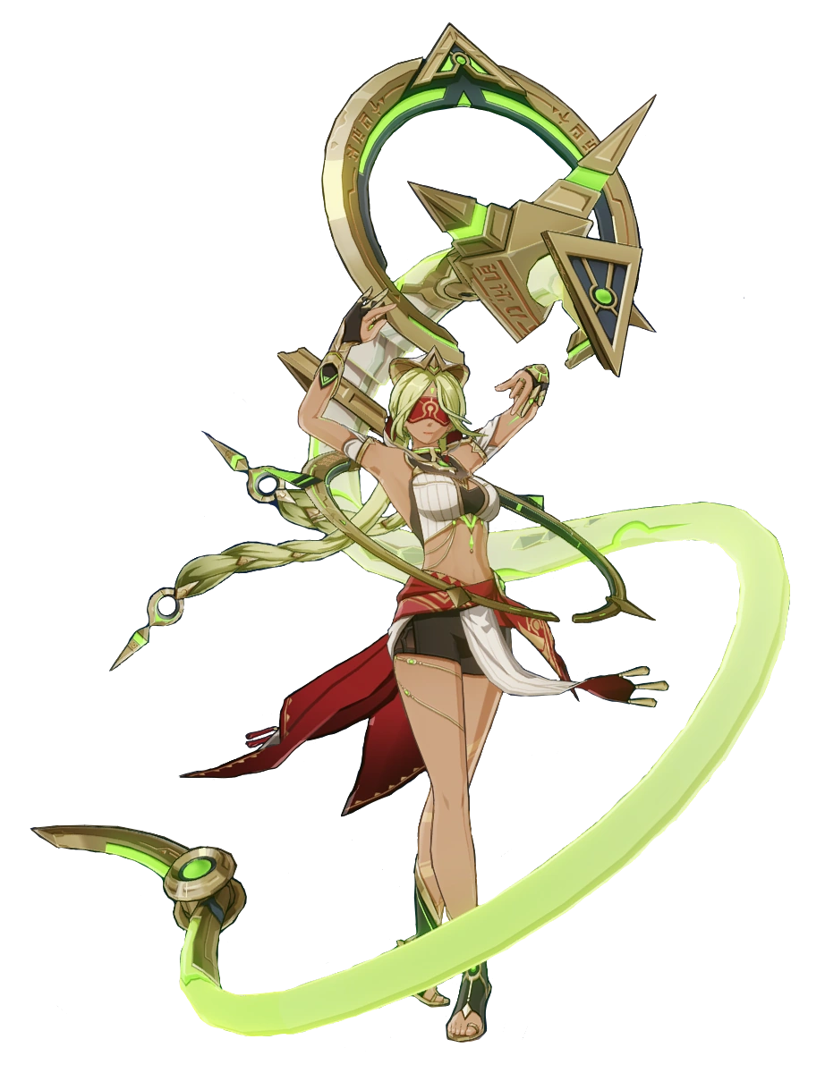
Nayla was a high ranking Eremite in her mercenary faction that was known for both her strength and beauty. But it was a reputation she shared with another. There was a Galehunter in their group with whom Nayla had a strong rivalry. Both had the affections of their people and liked to butt heads, but at the same time it wasn’t unusual to find them fucking their fellow warriors – sometimes even each other.

The woman knew the way as she set out into the desert. Despite being a ‘dancer’ she had a very serious personality, smiling largely only when she was dancing or in the bedroom. “Perhaps I will make it back by sundown. I wonder if anyone would be interested in scratching my itch when I return?” Staring up at the sky for a moment, she couldn’t help but think about it.

How much fun it might be to dance upon someone’s naked body that evening.

Unfortunately for Axel he hadn’t ended up in a very similar situation to what Joseph had – but it wasn’t exactly the same. While his friend had appeared in the Sumeru desert in the middle of the day, it was clearly late evening at the time he had arrived. He also wasn’t in the middle of the desert but in a quiet corner of what seemed like a large camp. With weapons littered everywhere he knew better than to make a scene, and instead hide in one of the doorless tents nearby.

“Is this an Eremite camp? I should’ve know that she would… she…?” Whispering to himself, for a brief moment Axel felt like he understood how he had ended up in a place that was clearly Sumeru’s desert in Genshin Impact. He recognized the scenery and the Eremite camp’s design. He’d infiltrated plenty of them during his time in-game after all. But he had forgotten? Who had sent him there? Why? “Did I actually know?” He wasn’t actually sure.

Evidently his memory was already being altered before his body had begun to follow suit.

Axel had been a much heavier guy than Joseph, and so to become someone worthy of surviving this dangerous desert it was that physique of his that needed to shift first and foremost. And it changed quickly. Just pacing uncertainly around the tent saw the pounds peel right off of him, a bulging tummy becoming compact in just a matter of seconds, excess weight shaved from his arms, legs, and face as well.

Such a dramatic loss of weight while dressed for a man of that size obviously drew his attention. “Huh!?” Because his jeans fell right from his waist and his shirt was as loose as a tent around. The man’s boxers survived only because he’d managed to grab them in time – the possibility of showing off his pale ass and balls to an Eremite who didn’t even know he was there probably wouldn’t have been a good risk to take. “What happened to my…? I’m so thin!?”

He used the hand that wasn’t holding up his boxers to lift up the bottom of his skirt, allowing him to see firsthand how his chest and stomach were tightening further. His muscles grew big and strong, arms and legs following suit as before long there was a great deal of power to his form. Yet as had been the case with Joseph, there was a growing feminine shapeliness to his body’s design. His narrowed waistline was part of it, but his hips had flared out too.

At the very least he no longer had to hold up his boxers since they were caught on those wide hips.

“This can’t… I’m so… Of course I’m strong!” Axel had taken full notice of his changes up until that point, but as indicated by how he’d blurted out his acceptance with a rough but womanly voice, it was becoming difficult for him to note them at all. The lips through which he had blurted had become more pronounced in size in the meantime, his facial design becoming slender with a sharp jaw beneath a more pronounced nose. Eyelashes grew longer around a narrowed gaze of an almost teal blue, and before long he looked more like a woman in her late twenties. Racially it looked similar to Nayla’s.

A smirk seemed to be his passive resting expression now. But the man felt oddly proud of himself, more notably his strength. In exchange though? Knowledge of modern technology had all but fallen out of his head in tandem with his dark hair lightening to a sandy blonde. This hair lengthened, pulled up into a long ponytail behind him while a visor wrapped around his own eyes. “Hah! I’m feeling very good!” The accent he spoke with might have been a touch thicker than Nayla’s too.

With his chest puffed out, he paid no notice to how his chest… was literally puffing out. Pectoral muscles were promptly obscured by the rising of a pair of firm and perky F-cup tits. Their shapes were left highlighted as his shirt tightened and shortened, becoming a brown, leather crop top with an impossibly low neckline and a gem matching his new eye color fastened directly between both tits. Arms were soon wrapped in leather gloves and armguards, concealing the now extremely calloused fingers beneath them.

“Mmn! Frisky, too!” She moaned in response to her masculine sex folding into the feminine, her pussy twitching from the need prompted by their sudden change beneath her lengthy, blonde bush of pubes. The surrounding areas of the woman’s body changed accordingly. Now that she was biologically a woman everything else more or less fell into place all on its own.

Her thighs made use of the additional width between her hips now (as well as the lack of a dick between her legs) and expanded gratuitously. Their muscular tone could still be observed beneath the softness, but the fact that they were rather plush was still clear. The same could be said of an ass that tripled in size, boxers yanked in between their cheeks before the underwear became a crimson thong.

Not that it was visible for long. The pants that had fallen from her hips near the transformation’s beginning were pulled back up by an invisible force. Now grey and cream colored, with the cream sections puffier than the rest, brown boots with pointed toes conceal her changed tootsies in kind as well. Throw in a diagonal headband across her sandy blonde hair and she looked like an Eremite that dealt with archery.

Well, the overly calloused fingers had foreshadowed that anyways.

Last but not least? Her skin color changed. Melanin greeted what was once so deficient that it was almost ghostly pale. Little by little a tan bled in, yet white markings were tattooed against her exposed abs. It wasn’t a tan that was as dark as Nayla’s, but it certainly wasn’t the natural skin color of a Caucasian person… or this world’s equivalent.

Lunja the Galehunter clicked her tongue as she adjusted the crimson visor over her sky blue eyes. “How did that come loose? I suppose since I move around so much…” Her muscular body glistened with fresh sweat, the woman recalling having just returned from a successful hunt. With her bow and familiar it was easy to secure food for her people, and it was part of the reason the mercenary group she sat in near the top of loved and respected her so much.

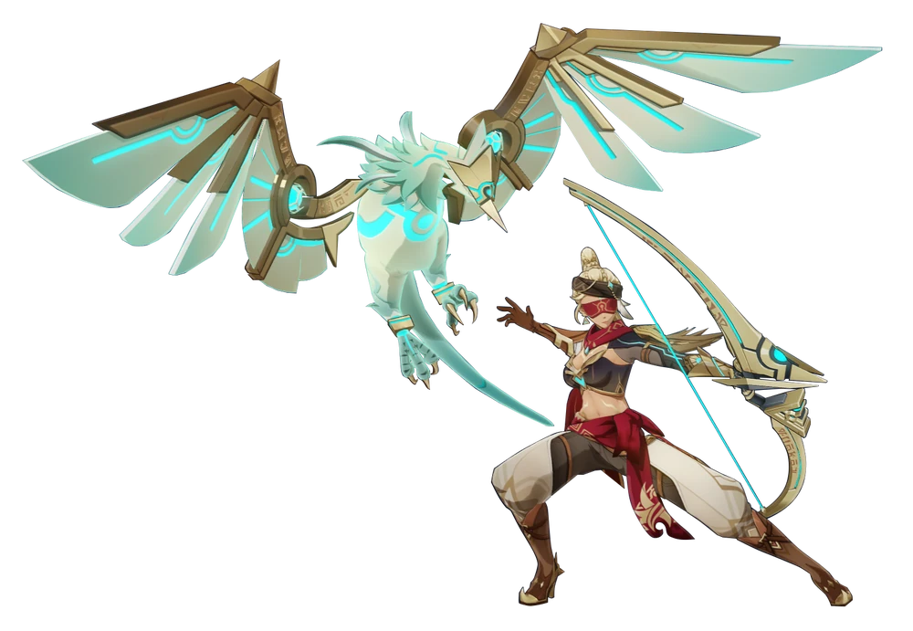Even if she was something of a strength freak. She was always pitting her strength and stamina against others, especially in the bedroom. It was part of the reason she had such a complicated relationship with Nayla. “Hmph! I’d love to go another round with her! Hahaha!” Lunja was as loud and boisterous as she was strong, and it wasn’t all that difficult to find her completely drunk late at night. Part of the reason she didn’t exactly get along with Nayla, who was more prudish and reserved in that area.

“Another round? I don’t recall having gone one with a beast like you, Lunja.” And speaking of the devil, it was Nayla who had strut up to her tent from the path leading into camp, her bronze body glistening with a day’s worth of sweat beneath a nearby torch’s light. She had spoken in deadpan but wore a mischievous smirk. She was trying to get under Lunja’s skin.

The Galehunter just clicked her tongue once more. “Hm!? Are you saying it wasn’t very memorable!?” No, she had known this woman since they were children. She understood the true meaning, something that was in the spirit of their people. Nayla had just issued her a challenge, one that Lunja was keen on taking her up on as she grabbed the Ring-Dancer and pulled her in for a deep kiss.

Which of the two would come out victorious on this night?

Both of them, probably.

