The Scent of Studliness
By Soul-Controller

When Martin first signed up for a gym membership at a brand new local gym, the Mexican man had originally planned to use the facilities to get rid of any remaining fat on his body and replace it with muscle so he could finally have the jock body of his dreams. This plan worked for a bit, but the top of the line machines of the brand new gym soon drew in a brand new form of clientele - aspiring bodybuilders. In the span of a month, the formerly dead and quiet gym became overrun with cocky hunks who had biceps larger than Martin’s own head!

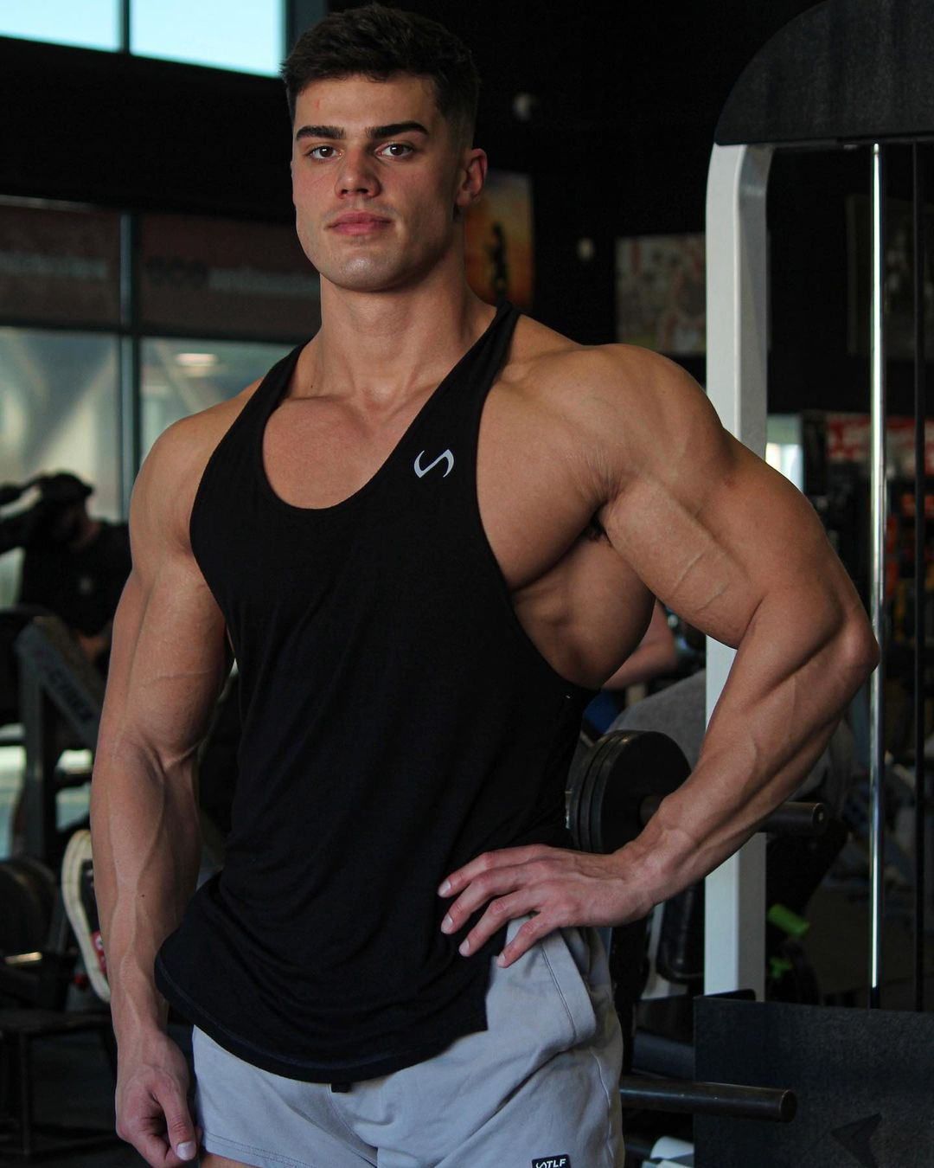
As a result, the 24 year old couldn’t help but grow increasingly self-conscious due to just how much he stood out against the gym’s brand new members. It seemed as though the other bodybuilders around him also picked up on this stark difference as Martin soon found himself constantly dealing with taunts and disparaging remarks from the hunks who were more than willing to put the man down in order to get him to leave their desired machine.

Although he had fairly tough skin due to being bullied back in his high school years, there was something about the brand new torment from a jock named Alex that constantly left Martin fighting back tears. Not only was the man insanely buff, but the man’s deep and intimidating voice loved to hurl insults Martin’s way that were extremely personal for no reason. Much to Martin’s annoyance as well, but Alex was incredibly hot! In fact, his obvious thirst for the man left Martin wondering if Alex was homophobic and decided to be especially cruel after picking up on Martin’s longing stares.

So once the weekend ended and Martin headed into the gym after work on Monday, the man was mentally preparing for more issues to arise between himself and Alex. So as he made his way into the locker room and suddenly heard Alex’s deep and booming voice fill the empty space, Martin suddenly stopped dead in his tracks.

“Nah, fuck you bro! I’m not gonna let some fat ass loser talk to me like that. Get ready for the ass-beating of your life!”

With his curiosity piqued about who Alex was speaking to (along with his relief at knowing that he was escaping the man’s wrath for the day), Martin quietly shut the locker room door and began to pace past a series of lockers to both hear and see the debacle better. Walking on tiptoe, the man successfully avoided alerting anyone of his appearance and was able to get a spot just a row of lockers away from the confrontation.

Peering his head slightly around the corner, Martin’s eyes narrowed as he attempted to figure out who the sweaty jock was talking to. Upon hearing the mystery man begin to speak though, the man quickly realized that Alex was cussing out the slightly overweight gym janitor. From what he could recall the man had always been super sweet whenever he talked to Martin, so the Mexican man had no doubt that Alex was exaggerating and being cruel for no reason.

“I don’t think you’ll want to do that, sir. If you so much as touch me, you’ll severely regret it.”

Upon hearing the meek janitor speak, Martin’s eyes widened at just how unfazed the man seemed to be by Alex’s threats of violence. If only Martin had an ounce of confidence that the janitor had! Unfortunately, it seemed as though the janitor’s words weren’t convincing enough as Alex chuckled.

“Oh yeah? What are you going to do about this then,” he asked, moving closer to the overweight janitor and extending a finger out.

As soon as he watched the man’s thick finger prod at the janitor’s flabby chest, Martin was expecting a big brawl to suddenly break out in the locker room. But out of nowhere, Alex let out a deep groan as his eyes suddenly rolled back and head slumped forward. Despite his clear shock at what he was witnessing, Martin refused to make a noise in fear of somehow alerting the janitor of his presence. This became a rather difficult task though as a loud ringing suddenly filled the locker room. Cringing in pain, the man cupped his ears from the high-pitched screech while continuing to stare at the jock.

Out of nowhere, a loud pop filled the room and the noise disappeared in an instant. As soon as the pop occurred, Martin’s jaw dropped as he watched Alex suddenly disappear. But as he continued to stare in their direction, he quickly realized that not everything had disappeared as the man’s sweaty workout clothes remained levitating in the air. After rapidly blinking his eyes a few times to verify that his mind wasn’t playing tricks on him, Martin watched as the janitor suddenly snapped his fingers and the clothing stopped levitating. As the snap finished echoing around the room, the clothes suddenly fell to a heap on the floor, causing the janitor to victoriously chuckle.

“Serves you right, you goddamn prick,” the janitor exclaimed, smirking as he leaned against a locker and stared down at the pile of clothes. “Looks like those muscles of yours didn’t come in handy huh? Now you’re just a discarded pair of clothes with no way to turn back.”

Despite the shocking sight he had just witnessed, the gym novice mentally forced himself to remain as quiet as possible. There would be nothing worse than somehow getting found out by the janitor and receiving a similar fate to Alex! So after holding his breath for several moments and remaining hidden in the corner, Martin was relieved to successfully avoid detection as he heard the janitor’s footsteps grow more distant just as the sound of the locker room door opening was heard.

After waiting a minute or so to verify that the locker room remained entirely silent, Martin finally forced himself to move out of his hiding spot and observe the fate that had befallen his jock crush. Upon making his way over to the area of the confrontation, the man tilted his head downwards and found himself looking at the two lone pieces of clothing strewn about on the floor. As he continued to look at the tank top and gym shorts, Martin was suddenly overcome with an urge to grab the clothing and inspect it. Given the fact that the janitor had said that the clothing was actually the real Alex now, the novice was quite intrigued to inspect the jock’s new form.

As he grabbed it and held it up to his face though, Martin found his inner kinks emerging in their full glory. The man had an intense kink for sweat, with his mind having countless fantasies of being forced by a jock to shove his nose into their sweaty pits and take in the ripe odor. Although this situation wasn’t at all similar to his fantasies, the prominent scent of Alex’s sweat was just as he had always envisioned it. So after checking to make sure that there was no one around to observe him, Martin gave a slight smirk before shoving his face deep into the damp fabric of the clothing.

Allowing the hunk’s sweat to pass through his nostrils and enter his body, Martin had no way of knowing that the still-potent magic that had just transformed the bodybuilder was having an unintended side effect on him. With each inhale he took from the sweaty clothing, the man’s average body was undergoing a drastic transformation as the magic was transferring Alex’s physique to Martin. As the man’s nose started its exploration on Alex’s shirt, Martin was oblivious to the fact that his upper body was transforming in severe ways. All at once, the man’s body was exploding with muscle growth, shifting the man from a novice to an avid gym goer in seconds. As he continued to sniff, the man’s shirt was suddenly facing intense stress to the point where the seams were suddenly tearing. With Martin now in possession of softball-sized biceps along with a wider torso due to his brand new lat muscles and prominent pecs, the seams eventually gave and filled the room with a loud popping sound. Despite the loud disturbance and discomfort of his tight yet tattered clothing, Martin remained completely oblivious to what was occurring to him.

Once the man’s slightly flabby lower torso disappeared and a prominent and well-defined six-pack of abs had finished growing, it seemed as though the sniffing of Alex’s shirt had finished providing all of the possible transformations for the young man. Luckily though, this was perfectly timed as Martin decided to stop sniffing the shirt and shift his attention towards the sweaty gym shorts.

As Martin observed the soft fabric for a second though, he noticed that sweat wasn’t all that was on the shorts as he noticed a wet spot on the front of Alex’s shorts. Upon leaning in and sniffing the area, Martin let out a slight gasp as he picked up on the salty scent of pre-cum. With the man considering the possibilities of Alex either getting turned on from his workout or the transformation that was occurring to him, Martin’s horny mind went into overdrive as he rapidly shoved his face directly into the wet spot.

With his eagerness to take in every morsel of odor from the shorts, Martin’s transformation to his lower half occurred even faster than his upper body. In an instant, the man’s legs were inflating to unimaginable proportions just as his calves were becoming thick bundles of muscle. While the man’s legs were undergoing their transformation, Martin was oblivious to the fact that he was gaining nearly a foot in height as his legs and torso were suddenly lengthening to inherit Alex’s 6’4” stature.

Now that his legs had finished their transformation, the man’s ass and cock began to undergo their changes in tandem. All at once, Martin’s formerly flat ass suddenly became a thing of the past - gaining two prominent ass cheeks that filled out his size medium shorts with haste. The man’s shorts soon underwent further assault as Martin’s cock and balls began to grow more and more prominent. With his dick suddenly snaking out until it became a perfect replica of Alex’s 8” manhood, the bottom of his shorts soon had a lot of weight to carry as a heavy scrotum with golf-ball sized testicles emerged to complete his lower body’s transformation into Alex.

With his body now a complete replica of Alex’s former bodybuilder-level physique, the connection between the clothing and Martin was becoming stronger than ever. Now that the man had fully indulged in his kinks for sweat, random thoughts began to quickly manifest into Martin’s mind - this time telling him to pull the clothes on and wear them. Although there was a slight moment of trepidation knowing that the clothes were the real Alex, Martin was unable to resist temptation and began to pull the clothes on.

As the man quickly stripped down out of his tattered clothing until he was fully nude (a random impulse made him eager to free-ball in the athletic shorts), Martin wasted no time pulling on the shorts. Once the shorts passed his prominent calves and thick thighs and stopped around his waistline, the man couldn’t help but smirk as he felt how great and form-fitting they were around his cock and ass. Despite not having any idea what was occurring to him as his skin was lightening to turn him Caucasian, Martin was adoring the way the cold sweat of the fabric was aligned flawlessly against the crack of his prominent ass cheeks and how the pre-cum stain on the shorts was perfectly lining up with the thick bulge that was now filling out the fabric.
Encouraged by just how great it felt to wear the shorts, Martin wasted no time grabbing the compression shirt and beginning to pull it on. While the man was most excited to lift his arms up once he finished putting it on and smelling Alex’s sweaty scent around his armpits, Martin had no way of knowing that the wearing of the shirt initiated the final changes. The first stage of this final act came in the form of physical changes, as Martin’s average features were quickly altered to become a perfect replica of Alex’s. As painless cracks in his jaw gave way to a wider and more prominent jawline, the man’s nose, eyes, and lips were also changing in severe ways. While the position of his eyes changed just as his lips began to inflate as if each one was the victim of a bee sting, the man’s nose and eyebrows soon became the most noticeable features on Martin’s new face. This was due to the widening and thickening of each area as Martin gained Alex’s perfectly shaped nose along with the man’s dark and bushy eyebrows.

Beneath the man’s skull though, the magical garment was quickly transforming every aspect of his mind. Although there was no complete personality shift to turn him into Alex in both body and mind, there were still severe changes to Martin’s personality to make him the perfect amalgamation of both men. Due to Alex’s prominent knowledge of fitness routines, counting calories, and diets, it quickly became clear that something would have to be sacrificed to allow all of that knowledge to transfer to Martin’s at-capacity brain. The magic of the clothing was quick to elect his video game skills along with all nerdy facets of Martin’s personality such as his intelligence to be erased to give him Alex’s bodybuilding info. Although that meant that he would become a stereotypical himbo given his newly dopey mind, it was a worthy sacrifice so that physique wouldn’t go to waste now that it was inherited by Martin. As reality further altered to make it so Martin was the bodybuilder hunk from now on, the man’s age was changing to where he became 22, the midpoint between the two men’s original ages just as Martin’s homosexuality and Alex’s heterosexuality was combined to turn the new man into a bisexual hunk.

So once the shirt was finally pulled over his head and in place, the apparent haze that was temporarily over Martin’s mind was lifted. Due to this, the man was understandably shocked as he looked down and noticed the brand new bodybuilder physique he had. Upon pulling off the tight compression shirt, the man couldn’t help but spend the next several minutes admiring his muscles. Although he knew that this wasn’t how he originally looked, the magic of the clothing had erased the entire transformation from his mind, making it so that no memory of Alex or his transformation into clothing existed.

With this slight confusion eventually emerging in his head, an intense migraine suddenly emerged for Martin. Needing to think quickly, the man took note of the stain of pre-cum in the front of his shirts and smirked as he realized what he needed to do. Whenever his himbo brain was being strained, there was nothing that provided more relief than slipping his hand beneath the waistband of his shorts and rubbing one out!

So as he went through with this and began bucking his hips as he felt himself rushing towards orgasm, the post-nut clarity would fully erase the experience of his transformation and thus remind him that it was time for his daily workout. Although he was looking forward to showing off his ripped physique to the countless people who couldn’t resist staring at him, there was this random fear that he had towards the awkward and chubby janitor that he always bumped into at the gym. He didn’t understand why, but he felt like something bad would happen if he bumped into him…

