Father of the Bride
A Vignette
By Maryanne Peters

“Dad has every right to bring a partner to my wedding, having paid for all of this,” said Sonia, waving her hand around the reception area. There were hours to go before the ceremony, but they had already been to the hairdresser and she wanted a final inspection of the facilities.

“But I had no idea that he was bringing a man as his escort,” protested her mother Margot.

“It’s ‘she’ Mom,” said Sonia. “And she is bringing a man. Five years on and you are still using the wrong pronoun.”

“It still seems wrong to me,” muttered Margot. The truth is that she had not seen her ex-husband since a few months after their separation, and before the start of the ‘transition’, so she still had an image of him as the man she married. She had treasured that image. This wedding was bringing back to her the memories of her own wedding. Happy memories forever besmirched by a divorce that she never wanted.

She wondered: ‘if only I had said that I could accept his desire to dress as a woman, maybe we could have stayed together’. But she could not accept that. She had screamed and wailed. She had married a man, not this creature. For Margot it was as if this woman Julia had stolen her husband Justin. Or worse still, she had murdered him in cold blood.

Sonia stood in front of her and took her hands. She looked at her squarely and said: “Now, Mom, Dad is coming here with Brad to meet you in a few minutes, well before the ceremony, so that any issues can be sorted out now. This is my wedding day and I want it to go smoothly. Now Dad has agreed to be low key. She has agreed that Dan can walk me down the aisle, although that’s not really a brother’s role. Dad will not make a speech, if you don’t. She just wants to share my day, and I want her here.”

Every use of the pronoun seemed to stab into Margot’s flesh, even after five years.

A what kind of person would this Brad be? Some kind of pervert interested in dating drag queens? Was he the kind of person who should really be attending her daughter’s wedding? These were the thoughts racing through her mind as she checked herself in the mirror. She approved of her own look.

She heard her daughter excitedly addressing her father in the garden outside: “Dad, it’s great to see you.”

A voice introduced Brad. Was it his voice? It was a woman’s voice, and yet, it was him. A voice that she had not heard for years. A voice she once longed to hear. A voice that had spoken to her so many times, of love. But now it was high and soft, and not him at all.

The muffled voice of a man. Her daughter saying: “I am so pleased to meet you Brad. Thank you so much for coming.”

‘Well, here goes,’ thought Margot. It was time to make an entrance. To sweep into the room and face this ugly stranger in lipstick, who had once been her husband. So, Margot walked out into the garden.

She was immediately confused. There was a woman in the garden with her daughter. And behind the woman a tall handsome older man. The woman was wearing a simple white dress, above the knee revealing shapely legs, and was low cut to show of a fulsome bust. Her blond hair was piled on top of her head. She was looking at Margot with a smile. A cheeky little suggestive smile on those pink painted lips. As if she knew Margot. And the eyes, delicately made up, were somehow familiar.  “Justin?” Margot asked.  “It’s Julia now,” the attractive woman replied.  Margot’s mouth was gaping like a fish on the floor of the boat. She could only say: “The hair?” | 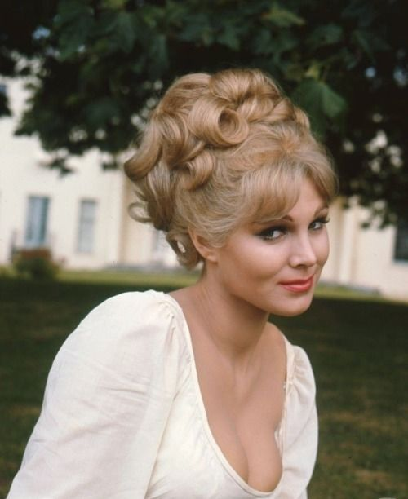

“Do you like it? A girl has to have an occasion for a do like this.”

Margot suddenly collected herself. This was the woman who stole my husband. She snarled: Why would you wear white to a wedding?”

“Well,” came the reply: “When Sophie told me she was wearing pink, I thought: What is a wedding without white. And I suppose I was suggesting to Brad that I might look quite good in white.”

Suddenly Margot felt very dowdy.

The End

© Maryanne Peters 2019

