DRAGON’S BLESSING
FEBRUARY 2022 REQUEST STORY
BY CHALDEACHANGE
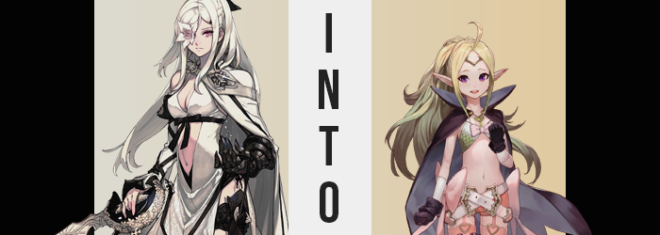

“I keep telling you to stop rolling around in your own shit!”

“BUT ZEROOOOOO!”

If you hadn’t been able to perceive what was happening, you might have assumed that that this exchange was between a very crass mother and her son, what with the nature of the words being thrown about. The truth of the matter was, well, kind of like that? The child’s voice was that of a young dragon named Mikhail, one who had a penchant for getting into trouble as all younglings did. He had been rolling around in the mud outside of the hut that his partner was living in temporarily.

And it was that partner that had yelled at him in the first place. As you could probably anticipate from the fact that she kept a dragon as a companion, this partner was no regular individual. In fact, Zero was anything but. An Intoner, a being akin to a goddess, her circumstances were far more fantastical than those of any human’s. They were far more tragic, as well.

A woman with long hair of white and soft pink eyes. Well, the left one was clearly pink. But the right? A white flower grew out of it mysteriously, intrinsically linked with the very nature of her own existence. For all Zero might have yelled at Mikhail, because in her mind he was a complete and absolute idiot, she really did care about him. That said, since he’d pissed her off again she’d slunk back into her hut to take a nap before they headed off to the next mark on their journey.

She had some sisters to kill.

It was complicated.

Mikhail knew that Zero cared about him too, but that didn’t mean it hurt any less when she scolded him. Even now, he was sulking in the mud pit he’d been rolling around in, mumbling to himself. “It’s not fair sometimes! Zero doesn’t know what it’s like…” Not that he would ever dare say this to her face. Not unless he wanted to get turned into a dragon-kabob.

Bonded as they were, there was still a fundamental disconnect in their partnership because while he acted with understanding towards her, that specific respect wasn’t exactly mutual. And so, along those lines, the young dragon clumsily made a wish that he hadn’t expected to be answered. “I wish she understood what it’s like to be a young dragon better!”

And beneath the muds he had occupied, a stone in its depths began to glow.

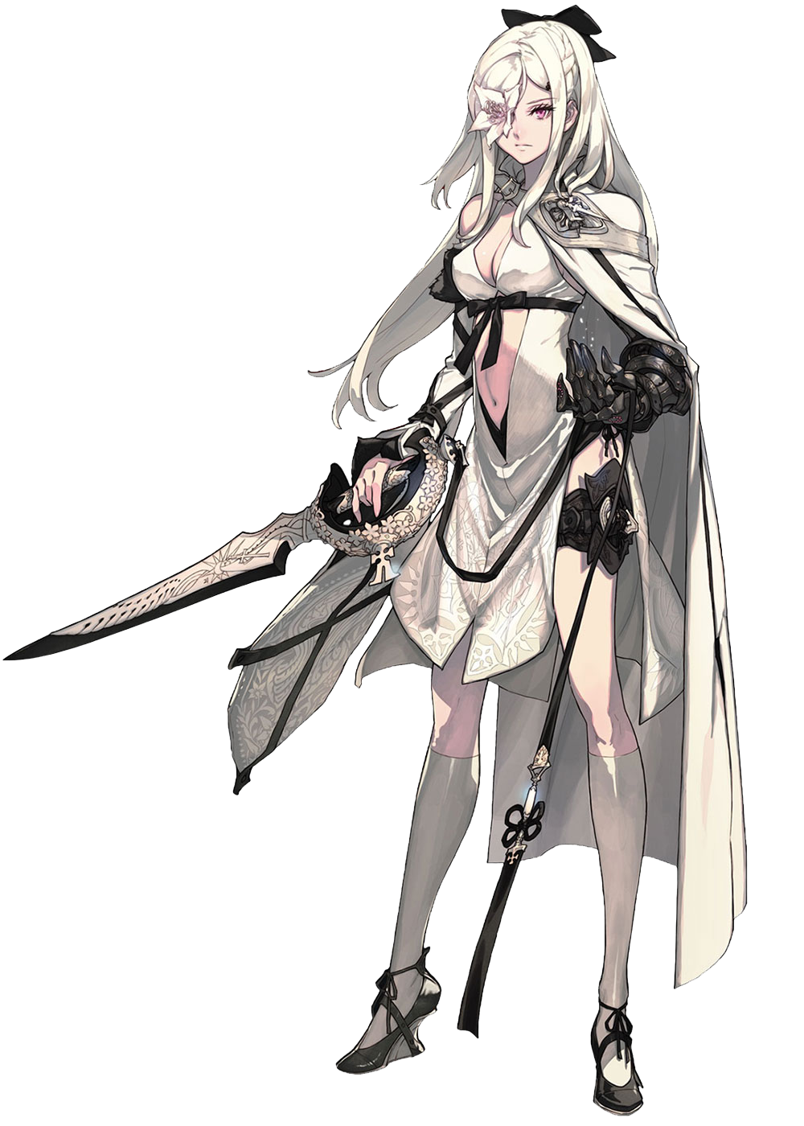
“What the hell!?” Some hours later, Zero finally awoke from the nap she had settled down to and lunged up with a start. She felt like she’d had a nightmare, and now? Her whole body was burning. “The fuck? Did I get sick?” She felt like she’d been hit by a carriage, honestly. Her head was throbbing, and even as she stood she didn’t exactly feel any improvement. Casting her gaze out the pane-less windows nearby, both eyes could perceive that it was late at night now.

Wait. Both eyes?

Shakily, the black prosthetic hand on her equally prosthetic left arm reached up to touch her right eye. She could see her hand through it, despite the fact that there absolutely should have been a flower there to prevent her from seeing it. “Holy shit!?” Through labored breaths she casted her attention back to the cot where she’d been sleeping, upon which the severed flower was resting, wilted. She knew the curse that plagued her. Under no circumstance should that have happened randomly, at least without a new flower growing back.

But just as strangely? The prosthetic arm she had raised? It suddenly fell to the floor with a THUD, leaving her with only a working right arm. “Seriously!? What the fuck is happening here!?” And where was Mikhail? Couldn’t he hear her screaming? He was actually just outside, but had been so exhausted from a day of rolling in the mud that he was completely passed out.

Zero knew it would be best to go fetch him. Loathed as she was to entrust another, if her condition worsened he needed to be aware of that. But as she resolved to go outside and try and find him despite how she felt, a thought beckoned her away from the idea.

That sounds booooring! I wanna play a game!

“Fucking—!?” It didn’t take a degree in rocket science for the Intoner to realize that a thought like that contradicted her very being. Something so childish and tame – a thought that was so blatantly opposite of the seething rage and hatred within that raged on each and every day – was not something that she would often consider. It was worse than she thought. Something was dealing a psychological blow upon her, altering the way she was thinking. So far it had only been isolated to that single thought, but who knew how far it would go?

Not that Zero didn’t have plenty worth worrying about physically, too. That said, the first and most obviously noticeable change might not have been considered too bad. A pressure had begun to build under the shoulder on her left, where a very obviously closed wound demonstrated just how cleanly her missing left arm had been cleaved off all of the moons ago. But the indentations where her prosthetic hooked in had filled in, explaining why said prosthetic laid upon the creaky floor of the hut now.

But the mending of these indents was only part of it. A dull, green light radiated from this spot, and eventually spread in a way that seemed to mirror a second arms resting at the woman’s side, forging a silhouette that was complete with a hand and fingers as well. Then, with a flash? The light disappeared, leaving Zero to gawk at what was obviously a second arm, complete and in the flesh. “Is this for gosh darn real!?”

…Gosh darn? It was almost like something deep down had turned the Intoner’s profanity switch right off.

Not that she had even realized.

The woman, instead, was left staring at this second hand, flexing the arm and the digits on the tip to make sure it was all in working order. She could feel everything, it was real. But it was also distracting her from alterations that were transpiring all the meanwhile, and they weren’t nearly as courteous as restoring an eye or presenting her with a limb that had long been missing. They had simply been returned to her because the power that was now influencing her required her to possess these things.

But other signs had begun to set in, and it was clear looking at her mane of long, white hair that this was the case. The tips in particular didn’t appear quite as they should have, with a darker color festering and beginning to weave upwards towards her roots. But the color in question wasn’t quite normal, either. Well, maybe it was? Two had blue hair, after all. But the color dyeing Zero’s hair, and permanently at that, was a grassy green that lightened to a yellower tone the closer it came to her scalp.

Were that not enough, there was also something about the length’s quality. It retained its volume for the most part, but also received a little extra thanks to the thickness of it all, and even then that was not the quality change that was most dominant. In truth, that was more of a reference to its cleanliness. Because while the Intoner cared enough about getting unnecessarily filthy and made a point to bath whenever she could (and had even done so before her nap in a river nearby). Her hair was her pride and joy, above all.

And yet now spots of dirt had begun to emerge throughout the green hair. Not only dirt, but twigs, and even the odd bug. It really looked like she hadn’t washed it properly in a long while, and didn’t really seem to care all that much about cleanliness in the first place, and ultimately? The rest of her body came to reflect that too, with crusted filth splotches appearing here and there on her skin.

“Something’s not… Heehee! …FRICK!” Try as she might to resist it, Zero was powerless against the welling cheer within that left her core personality in shambles – which ultimately made it even easier for this new personality to settle in, anyways. She could feel it. Her mind? Simplifying. Her desires? They were becoming far more childlike. Everything about herself was being undone in real time.

Just as the color of her pink eyes darkened to a purple, the orbs themselves becoming bigger and rounder than ever. Which was ultimately part of a dramatic shift in the woman’s facial structure – one that saw a youthfulness set in with soft cheeks, thin lips, and an immense forehead that was not at all helped by lengthened bangs now parting in the center.

This left her looking downright kiddish, but what also stood out was the emergence of a set of growths creeping out from behind the longer hair that framed her face’s sides. They were undoubtedly the woman’s ears, but their tips had become pointed. Little by little they stretched longer, thinner, and yet her ability to hear overall increased as a result. While looking quite elvish, they didn’t actually belong to an elf. That is to say… That wasn’t what Zero had been doomed to become.

After all, weren’t elves typically regarded as a taller race? That wasn’t quite what Zero’s frame had begun to exhibit, but before that could become super clear, her greater figure had to undergo adjustments. “Heehee! That tickles!” Unable to resist giggling, the process prompted her to cry out with a high-pitched voice that certainly suited the current appearance of her face. The old Intoner really would have been pissed off about the cause of this ticklish feeling, however.

What was actually happening to cause this was a phenomenon that plagued her breasts and butt alike – two areas that Zero took great pride in. She was sexy and she knew it, and if anything every threatened that sexiness? Well, she would have responded with aggression. But because of her nature, which was rapidly becoming bubblier and more pacifistic, she only found joy in the emptying of her dress’ front, as once D-cup tits deflated until they were little more than mosquito bites across an otherwise flat chest, with nipples no bigger than dimes.

Her ass, just as tragically, underwent a similar experience. Perky cheeks regressed in size and perceived age, ultimately tightening into a pair of buns that definitely appeared to have room to grow in the future. As they ended up, however, there was little more than a promise of what was to come in how they protruded. The same was true of her thighs, and her hips had even collapsed, part of a bigger change in the end.

Because that whole ‘she wasn’t becoming an elf’ comment? Well, that was making itself rather clear. Her body’s height regressed dramatically, limbs shortening so that her dress dangled off of her in a manner that dangerously suggested it might slide off at any moment – just as her underwear did. “Whooooa!?” But despite it all, the woman (or girl?) seemed to be enjoying her descent. It reminded her of a game!

When the proverbial dust settled, she was only 4’3”. No bigger than a child around the ten to twelve range, with a body to match. Fingers and toes were just as teensy, and they were messy with dirty and the like that had otherwise tainted her skin. But despite how young, carefree, and unimposing she seemed, there was a power lurking within that no human could properly comprehend nor wield. She was missing the key component to do so anyways.

In the time it took the girl’s purple eyes to blink, her ill-fitted dress was replaced with a cute little number that fit her to a T. Pink shorts, a scaled, green bikini top with a pink bow in the center, and a purple cape made up the most eye-catching features, largely because her belly was utterly exposed. But there were also leather boots, matching gloves, pink thigh highs, and a silver headpiece across her forehead. It was decorated with big, rose bows and hearts wherever they could be fit.

Absolutely adorable. Zero’s polar opposite.

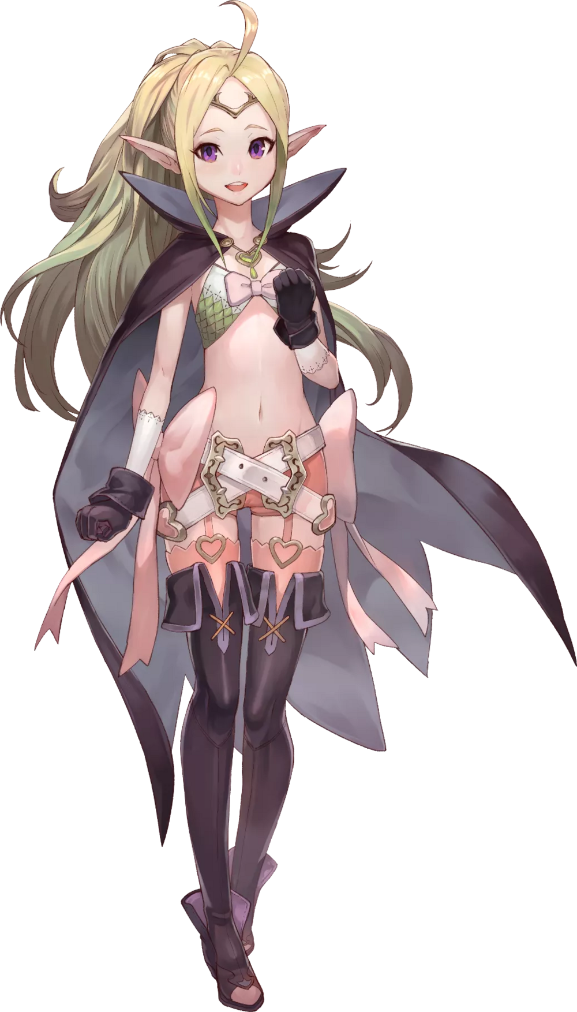
“Hellooooo? Is anyone out here? Do you want to play a game with me?” Having completely shaken off the side effects of her transformation, the girl now felt healthier than ever. She just had so much energy! Even though it was the middle of the night, Nowi bolted out the door of the hut in order to find a potential playmate. Something deep down was telling her that someone who could fit that description was nearby, but she didn’t think very hard about what that something was.

It was actually an instinct provoked by kinship. Deep down, she could sense another draconic being nearby. “Whoa! It’s so muddy out here!” Even though it was dark, the moonlight was enough to reveal what it was she was stepping in – and sinking into. While Zero would have been disgusted by this, seeing it as an activity for children? Nowi cast her boots aside and jumped right in. “Wahoo! This feels so nice!” It was so deep that she was practically swimming in it!

All of the noise the Manakete was making did eventually stir the slumbering Mikhail, who, confused, raised his scaled head from the nearby shore. “Is someone there?” He didn’t know why he asked. He could tell. He sensed something familiar in them, something that almost felt a little like his bond with Zero? But he could also tell by her scent, even if it was masked a little by the mud. Despite her human-like appearance, she was a dragon like him. “H-Hey!? Are you like me!?”

By this point, Nowi had started making mud angels in the gooey, smelly, liquified dirt. Hearing these words, her eyes finally noticed the individual she’d been searching for. A dragon boy! “Mhm! Nowi is a dragon too! Do you want to play with me!? Come on, splash around in the mud with me!” Mikhail didn’t really waste any time on this, and with a mighty splash he jumped into the pit.

Among all of the mud that flew up into the air, coating Nowi even more, there was something shining. A gemstone that landed right in front of her, and she immediately managed to understand what it was. “Oh, hey! You found my Dragonstone! I was wondering where that went!” The stone in question was actually the trigger that had transformed Zero in the first place. But neither of them knew this was the case, and Mikhail certainly hadn’t put two and two together that this dragon girl might be his abrasive partner. She was just so… cute and different!

As the night wore on, he kind of started to think that maybe he was developing a crush on her. It wasn’t until the morning that the thought suddenly struck him. Why hadn’t Zero woken up midst all this?

“Did she abandon me!?”

Far from it. But nonetheless, Nowi told him she’d journey with him to help find this mysterious missing person with a number for a name.

