How to use skysa animation and AMR animation

To use skysa animation, first install these Mods

Dynamic Animation Replacer

(SGC) SkySA

Nemesis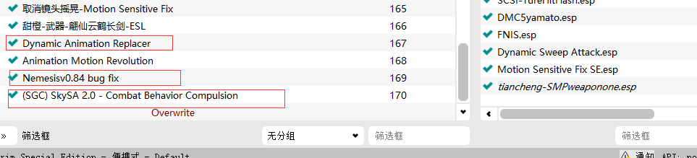

Normal weapon animation is installed directly using mod manager

For example: sword, greatsword, Warhammer 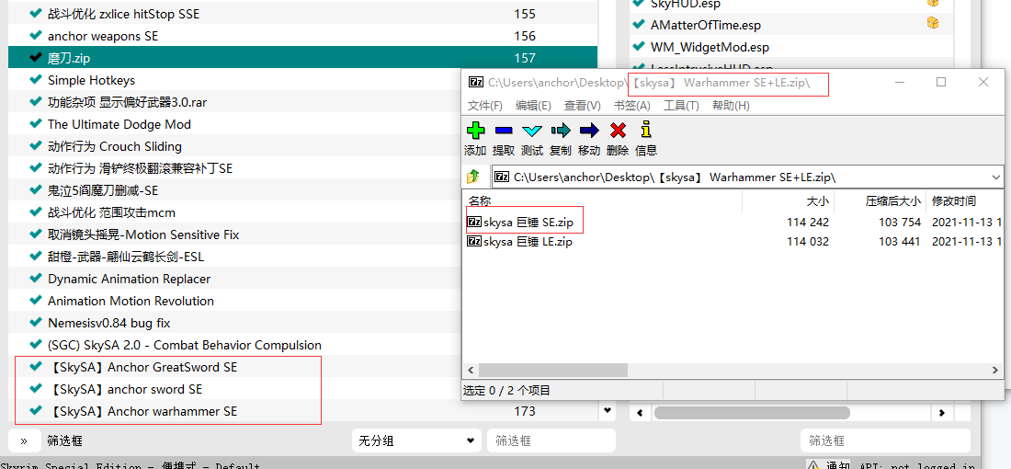

attention：

(SGC) skysa is below the nemesis

Animation packages are below (SGC) skysa

Now, Run Nemesis

First click update. Then choice gender and skysa

Last click launch

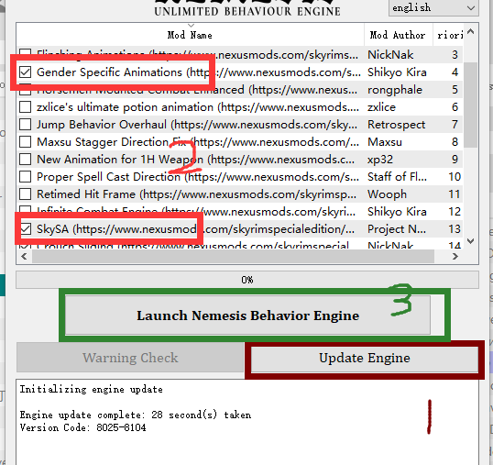

Now You can use the installed skysa animation

About amr animation

Only se has AMR。 LE.......

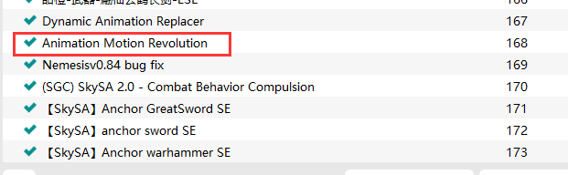

What animation is suitable for AMR animation

such as： katana（greatsword） spear（Battle Axe） yamato（sword）

Maybe you've found out，Although it is different animation，But the weapon types in the game are repeated，If you install this special skysa animation directly。The animation settings of normal weapons will be overwritten，And various problems arise。

If you have AMR, you can solve this problem.

such as： sword and yamato

first。Create a folder with a larger number in the long sword bag。Then copy the AMR animation into the new folder。

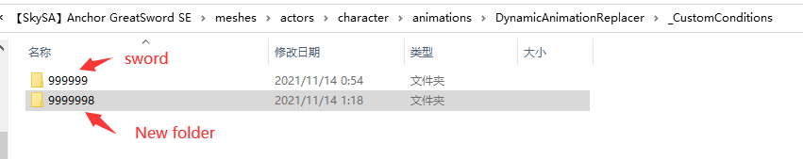

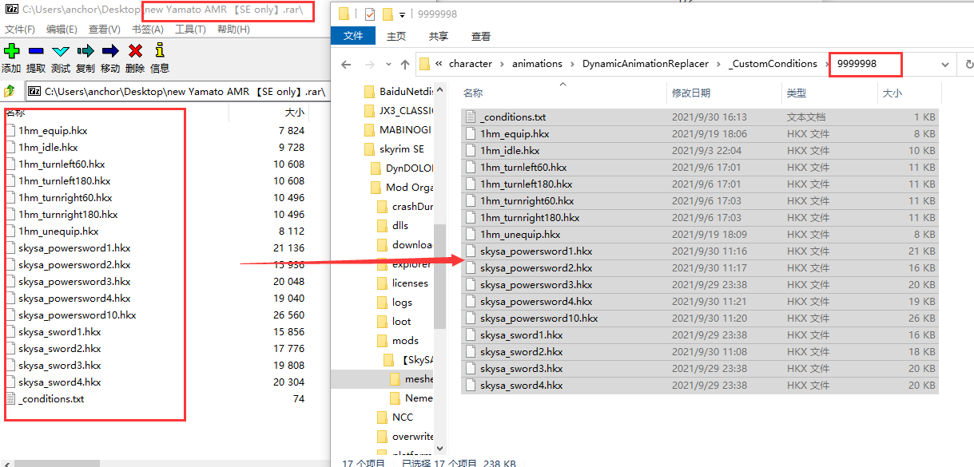

Attention again:Copy _conditions.txt together!This is the DAR setting file，I've set it up。This is important。Why is the number of special animation folders larger than that of normal animation folders，Because Dar has its own rules。The higher the number, the higher the priority。The setting range of normal weapon animation is wider。If it's not bigger than it，Will make the special weapon animation covered and unusable。

Here, the operation is completed。Enter the game and use it

Mh katana，Spear animation is The same way。

Just，katana is greatsword。Spear is Battle Axe。

About _conditions.txt

Use Dar to assign a special weapon animation to a specific weapon。No designated weapons are not used IT。This requires the right conditions

such as: yamato

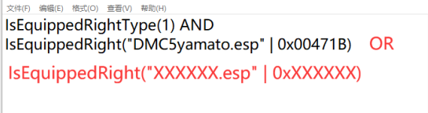

You can change this setting to add weapons that can use this animation

Xxxxx.esp = ESP name of your weapon 0xXXXXXX = weapon id

Click the weapon on the game console to get base id

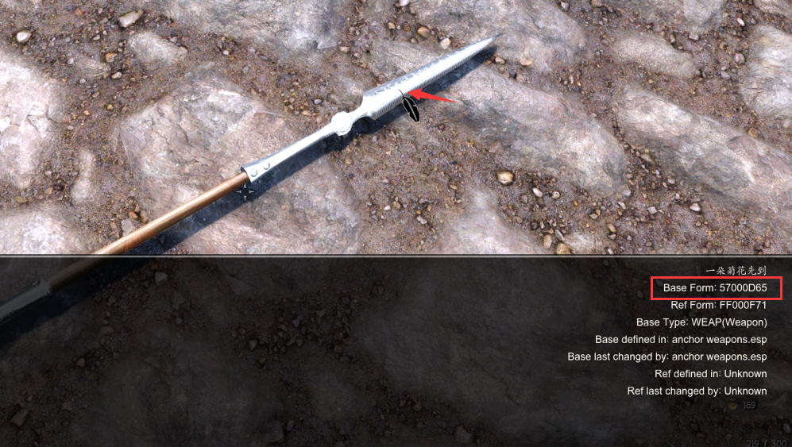

57000d65 = 0x000d65。

I have no settings get the weapon by forging。

So, you need to use the ‘add item menu ‘to get weapon from the esp！

END!!!!!!