SOMEONE’S MASK
COMMISSION STORY
BY CHALDEACHANGE
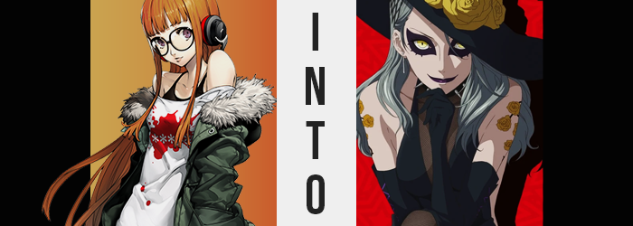

“Ugh, I guess I should just go home for the day. I’m not making any progress here.”

Futaba Sakura had stayed in the Metaverse long after her friends had left that day, searching for exploits in the newest Palace that they had to infiltrate. And boy was the owner of the Palace a doozy of an individual. Sae Nijima – Makoto’s older sister and a Public Prosecutor. Honestly, when it came to potential foes she was likely among the worst of the worst.

But even so, the Phantom Thieves didn’t back down from a challenge! The casino-based Palace was intimidating enough on the inside, but the security system that had been put in place was even more intimidating. If it were just disabled, their travels through the domain would have been so much easier. That was the mentality that they’d all ended up with after several days of investigation, and it was an issue that Futaba was uniquely equipped to deal with.

Hacking, of course! If she could hack the security system in the Palace then it would make all of their lives way easier. That was why she’d remained in the Metaverse long after, lingering outside of the casino where it was safe while she tried to take hold of its systems using her abilities. It was a flop, though.

“Maybe it really would be easier to hack from within? But that means I’ll need the others with me, so no point in trying anything else tonight.” Content with the fact that she had exhausted all of her efforts, the girl was quick to set on returning back to the physical world. Her Metaverse costume disappeared, leaving her in her casual wear, but…
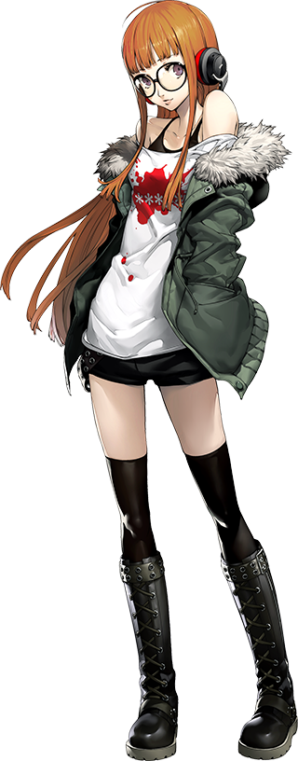
“Huh? This isn’t the real world, is it?” The vibes certainly felt more akin to those in the Metaverse, but that wasn’t what she was getting at exactly. Rather it was her surroundings that were much more telling. “Uh… WHAT!?” She was standing on a copper platform in the middle of what looked to be a gigantic roulette wheel. The bright lights in the room also contributed to an answer that didn’t sit well with her.

That not only was she still in the Metaverse, but she had been transported into the heart of Sae Nijima’s Palace.

“How did I get here!? And wait a sec… If I’m still in the Metaverse, why did my costume disappear!?” Not only that but she couldn’t seem to conjure her Persona in any capacity. That wasn’t normal, but who was she to say how the Metaverse was supposed to work at the end of the day?

Fortunately for her, the room appeared to be empty. That meant that with any luck she would be able to just sneak out again, and keeping that in mind she crept towards the edge of the platform that sat in the middle of the roulette wheel. “OW!?” That which she certainly wasn’t expecting was to collide face first with a wall? A barrier? Whatever it was, she couldn’t see it. “Hey, what’s the big idea? Let me out!”

FAT CHANCE!

A voice called out that felt omniscient in volume, but Futaba was hardly able to challenge it before the platform she was standing on began to glow gold – and that gold light suddenly erupted like a fountain with her standing within its confines. “AAAAAH!?” The surprise of it all had forced her to scream, but it didn’t exactly hurt? Rather, it tingled a lot and by the time the light had faded? Her clothes, glasses included, were all gone.

It would have been like something out of anime if Futaba had fallen down to her hands and knees in shock at that moment, but she kept herself composed. “What the hell was that beam of light!? I can’t even tell what’s going on now!” Without her glasses it was naturally difficult for her to make sense of a world that she barely knew anything about in the first place. At best she was frantically trying to cover her breasts and groin with her hands and groin. “Someone’s there, right? Who is it!?”

WHY, IT’S YOU! WHO ELSE WOULD IT BE?

“What!? That doesn’t make any sense! At least give me back my clothes!” That disembodied voice replied finally, but it didn’t provide the girl with anything meaningful short of continuing to make her feel upset. That clearly wasn’t her voice, so it couldn’t be hers. If anything it sounded like the voice of the Shadow that controlled this domain. In the end though, that was more or less the point.

The hacker blinked a moment as something about her surroundings struck her. Which was something worth noting, because just seconds prior her surroundings had been a complete and utter blur. “Huh? Wait a sec…” Had her vision returned? But she wasn’t wearing glasses! That should have been impossible, and yet she could deny the reality of it!

Although from the point of view of the audience, it certainly wasn’t something worth celebrating. After all, her vision had returned thanks to a golden glow that now radiated from her irises. The very same golden gleam that could be seen in the eyes of a powerful Shadow. The situation around her eyes appeared to worsen just the same though, for dark makeup came to shape the corners of her eyes with black in a way that looked unconventionally sinister. Not to be left behind, her lips grew sticky with this very same paint as well.

“Ugh, this is… Ugh? Why do I feel so…?” Her vision was a perfect 20/20 now, but Futaba wasn’t afforded very much time to revel in it. She was forced to hold her head in her hand thanks to sudden wave of inexplicable exhaustion that accompanied a light, but just as sudden headache. Futaba herself couldn’t explain it, but it very quickly agitated her.

In the meantime, the orange dye in the girl’s hair had undone itself, leaving her locks the natural black and straight design they were supposed to hold. Even that was but a fleeting state though, for their straightness was lost to a natural perm that left them wavier and wavier as time wore on. They didn’t exactly become curly, at least not in a traditional sense, but the waviness the ended-up embodying certainly looked like much more work to comb.

“I don’t feel right. I feel… weak?” She shook her head again, oblivious to its changed style or even the fact that an ashen brown had found its way into her roots before crashing through the rest of her mane in a manner that shifted the style so that everything in the front was swept over her left eye – still glowing gold. “If I’m weak, I cannot accomplish… What? What is it that I wanted to accomplish?”

A question the girl certainly didn’t have an answer for quite yet, but it was one that would come with time. The powers affecting her were much like a blooming flower in the sense that their beauty could not be appreciated until she’d fully bloomed. Perhaps alluding to that, on her bare upper arms bright yellow flower tattoos ultimately etched themselves. Which was strange, because Futaba was too scared to get her ears pierced much less get a tattoo!

Though, for what it was worth, holes had not only appeared in her earlobes now, but silver earrings dangled from these holes.

“Ow!?” A warm tingling around her bosom had provoked the maiden to tilt her neck downwards, and she hadn’t at all been expecting to practically stab herself beneath her chin thanks to… something. “What is that!?” Quickly reaching up a hand, she found spikes sticking out of her neck! Wait, no… They were attached to a collar? “Why am I wearing this!? This isn’t my style at all… Is it?” Why did she sound so unsure about that?

The choker provided a much-needed distraction for the sensation that had provoked her to look down in the first place to take root, as Futaba’s bare breasts jiggled in place thanks to fresh meat that saw either orb, wholly minor to begin with, swelling to proportions that stood out much more abundantly against her current, short frame. Areola were wider, her nipples were thicker, and on the whole each tit was now a perky C-cup.

Looking down again with care for her choker, however? “What the—When did my rack get so big!?” In terms of personality she still sounded like herself, but Futaba’s voice? It was deeper now, somehow. It had also begun to carry an almost mechanical echo that did the golden glow of her eyes proud. She couldn’t help but fondle herself a little, being perverse deep down as she was.

Her headache had mostly cleared up now, and the fact that she felt ‘weak’ was vastly improving itself. How could she be weak with such big tits, after all? Maybe that didn’t make much sense at a glance, but this ‘weakness’ she had been referring to had actually been code for ‘confidence’ – something that Sakura Futaba severely lacked. But her breasts made her feel more so, and other aspects of her body continued that trend.

Her hips were quick to part next, but not without probably cause. The weight of her ass had thickened and bulged, and firm but sensual cheek had grown so large that those hips had been afforded little choice but to comply in their need for additional space if any comfort was left to be afforded to the girl. “Oh! Oh yes!” The girl cooed as hands took a firm grip of her equally firm rump, and in the meantime any excess found its way into thighs that steeled themselves in a similar manner.

Still, because Futaba’s height had not changed at all, she really just looked unusually stacked for a girl of her age.

What suggested that this would change was the look of her face. Of course, the heavy black eyeliner and lipstick had already down a great deal dissuade the childishness she normally exuded, but the painted lips had swollen a great deal along with her tits and ass. Her eyes had also narrowed some, and her face’s overall design was longer and more mature. In fact, nothing about the girl’s face quite resembled how it had once appeared. If anything, she looked far more like Makoto’s sister.

“This isn’t enough though! I need more! MORE!” Caught up in the power of it all, she cried out for more confidence. For more things to be confident about! She could already think of a million ways to use her new appeal for her own benefit, but just think of how much more she could accomplish were she even more beautiful. Such thoughts weren’t exactly typical of Sae, but the presence of Futaba’s ego hadn’t exactly faded yet either.

Almost like it was obliging her request, the girl’s woman’s body soon stretched upwards. Inch after inch found itself into her body, seeing everything lengthen in equal measure. And yet, after each area completed its growth, her nudity was gradually dealt with. For example: once her arms and hands had grown slender, black leather gloves ultimately shaped themselves from nothingness to reach up past her elbows.

When it came to her feet and legs, the growth certainly made her thickened thighs appear much more realistic in terms of weight. Though the added benefit of thigh high, fishnet leggings beneath black leather boots certainly added to their charm. These leggings connected to a pair of black leather panties that clung to her pussy and hid her pubes, riding the shape of her big ass more keenly in the back.

But a glimpse of this area was only as fleeting as the main body of her outfit, which ultimately took form once the woman’s body peaked at 5’6 – a full six inches taller than she had been initially. A black leather dress, skirt flowing past an exposed right leg, fell down to her ankles. It had the entire middle cut out, filled only with more purple fish-netting while a dark and thin material laced between the netting allowed her inner boobs to be fully displayed. It was certainly an arousing sight, something that woman had certainly realized.

But she was sexy because she looked dangerous. The gun appearing on her right hip and the black sun hat tilted across her left eye certainly contributed to that, along with the tattoo of a scary black dog across a back that was more or less entirely bare.

She felt hot. She felt powerful. She felt evil. And she didn’t feel at all like Futaba.

“So what was the goal here? To turn me into a copy of Sae Nijima’s Shadow? Ahaha! Well, it clearly worked wonderfully!” Clad in a fanciful dress and decorated with flowers, the new Shadow clapped her gloved hands together with humor. She could recall being Futaba Sakura, yet that identity no longer held any significance to her. She was now Shadow Sae in body, heart, and soul.

Did this now mean that there were two of them? It did indeed, but the original was nowhere to be found. Even so, the copy could feel it – an intimate link between herself and the original. They shared memories, motives, and goals. Yet while they were fundamentally the same in every conceivable way… “Oh, so that’s it, is it? My sister can’t do that.” There was one major difference in what they were capable of, and she now understood what that was.

Something crucial. Something no other Shadow had the potential to do, because she had been created from a girl that hailed from reality. “Shall I test it, then?” Crossing her arms beneath her chest, the woman appeared to be asking this question to herself. This wasn’t the case. She was asking it to her ‘other self’, the Shadow Sae that had created her. “Oh, so you’re okay with it then? Very well.”

And so, the copy closed her eyes.

In the real world, Sae Nijima had been sitting at her desk in her office. Paperwork had been piling up with all of the Phantom Thieves cases, and she had wanted to get through a sizable chunk of it before she went home to Makoto that night. And she’d succeeded! Things had been going well. At least up until the point that an extremely painful migraine had forced her eyes shut. “Ugh, ibuprofen… ibuprofen…”

Guided by memory, her hands slapped against the desk looking for her bottle. Yet just as she was inches from grabbing it – not only did she stop, but a sadistic smile crept across her facial features. Slowly her eyes opened, and once they were fully so? It was plain as day that her eyes were glowing the very same gold as those of Shadows. “Ahaha! So it did work! Now we’re in control both in the Palace, and out here. I’d like to see those foolish Phantom Thieves try anything now!”

But even without Futaba, they would inevitably still succeed.

