FUTURE SWAP
BIWEEKLY STORY #135
BY CHALDEACHANGE
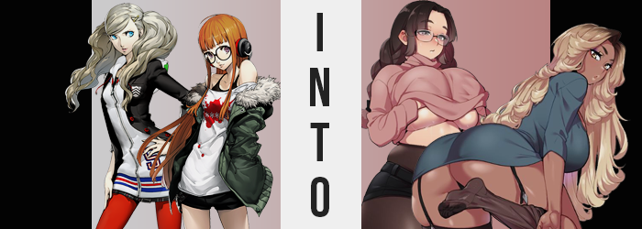

“Futaba-chan! You can’t keep reverting back to doing this!”
“But a new game came ouuuuuuut!”

Ann Takamaki was at wit’s end. It almost felt like she was pulling hairs, in fact! Because Futaba Sakura could be a little difficult to deal with at times. Despite the conviction the ex-shut in had shown after her Palace had been conquered, and despite having made great strides in her efforts to get out of the house more… There were moments when she had a bad habit of slipping back into old habits.

When she got into a new anime series, when a new game came out; there would be days at a time when she refused to make any efforts to leave and just stayed holed up in her room again. With Joker having gone back home after the incident with Shido had been resolved once and for all, the rest of the Phantom Thieves had promised to take care of her.

Although it seemed Ann was the only one available enough to deal with it for the moment. “But you can play that game after school, right? You can even stay up late if you’re okay with running on less sleep! You’re going to worry Sojiro, right? Not to mention you need to think of your future…” And if she recalled correctly, Futaba had to submit a paper about her future plans soon.

“Easy for you to say. You’re a model! You’ve got everything figured out already.” This evidently ended up being a sore spot for Futaba, who barked back with a topic that was equally sensitive for Ann, who had been thinking a lot about whether or not she wanted to continue modeling recently.

“Wh-What do you know!?”

“Well, that do you know!?”

Ann’s efforts had naturally gone downhill from that point on. The two had barked at each other about not knowing what it was like to be in the other’s shoes. Futaba thought Ann had the life of a glamorous model in her future, while Ann had accidentally made an insensitive comment about Futaba remaining a shut-in for the rest of her life. Things escalated, and Ann ended up storming off.

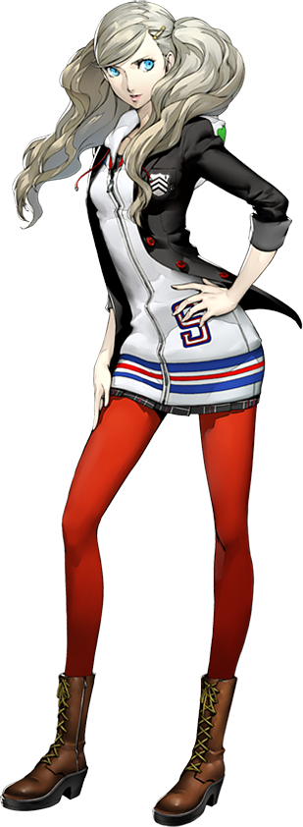
“…Eh?” But when she got home and into her room? The young model encountered an alarming sight. Gone was the usual clean and clutter-free environment that she strived to maintain within her room (most of the time), and instead it was dimly lit, with worn clothes littered about. It seemed her light switch didn’t work, the only light coming from a desktop computer monitor in the corner of the room. “…Whose computer is that?” She had a laptop! Had she walked into someone else’s home somehow!?

No, the rest of it had looked normal! Ann moved further into the room, careful to avoid tripping over clothes that looked big and comfortable, but they definitely not her style. They almost resembled things she’d catch Futaba wearing about her house but… supersized. “This is really weird.” And she didn’t know the half of how weird things were going to get.

There were already signs of this, in fact. But because the room was so dark and her attention was elsewhere, Ann didn’t really notice them. Well, it was more than that in a sense. Anything that happened to the girl from this point on could only be acknowledged briefly before changes that were altering her brain chemistry simultaneously would nudge her away from acknowledging that anything was even different.

So even noticing that, say, her hair was darkening away from its natural blonde towards a dark brown that was more common among those of pureblooded Japanese youths than her own, wouldn’t have received much of a reaction. Nor that the vague curls that these locks possessed were straightening until they felt almost impossibly so comparatively. This hair generally became a little straighter and felt a little fuller, whereas her bangs parted like a pair of curtains being spread apart to show off her forehead… as well as just how bushy and brown her eyebrows had become in kind.

“I need to figure out who put my stuff… My stuff?” It was only briefly, but she was hung up on this for a brief second before her concerns were alleviated. Like my computer? This really is my stuff… The room and everything in it was hers, right? And the more she became certain of that, the less and less she wanted to leave it. Was it related then that her complexion seemed to pale just a touch? Like she hadn’t been outside in a very long time?

Yes. But paled skin also looked looser, and when the changes washed over her face, they inherited similar traits that continued to suggest the possibility that Ann was getting older; significantly so. Thin lines etched themselves into the corners of her eyes, eyes whose bright blues dimmer to a steelier shade instead while shapes narrowed to be even more traditionally Japanese. Like the foreign blood from her Caucasian half no longer even existed. This could be seen elsewhere in her face’s structure, with lips growing full and plush, and cheeks seemingly rounder overall.

But she definitely looked older. “I feel so tired all of a sudden…” With her voice a little deeper, the woman unknowingly touched on another side effect of this change. She had to be around forty or so just looking at her face alone, and getting older naturally meant you became tired much easier. But there was an additional reason for her fatigue. She had begun to feel strangely heavy out of nowhere.

“BURP!? Oh!” Ann hadn’t meant to at all, but she’d belched. It accompanied a bloated feeling that plagued not just her stomach but almost her entire body, clothing tightening around contents that were clearly becoming far too abundant to be properly contained. Regardless of how far reaching this phenomenon was though, her stomach was the starting point. Weight built around her bellybutton and rolls of fat began to form.

There rolls forced her stomach to push past the hem of her skirt and lift her hoodie’s base, revealing bare skin that kept pushing forward and to the sides. “Wh-What’s wrong with my clothes?” And yet the older woman didn’t even see it as a problem with her figure, even as her traits as a model were being stolen from her in real time to the unfortunate side effects of living a sedimentary lifestyle. …But was that all it was?

Because, in the end? The weight she put on as well as where it was applied seemed to suggest that there was more to the story. That whatever was becoming of her, her base was that of a full-figured woman aside from the monumental tummy bump that was now almost entirely exposed with her top lifted up and over it.

And that was because even becoming overweight with Ann’s original figure would force her hips to widen five inches, nor would her thighs bloat and swell to surpass that belly of hers in size. Needless to say, her panties did not survive an expansion that similarly saw her ass grow into an inexplicably enormous size. “So heavy… Ugh, I wanna sit doooooown!” Had the woman always been so whiny? No, but the woman she was becoming certainly was.

She could remember spending entire nights online whining about stupid video game and anime things.

But she hardly ever whined to anyone in real life though, because despite how abundant her body was in ways that would appeal to many, she didn’t want to go outside. She wanted to stay in her room, fat tits and all. Fat tits? They had grown a little fuller as she’d gained weight elsewhere, but it wasn’t until her thighs and ass had become so obscenely full that they made the full push into the forms Ann now recalled having.

And they really did balloon. In a matter of seconds, they had reached a sizing similar to DD-cups, a cup size that most women would agree was the ideal weight before getting too big. But it wasn’t really a matter of Ann’s tits getting ‘too’ big so much that they became ‘way too’ big. “A-Ah!” The woman that they were featured upon couldn’t even comprehend what was happening as her shirt and sweater lifted up to her chin, nipples bigger than her eyes standing perky upon a set of M-cups that defied the laws of perkiness. She remembered that they’d always been enormous to the point that boys always followed her around in school. But when she’d gained weight? They’d grown obscenely large.

“Wait, what’s going on? I can’t see…” It was dimly lit in the room of course, but things had just become blurry all of a sudden. The world around her hadn’t changed, of course, but her eyes had. Her vision had taken a dramatic dip. “Or… not?” But it cleared once more, unknowingly because a pair of round-rimmed glasses now sat upon her nose. Though it wasn’t just glasses; her entire outfit had changed to fit.

The woman now wore black tights that barely contained her thick thighs and ass, hoisted around her tummy in a poor attempt to make her look thinner, along with tight, black short-shorts and a necessarily huge, pink turtleneck that hang down to the shorts. Her hair was also messily pulled into two thick braids that hung behind her shoulders. But an aching in her chest pushed her to lift the sweater and fondle herself – a side effect of them being so large.

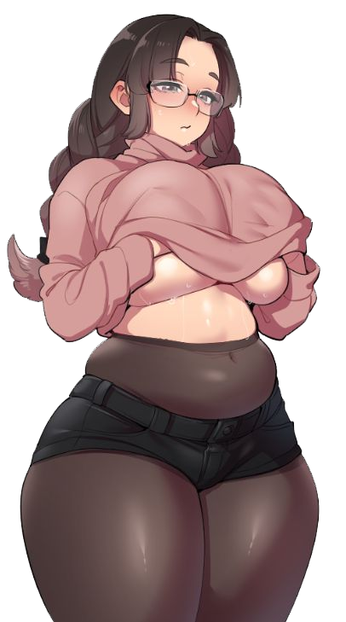
“They really are a pain… My back’s starting to hurt from sitting in the desk with all of this weight…” Forgetting all about the transformation she had just undergone, Aina Takamaki instead found herself focusing on different concerns as she massaged her massive tits underneath her thick, pink turtleneck. Her chubby body was already difficult to move in alone, but tits bigger than her head certainly made her shut-in life more difficult when she spent so much time hunched over in front of a screen.

But she returned to her computer chair anyways. “N-Not like I can go to the doctor to ask about it.” While she may have been a transformed Ann, her history and identity had been rewritten so that she was her mother’s own sister, now using a spare room that had once belonged to a daughter she no longer had. But Aina was fearful of the outside world and preferred the sole comfort of her room even as a woman in her early forties. “Uu…”

It was as if she was now living the future life that she had accused Futaba of being on the road to living.

After Ann had stormed off, Futaba had fiddled around with something she probably shouldn’t have before heading off to take a shower. A new site had been going around in the schools that was all the rage. You typed your wish in the field on the website and then supposedly that wish was granted. The teen didn’t really believe it would grant anything, but her mood had been soured by her interaction with Ann.

I wish Ann Takamaki could understand what it was like to be like me!

Or, at least, that was what she had written. It wasn’t like she thought it would work, or that if it did, that the wish granting power would consider the conversation the two girls had had. Nor did she know that for a wish to be granted, there was something like a monkey’s paw cost to be paid for having it granted. “Maybe I should just apologize…”

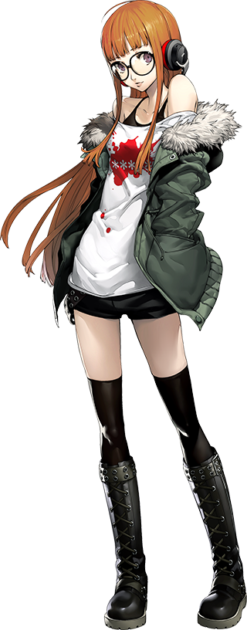
In the end, wrapped in only a towel without even her glasses on, Futaba was already over the disagreement by the time she had left the shower and entered her room again. “…HUH!? What happened to my room!?” But said room wasn’t in the same state it had been in when she’d left. All of the furniture was fancier, all of her clothes tucked away and – no, were those even her clothes? The ones she could see in her closet seemed to be very fashionable and much too big.

“Whose stuff is all this? There’s no way someone moved all of this stuff in so quickly…” But a peculiar thought struck her just moments after thinking that. Why would anyone move my things in here? I’ve lived here for months! “…What?” At first? She wasn’t sure why such a thought had crossed her mind, but the longer it lingered the more she wondered why she was questioning such an obvious fact in the first place.

While there were bigger things that she should have been questioning. Her eye level, for one. Futaba blinked. “Is something…?” Wrong? She wanted to think as much – her room somehow seemed smaller. But she couldn’t actually process the reason for this, that her eye level had legitimately risen a whole five inches courtesy of her body becoming taller. The base of her shirt was lifted up to show off her navel and her thigh highs had slipped down to her knees.

But there was the added side effect of her feet now being a little too large for her stockings as well as the reality that, to avoid her appearing dissonantly lanky in the meantime, she had even grown wider around her shoulders and hips, rendering her shorts very tight on the side. But so far? She wasn’t exactly exploding out of her clothing. That would come later.

“Must be a trick of my imagination.” Was her voice sounding so sultry and husky all of a sudden also a trick of her imagination? Of course it wasn’t, and she idly wondered for a brief second why it had felt so hard to speak. It was as if her lips hadn’t been interacting with each other quite like how she accustomed to but couldn’t figure the reason out. Even though it was completely obvious to an outsider.

Futaba’s lips had been inflating. Not just a little bit, mind you, but a lot. They puffed up to a size so large that they looked fake and hard, and this was actually the truth of things. Collagen had been injected into them to make them artificially fuller on top of a more natural size increase, the necessity of which made clearer as the girl’s face could be observed aging. Skin loosened, Crow’s feet formed – the whole shebang. But little by little her identity became questionable too, with cheeks becoming rounder, lashes lengthening, and even her eyes taking on a silvery color.

Something about it all felt a little exotic, even though she was still clearly and fundamentally a Japanese woman. It just so happened that she resembled a Japanese woman in her forties now. Not to mention one whose skin color was shifting from pale to an almost gaudy copper. It was clearly a fake tan, the sort you get from a tanning booth (and the tan lines across her breasts and the front of her pelvis confirmed that, despite suggesting she’d tanned while wearing a thong).

“Hmm…” Futaba stepped into her room further, at an impasse about whether anything was actually wrong or if she was simply tired. All the while her appearance continued to take on a more and more artificial look, now with the orange dye in her hair lightening to a sandy blonde instead while dark roots stuck out a few inches from her scalp to make it clear it was just a dye job. This hair grew thicker and more luscious in look and feel, fanning out to the sides in layers. But her brows and pubes? Both regions became fluffier and retained her natural, darker hair color.

While the woman did look ‘fake’ now in numerous ways, the more that she changed the more it became clear that this was merely to enhance a beauty that already existed. Her face was aged, but still incredibly beautiful and easily comparable to a model’s. In fact, much of her body gave a similar impression as this taller form of hers filled out. Her breasts and ass alike all bloated, skin stretching sensually around tanned mass that was heftier below her waist than it was above.

Although even her tummy bulged a touch, only enough to represent her age relative to how expansive the rest of her body was becoming. “So… tight…!” This was all she could croak out as her graphic tee stretched around her bosom. Breasts had exploded into G-cups that her short, teenager-sized shirt could not contain any further without tearing down her neckline. Why am I wearing children’s clothing!? Somehow this was the only takeaway she took from it.

Just like she groaned about her shorts and tights, all of which succumbing in their own ways to their contents outgrowing their integrity. Panties were swallowed by tanned cheeks erupting into a full, bouncy peach shape that struggled to, but eventually did tear through her shorts so that tatters spilled off her abundant, naked flesh. Even her thighs engorged, pushing hips five inches wider as they expanded to match her own waistline in density.

If Futaba’s clothing situation seemed unreasonable, then it wasn’t really for long. As had been the case with Aina, her outfit was replaced the moment her physical transformation had ended. A dark green dress with a skirt that only reached the peaks of her thighs, tight enough that if she bent over her cheeks would be visible along with the black thong within. She was also wearing dark, translucent tights now that made her thighs bulge around them – adding an appeal similar to the vast cleavage of this new dress.
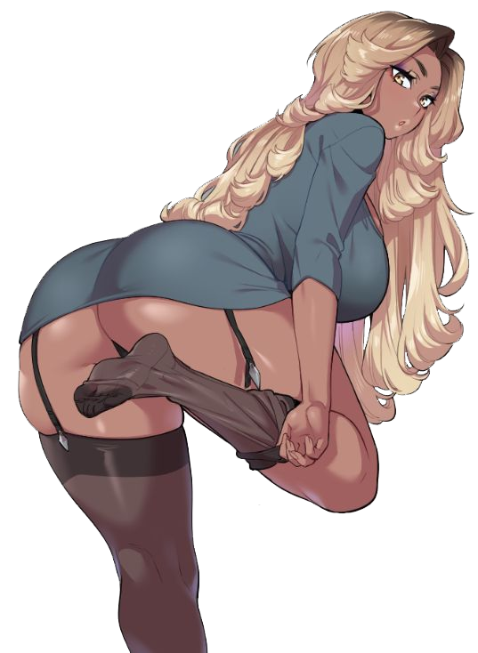
Fumika Sakura allowed a sensual moan to escape her full, glossy lips as she adjusted the dress that she believed had been on her body the entire time; even though it had only just appeared on her once naked body along with the relevant undergarments. “It’s getting a little tight. Sigh. It seems the older I get, the harder it is to stay in shape.” And it had certainly been something weighing on her mind lately. Her age, that was.

Times were tough lately. In her prime – her teens, twenties, and even much of her thirties – she had been one of the most popular models in Japan. But then her years had caught up with her. Her body aged like a fine wine in general, but she still got less and less work as her stomach and the surrounding areas had grown plumper. Now? Fumika hardly got much work at all and was crashing in the home of her cousin, Sojiro.

“Well, at least I can count on family in times of need but it’s still a bummer.” She collapsed on her bed and pulled a tablet out of her bedside drawer. It was the only device she owned aside from her phone for accessing the internet, and it had become very useful lately. Because she had met someone on a dating site! They were really handy for a woman in her forties who was struggling to find a partner. “Now where was her name again…?”

“Aha! Aina Takamaki! She keeps declining to meet in person, but I’ll make her crack sooner or later!”

And she would! It would just take three more months.

